Name: Rugvedi Jamgaonkar.
Enroll No: 2002242
------------------------------------------------------------------------------------------------------------------------
Cloud Computing
Practical Assignment No. 9
------------------------------------------------------------------------------------------------------------------------
Build your VPC and Launch a Web Server

Step 1: At the top right panel above the console, choose Start Lab to launch your lab.

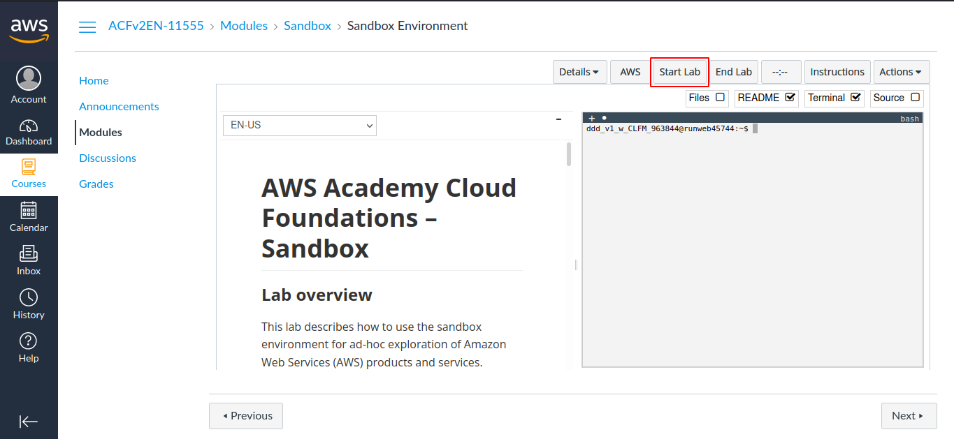

Step 2: Wait until you see the message "Lab status: ready", then choose the X to close the Start Lab panel.

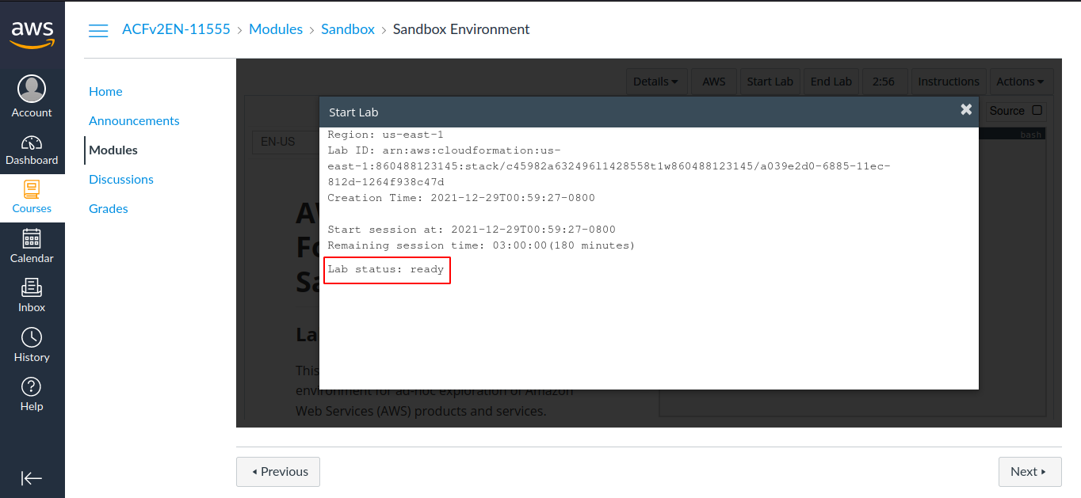

Step 3: Now choose AWS
This will open the AWS Management Console in a new browser tab. The system will automatically log you in.

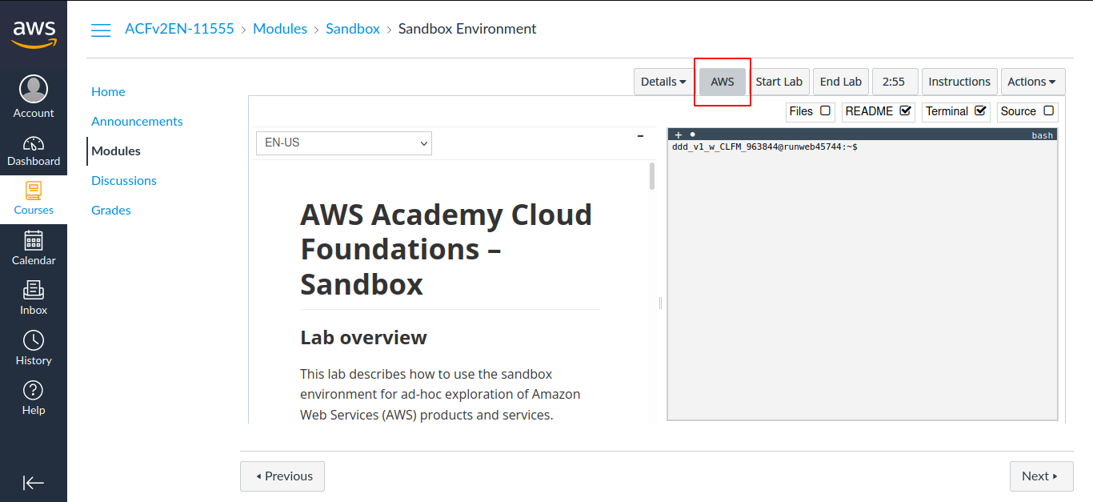

Step 4: In the AWS Management Console on the Services menu, choose VPC.

Step 5: Choose Launch VPC Wizard

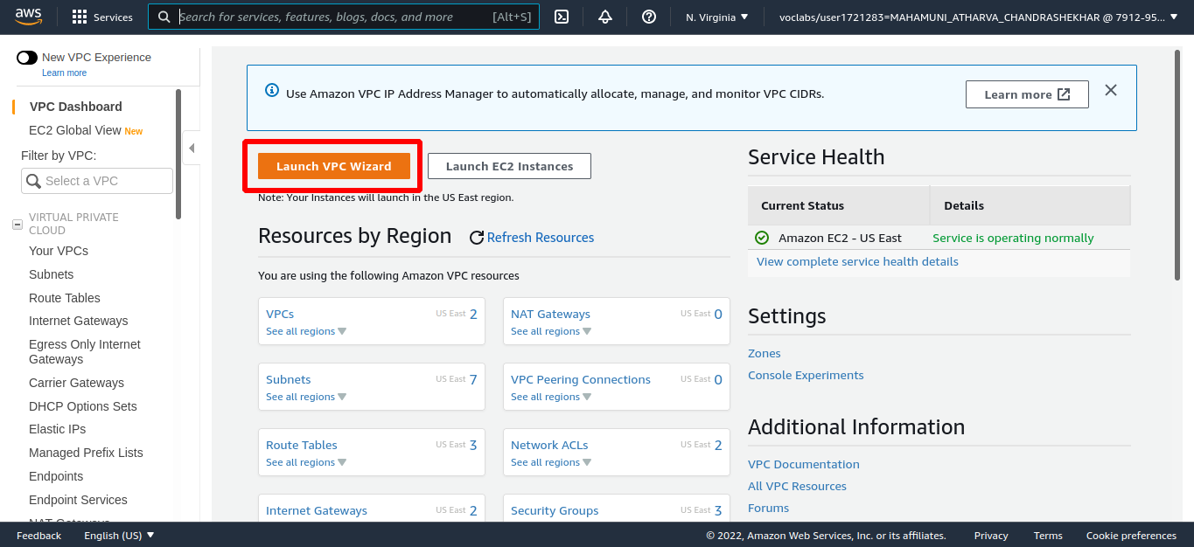

Step 6: In the left navigation pane, choose VPC with Public and Private Subnets (the second option).

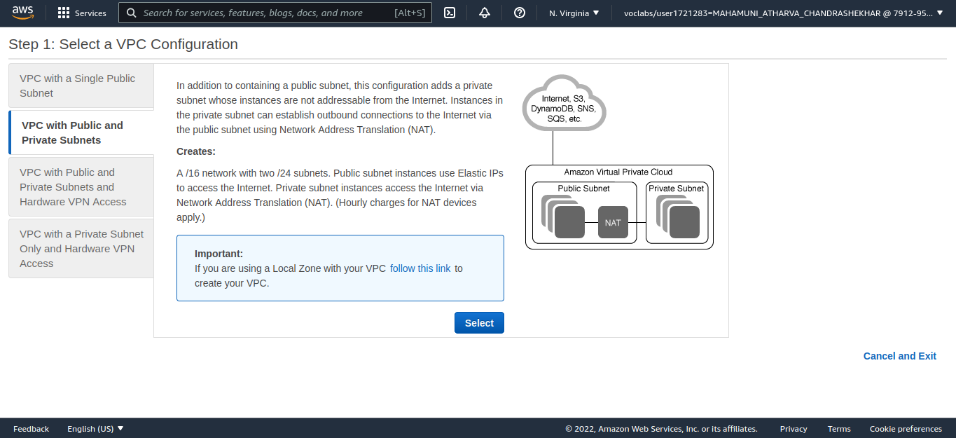

Step 7: Choose Select then configure, Once it is complete, choose Create VPC

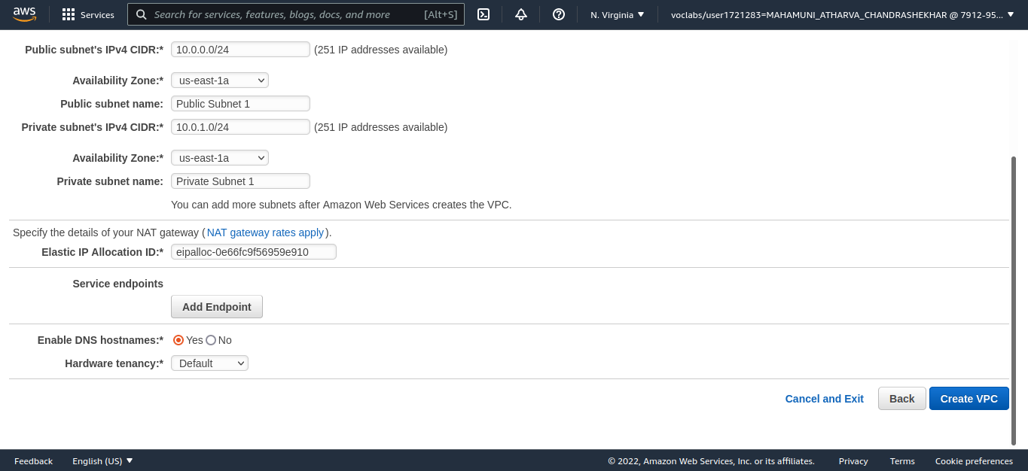

Step 8: Create Additional Subnets
In the left navigation pane, choose Subnets.
First, you will create a second Public Subnet. Choose Create subnet then configure:
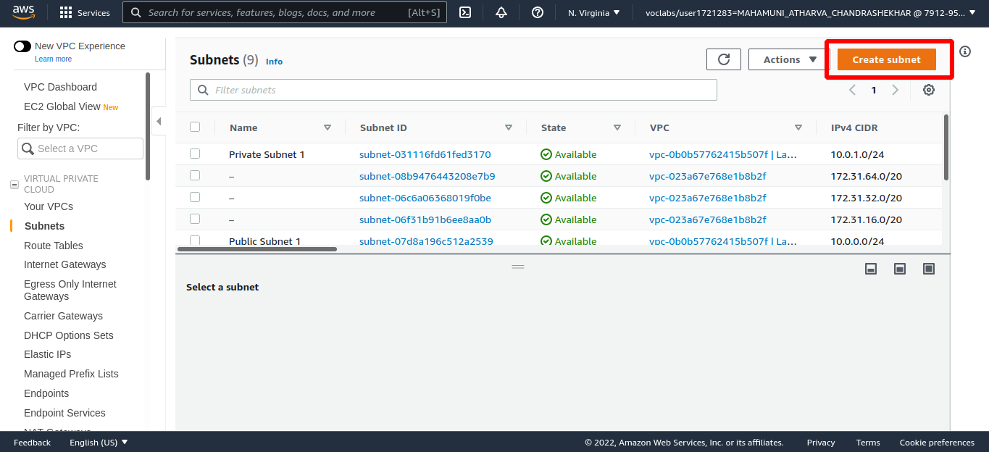

Step 9: Choose Create subnet

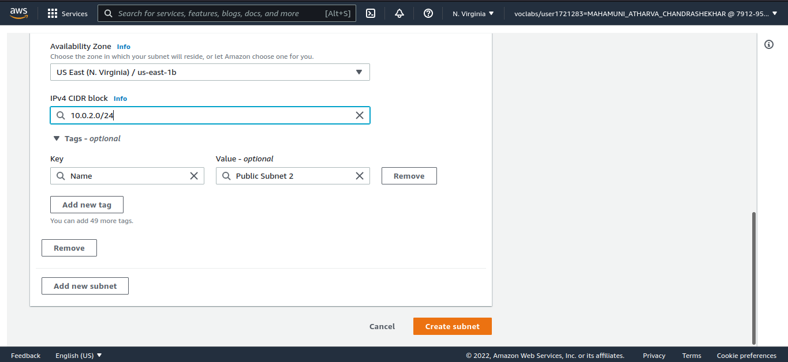
Do the same for private subnet 2

Step 10: In the left navigation pane, choose Route Tables.

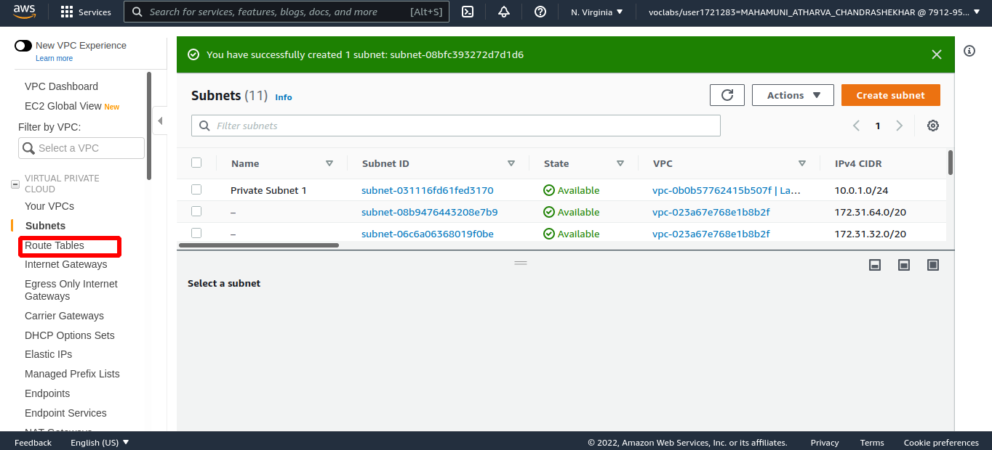

Step 11: Select the route table with Main = Yes and VPC = Lab VPC

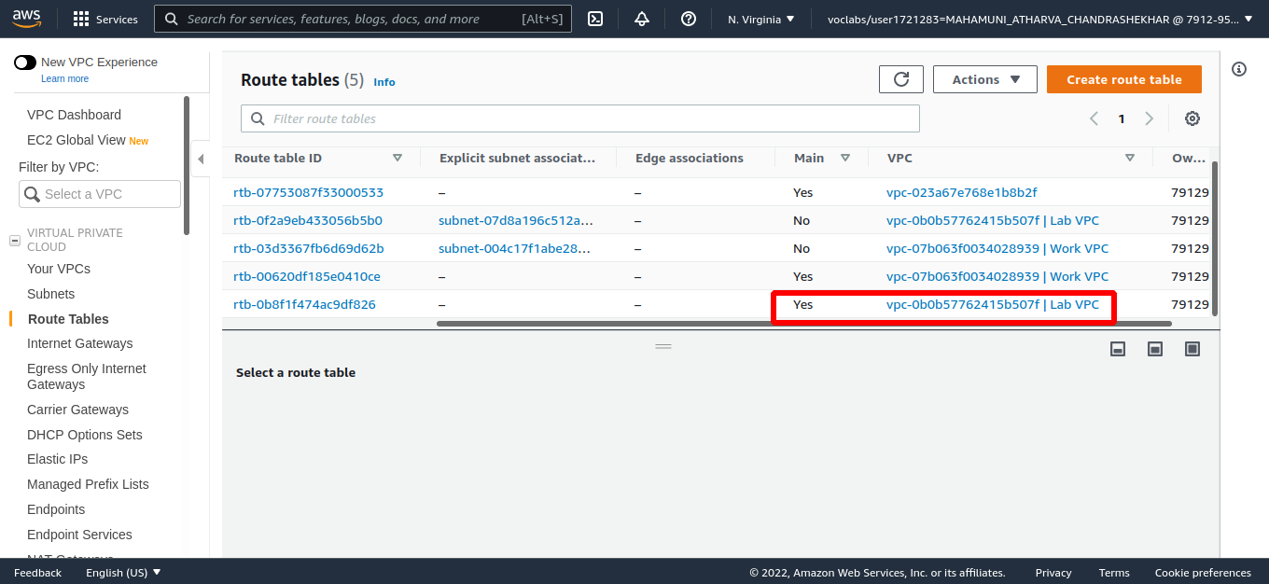

Step 12: In the Name column for this route table, choose the pencil then type Private Route Table and choose Save

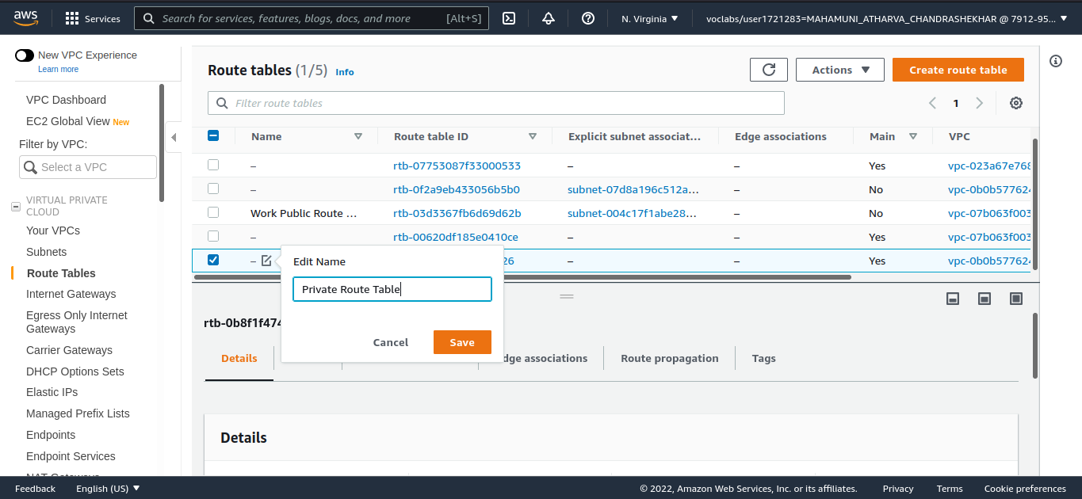

Step 13: In the lower pane, choose the Subnet Associations tab.
Choose Edit subnet associations
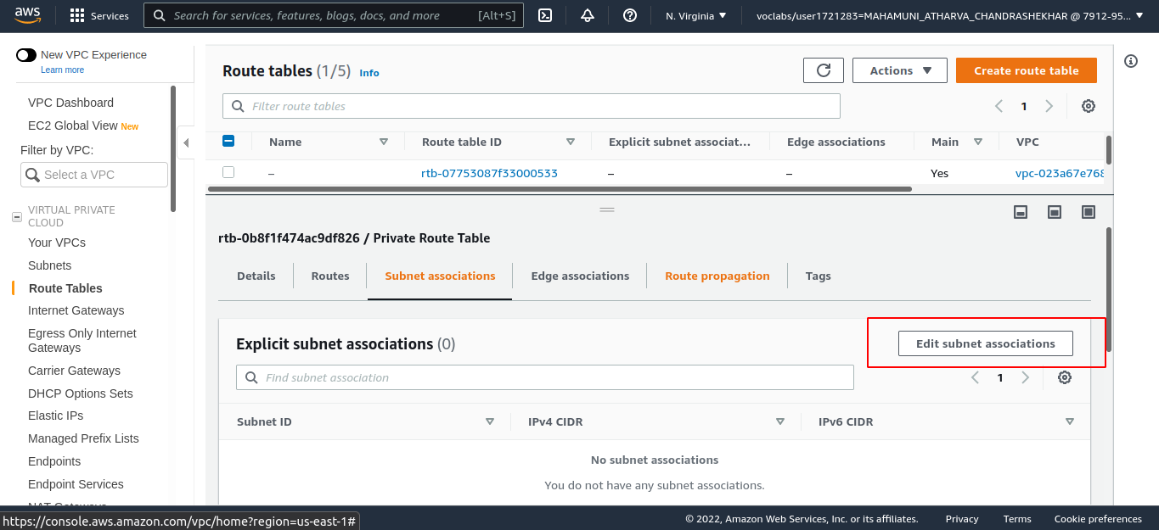

Step 14: Select both Private Subnet 1 and Private Subnet 2.
Choose Save associations
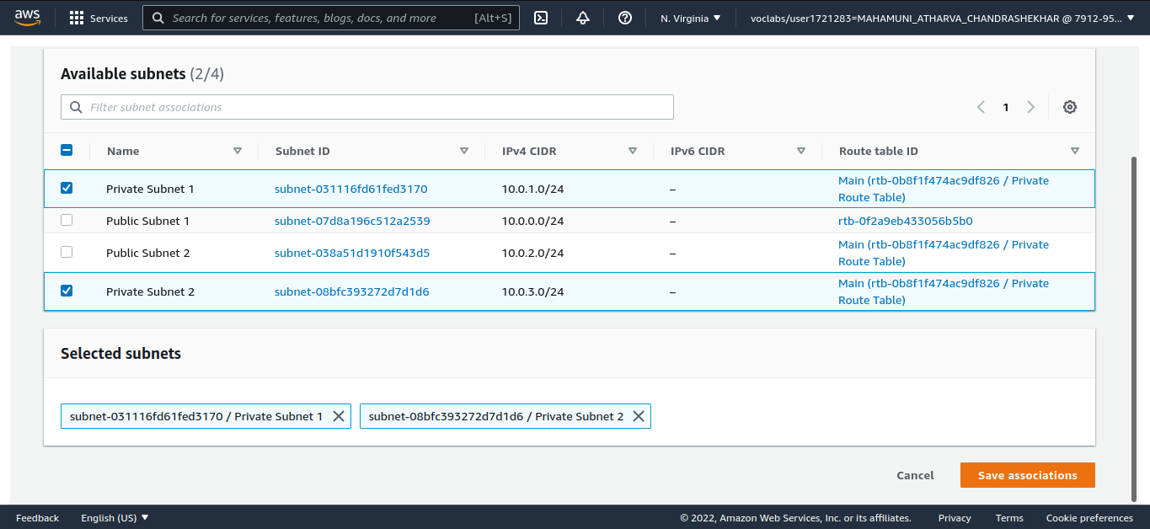

Step 15: Select the route table with Main = No and VPC = Lab VPC (and deselect any other subnets).
In the Name column for this route table, choose the pencil then type Public Route Table, and choose Save

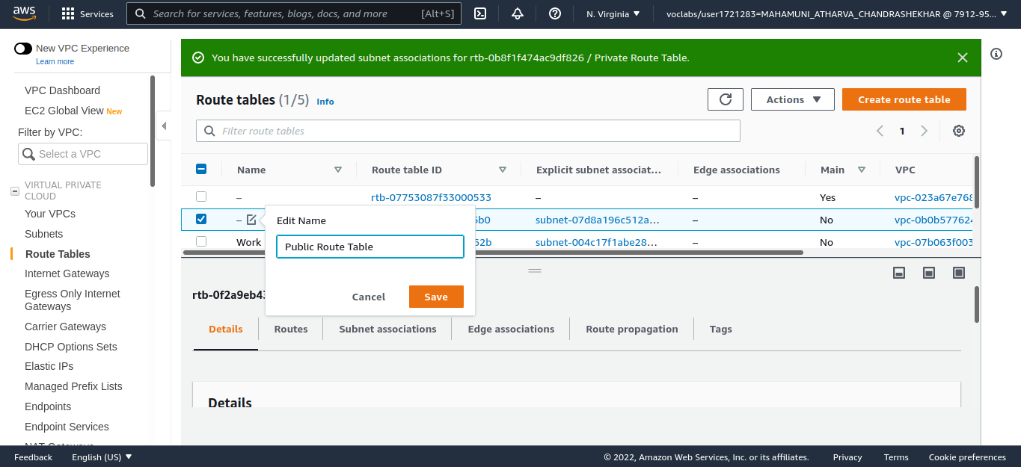

Step 16: Choose the Subnet Associations tab, Choose Edit subnet associations
Select both Public Subnet 1 and Public Subnet 2, Choose Save associations
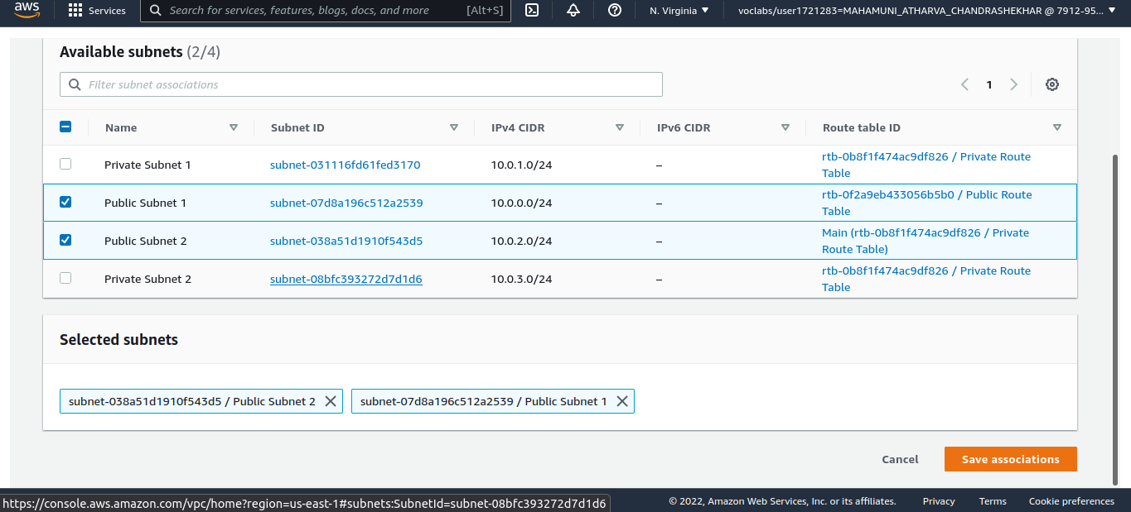

Step 17: Create a VPC Security Group
In the left navigation pane, choose Security Groups, Choose Create security group and then configure:
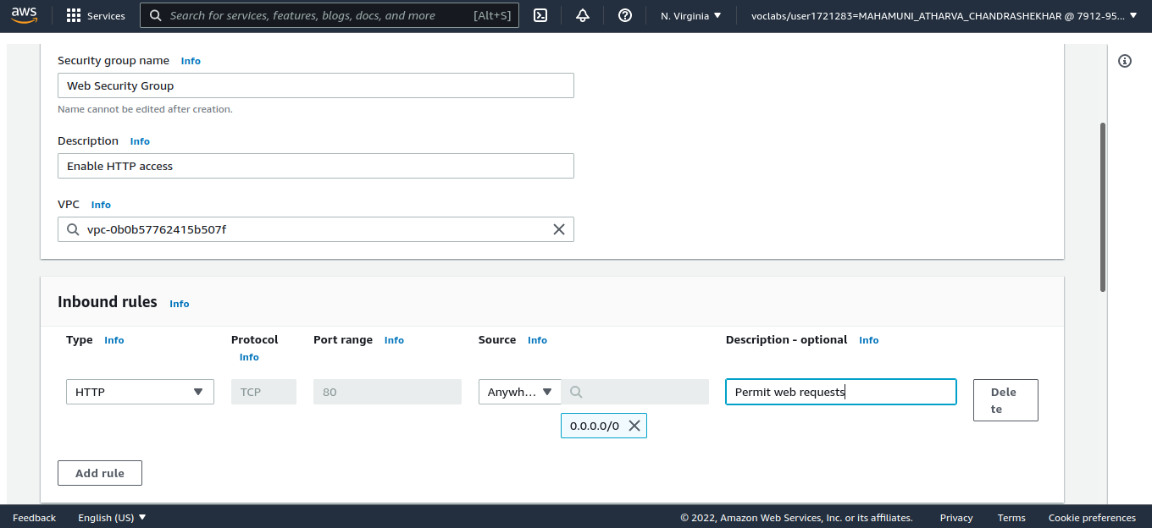

Step 18: Launch a Web Server Instance
On the Services menu, choose EC2. Choose Launch Instance, and then choose Launch Instance

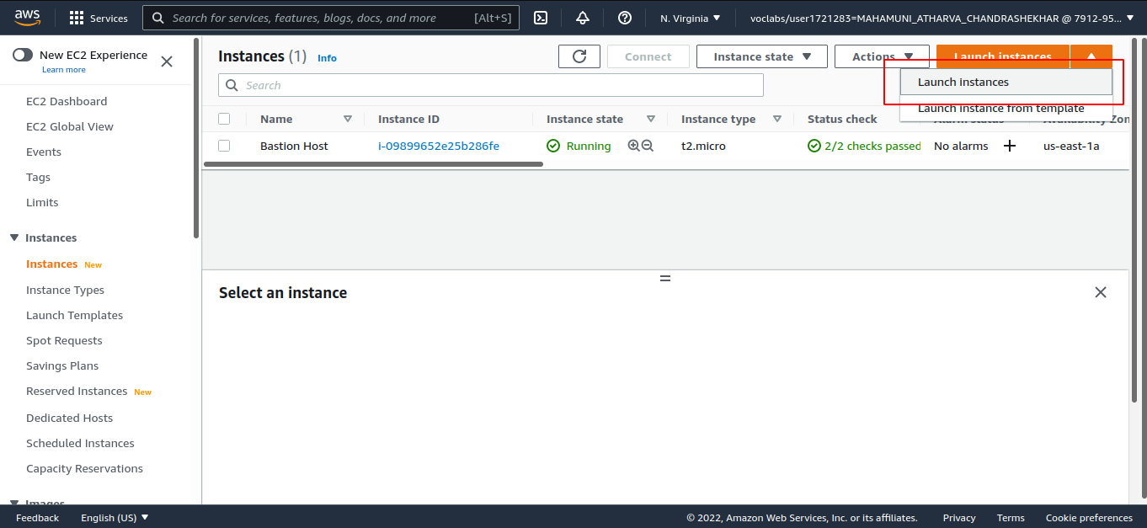

Step 19: In the row for Amazon Linux 2 (at the top), choose Select
Select t2.micro (shown in the Type column).
Choose Next: Configure Instance Details
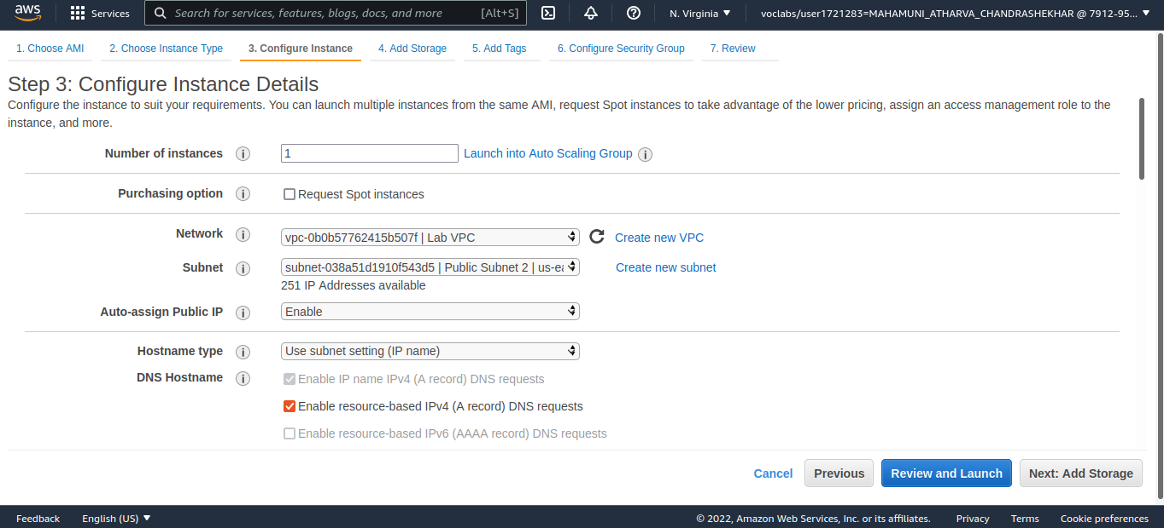

Step 20: Choose Add Tag then configure:
- Key: Name
- Value: Web Server 1
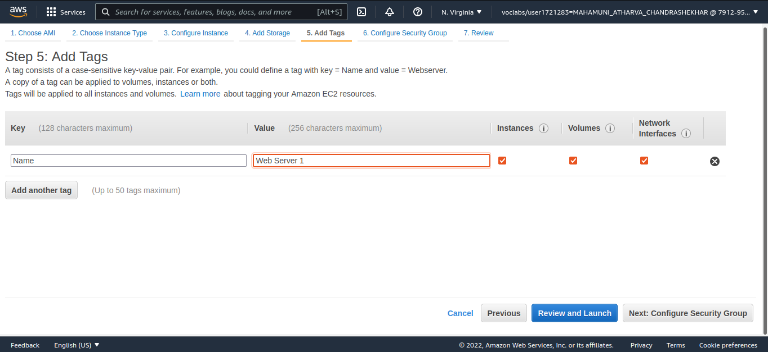

Step 21: Choose Next: Configure Security Group, Select Select an existing security group
Select Web Security Group, Choose Review and Launch
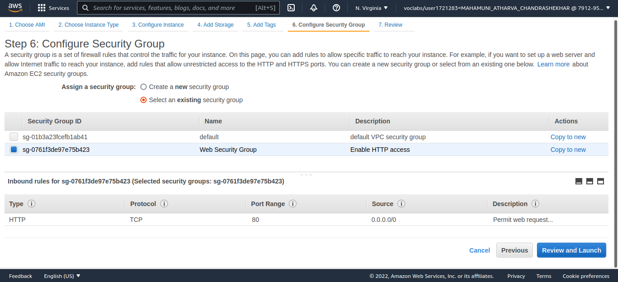

Step 22: Review the instance information and choose Launch
In the Select an existing keypair dialog, select I acknowledge....
Choose Launch Instances
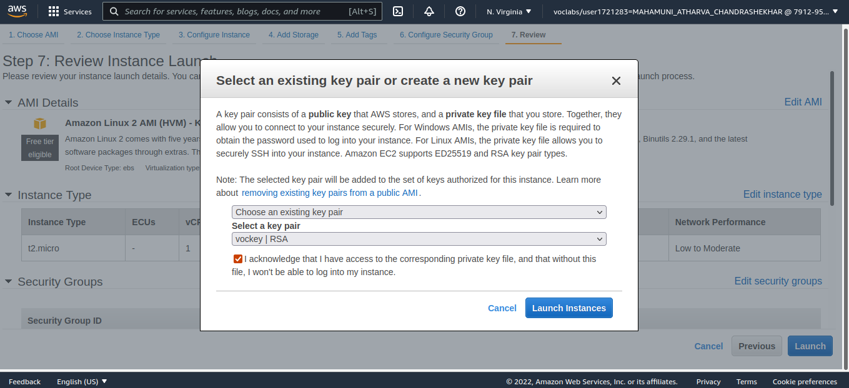

Step 23: Wait until Web Server 1 shows 2/2 checks passed in the Status Checks column.
Select Web Server 1.
Copy the Public DNS (IPv4) value shown in the Description tab at the bottom of the page.
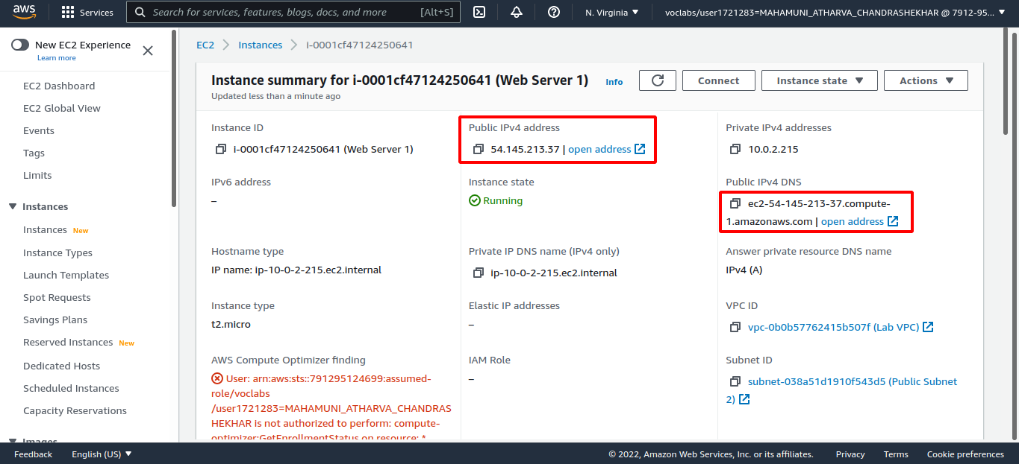

Step 24: Open a new web browser tab, paste the Public DNS value and press Enter.
You should see a web page displaying the AWS logo and instance meta-data values.
