Name: Atharva Mahamuni.
Enroll No: 2002276
------------------------------------------------------------------------------------------------------------------------
Cloud Computing
Practical Assignment No. 4 - Practical Implementation of Storage as a Service
------------------------------------------------------------------------------------------------------------------------
Create an S3 Bucket, Upload a file to S3 Bucket, Retrieve a File from S3 Bucket, Delete a File From S3 Bucket using AWS.

Step 1: At the top right panel above the console, choose Start Lab to launch your lab.

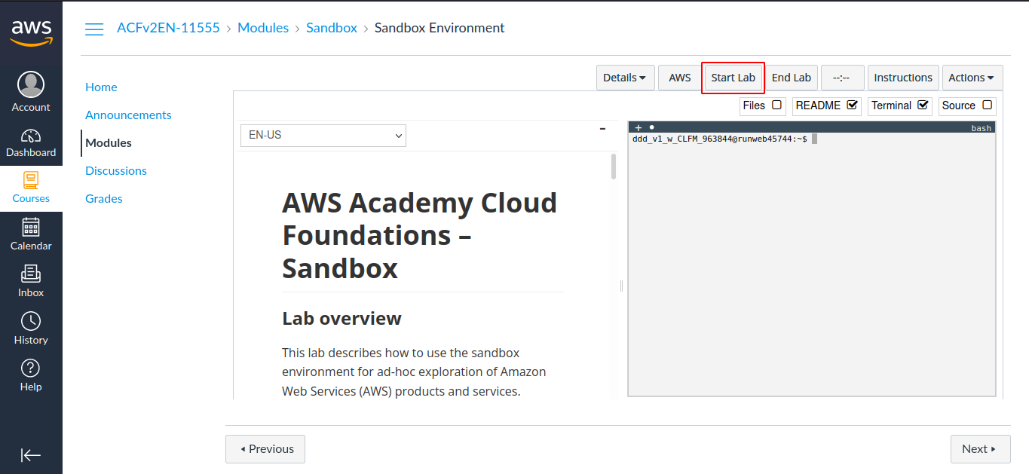

Step 2: Wait until you see the message "Lab status: ready", then choose the X to close the Start Lab panel.

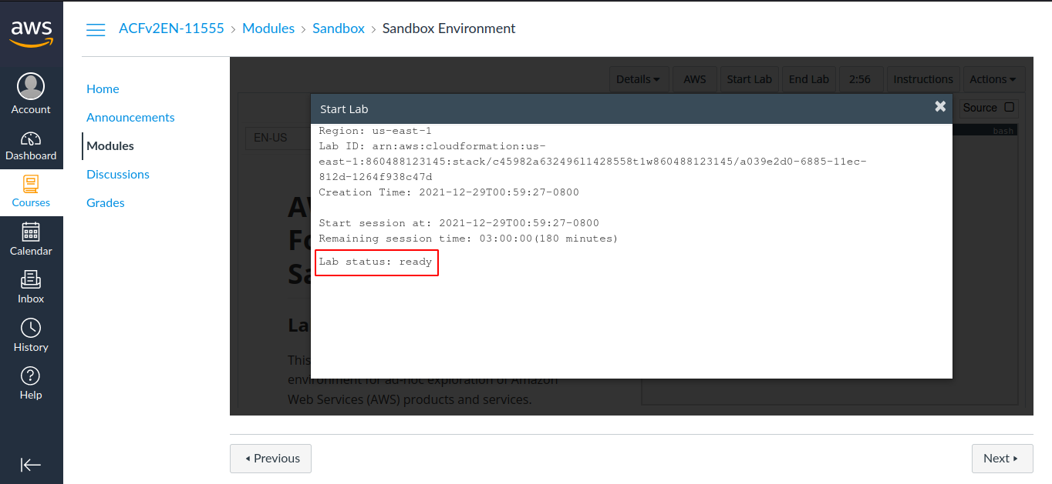

Step 3: Now choose AWS
This will open the AWS Management Console in a new browser tab. The system will automatically log you in.

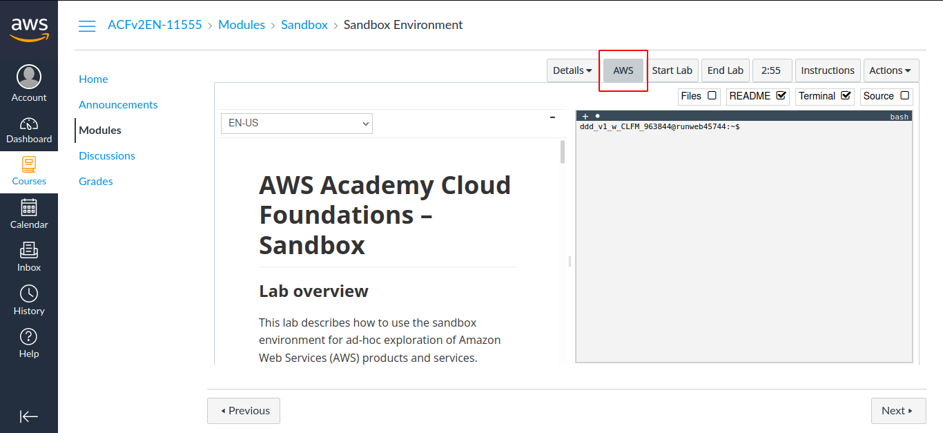

Step 4: In the AWS Management Console on the Services menu, choose S3.

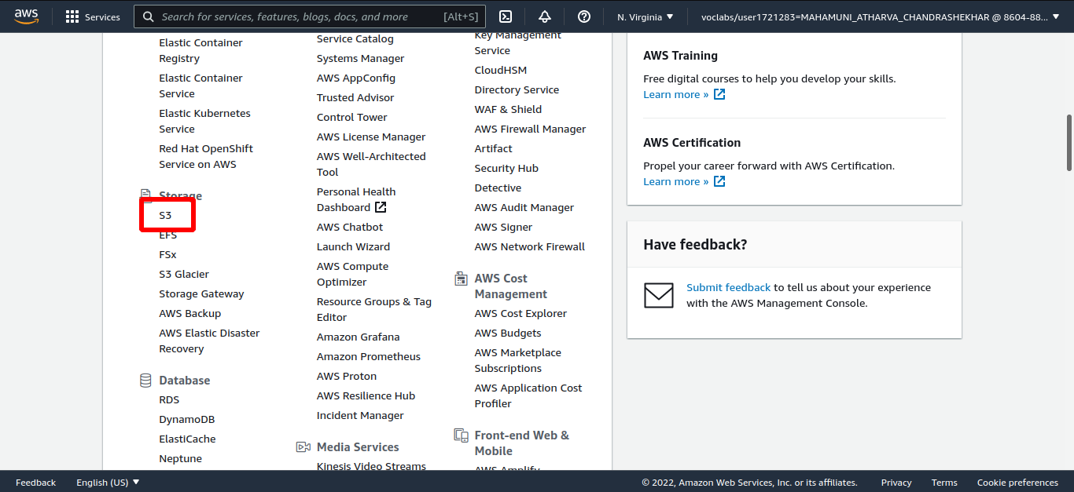

Step 5: Click on Create bucket.

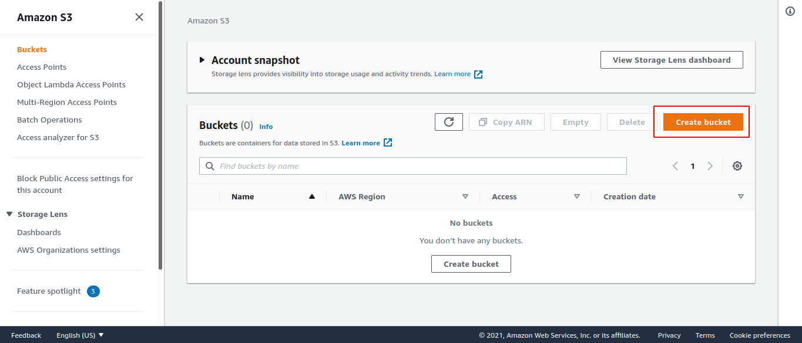

Step 6: Add bucket name.

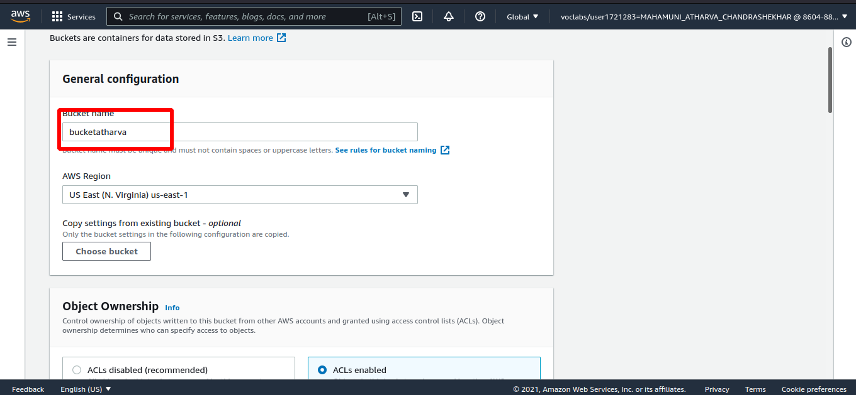

Step 7: Select ACLs enabled and scroll down.

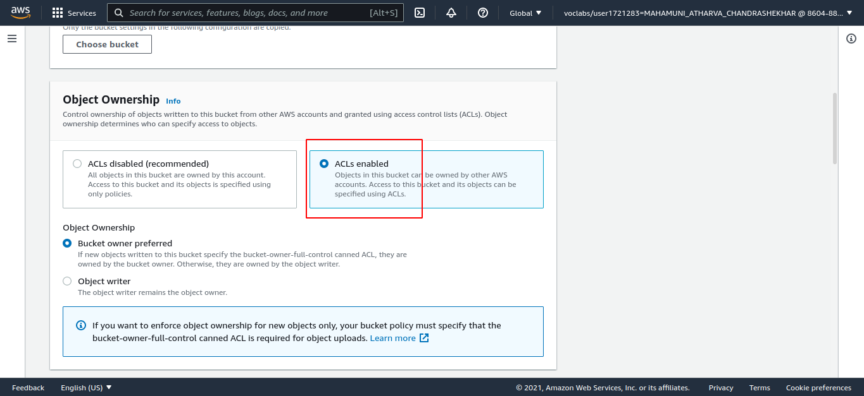

Step 8: Remove checkbox of block public access and select I acknowledge that...

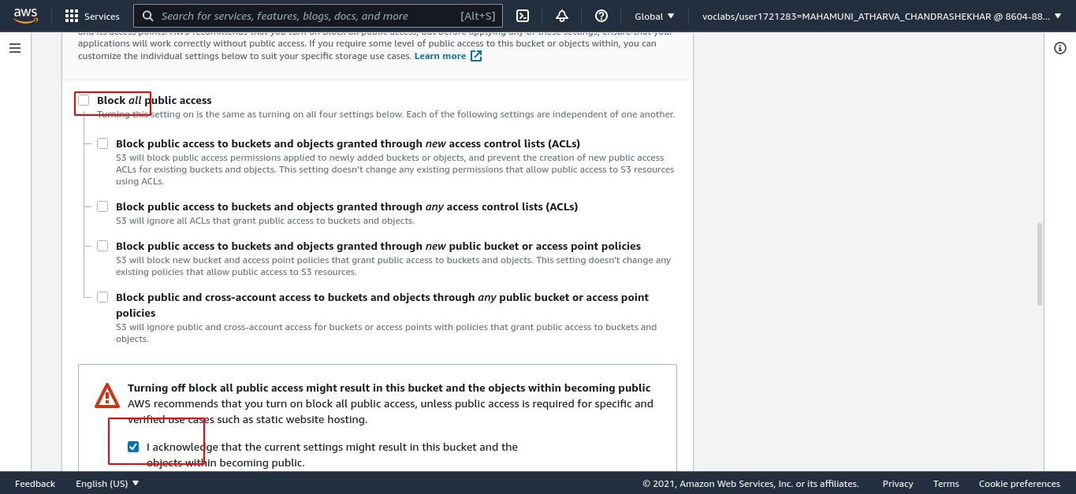

Step 9: scroll down and click on create bucket.

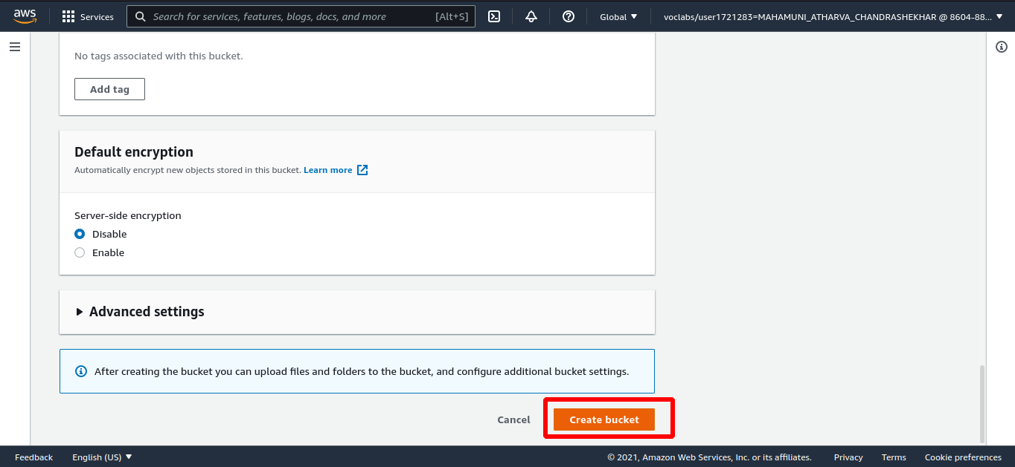

Step 10: Select your bucket and Choose upload

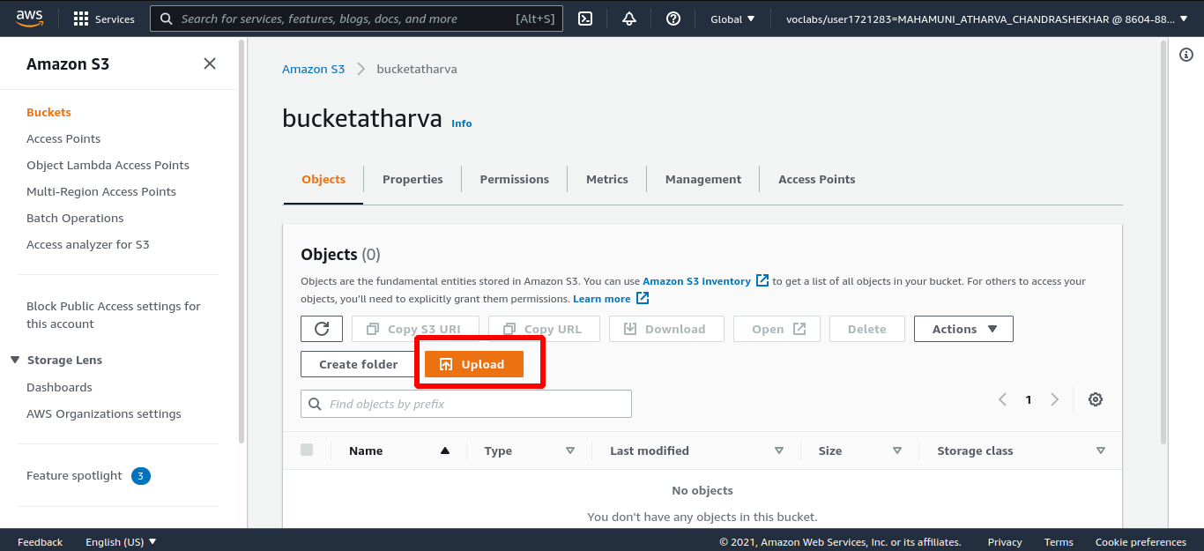

Step 11: Click on add files and select a file to upload and click Upload.

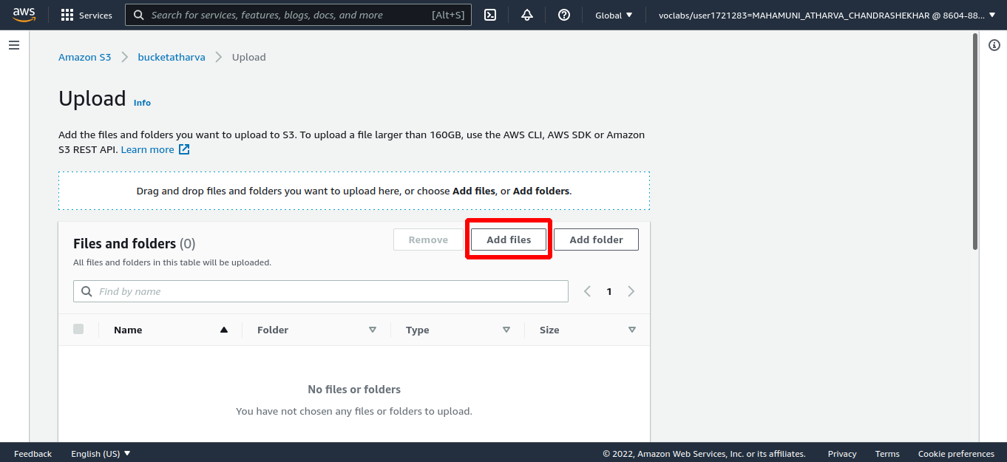

Step 12: click on the file and select Download.

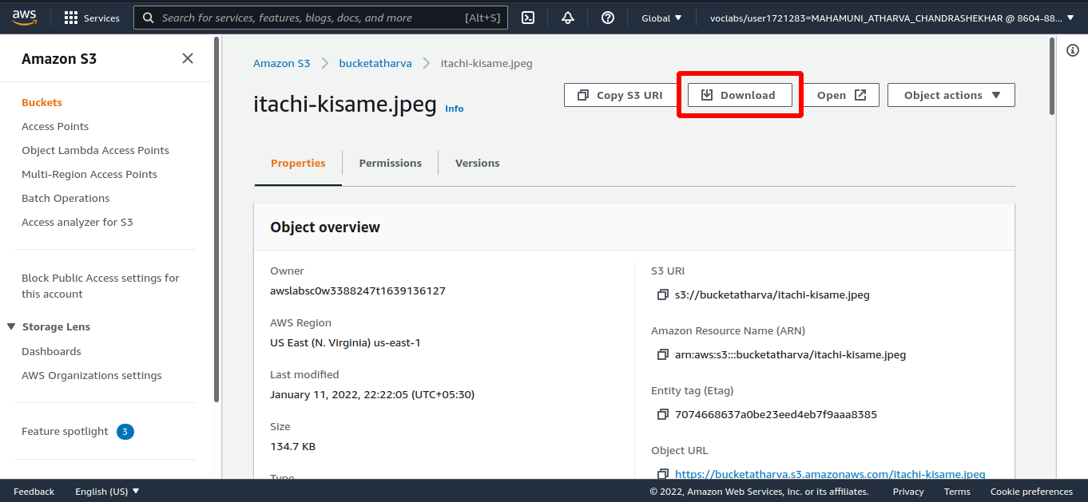

Step 13: Select a file and click on Delete.

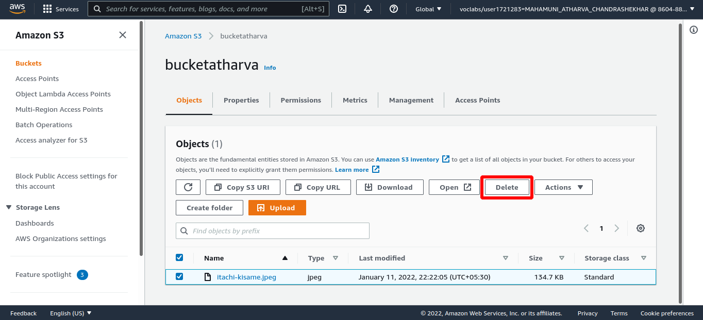

Step 14: type permanently delete and click Delete objects.

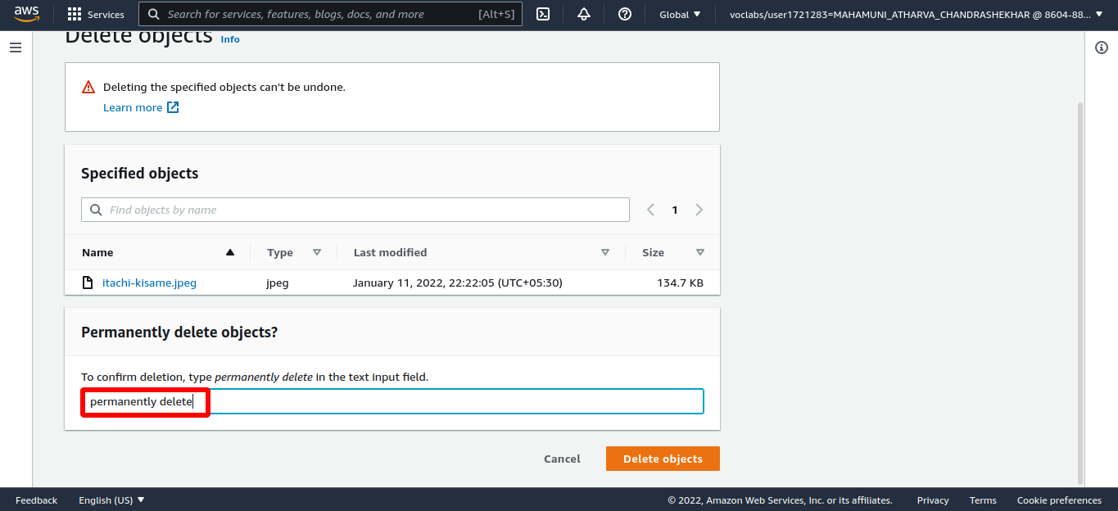

Delete your bucket and end lab.

