Name: Atharva Mahamuni.
Enroll No: 2002276
------------------------------------------------------------------------------------------------------------------------
Cloud Computing
Practical Assignment No. 4 - Practical Implementation of Storage as a Service
------------------------------------------------------------------------------------------------------------------------
Hosting a static website in AWS using S3.

Step 1: At the top right panel above the console, choose Start Lab to launch your lab.

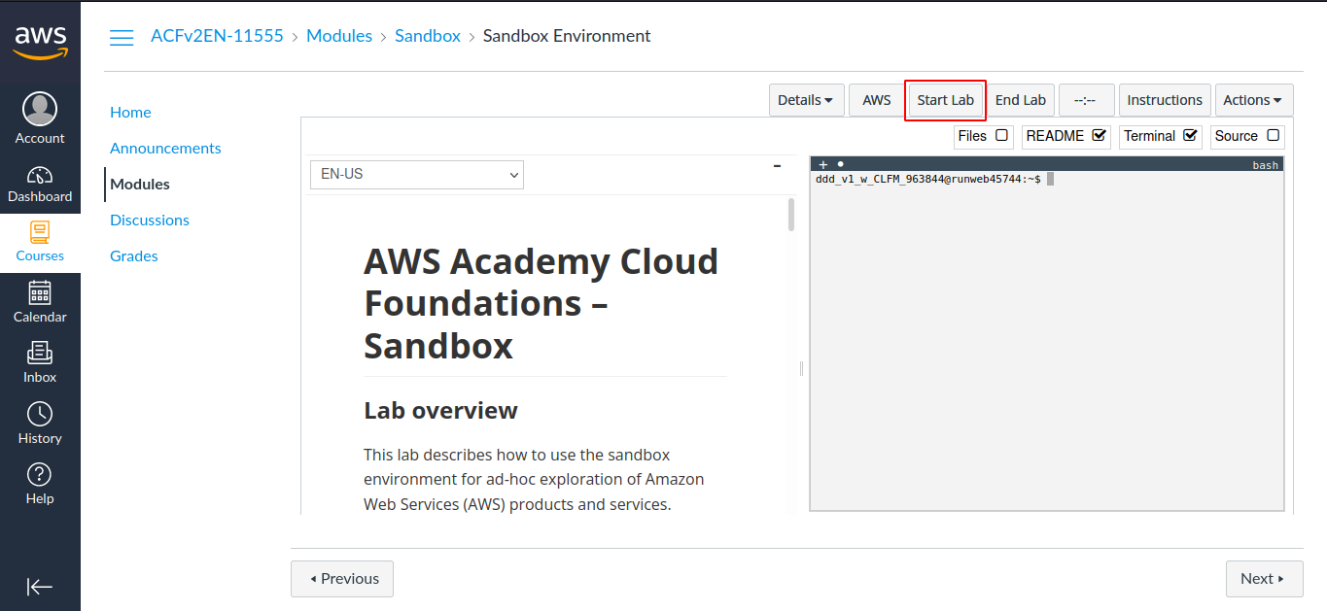

Step 2: Wait until you see the message "Lab status: ready", then choose the X to close the Start Lab panel.

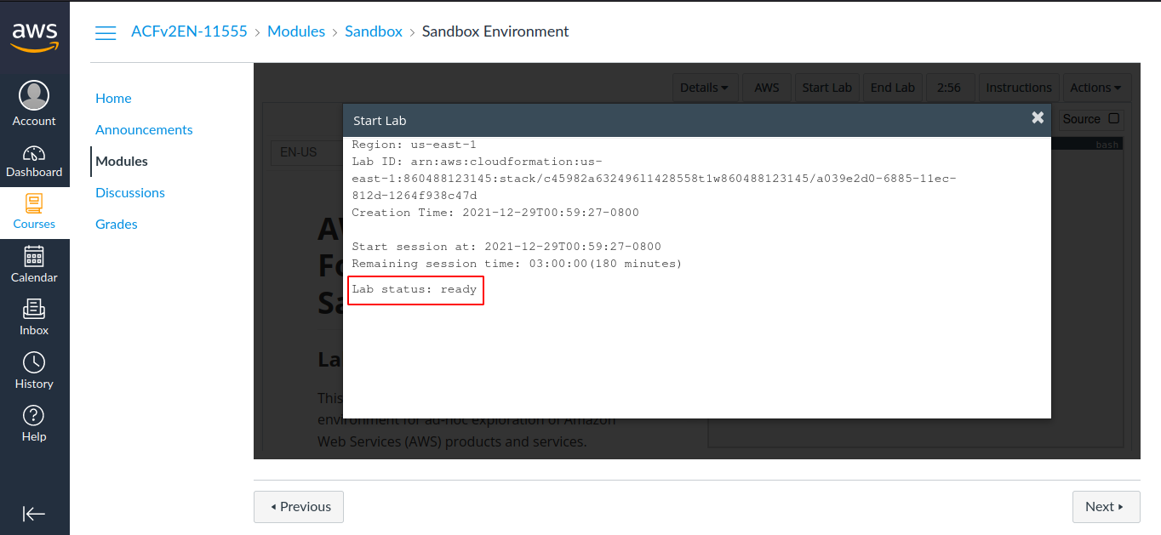

Step 3: Now choose AWS
This will open the AWS Management Console in a new browser tab. The system will automatically log you in.

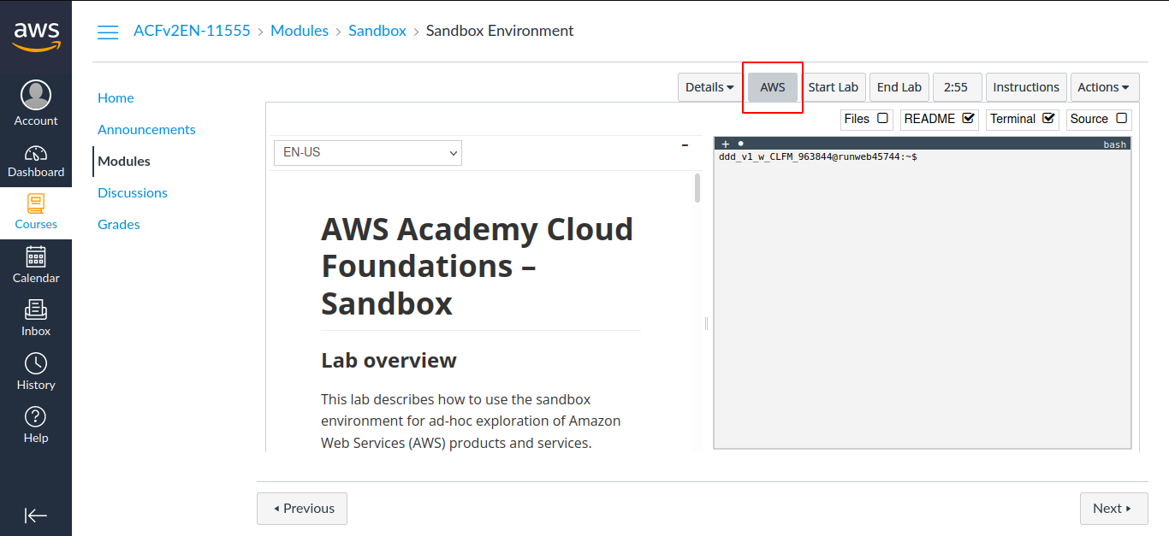

Step 4: In the AWS Management Console on the Services menu, choose S3.

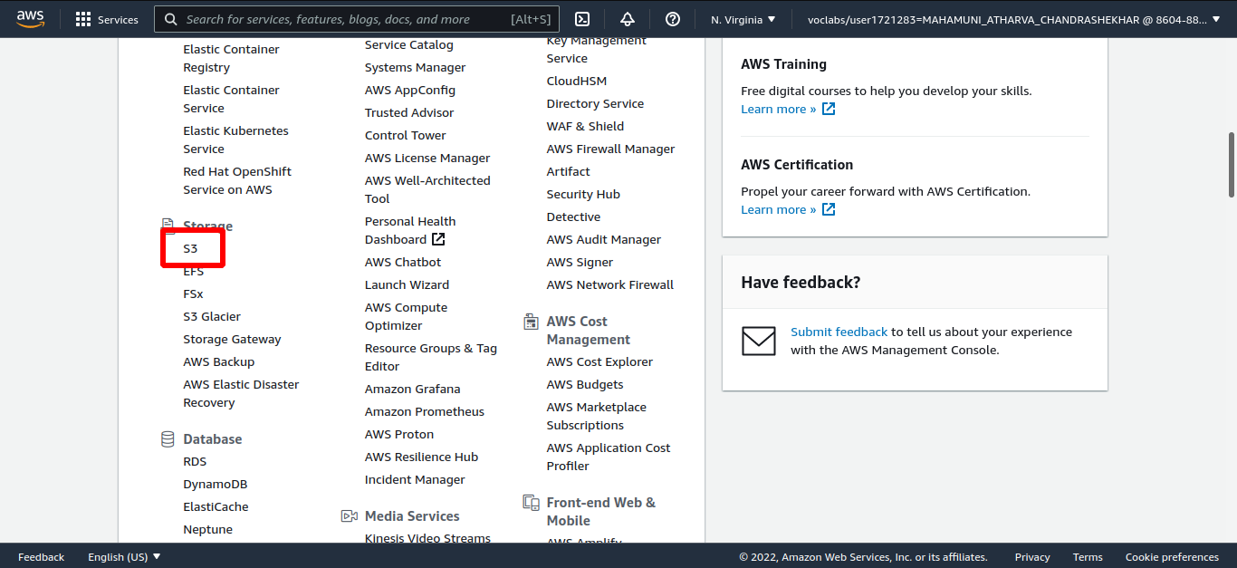

Step 5: Click on Create bucket.

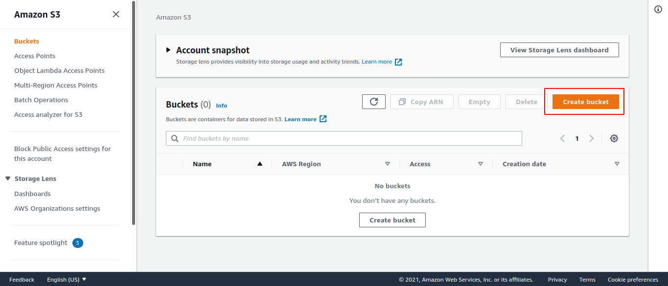

Step 6: Add bucket name.

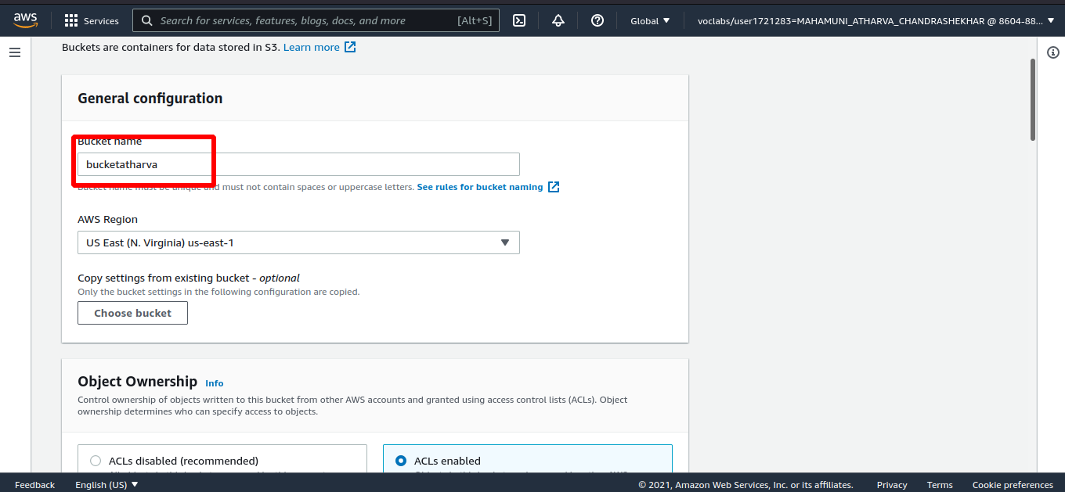

Step 7: Select ACLs enabled and scroll down.

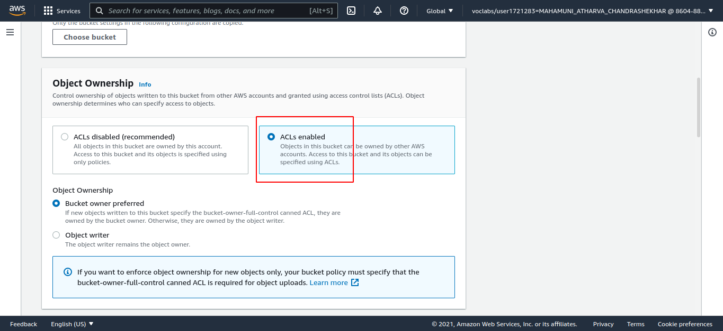

Step 8: Remove checkbox of block public access and select I acknowledge that...

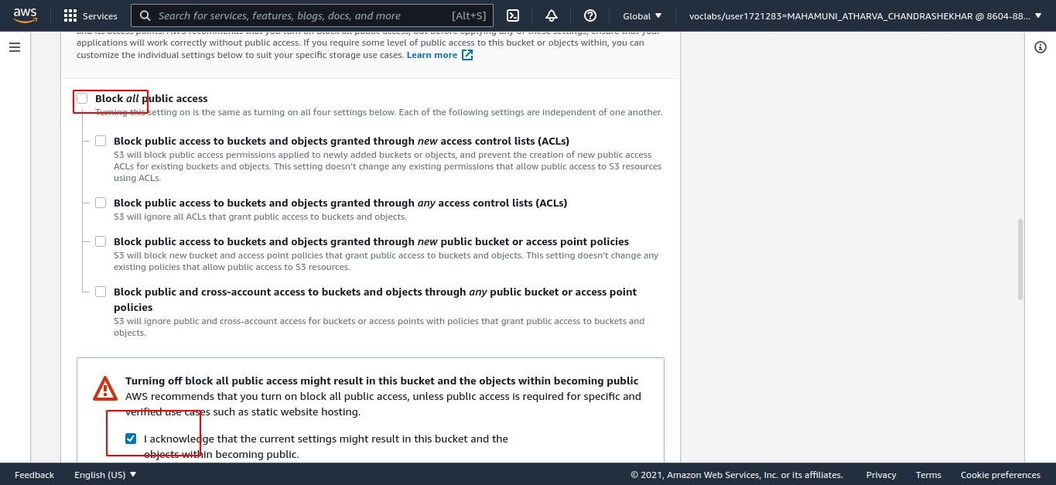

Step 9: scroll down and click on create bucket.

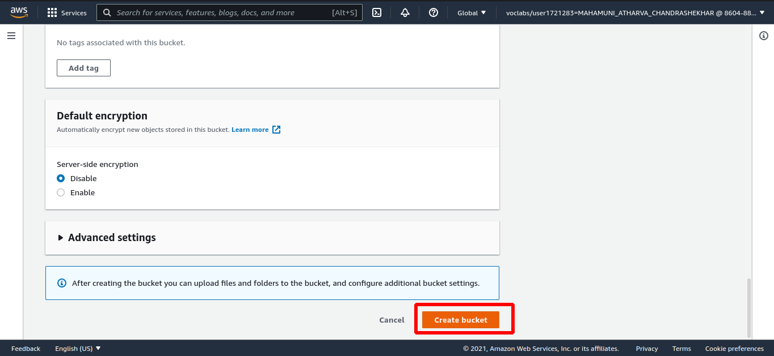

Step 10: Then click on your bucket and go to Properties.

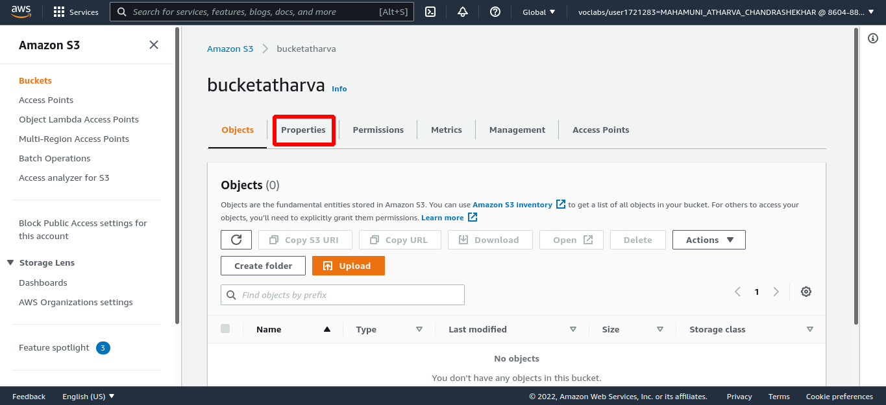

Step 11: scroll down and edit static website hosting.

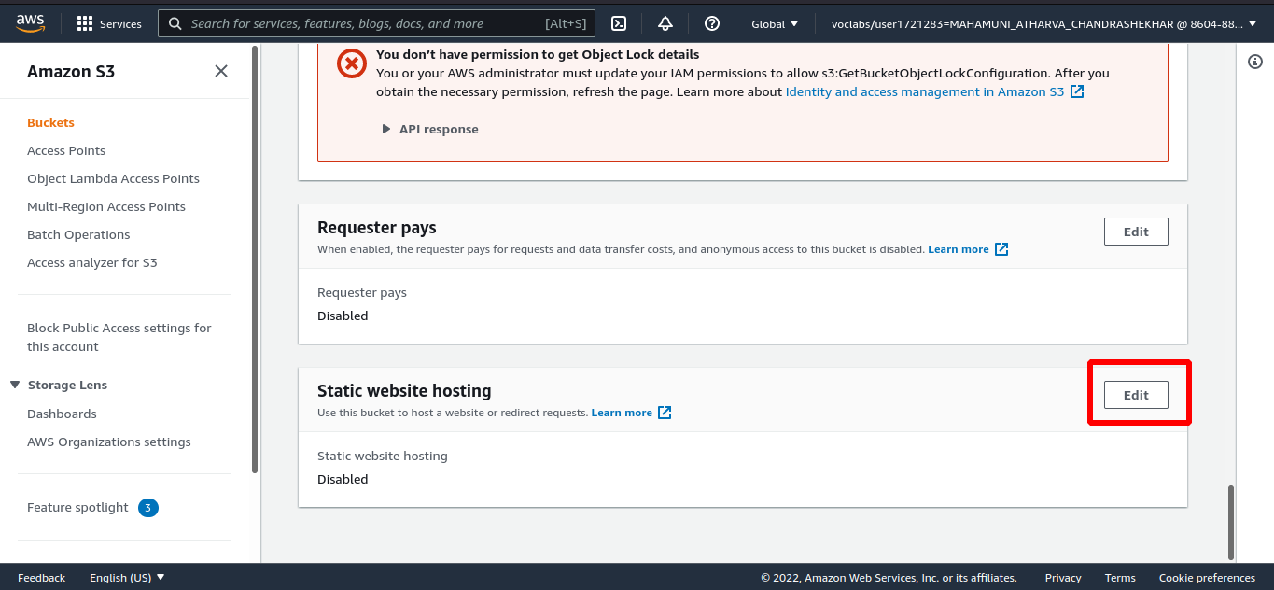

Step 12: Click on enable static website hosting and save.

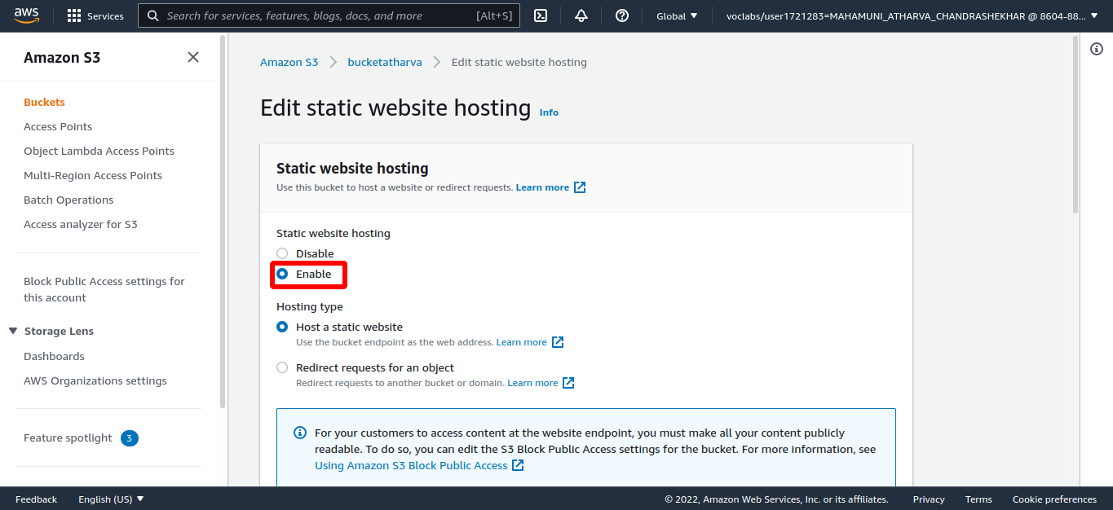

Step 13: Go to objects and click Upload file then add file.

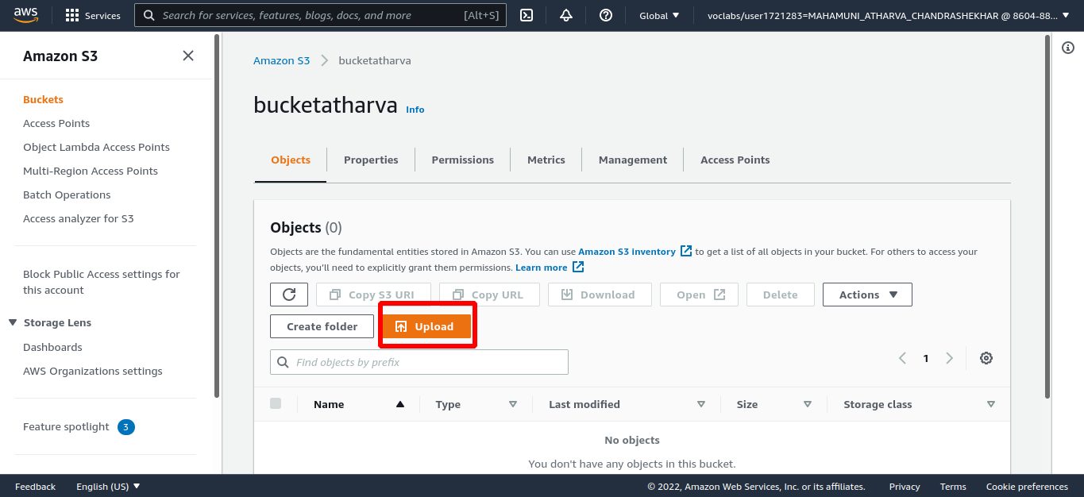

Step 14: Go to properties and scroll down to the http link and click on it.

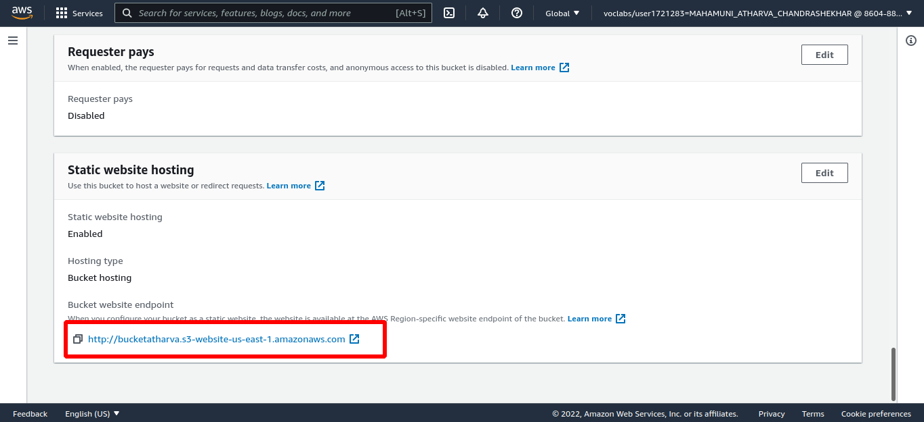

You’ll see your page hosted.

