Sports Live

by

<Student’s full official name, previous degree(s) abbreviated>

Presented to the Faculty of
Modern College
In Partial Fulfillment
Of the Requirements
For the Degree

Masters of computer science/ application

THE UNIVERSITY OF Rune

June, 2022

< Leave this page blank >

Sports Live

by

<Student’s full official name>

APPROVED BY

__________________________________________
<Chair’s Name, Degree>, Chair

__________________________________________
<Member’s Name, Degree >, Committee Member

__________________________________________
<Member’s Name, Degree >, Committee Member

__________________________________________
<Member’s Name, Degree >, Committee Member

RECEIVED/APPROVED BY THE COLLEGE OF Modern College:

<Associate Dean’s Name, Degree>, Associate Dean

__________________________________________
<Dean’s Name, Degree>, Dean

< Leave this page blank >

Acknowledgments
<Optional. If you do not include a dedication, delete this entire page. Do not delete the section break on the Dedication page above. Press Ctrl+Shift+8 to see the section break.>

< Leave this page blank >

ABSTRACT
Sports Live

<Student’s official name >
University of Pune, 2022

< Project> Chair: <Chair’s Name>
Co-Chair: <If applicable. Co-Chair’s Name>

[Abstract text must not exceed 350 words. Provide a complete, succinct snapshot of the research, addressing the purpose, methods, results, and conclusions of the research. The abstract should be able to stand alone, with no formal citations or references to chapters/sections of the work.]

TABLE OF CONTENTS

Level 1 Heading 1
Level 2 Heading 1
Level 3 Heading 1
Introduction 4
About the project 4
Application Features 4
Assumptions 4
Out-of-scope 4
Caveats 4
Feasibility study 5
Technical feasibility 5
Market research and analysis 5
Unique preposition & value creation 5
Stakeholder Analysis 5
Identification of stakeholders 6
Persona identification 6
Stakeholder engagement 6
Stakeholder communication 6
Project Plan 7
Project Management Plan 7
Project Scope 7
Risk Management plan 7
Identification, analysis and mitigation plan 7
Risk response Strategies 7
Project Team structure, roles and responsibilities 8
Project Tracking, Scheduling 8
Product Backlog, Scrum cycle, methodology 8
Requirement Analysis 8
Requirement collection methods used 8
Requirements finalization process 9
User Stories 9
Detailed User stories description 9
Requirements Estimation 9
Effort Estimation Report 10
Design 11
Software Development Methodology 11
Peer review process 11
Collaboration Methodology 11
Coding Guidelines 11
Source Code Repository 11
Technical stack details 12
Technologies used, their versions 12
Database Design 12
ER Diagrams 12
Flowcharts 12
Component Diagram 12
Sequence diagrams 13
Wireframes 13
Development 14
Application flow 14
Application features 14
Feature 1 14
Feature 2 14
Testing 15
Quality process 15
Test Cases identification 15
Test Cases execution 15
Defect Tracking and analysis 15
Implementation 16
Conclusion 17
References 18
Glossary: 19
Appendix A: 20

List of Tables
Table 2.1[press Shift + Enter] Sample Table Caption [Use “Table Caption” Style”] 3

List of Figures
Figure 2.1[press Shift + Enter] Sample Figure Caption [Use “Figure Caption” Style”] 3

Level 1 Heading

Level 1 heading should always start on ODD PAGE number. If required include a blank page so that the heading starts on an odd page.

{Sample Text Sample Text Sample Text Sample Text Sample Text Sample Text Sample Text Sample Text Sample Text Sample Text Sample Text Sample Text Sample Text Sample Text }
Level 2 Heading
{Sample Text Sample Text Sample Text Sample Text Sample Text Sample Text Sample Text Sample Text Sample Text Sample Text Sample Text Sample Text Sample Text Sample Text }
Level 3 Heading
{Sample Text Sample Text Sample Text Sample Text Sample Text Sample Text Sample Text Sample Text Sample Text Sample Text Sample Text Sample Text Sample Text Sample Text }

- Sample bullet Text Sample bullet Text
- Sample bullet Text: Sample bullet Text
Sample bullet Text Sample bullet Text
- Sample Text Sample Text Sample
- Text Sample Text Sample Text Sample
- Text Sample Text Sample Text Sample
- Text Sample Text Sample Text Sample Text Sample Text
  - Text Sample Text Sample Text Sample
  - Text Sample Text Sample Text Sample
- Text Sample Text Sample Text Sample
- Sample numbered Text
  - Sample numbered Text
  - Sample numbered Text

Table 2.1[press Shift + Enter]
Sample Table Caption [Use “Table Caption” Style”]
Variable | % | N
Value | x | x
Value | x | x
Value | x | x


Figure 2.1[press Shift + Enter]
Sample Figure Caption [Use “Figure Caption” Style”]

Introduction
<Introduction of the document, overview, purpose, structure of the document>

{Sample Text Sample Text Sample Text Sample Text Sample Text Sample Text Sample Text Sample Text Sample Text Sample Text Sample Text Sample Text Sample Text Sample Text }

About the project
Last decade has been a decade to remember in terms of sports in India, our country has achieved a lot of milestones and we have done better in the sports which were considered out of reach of Indians. These huge achievements in the sports have created a lot of fan base, especially the young generation, who not only love to play or watch these sports but are also eager to know every bit of it. To get such updates we have some apps like Cricbuzz. But as we know India is a country where cricket is treated as a religion. This app only focuses on cricket, but what about those people who love to play or watch football, kabaddi, tennis, badminton, athletics, etc. Sadly for these people there are very limited or no platforms where they can get updates about their favorite game, and the apps available only focus on a popular sport like cricket or football etc. So to overcome this limitation we thought of a system where we provide live updates of each and every sport along with stats, scorecard, rankings and each and every stuff related to that particular sport.
Application Features
Sports the app will cover are
- Cricket
- Football
- Tennis / Badminton
Under each category it will have
- Ongoing matches
- Upcoming matches
- Scorecard
- Historical matches
- Player, Team and Match statistics
- News
Users can follow certain Team or Sport and they’ll get
- Personalized notifications
- Filtered list of events
- Curated news

Assumptions
- We are assuming that there is no single application which provides details of different sports on a single platform.
- We are assuming that the data we are getting from the API is true and correct.
- We are assuming that most people will love these sports(Cricket, Football & Badminton) so we are developing an application for these sports.
- We are assuming that the application will be used for entertainment / informative use only.

Out-of-scope
- Right now in our application there are few sports but we can add more sports in future.
- Right now we are not showing each and every detail of each sport but can be implemented.
- We haven't added any premium membership / subscription.

Caveats
Our application is partially dependent on third party API. If sometimes they won't work properly then the application will have an issue.

Feasibility study

Technical feasibility
Open source and reliable software-frameworks will be used, hence it is technically feasible
- NodeJS with Express for back-end server.
- ReactJS for front-end.
- MongoDB for Database Management.

Market research and analysis
In this fast-moving world, who has the time to have a set up in their living room to sit back and watch the cricket match or a Football match etc.?
Hence we came up with an idea of sports_live web app, it is a platform that
features news, articles, and live coverage of matches that includes videos,
players information, and team rankings etc.
If we talk about the market size of the sports industry across India was over 16 billion Indian rupees in 2020. The majority of the media consumption in the sports industry in the country was from the Indian Premier League. Recently however, other domestic leagues like Pro Kabaddi and the Indian Super League have gained popularity.
The market size of the sports industry is represented with the help of the graph below.
Market size of the sports industry across India from 2017 to 2020(in billion Indian rupees)
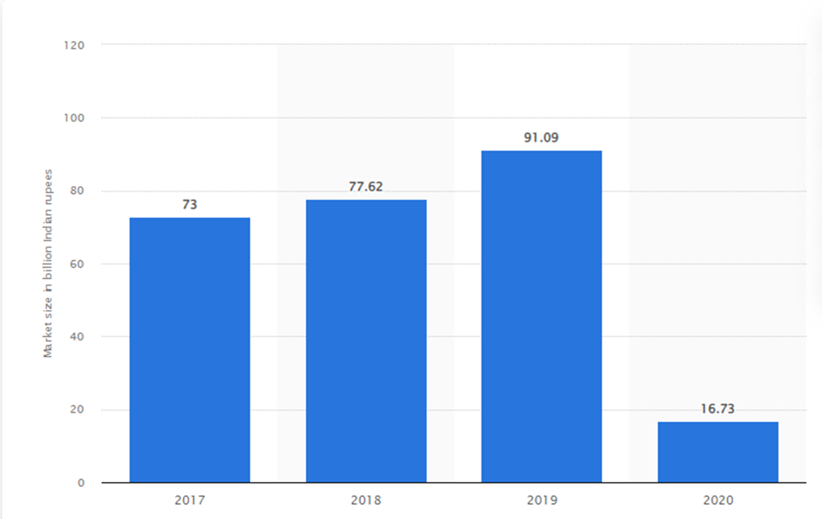
There is one interesting fact for us that the Indian sports market size keeps growing each year, and it is estimated to be worth $27.89 billion Dollar in 2022. This means that people have been and will always be interested in sports. Therefore, the business owners operating in the sports industry should expect high profits, given a proper business strategy, planning, and management.
So, why don’t we enter the market using one of the most innovative approaches, developing your own custom web app and launching it for the mass market?
No doubts, this idea is not just good, it is sound. Yet, we need to think through the feature list of our future app very thoroughly if we want to withstand the cutthroat competition in the market. (The major competitors of this domain are ESPN sports, Cricbuzz etc.).
Unique preposition & value creation
Having to google every time for different sports events that you usually watch is a tedious task.
We propose a single app which will incorporate multiple sports events and news so you don’t have to search or browse at multiple locations.
Moreover, you can follow your favorite team or sport to get personalized
notifications and you won’t miss the latest news

Stakeholder Analysis
Identification of stakeholders
Internal stakeholders -
- Employees
- Managers
External stakeholders -
- API provider
- Investor
- Users / Customers

Employees -
Employees have a direct stake in the company. They interact directly with the customers, earn money to support themselves and give support to business operations as well.

Managers -
Managers carry out managerial, supervisory or other functions.

API Provider -
They provide endpoints and data services that the company uses to create a product.

Investor -
They invest their funds in the project for their financial gain or fractional ownership of the product.

Users / Customers -
They buy or use the company’s product.

Persona identification
Persona 1
Name - Alan
Age - 20
Psyche - Introvert
Background - CSE student
Emotions towards tech - Likes technology and detailed info of an event.

Needs of this persona and situations -
Alan is a Computer student and he likes sports very much. He likes to check his favorite team’s schedule and scores and compare the performance with previous matches and other teams. He likes to be updated with the live score of an event when he’s busy doing other work.

Persona 2
Name - Rick
Age -35
Psyche - Extrovert
Background - Sales manager
Emotions towards tech - Fairly experienced with technology and likes basic info of an event.

Needs of this persona and situations -
Rick is a sales manager at a company. He works hard at his job and enjoys sports in his leisure time. He enjoys multiple sports and likes to be updated with the latest news and matches. Rick doesn't have much time and patience to look through a lot of pages and likes info in a compact manner.

Persona 3
Name - Carol
Age - 45
Psyche - Introvert
Background - Local shop owner
Emotions towards tech - Inexperienced with technology and likes basic info of an event.

Needs of this persona and situations -
Carol is a local shop owner and likes to watch sports. She is mostly busy with her shop and likes to check the leader boards of the series and scores of the teams. She cannot handle technology that well and sometimes struggles to navigate through online content.
Stakeholder engagement
- Engage internal stakeholders, plan an action and act.
- Engage users with each release of the application and take feedback and review on the above said actions.

Stakeholder communication
- Communicate with internal stakeholders on a daily basis via scrum calls and internal meetings.
- Communicate with the API provider whenever using a new service from them.
- Communicate with Users / Customers after each major release of the application and get feedback and review.

Project Plan
Summary:
The idea of sports_lives is to provide real time information about sports results from various disciplines. Sports_lives is usually free and can become very popular among sports loving young population of the country. In the past, live services were only available on TV through teletext or on the radio. There are now few websites providing live sports.
Sports_Live will feature 3 major sports namely Cricket, Football, and Badminton.

Project Management Plan
Objectives:
- Build a well designed working back-end.
- Build an attractive and user-friendly UI.
- Deploy the project.
- Market and advertise the site.
Time frame:
- Phase 1: Project design
- Phase 2: Prototyping
- Phase 3: Deliverable 1
- Phase 4: Testing & Deployment

Project Scope
The idea of sports_lives is to provide real time information about sports results from various disciplines. Sports_lives is usually free and can become very popular among sports loving young population of the country. In the past, live services were only available on TV through teletext or on the radio. There are now few websites providing live sports. By sports_live It is possible to follow live results of many events at the same time,our application also provides some additional information, such as a player list, player details, player statistics, upcoming schedules etc. where sports fans can gather and can get all possible information about their favorite sports.

Risk Management plan
1. Data Privacy and Online Security Risks
Hackers are becoming more and more sophisticated every day. It’s easier for malicious actors to find their way into our systems from the inside, obtaining credentials through phishing, or by deploying malware and ransomware in fraudulent links in emails. The average cost of a data breach is around $4.24 million, but reputational damage could cost you even more.
Solution
The best way to avoid a data breach is to prevent it. Establish and enforce a strong data privacy and online security policy, train your team, and incentivize them to become data security champions. Implement protocols like two-factor authentication (2FA) to add an extra layer of accountability.

2. Risk: Exploitation of Vulnerabilities
Malicious actors are always standing by to take advantage of any vulnerabilities in your network. Unpatched software, legacy systems, and lax endpoint protection leave you open to attack.
Solution
Keep software, SaaS, and plugins up to date. Remove and uninstall incompatible plugins and themes immediately. Enable firewalls and virus protection—but don’t rely 100% on device settings. Look into more comprehensive solutions based on your data protection needs.
Might consider a periodic security audit or penetration testing to understand their vulnerabilities.

3. Risk: Human Error
We’ve all deleted a file or “lost” a folder at one point or another. Human error is still the most common cause of data loss and most of the time, it’s just an innocent mistake.
Solution
Deploy a backup and recovery solution like Rewind. Rewind online backups or can take regular backups which allow us to restore and recover quickly after an error, minimizing downtime and helping you get back to work faster.

4. Risk: Poor CX
Customer experience (CX) is everything these days. If your site is slow to load, if visitors can’t find what they’re looking for, your site is difficult to navigate or understand, or if your content (images, descriptions, blogs, etc.) is low-quality, most won’t hesitate to click away—and they probably won’t return.
Solution
Invest time and effort into improving your website and store design.
Make sure your e-commerce store is responsive—meaning it is mobile friendly and looks and performs the same on any device.
We can put all our most popular products up front and create landing pages for all our data.
Basically, the idea is to make it as easy as possible for our customers. Good CX translates to loyalty, which means more traffic. And that’s always the bottom line.

5. Risk: Loss of Premises Due to Disaster
Disasters happen, and they come in many guises. Fire, flooding, building collapse, electrical grid failure, power surges, internet failure—and the list goes on. Having the right protections in place will help you get back up and running so your website can carry on.
Solution
Design and implement a disaster recovery plan (DRP) that covers every possible scenario.
Every company operates differently, so it’s critical to look at our business model and determine what makes sense for us. We can find DRP templates on the web to get you started, but these are just a jumping-off point. An effective DRP is a dynamic document that you’ll update as needed throughout our business life cycle.
One significant aspect of any comprehensive DRP is cloud backup and recovery software. With your e commerce store and all its data secured in the cloud, you can be confident that none of your vital data is lost, no matter what happens.
Identification, analysis and mitigation plan
We’ve outlined many different scenarios and talked about ways to reduce the risks involved with running our application.
Risk mitigation is an ongoing practice, meaning we can’t let our guard down for a moment. Today’s burgeoning threat environment is just one among many concerns, and none should be taken lightly. Smaller operations tend to think that they aren’t attractive to malicious actors, but the opposite is actually true.
Ransomware targets businesses of all types and sizes. Cybercriminalssoften know that smaller operations are easier to gain access too—often because companies with only a handful of developers do not have or enforce a security policy or train their employees as to the risks of security threats.
So if we don’t want our application to be part of the statistics, we need to take the necessary steps mentioned below to protect ourselves. Implementing the solutions outlined above will reduce risk, lower liability, and help us to recover quickly if we do experience such an incident.
- Ensure our security protocols are updated.
- Institute strong security policies around passwords.
- Regularly monitor for suspicious or fraudulent activity.
- Use security platforms and firewalls.
- Design, implement and enforce a strong security policy.
- Educate peers on how to detect incoming security threats.
- Work on your DRP and update regularly.

Risk response Strategies

Project Team structure, roles and responsibilities
Atharva M - Full stack developer
Akshay V - Full stack developer
Mokshada M - Full stack developer
Responsibilities:
Atharva M – Designing and Implementation
Akshay V – Designing and Implementation
Mokshada M – Designing and Implementation

Project Tracking, Scheduling
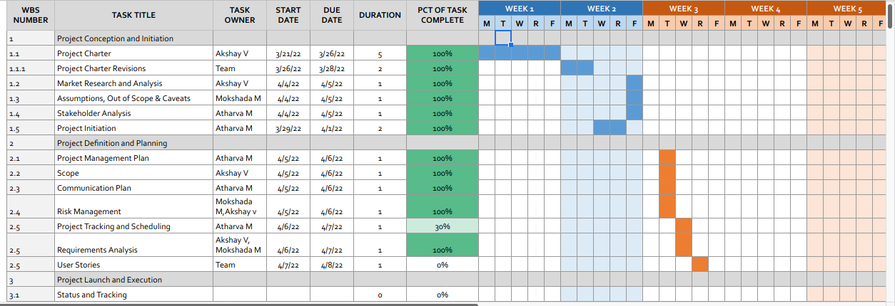
We're using a Gantt Chart to track all the tasks which are scheduled.
The project schedule contains:
- A project timeline with start dates, end dates and milestones
- The work necessary to complete the project deliverables
- The team members that are responsible for each task
ProjectSchedule

Product Backlog, Scrum cycle, methodology
Product Backlog
We’re using Trello for keeping track of product backlogs and agile sprints.
Our Trello board has a list for:
- Product backlogs
- To Do
- Doing
- QA
- Done

Scrum Cycle
Considering the time frame for the project, we have a 1 week sprint duration. In this cycle, the team decides on a goal for that week and we conduct a daily scrum call at the start of the day and discuss what tasks each team member will do for that respective day.
At the end of the sprint we review the work done with the previously set goal and assess the speed and performance of the team and look for ways to improve.
Requirement Analysis
As the goal of the application is ease of use and to provide an interactive interface, extensive research has been done to gain an insight into the needs and behaviors of various users. The working of the application is made convenient and easy to use for the end user. Based on our project
Users can be classified into two types based on their knowledge of the application that suits their needs. They can be classified as users who know about such applications that would satisfy their needs. Users who know about the product should be able to find the application easily with the click of a button. Such users can search for the product by using the app name as the search term.
Requirement collection methods used
In order to produce the Organization, Vision and Scope of the application, we propose a method consisting of a series of activities that is ordered in a certain way. In these methods, there are activities for resolving the sports-live key elements to ensure that the developed sports-live website/application will lead to business success. The rationales of the proposed method are as follows:
1. Interviews
To make it user friendly we have conducted few interviews of our peer groups to find out what features they would love to have in their favorite
Sports app.
2. Surveys
We also conducted a few surveys regarding the interest of people in sports and how they manage to keep themselves updated in their busy schedule respectively.
3. Surveying and analyzing similar websites:
The purpose of these activities is to learn/analyze the competitors and the results are then used to formulate the key elements of the competitive environment and advantages. The survey includes tasks such as analyzing the web features that annoy as well as impress users, completeness and interestingness of the information, the user interfacing (pages lay out, navigation between pages, ease of use, guidance, etc.), the transaction procedures, and customers relationship management (CRM) features (for instance, contacts, review/comments, personalization of messages and content).
4. User observation:
We have observed many potential users who are busy in their daily life who sometimes don’t get time to catch up with their favorite sports and in many cases people keep googling every now and then, so in such scenarios our application can be very useful.
Requirements finalization process
Review and Prioritize Requirements
In this step, requirements are reviewed and analyzed against the goals and business case of the project. Record the outputs in requirements documentation, for example, a simple table with high-level details.

User Stories
{Sample Text Sample Text Sample Text Sample Text Sample Text Sample Text Sample Text Sample Text Sample Text Sample Text Sample Text Sample Text Sample Text Sample Text }

Detailed User stories description
{Sample Text Sample Text Sample Text Sample Text Sample Text Sample Text Sample Text Sample Text Sample Text Sample Text Sample Text Sample Text Sample Text Sample Text }

Requirements Estimation
{Sample Text Sample Text Sample Text Sample Text Sample Text Sample Text Sample Text Sample Text Sample Text Sample Text Sample Text Sample Text Sample Text Sample Text }

Effort Estimation Report
{Sample Text Sample Text Sample Text Sample Text Sample Text Sample Text Sample Text Sample Text Sample Text Sample Text Sample Text Sample Text Sample Text Sample Text }

Design
{Sample Text Sample Text Sample Text Sample Text Sample Text Sample Text Sample Text Sample Text Sample Text Sample Text Sample Text Sample Text Sample Text Sample Text }

Software Development Methodology
{Sample Text Sample Text Sample Text Sample Text Sample Text Sample Text Sample Text Sample Text Sample Text Sample Text Sample Text Sample Text Sample Text Sample Text }

Peer review process
{Sample Text Sample Text Sample Text Sample Text Sample Text Sample Text Sample Text Sample Text Sample Text Sample Text Sample Text Sample Text Sample Text Sample Text }

Collaboration Methodology

Coding Guidelines
{Sample Text Sample Text Sample Text Sample Text Sample Text Sample Text Sample Text Sample Text Sample Text Sample Text Sample Text Sample Text Sample Text Sample Text }

Source Code Repository
{Sample Text Sample Text Sample Text Sample Text Sample Text Sample Text Sample Text Sample Text Sample Text Sample Text Sample Text Sample Text Sample Text Sample Text }

Technical stack details
{Sample Text Sample Text Sample Text Sample Text Sample Text Sample Text Sample Text Sample Text Sample Text Sample Text Sample Text Sample Text Sample Text Sample Text }

Technologies used, their versions
{Sample Text Sample Text Sample Text Sample Text Sample Text Sample Text Sample Text Sample Text Sample Text Sample Text Sample Text Sample Text Sample Text Sample Text }

Database Design
{Sample Text Sample Text Sample Text Sample Text Sample Text Sample Text Sample Text Sample Text Sample Text Sample Text Sample Text Sample Text Sample Text Sample Text }

ER Diagrams
{Sample Text Sample Text Sample Text Sample Text Sample Text Sample Text Sample Text Sample Text Sample Text Sample Text Sample Text Sample Text Sample Text Sample Text }

Flowcharts
{Sample Text Sample Text Sample Text Sample Text Sample Text Sample Text Sample Text Sample Text Sample Text Sample Text Sample Text Sample Text Sample Text Sample Text }

Component Diagram
{Sample Text Sample Text Sample Text Sample Text Sample Text Sample Text Sample Text Sample Text Sample Text Sample Text Sample Text Sample Text Sample Text Sample Text }

Sequence diagrams
{Sample Text Sample Text Sample Text Sample Text Sample Text Sample Text Sample Text Sample Text Sample Text Sample Text Sample Text Sample Text Sample Text Sample Text }

Wireframes
{Sample Text Sample Text Sample Text Sample Text Sample Text Sample Text Sample Text Sample Text Sample Text Sample Text Sample Text Sample Text Sample Text Sample Text }

Development
{Sample Text Sample Text Sample Text Sample Text Sample Text Sample Text Sample Text Sample Text Sample Text Sample Text Sample Text Sample Text Sample Text Sample Text }

Application flow
{Sample Text Sample Text Sample Text Sample Text Sample Text Sample Text Sample Text Sample Text Sample Text Sample Text Sample Text Sample Text Sample Text Sample Text }

Application features
Description and actual screen shots of the application, pages, screens
{Sample Text Sample Text Sample Text Sample Text Sample Text Sample Text Sample Text Sample Text Sample Text Sample Text Sample Text Sample Text Sample Text Sample Text }

Feature 1
{Sample Text Sample Text Sample Text Sample Text Sample Text Sample Text Sample Text Sample Text Sample Text Sample Text Sample Text Sample Text Sample Text Sample Text }

Feature 2
{Sample Text Sample Text Sample Text Sample Text Sample Text Sample Text Sample Text Sample Text Sample Text Sample Text Sample Text Sample Text Sample Text Sample Text }

Testing
{Sample Text Sample Text Sample Text Sample Text Sample Text Sample Text Sample Text Sample Text Sample Text Sample Text Sample Text Sample Text Sample Text Sample Text }

Quality process
{Sample Text Sample Text Sample Text Sample Text Sample Text Sample Text Sample Text Sample Text Sample Text Sample Text Sample Text Sample Text Sample Text Sample Text }

Test Cases identification
{Sample Text Sample Text Sample Text Sample Text Sample Text Sample Text Sample Text Sample Text Sample Text Sample Text Sample Text Sample Text Sample Text Sample Text }

Test Cases execution
{Sample Text Sample Text Sample Text Sample Text Sample Text Sample Text Sample Text Sample Text Sample Text Sample Text Sample Text Sample Text Sample Text Sample Text }

Defect Tracking and analysis
{Sample Text Sample Text Sample Text Sample Text Sample Text Sample Text Sample Text Sample Text Sample Text Sample Text Sample Text Sample Text Sample Text Sample Text }

Implementation
{Sample Text Sample Text Sample Text Sample Text Sample Text Sample Text Sample Text Sample Text Sample Text Sample Text Sample Text Sample Text Sample Text Sample Text }

Conclusion
{Sample Text Sample Text Sample Text Sample Text Sample Text Sample Text Sample Text Sample Text Sample Text Sample Text Sample Text Sample Text Sample Text Sample Text }

References
<Use the citation style for your discipline. Indicate materials referenced in the project and from sources you have actually used.>
{Author, A. A., Author, B. B., & Author, C. C. (Year). Title of article. Title of Periodical, volume number(issue number), pages. http://dx.doi.org/xx.xxx/yyyyy}

Glossary:
{Sample Text Sample Text Sample Text Sample Text Sample Text Sample Text Sample Text Sample Text Sample Text Sample Text Sample Text Sample Text Sample Text Sample Text }

Appendix A:
{Sample Text Sample Text Sample Text Sample Text Sample Text Sample Text Sample Text Sample Text Sample Text Sample Text Sample Text Sample Text Sample Text Sample Text }

