PE EDUCATION SOCIETY’S

MODERN COLLEGE OF ARTS SCIENCE AND COMMERCE

SHIVAJINAGAR PUNE - 05

Department of Computer Science

CERTIFICATE

This is to certify that **Master. Atharva C Mahamuni** and **Master. Shubham D Mankar.** Roll no 54253 and 54238 respectively.

From class TY BSc Computer Science have completed their Project titled

**FreshFromFarm**

as a part of curriculum during the academic year 2019-2020

Date:

Prof S.S. Deshmukh

(Vice Principal, Head of Department)

|  |  |
| --- | --- |
| **Examiners** | **Signature** |
| 1 |  |
| 2 |  |
| 3 |  |
| 4 |  |

**INTRODUCTION**

The process of marketing is a big challenge faced by farmers across the country. There is big chain between farmers and customers. Many trades are involved hence farmers get low price for their product. There is no direct connection between farmers and customers. If farmers sell their products to customers directly then they can get good rates for their products.

But communication between farmers and customers is difficult. How can farmers interact directly with customers? These question raises. So, it is beneficial if there is website which helps farmers to interact with customers and make communication possible. This website will help farmers to make his product ' s advertisement with proper details and description. This website provides information about customer ' s needs and demands. Farmers can sell their product directly to retailers, wholesalers or to a common man.

This system contains the records of all products of farmers. Each farmer is provided with the Login Id, so they can update their information as per needed. This system keeps the records of farmers along with their products and address. This system informs about the products of the farmers to the customers.

In the proposed system, the farmers are provided with the id given by admin and only admin can change the farmer ' s records. It will make the system more versatile and user friendly.

Fresh from Farm (FFF) is a web-application based project which helps customers to buy fresh farm goods directly from farmers and it will be delivered directly to the customer's doorstep.

This will help the farmers to earn justifying amount for their goods by eliminating the mediator. The existing system has mediators who buy goods from farmers for some price and sell to end customers for increased price. This system sounds okay but in reality, the amount which they pay to the farmers is mediocre and does not at all justify the hard-work the farmer puts in. This will also encourage the farmers to connect to the digital world.

So, this project proposes a platform for farmers to list their goods online for a fair price and customers can buy directly from the respective seller. The delivery of the goods will be done by a third party.

PROBLEM DEFINITION

The process of marketing product, finding storage and obtaining information is a big challenge to farmers. The existing system are unreliable and manual as they don ' t offer information concerning marketing services and storage facilities to farmers. Farmers have to sell their products at low prices confined to their localities, product less yields thus the situation being less profitable and time consuming.

It is necessary to carry out an investigation on the current method of searching for storage facilities, marketing so as to develop a farmer ' s website that displays and manages these components.

**FEASIBILITY** **STUDY**

**TECHNICAL** **FEASIBILITY**:

* System can be developed according to customer ' s requirements.
* System can also be modified according to customer ' s changing requirements.

**ECONOMICAL** **FEASIBILITY**:

* The cost required to maintain this system is less.
* Cost of hardware and software for class of application is being considered.
* Economical analysis is the most frequently used technique for evaluating the effectiveness of a proposed system. It is commonly known as cost benefit analysis.

**OPERATIONAL** **FEASIBILITY**:

* It is mainly related to human organization and partial aspects.
* Any person can operate or use the proposed system and no special kind of training or experience needed.
* The system is operational feasibility as it is very easy for users to operate it.

**FACT** **FINDING** **TECHNIQUE**

Fact finding is the formal process of using research, interviews, questionnaires and other techniques to collect information about system requirements and preferences. It is also called as information gathering and data gathering.

**Observation:**

Our team visited the organization and understood the flow of documents, working of the existing system and the users of the system.

**EXISTING SYSTEM**

Existing System collects information of farmers, customers that are kept as a paper document. There may be loss of data the security is too low and there is no integrity of data.

*FRESH FROM FARM*

To contribute all documents and avoiding security issues and security by keeping centralized server for database.

**PROPOSED** **SYSTEM**

The proposed " FRESH FROM FARM " helps the people who are in need to sell their farm products by giving them all details of a particular product. This website works 24x7 so user can get information of farm product.

ADVANTAGES:

* It is user friendly.
* The proposed system has maintenance of schedule erroneous and it is very easy to operate.
* Reduce the time spend on the paper work.
* Storing the farmer ' s details as well as their details properly.

ERD AND UML:

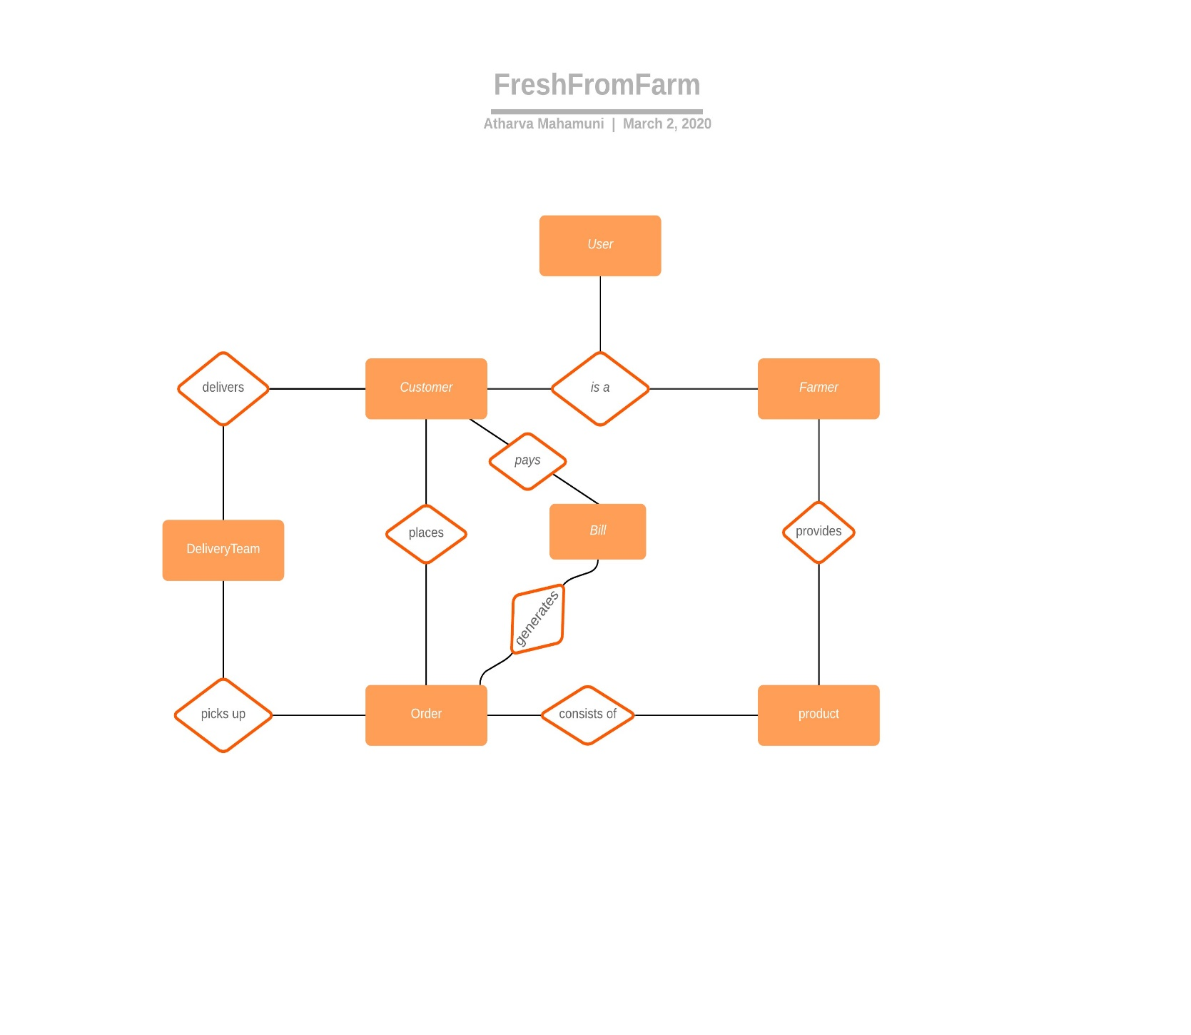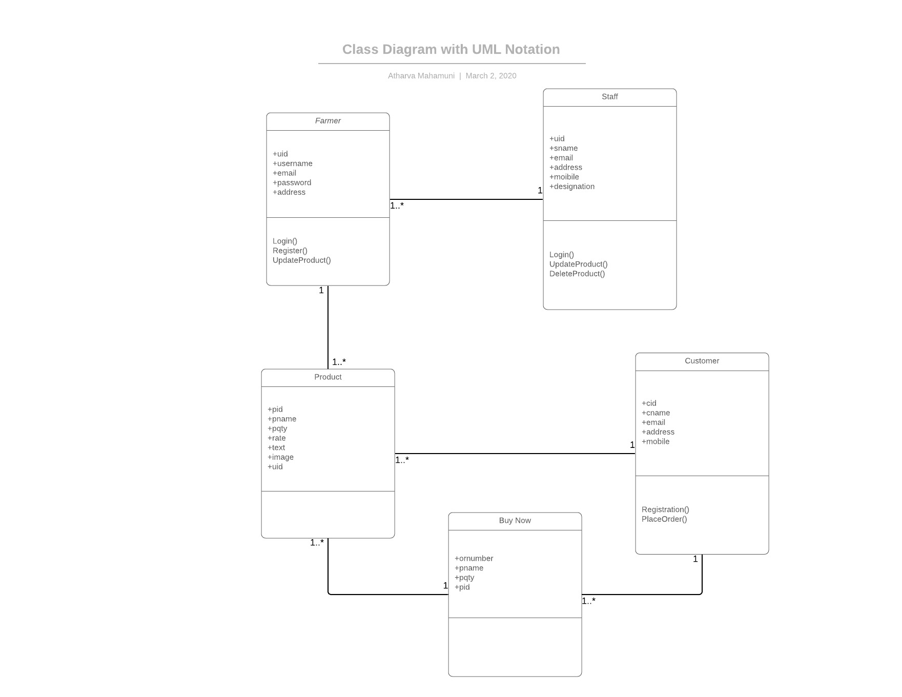

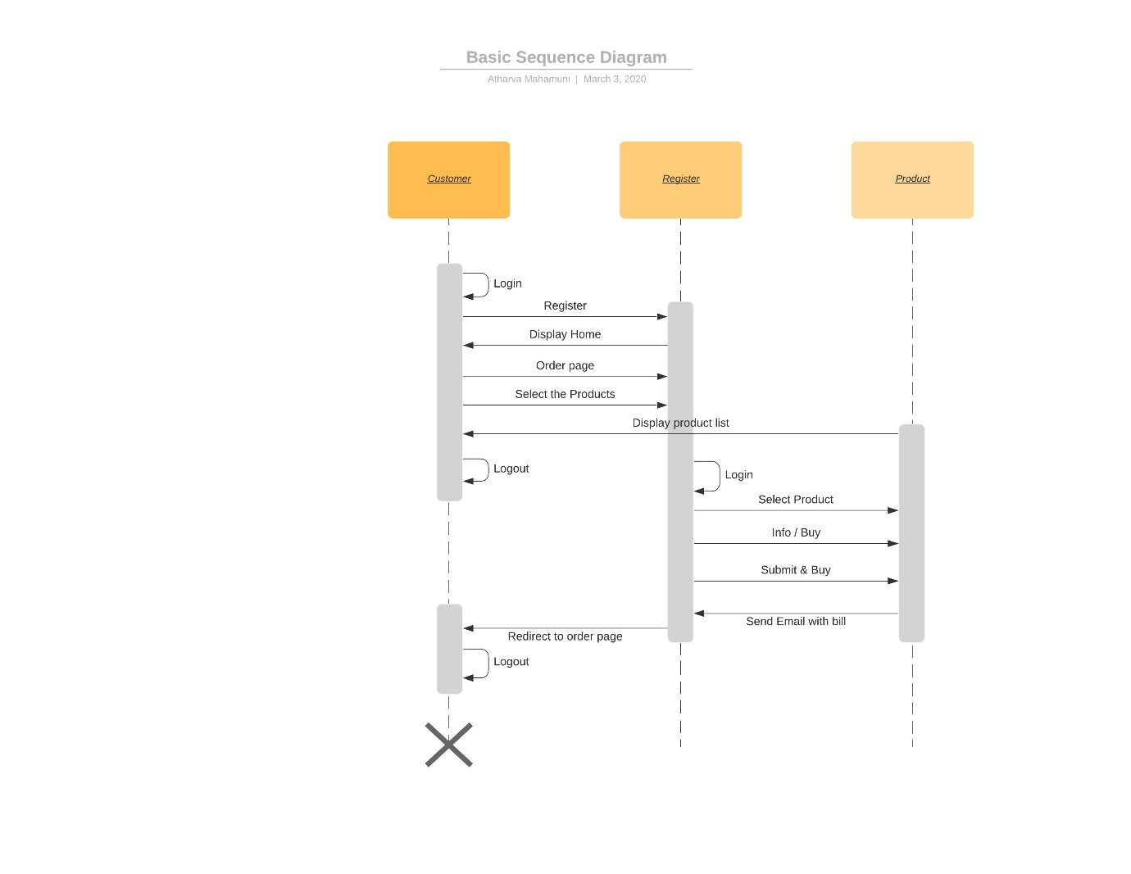

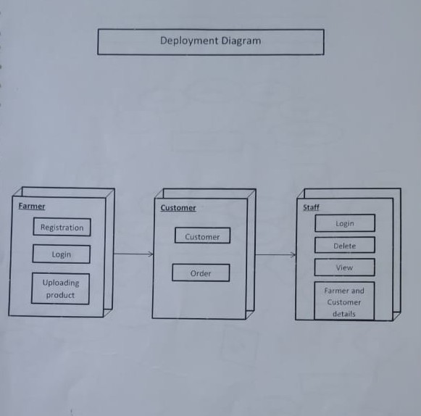

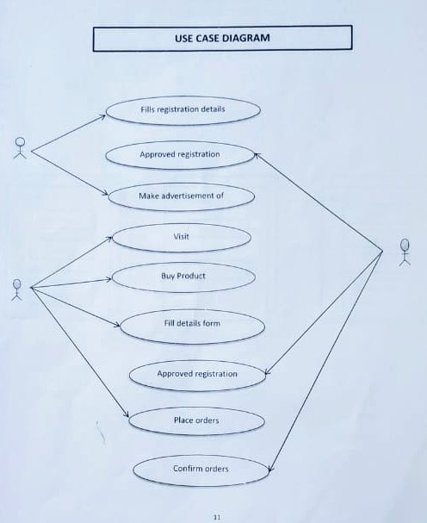

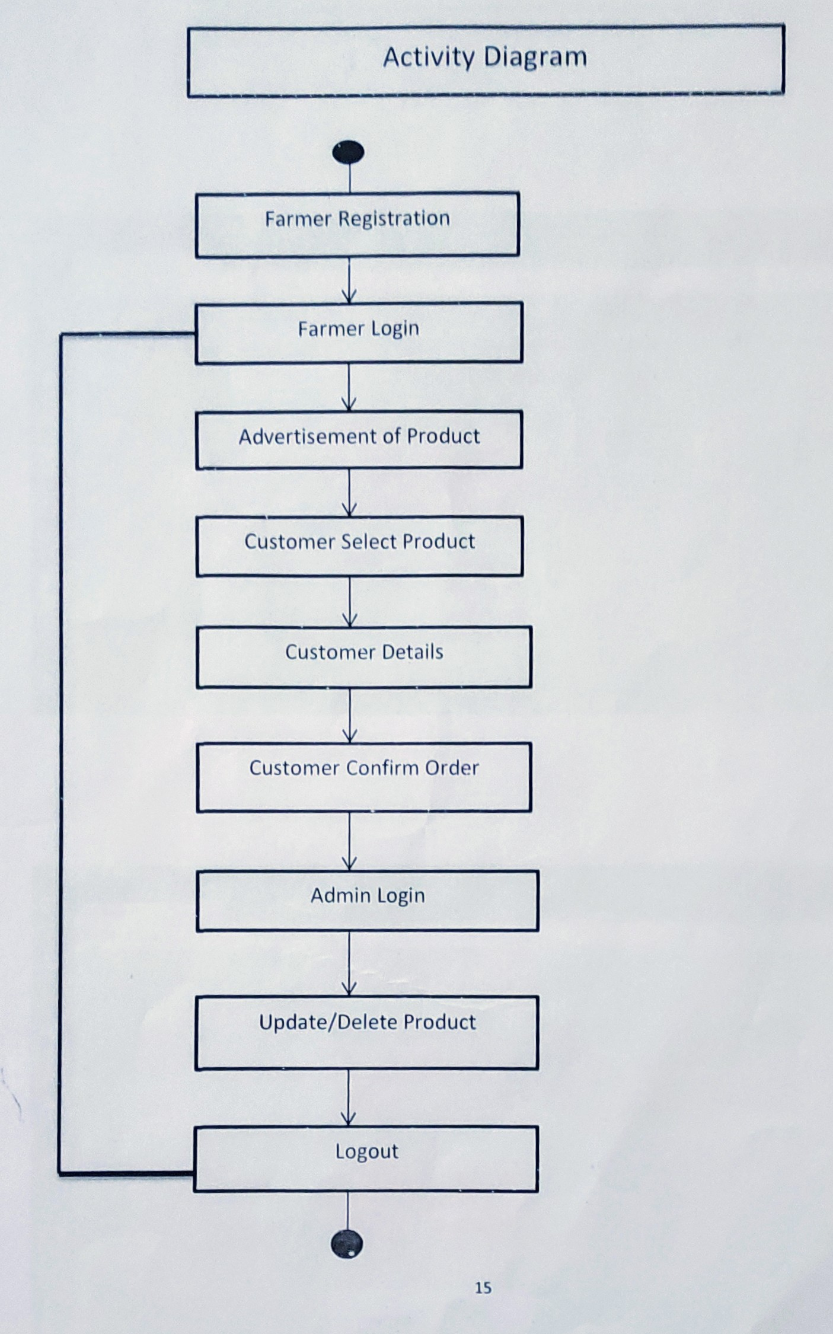

**DATA DICTIONARY**

**Table Name: users**

|  |  |  |  |  |
| --- | --- | --- | --- | --- |
| **Fields** | **Type** | **Null** | **Key** | **Default** |
| **user_id** | int | no | primary | 0 |
| **username** | varchar | no |  | Null |
| **password** | varchar | No |  | Null |
| **date** | date | No |  | Null |
| **type** | char | No |  | Null |

**Table Name: customer**

|  |  |  |  |  |
| --- | --- | --- | --- | --- |
| **Fields** | **Type** | **Null** | **Key** | **Default** |
| **user_id** | int | no | foreign | 0 |
| **mobile** | bigint | no | primary | Null |
| **firstname** | varchar | No |  | Null |
| **lastname** | varchar | No |  | Null |
| **Address** | varchar | No |  | Null |

**Table Name: Farmer**

|  |  |  |  |  |
| --- | --- | --- | --- | --- |
| **Fields** | **Type** | **Null** | **Key** | **Default** |
| **user_id** | int | no | foreign | 0 |
| **Mobile** | bigint | no | primary | Null |
| **Firstname** | varchar | No |  | Null |
| **Lastname** | varchar | No |  | Null |
| **Type** | varchar | No |  | Null |

**Table Name: payment**

|  |  |  |  |  |
| --- | --- | --- | --- | --- |
| **Fields** | **Type** | **Null** | **Key** | **Default** |
| **Mobile_no** | int | no | foreign | 0 |
| **Card_no** | Int | no | primary | Null |
| **Cvv** | Int | No |  | Null |
| **Card_expiry** | Int | No |  | Null |
| **balance** | float | No |  | Null |

**Table Name: product**

|  |  |  |  |  |
| --- | --- | --- | --- | --- |
| **Fields** | **Type** | **Null** | **Key** | **Default** |
| **Prod_id** | int | no | Primary | 0 |
| **Prod_name** | Varchar | No |  | Null |
| **Product_price** | float | No |  | Null |
| **Stock** | Int | No |  | Null |
| **url** | varchar | No |  | Null |

**Table Name: cart**

|  |  |  |  |  |
| --- | --- | --- | --- | --- |
| **Fields** | **Type** | **Null** | **Key** | **Default** |
| **User_id** | int | no | Foreign | 0 |
| **Prod_id** | int | No | foreign | 0 |
| **qty** | int | No |  | Null |

**TEST CASES :**

1. Tested password strength with at least 1 capital letter, 1 small letter, 1 alphanumeric character and minimum length 8.
2. Tested wrong inputs when logging in.
3. Tested for buying product with negative quantity.
4. Tested adding quantity with existing items in cart.
5. Tested removing items from cart.


 