**Microprocessor and Computer Architecture**

**UE21CS251B**

**4th Semester, Academic Year 2021-22**

Date:16/02/23

|  |  |  |
| --- | --- | --- |
| Name: Atharva Menkudle | SRN: PES2UG21CS104 | Section: B |

Week#____4______ Program Number: ____1___

Title of the Program

1. **Write an ALP to add two 64 bit numbers loaded from memory and store the result in memory.**

**Code:**

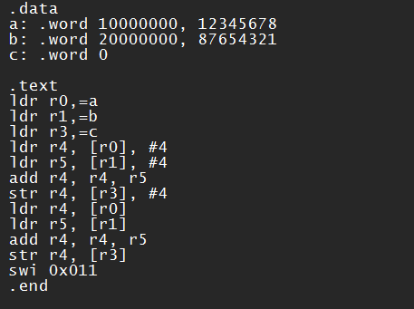

**Output:**

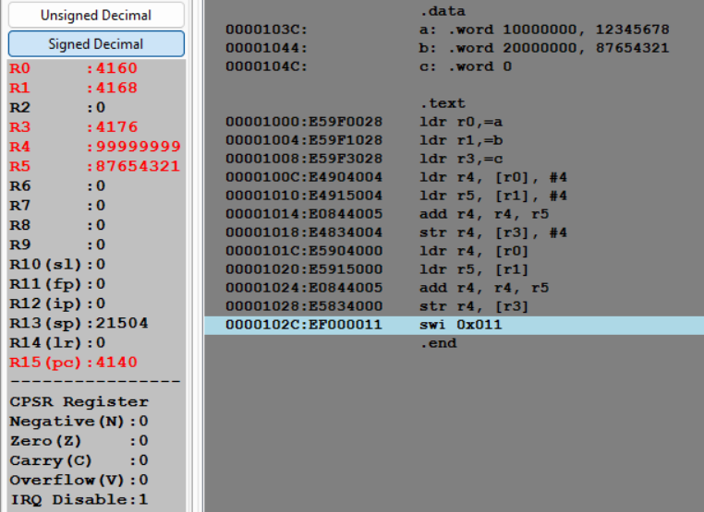

Week#____3_______ Program Number: ____2___

Title of the Program

1. **Write an ALP to find 1’s and 2’s complement of a 32 bit number**

**Code:**

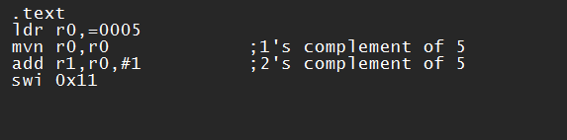

**Output:**

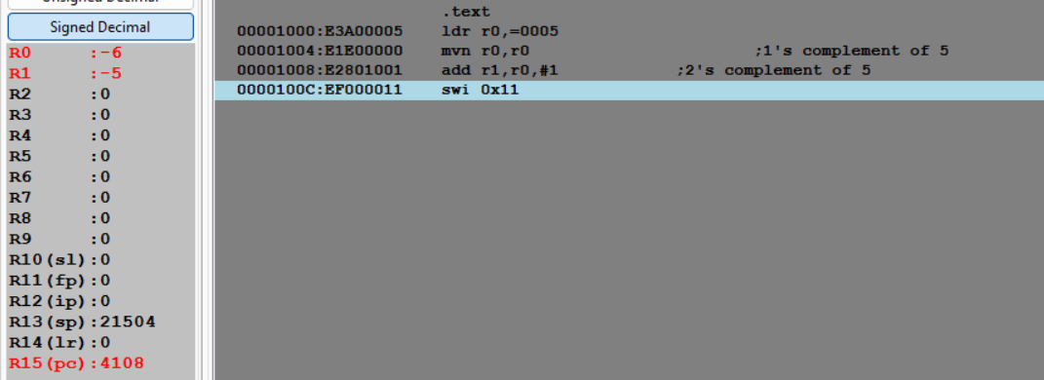

Week#____4_______ Program Number: ____3___

Title of the Program

1. **Write an ALP to scan a 32 bit number if it is negative or positive**

**Code:**

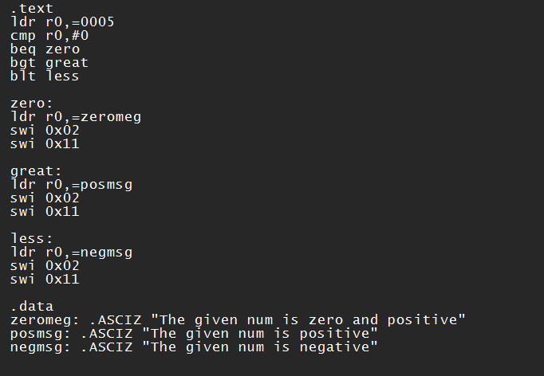

**Output:**

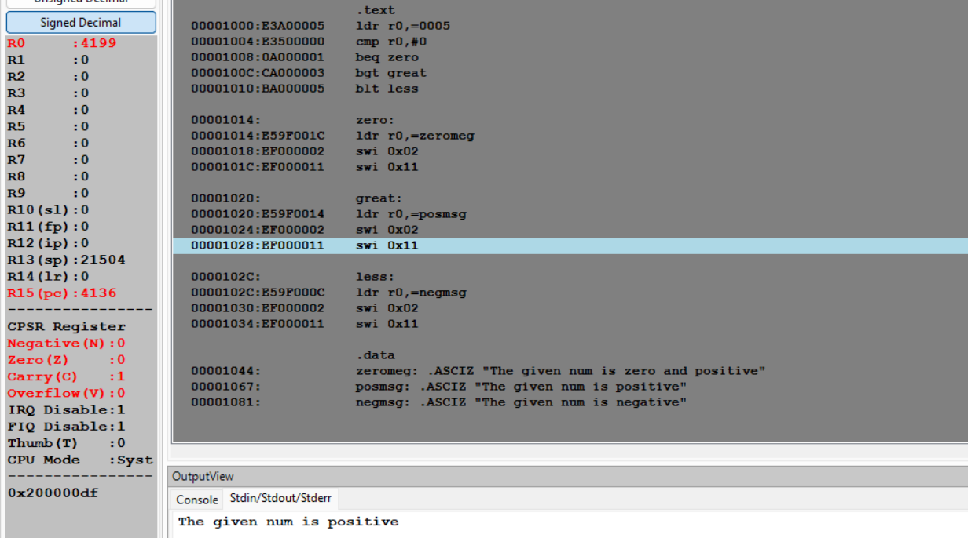

Week#____4_______ Program Number: ____4___

Title of the Program

1. **Write an ALP to find the number of zeroes, positive and negative numbers in a given array**

**Code:**

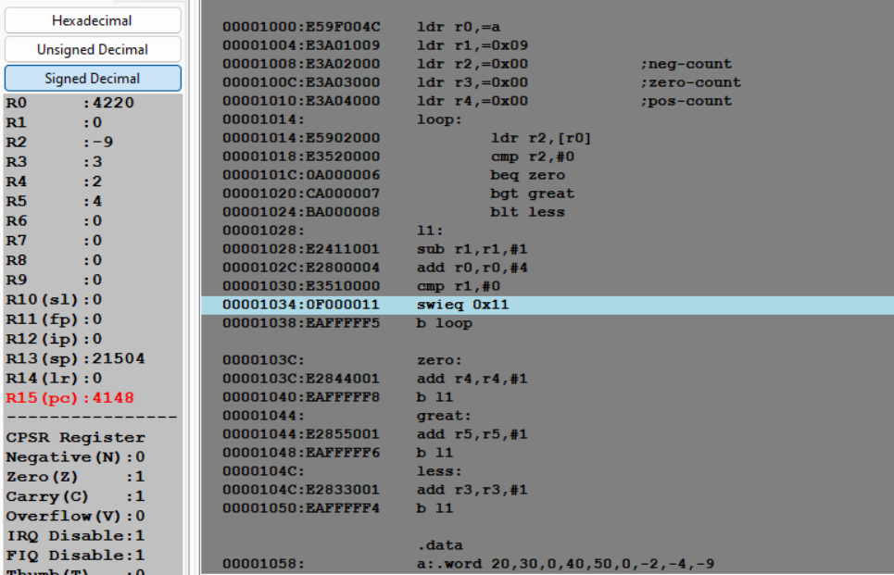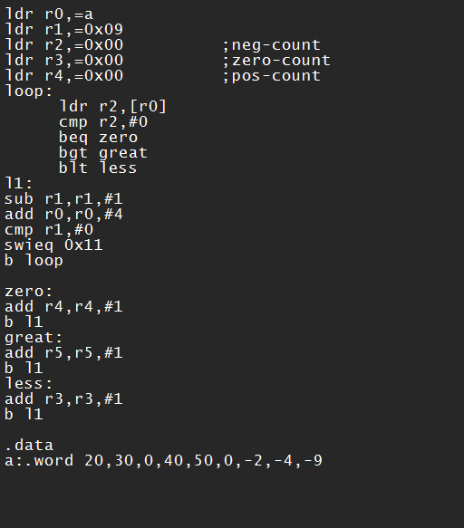

**Output:**

Week#____4_______ Program Number: ____5__

Title of the Program

1. **Write an ALP to count the number of 1’s and 0’s in a given 32 bit number.\**

**Code:**

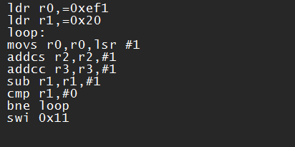

**Output:**

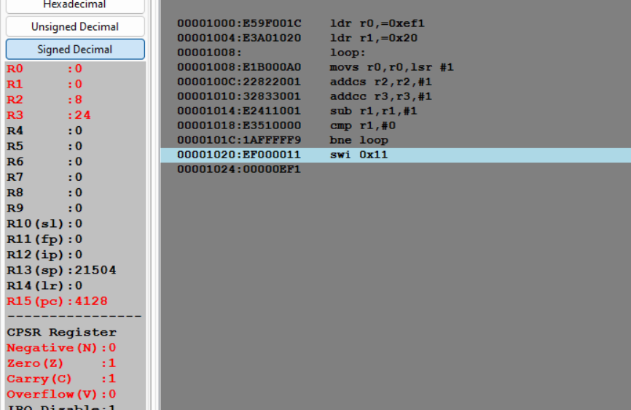

Week#____4_______ Program Number: ____6___

Title of the Program

1. **Write an ALP to check the given number has odd or even number of 1’s and display the result. (Even Parity and Odd Parity)**

**Code:**

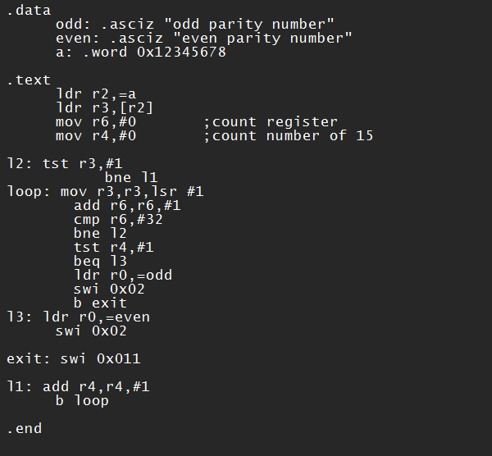

**Output:**

