# Microprocessor and Computer Architecture UE21CS251B

**4th Semester, Academic Year 2021-22**

Date:20-03-2023

|  |  |  |
| --- | --- | --- |
| Name: Atharva Menkudle | SRN: PES2UG21CS104 | Section: B |

**Include in your submission**

ARM Assembly Code Output Screen Shot

Week# 8 Program Number: 1

Title of the Program

Question:

Consider a main memory having 64 bytes capacity and cache memory of 8 byte and initially cache is empty. Consider the following addresses are generated by the CPU -

0,3,4,1,2,5,7,6,0,3,1,11,5,15,9,4,0,4,3  
Compute using LRU policy

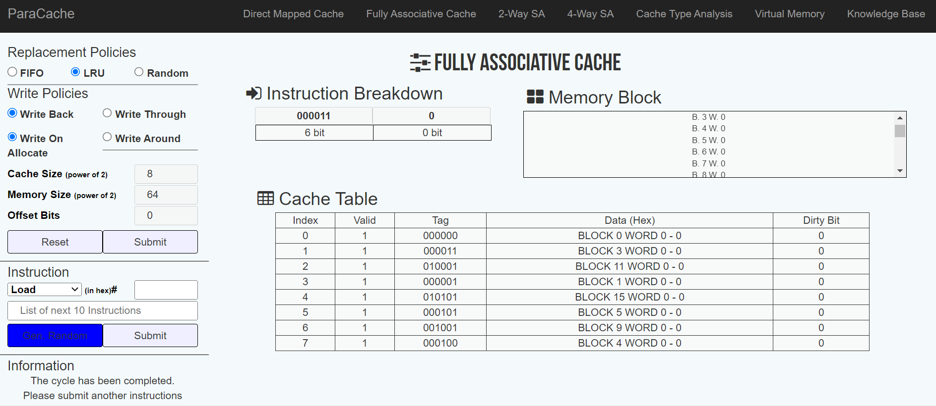Output:

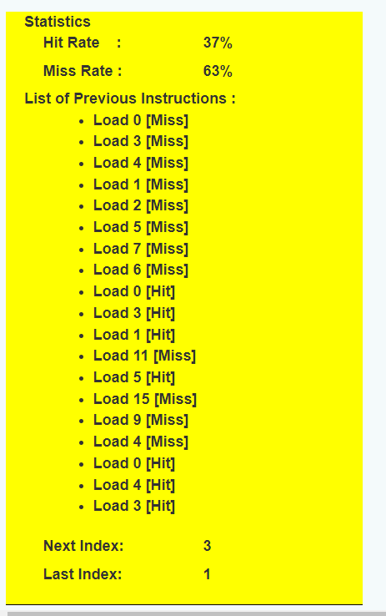

Week# 8 Program Number: 2

Question:

Consider 2 way set associative mapping, with the following design , cache memory is 16 bytes, and main memory is 256 bytes. Calculate hit and miss ratio for the following sequence

offset is 2 bits

3,6,0,8,5,1C,14,15,2,1D,11

use LRU and FIFO as replacement algorithms

Using LRU :-

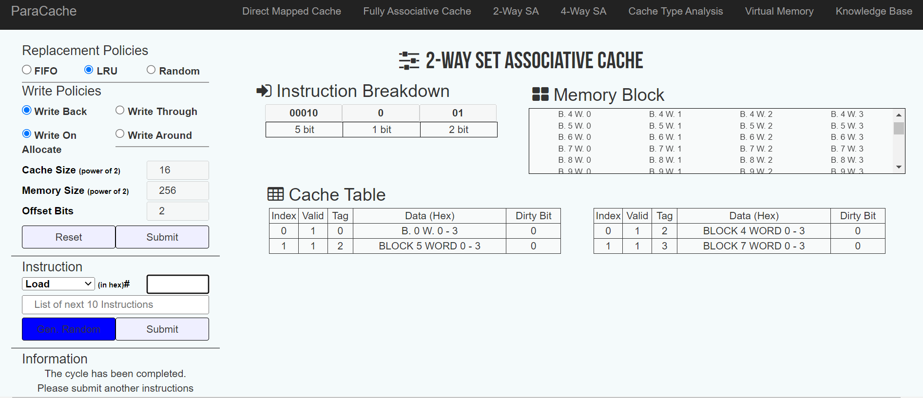

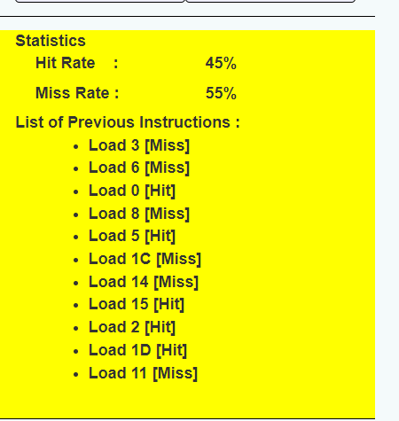

Using FIFO :-

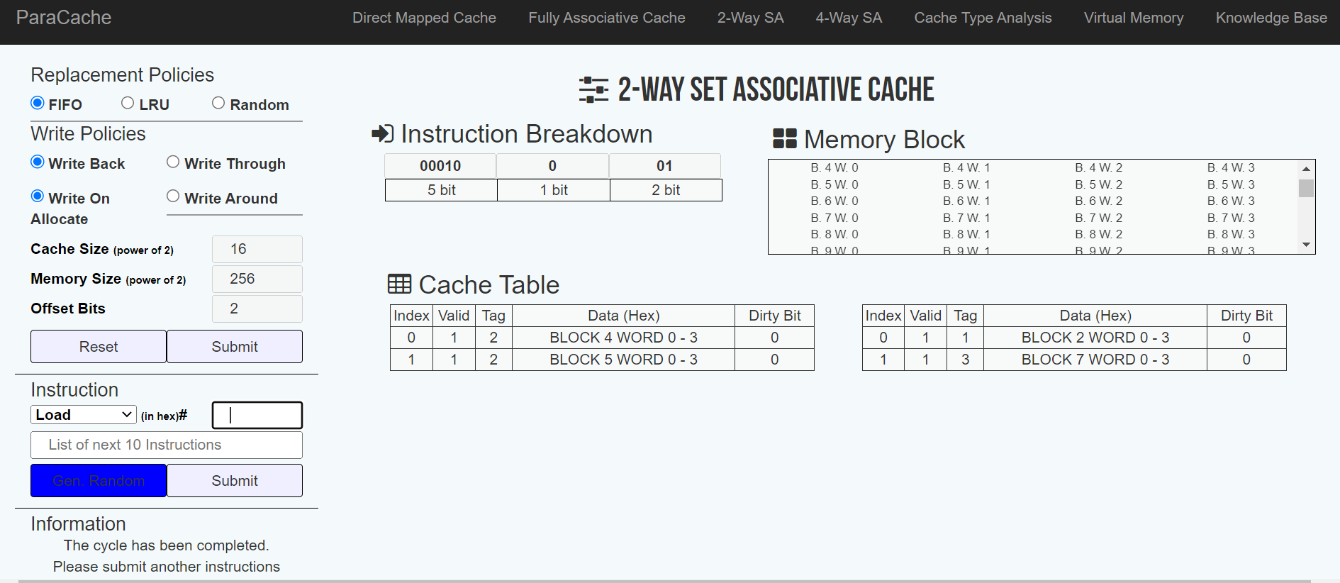

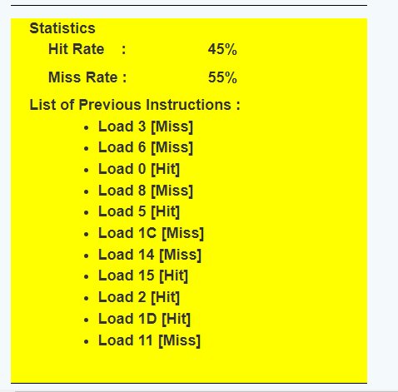

# Disclaimer:

* The programs and output submitted is duly written, verified and executed by me.
* I have not copied from any of my peers nor from the external resource such as internet.
* If found plagiarized, I will abide with the disciplinary action of the University.

Signature: Atharva Menkudle

Name: Atharva Menkudle

SRN: PES2UG21CS104

Section: B

Date:23-03-2023