EvoMind, Explained
A plain-English guide to what was built and how it works — no prior technical knowledge assumed.
The Big Idea
Imagine a software project — an app — is a house that's constantly being renovated. Every time a programmer makes a change, that gets written down, like a diary entry: what changed, when, and why. Over years, this diary gets very long.
Our tool's whole job is: read that diary, and guess which rooms of the house are most likely to break next. That single idea is what everything below is in service of, plus a few bonus features.
Step 1 — Reading the Diary (“Git History”)
“Git” is just the system that keeps that diary. Every change to the code — even a one-line fix — gets saved as an entry called a commit. A commit records who made the change, when, which files it touched, and a short message describing why (“fixed the login bug”, “added a new button”, and so on).
A real project can have thousands of these entries going back years. Our tool downloads this whole diary and reads through every single entry. That's the very first thing that happens when you click “Analyze.”
Step 2 — Turning the Diary into Clues
For every file in the project, we count things from the diary, like a detective building a profile:
- How many times has this file been changed? (Changed 200 times is riskier than changed twice.)
- How many different people have touched it? (More cooks, more chance of miscommunication.)
- How much code got added or removed each time — we call this “churn.”
- How old is the file, and how recently was it touched?
We also look at the actual code and measure things like how long the file is, and how tangled the logic inside it is — how many decision points (if/else branches) it has. More branches generally means more ways for something to go wrong. All of these numbers together are called features — they're the clues we hand to our prediction system.
Step 3 — Teaching a Computer to Guess (Machine Learning)
We don't guess randomly which files are risky — we teach a computer to learn the pattern from the project's own real history.
Here's how: we pick a point in the past — say, “pretend it's exactly two years ago” — and ask: using only the clues that existed up to that point, can we predict which files broke in the following year? We already know the real answer, since it already happened, so we can check whether our guesses were right.
We repeat this with many examples until the computer learns: “files with these kinds of clues tend to break; files with these other clues tend to be fine.” This learning process is called training a model. We train two different guessing methods and compare them, to see which one guesses better.
Once trained on the past, we point the model at today and ask: “given everything you've learned, which files right now look the riskiest?” That's the “Current risk ranking” table on the dashboard.
Step 4 — Making Sure Our Training Answers Were Honest (SZZ)
Here's a subtle problem we had to solve. To teach the computer “this file broke,” we scan the diary for commits with messages like “fix: crashed on login” — looking for the word “fix” and similar bug-related words.
But that's a bit sloppy. What if a “fix” commit is actually repairing something that was introduced after our pretend cutoff date? Then we'd be teaching the computer using information it shouldn't have had yet — like letting a student see tomorrow's exam answers today. That would make our results look better than they honestly are.
So we built something called SZZ (named after the researchers who invented it) that does real detective work: for every “fix,” it traces backward through the diary to find the exact earlier change that actually caused the bug — using a tool called git blame, which can point to exactly which past change is responsible for each line of code. If that original bug-causing change happened before our cutoff date, the label is trustworthy. If not, we throw it out.
Step 5 — Double-Checking SZZ's Guesses with AI
SZZ isn't perfect either. Sometimes it points at the wrong earlier change — like blaming someone for a mess because they were the last person to touch that area, even if they were just tidying up (reformatting, renaming) and didn't actually cause the problem.
So we added an optional extra step: we show an AI (Claude) both the “fix” and the “blamed” earlier change, and ask it to judge whether the earlier change really looks like the actual cause, or looks like an innocent bystander. This is the “Use LLM-assisted SZZ” checkbox on the dashboard. It only ever removes bad guesses — it never invents new ones.
This follows a published research technique called LLM4SZZ (2025) — it is an applied technique following an existing published approach, not something original invented for this project, and that distinction is worth being upfront about in a report or defense.
This step needs a paid AI API key. Without one, the tool quietly falls back to the plain SZZ result instead — no crash, no error, just a small honest note explaining that it fell back.
Step 6 — Mapping How Files Depend on Each Other
Separately from bug prediction, we also read every file's code and figure out which files rely on which other files — like a family tree, but for code (“this file needs that file to work”). We draw this as a map, called a dependency graph.
From that map we can spot two useful things:
- Which files are depended on by almost everything else (risky to change carelessly).
- Circular dependencies — groups of files that all depend on each other in a loop, generally considered messy design, since you can't really change one without touching all of them.
This works for Python, JavaScript/TypeScript, and Java code specifically — each language writes “I need this other file” differently, so the tool had to learn each language's own way of saying that.
Step 7 — Getting Written Advice
Once we know a file is risky (Step 3) and how it connects to everything else (Step 6), we can ask an AI to look at that file's actual code and statistics, and write plain-English advice: here's specifically why this file looks risky, and here's what could be done about it. That's the “AI recommendation” button — an on-demand feature you click per file, not something that runs automatically for every file (that would be slow and expensive).
Step 8 — The Dashboard
Everything above happens in the background. The dashboard is the webpage that lets you type in a repository, click “Analyze,” watch it work through a live progress checklist (so you're never staring at a frozen screen), and then see all the results laid out clearly — sortable and searchable tables, charts, color-coded risk labels (green = low risk, red = critical), and buttons to dig deeper into any specific file.
Bonus — Rolling-Origin Evaluation
This is a separate, more rigorous test of how good our guessing really is. Instead of testing the model's guesses just once, we test it several times across different points in the project's history, to make sure it wasn't just “getting lucky” once. It isn't part of the live website — it's a script run separately to produce extra numbers for a written report.
How It All Connects
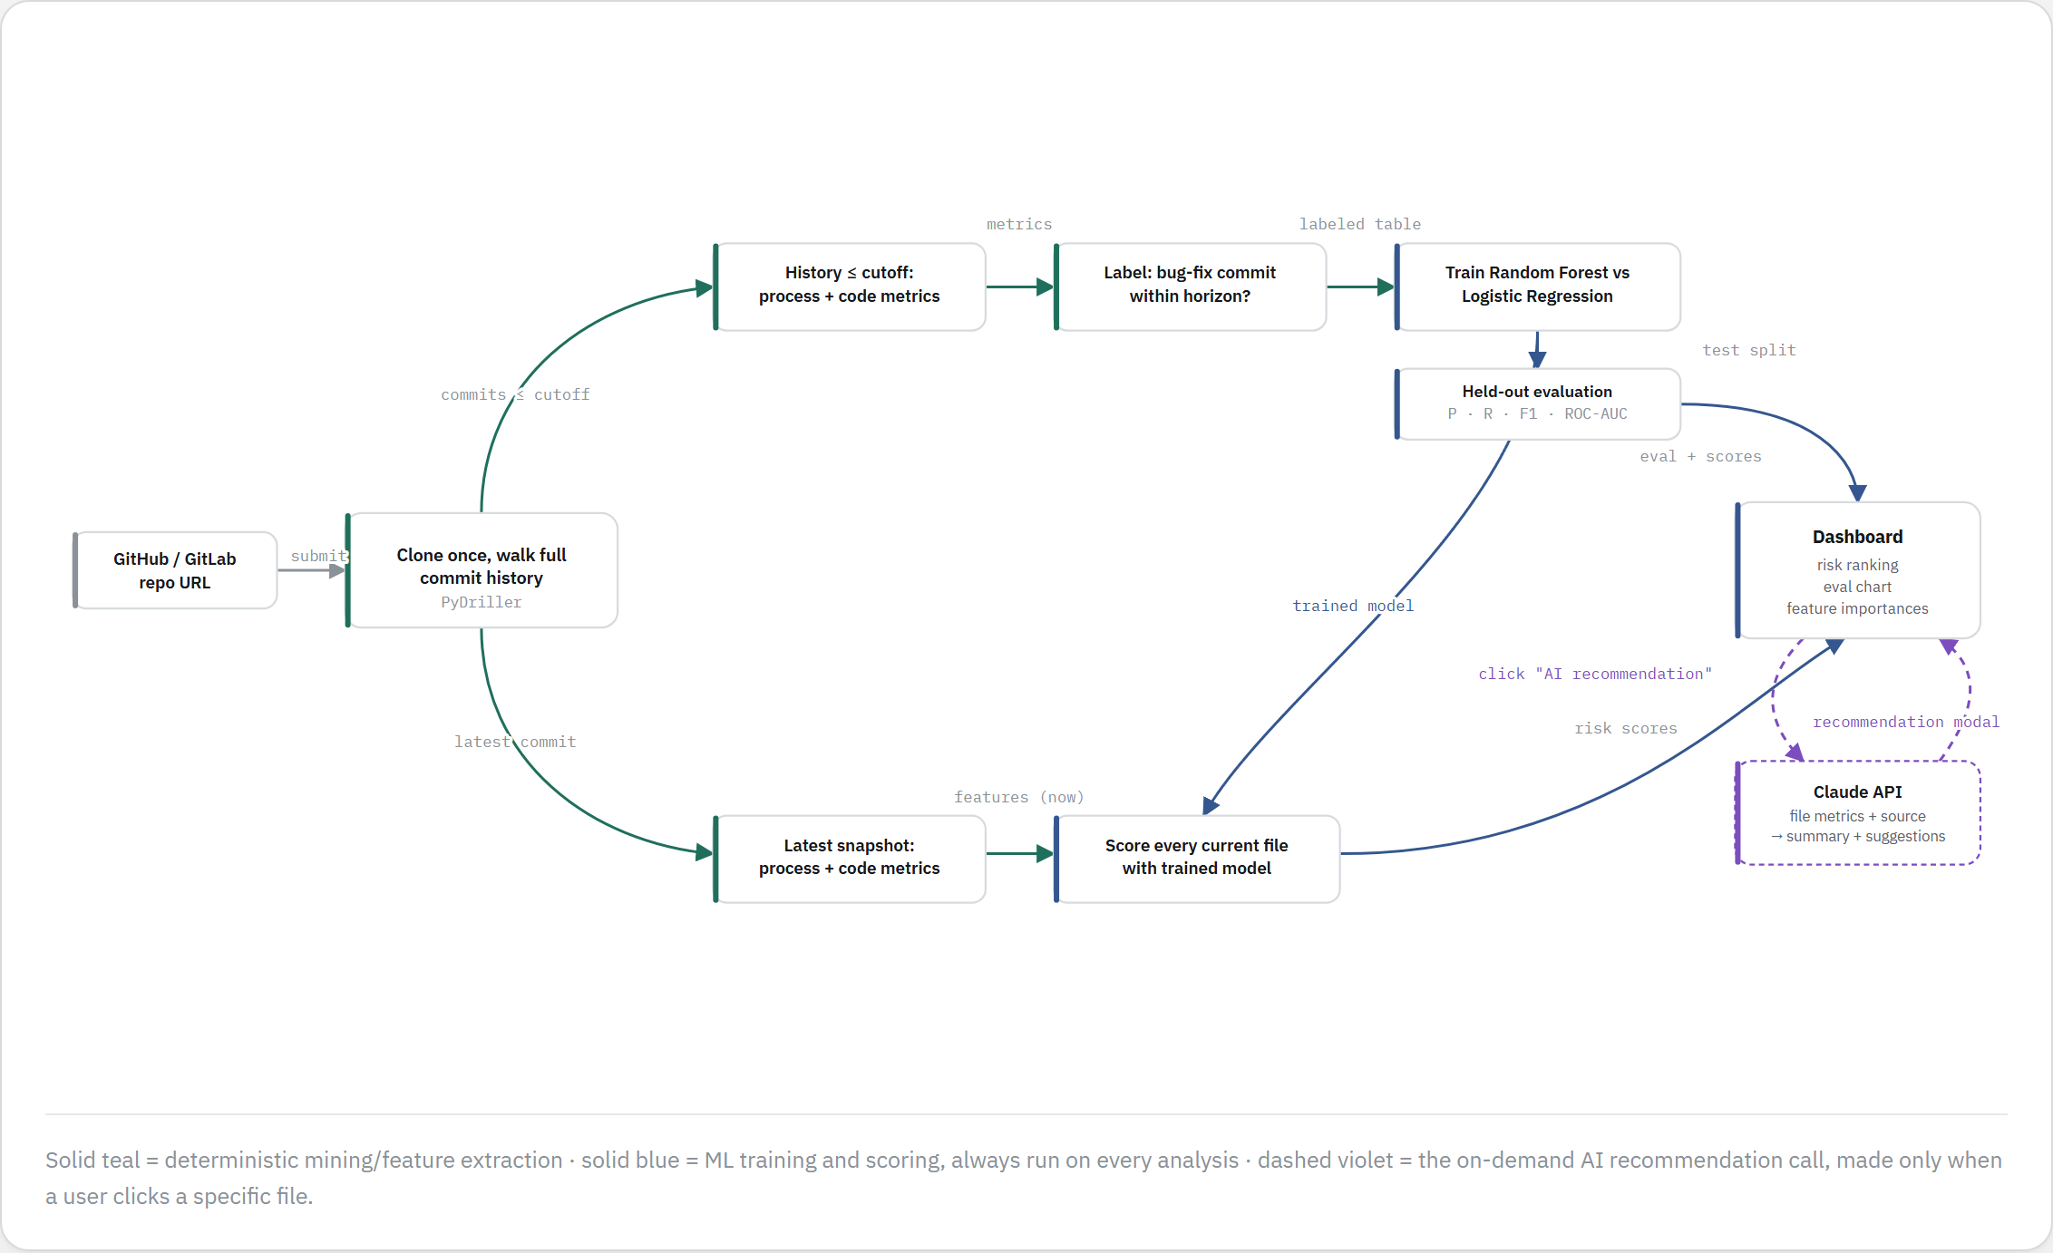
Solid teal = deterministic mining/feature extraction · solid blue = ML training and scoring (runs on every analysis) · dashed violet = the on-demand AI recommendation call (only when a specific file is clicked).
In One Sentence
We read a project's entire change history, teach a computer to spot patterns in what tends to break, double-check our training data is honest using real detective work (optionally sharpened by AI), map how the code's pieces connect to each other, and present all of it — plus AI-written advice — on one webpage.
Quick Glossary
Term | Meaning
Commit | One saved change in a project's history — who, when, what, and why.
Git | The system that stores a project's entire change history.
Feature (ML sense) | A measurable clue about a file, e.g. how often it changes.
Model / Training | The computer program that learns patterns from past examples.
Cutoff / Horizon | The pretend “today” used for training, and the future window checked afterward.
SZZ | The method for tracing a bug fix back to the change that actually caused it.
LLM / Claude | An AI language model, used here to double-check guesses and write advice.
Dependency graph | A map of which code files rely on which other files.
Dashboard | The webpage where you run an analysis and see the results.

