To execute an R Script using the Command Manager and automate the process, it is necessary to configure system environment variables.

1. Copy the path to the "bin" folder where you have installed R. The default path is typically located at C:\Program Files\R\R-4.3.1\bin. Search for Edit Environment variables in windows search.

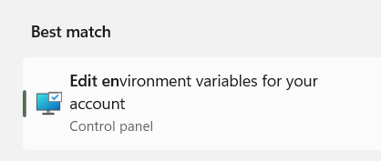

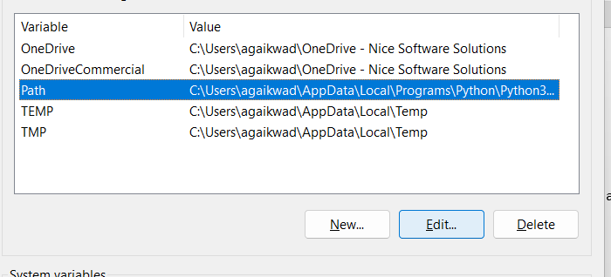

1. Click on "Path," and then select "Edit."
2. Choose "New," and paste the path to the "bin" folder in the field.
3. After configuring the environment path variable, open the command prompt.
4. In the command prompt, type "R" to verify whether the path was set successfully or not.

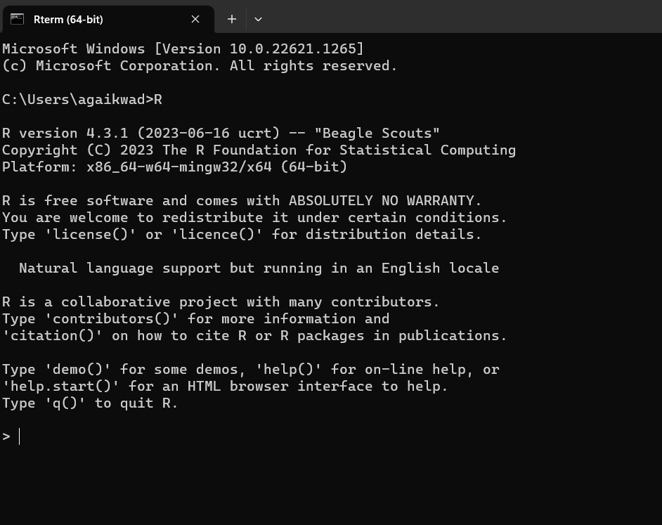

Now, navigate to the directory where you have saved the R Script. Open a command prompt in that directory. To execute the script, enter the following command:

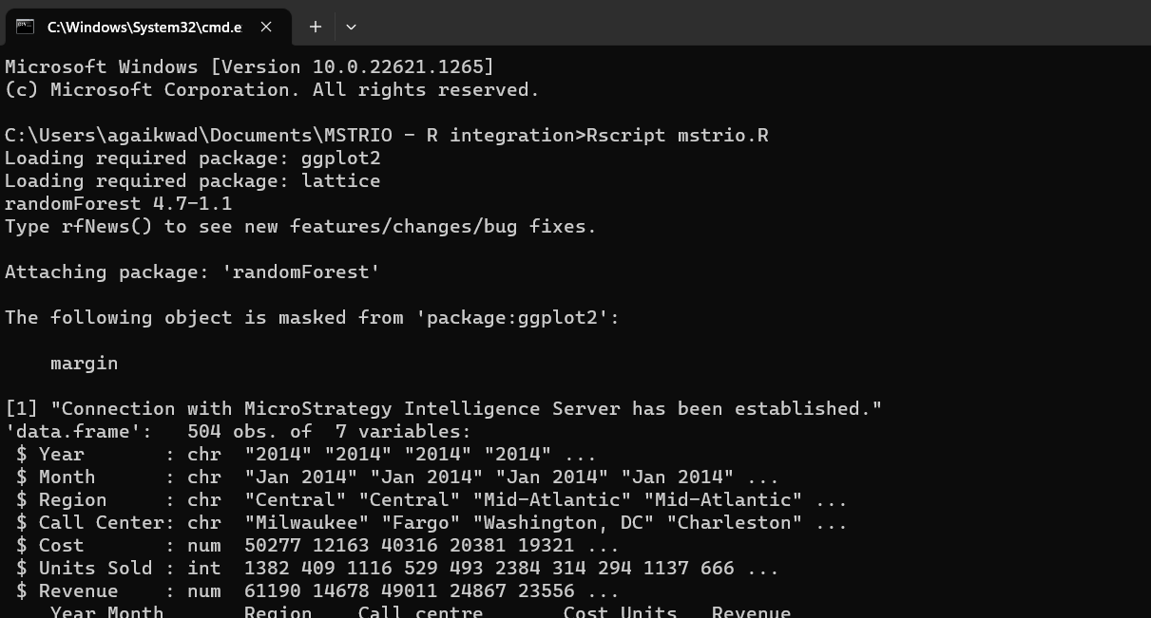RScript<Name of the file>

RScript will run and the output will be displayed on the command prompt.

**Automation with task scheduler**

1. Create a task in windows Task scheduler by providing all the details.

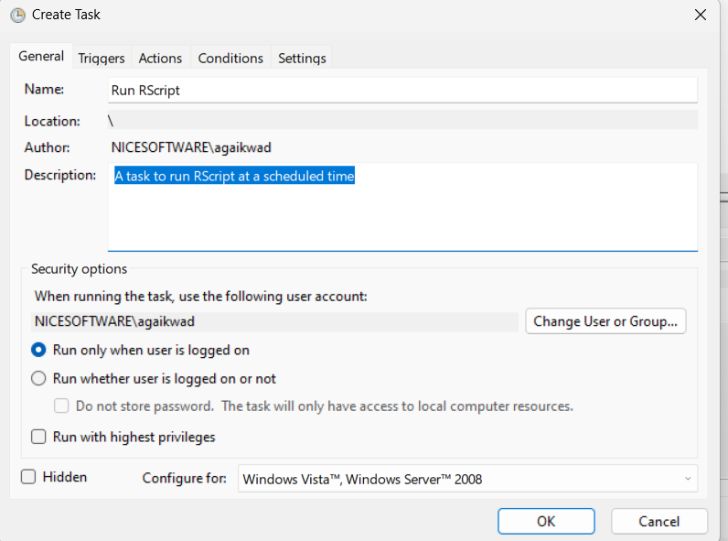

1. Click Next and provide the schedule details, for the time when you want to Run the Script.

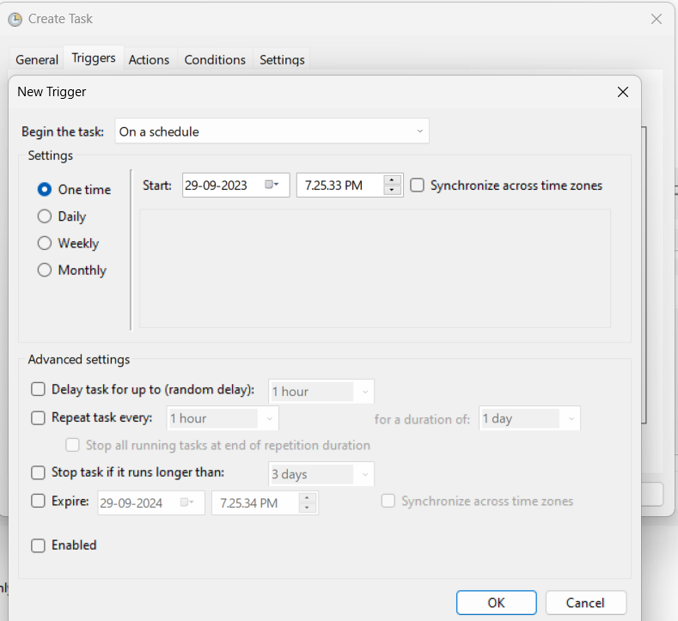

1. Click ok.
2. Click on Actions.
3. Click new to create an action to start a program.
4. Provide the path to RScript setup in the bin folder.
5. In Add Arguments option , add the path to R file along with file name and .R extension. Example - C:\Users\Users\Documents\MSTRIO\mstrio.R

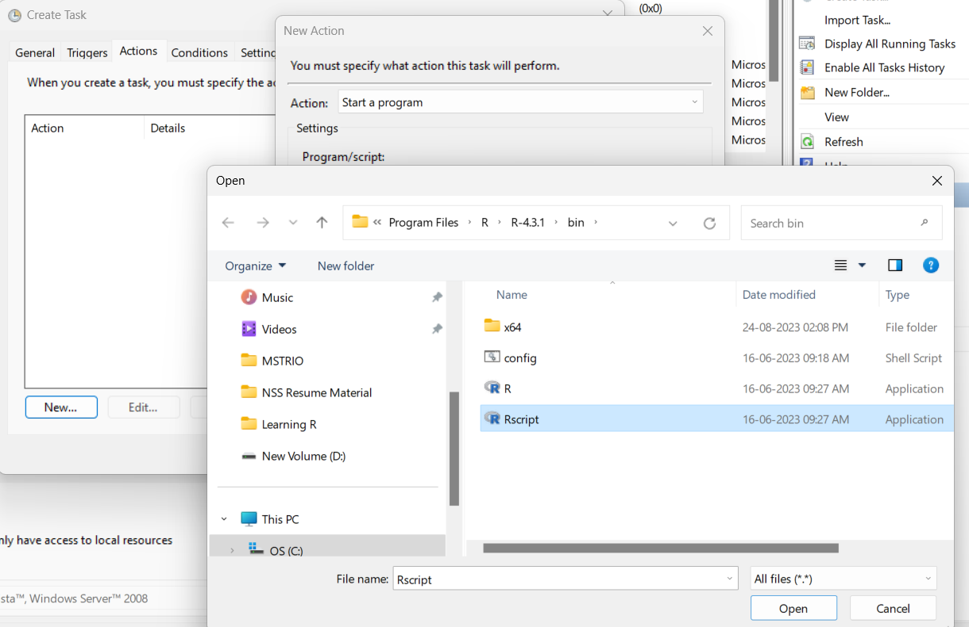

1. Click on ok and the task should appear on the scheduled tasks list.

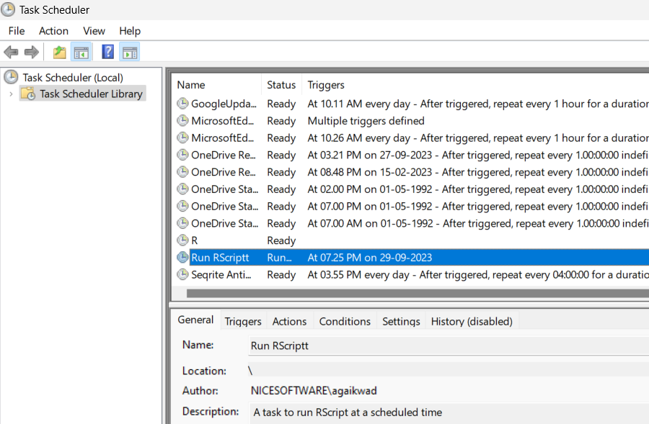

After the scheduled task is run , the RScript will get executed in command prompt.

