# **Criterion D: Product Design**

**Overall Structure**

**Table Structure**



**Relationship**

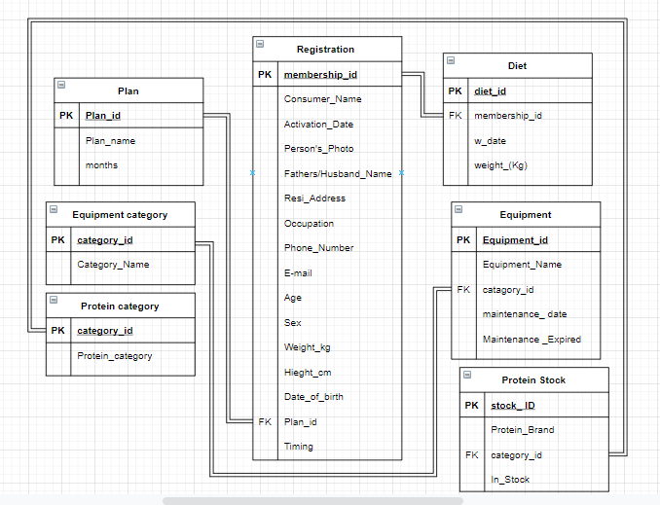

**Main-Menu Page**

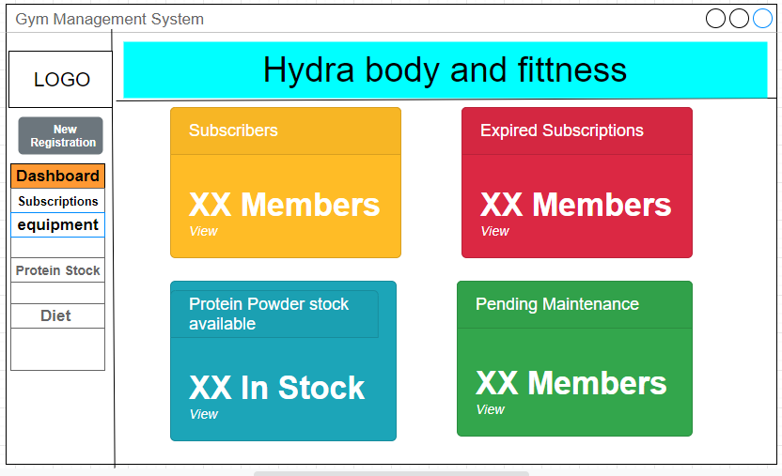

**Form Designs**

**Member Form**



**Plans Form**



**Equipment Form**



**Equipment Category Form**



**Protein Stock Form**



**Protein Category**



**Diet Form**



**Report Design**



**Navigation Diagram**



**Internal Structure**

### **List of Resources and Techniques**

| **Resources** | **Details** |
| --- | --- |
| Data | Data such as sample data, calculations performed, gym logo, information of gym which is provided my client RAM |
| Microsoft Access 2016  (Learning resources:   * How to use Microsoft Access - Beginner Tutorial: <https://youtu.be/ubmwp8kbfPc>’ * Calculate Dates in Access: <https://youtu.be/gs_KUeCEvaQ>) | Microsoft access is a tool that I am going to use to develop the application. It is a tool used for data manipulation and uses a database. It has various features to develop an application. Comes with a microsoft office. Learning the Ms access using resources. |
| Cloud Converter PNG to ICO Converter:  <https://cloudconvert.com/png-to-ico> | The icon converter will be used to convert images in icon (.ico) format then the icon file will be used as icon for application. |
| Adobe Photoshop CC 2019:  <https://youtu.be/lhmXoD15dKg> | It’s an image manipulation tool that is needed to resize the gym logo and do minor editing. |
| Microsoft visual basic for application (  Learning resources:   * VBA - If Statement: <https://youtu.be/d5-XKNC5whc>) | It is an application to do the VBA programming by which I can create custom functions that I can use in my application. I will learn some basics of vba using these resources. |

| **Techniques** | **Details** |
| --- | --- |
| Tables | Tables will be used to name the field and setting and appropriate datatype for it for example if the consumer name is the field its datatype will be string, not a number or boolean. |
| Relationships | In the tables, there will be the data that will be redundant like in the diet table when the entry will be done then it will repeat the customer name. Taking names from another table can be very useful. Using the concept of primary key and foreign key. |
| Unique Id | Each entry in the table will have its own unique identification which will be done by using an auto-number data field. Giving a unique id can be useful to get accurate data. |
| Forms | Forms will be useful in creating the User interface. The navigation form will have buttons to navigate to different forms, run queries, and open reports. The forms will allow users to add, delete or update the records in the table. |
| Report | The report will be used to show the data in tables like pending maintenance and expired subscriptions will be displayed using the report. |
| Query | The query will be used to filter, sort, and make necessary calculations. It will mainly be used to calculate the expired dates, BMI, and ideal weight. |
| VBA | VBA will be used to build the module, which will contain a customized function that will be used in the calculation. |
| Chart | This will be specifically used for displaying the graph of the progress report in the diet table. It will display filter data of a particular customer and show its progress report as a line graph. |
| Styling | Styling will be used as a cosmetic for the application. It will make the application look good. It's mainly related to designing like background color, font styling, etc. |

**Test Plan**

| **Test item** | **Test data** | **Part of system tested** | **Expected outcome** | **Actual outcome** | **Comments** | **Ref. in product** |
| --- | --- | --- | --- | --- | --- | --- |
| **Cover Page Testing – REQUIRED ELEMENT FOR CRITERION G** | | | | | | |
|  |  |  |  |  |  |  |
|  |  |  |  |  |  |  |
| **Product Testing** | | | | | | |
| Main Menu |  | Switchboard | Showing all the elements for navigation | Works: the switchboard able to show buttons for navigation |  | Main-menu when the application is opened the end user lands on it. |
| Forms | Fields are shown and the data | Forms | All the fields are correctly displayed and the data is enterable | Works: The forms are working and the data is viewable and editable |  | When the buttons are clicked on main menu it opens the form |
| Buttons | Sample data | buttons | Buttons are clickable and perform their action | Works: the buttons are able to perform various action such as insert, delete and search |  | Buttons are located in main menu and forms |
| Parameter Inputs | Sample data | Parameters input | The application asks for input | Works: parameters inputs are working it asks for input when there is need of one |  | Parameter input is in the realtime calculator and view progress report. |
| Charts | Sample data | charts | Display the charts | Does not Work | I was not able to integrate this function in the application as the application does not allow me to make accurate graphs and i can’t find the way to integrate it. |  |
| Reports | Sample data | reports | Display the reports | Works: the reports are viewable with the data which they intend to show. |  | The main reports of expired subscription and maintenance are in main menu and other report are used to function view all report |
| Relationships | Sample data | relationships | The components are working in a relationship | Works: relationships works and has been used thoroughly in the application to perform its functionality. |  | It is not visible in the application it is something which is on backend |

**Agreement of Client**

**Client Signature**



