# **Criterion E: Product Development**

Advance techniques Used

* Complex Queries
* Visual basic for applications
* Parameter Inputs
* Relationships

**Overall Structure of Database**

**Tables**



The tables screenshots display the field names and their data type. For each table, there is a Primary key that allows a unique identification for each record. The foreign keys are named the same as in the primary key of the different tables where the data needs to fetch. These field names will work as a data entry accept primary key and foreign key, it will be fetched from another table or it will be an auto-number.

For timing and Sex, the lookup wizard has been used because the value will not be changing in the table. The values have been integrated manually.



**Relationships**

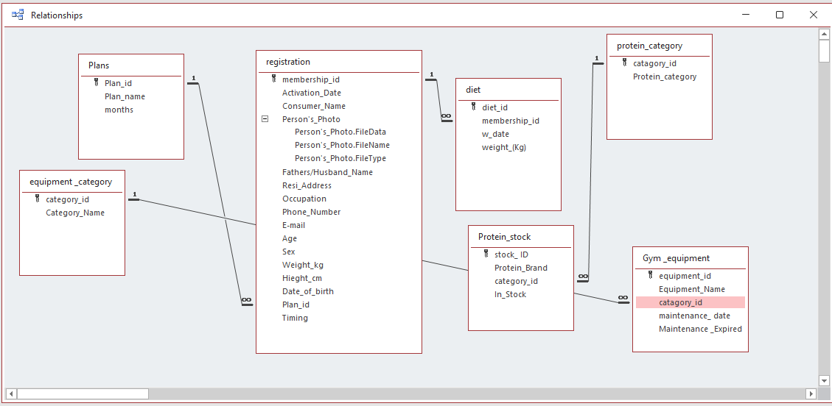



Relationships are created in the tables where the data is going to reoccur in the table. One to Many relationships is used with Enforce referential integrity. The auto-number has been used for the identification by which accurate data will be fetched.

**Application Name and Logo**

In the current database option, the name and logo have been inserted for the application.

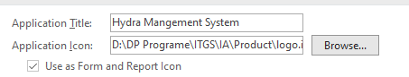



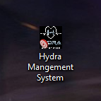



**Forms**

Form Design

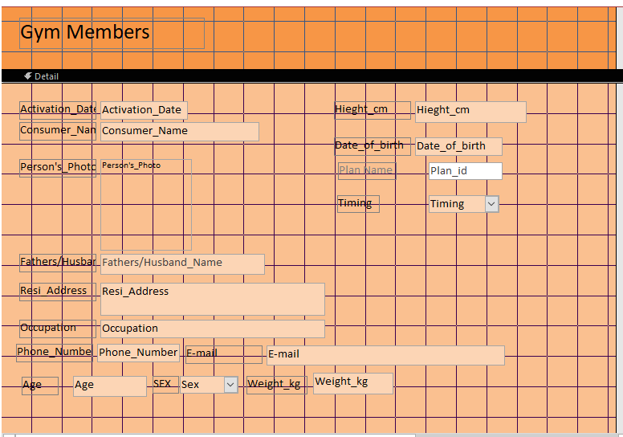

Creating Dropdown for Plan name

There is already a relationship created between table registration and plans.

The combo box has been used to creating a dropdown. The values have been taken from another table then.

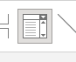

Combo Box Wizard



After fetching the data from another table it needs to be bounded with the forgin key in the registration table.



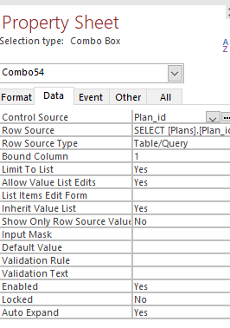

The control source has been set to Plan_id in the registration table which will store the data in the field name Plan_id.

Using the Same process other forms are created as well with a combo box

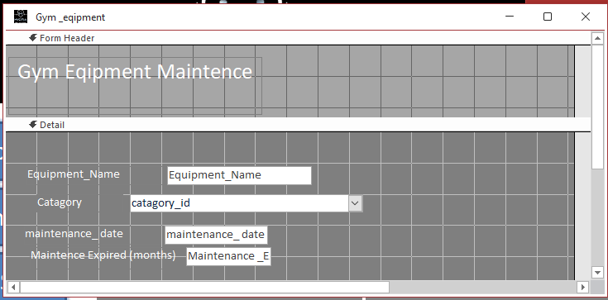

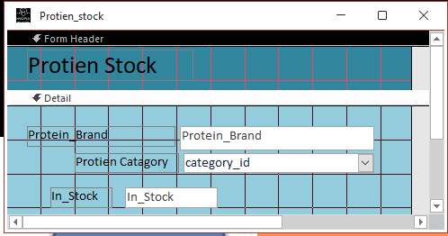

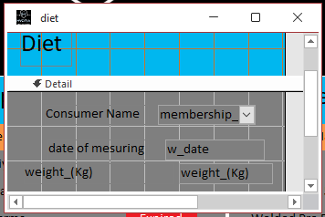

Use of buttons for navigating and performing tasks.

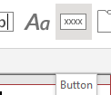

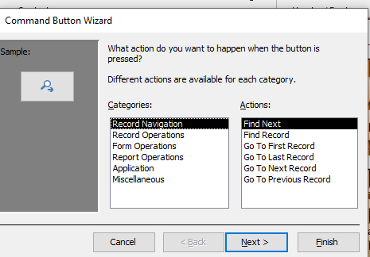

Styling forms and buttons

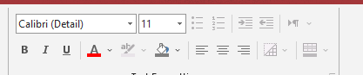

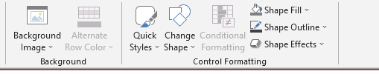

View all Reports to show all the available names.



Creating a navigation form that will be the main menu of the application. This form will be used for navigation between forms and reports.

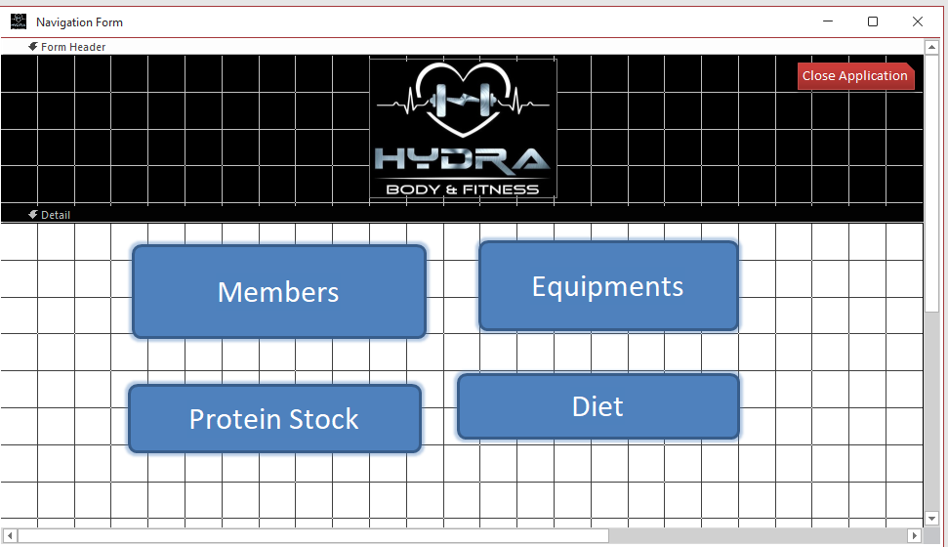

Final Forms

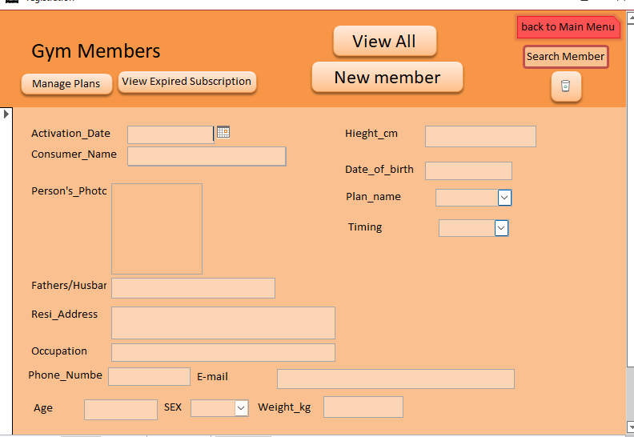

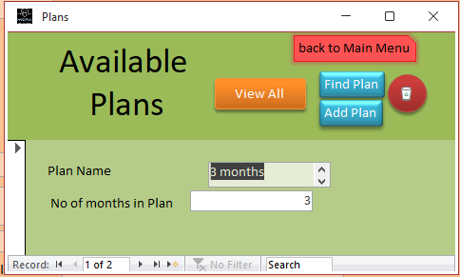

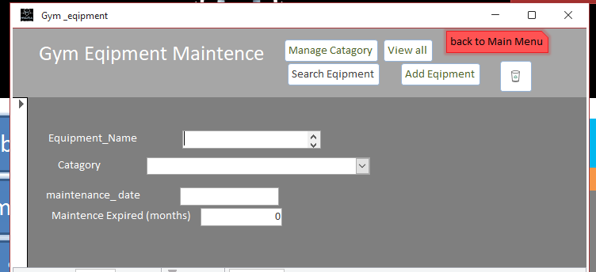

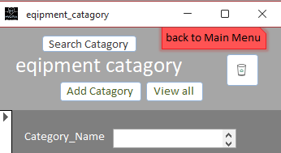

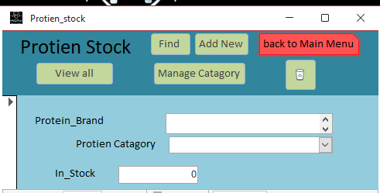

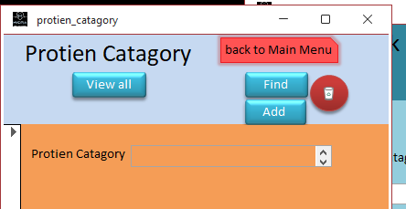

**Query**

For performing the calculation which will function, the main functionality of the application query are created.

The query is created for showing whether the customer subscription is expired or active. This query needs to calculate the expiration date of the subscription with the plan that the customer has taken and compare it with the current date to show the status that the subscription is expired or Active.

In the Ms access, the number is added to the date then the number is considered a day. Using this logic expiration date can be calculated.

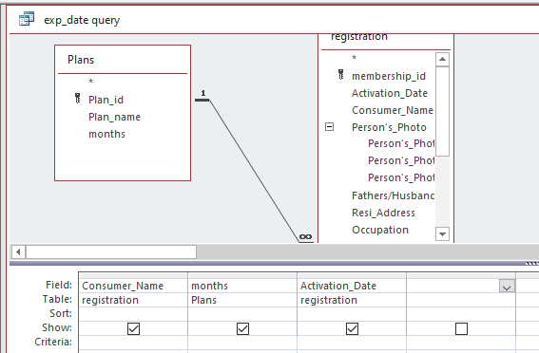

This field has been taken from the tables.

Calculating plan days

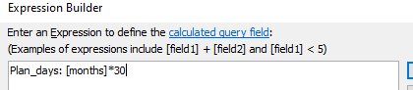

A month has been assumed of 30 days and then multiplied by the months from the plan table. This value will give the total number of days in the plan.

Calculating Expiration date of subscription

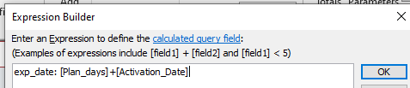

The plan days have been added to the activation date taken from the table registration that will add days from the activation date resulting in giving the last date which will represent the expiration date.

This is the only calculation of the expiration date of the subscription; it does not compare whether the subscription is active or expired for that comparison of the current date and the expiration date needs to be done.

Creating function for giving value whether the subscription is expired or Active. The function is created so that it can be used in the query.

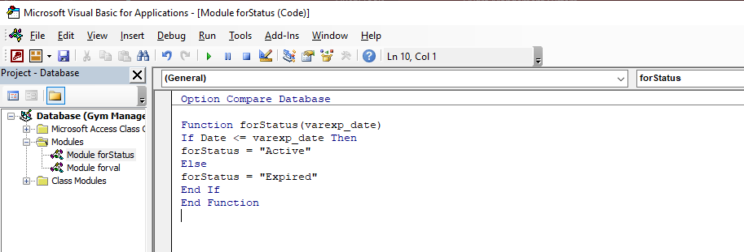

In this module, simple if and else statements are used where the variable is taken and compared with the current date (date () is an inbuilt function in the VBA that represents the current date). If the expiration date has not been passed then it will return string value active. If the expiration date has been passed from the current date then it will return string value expired.

The function used in the query

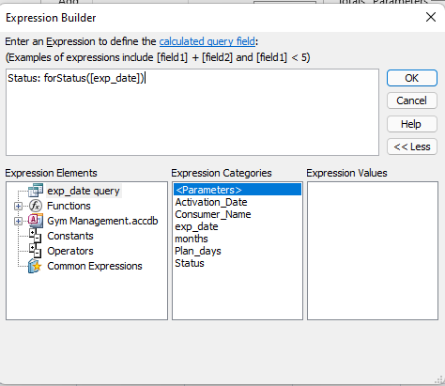

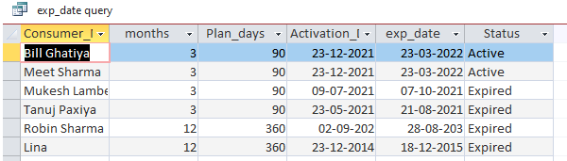

The function will return whether the subscription is active or expired, There is no need of showing active subscriptions. Creating a double query and giving criteria as ‘Expired’ will filter the data for people whose subscription has expired.

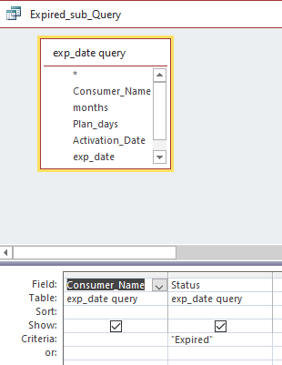

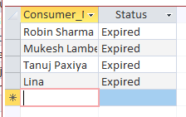

Using the same logic used in the exp_date query for creating the functionality of pending maintenance.

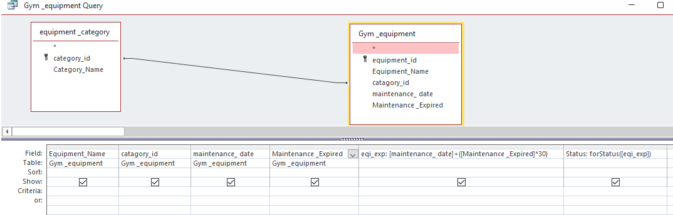

This query calculates the expiration date. The initial date and in months the maintenance is being expired of specific equipment has been taken as an input from the user. Using the same function forStatus () for returning the value whether the maintenance is pending or maintained.

The double query for filtering the expired maintenance

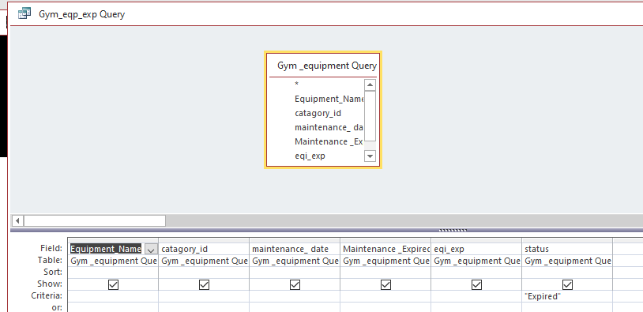

This query will filter the data for expired maintenance. Using this query the report will be generated which will be shown in the main menu.

Calculating BMI and Ideal weight

For calculating the BMI formula is used



For Calculating the Ideal weight

Val =

Male & Others: 50

Female: 45.5

(Val)+ (0.91 × [height in centimeters − 152.4])= Ideal weight (KG)

From the registration table, the values have been taken

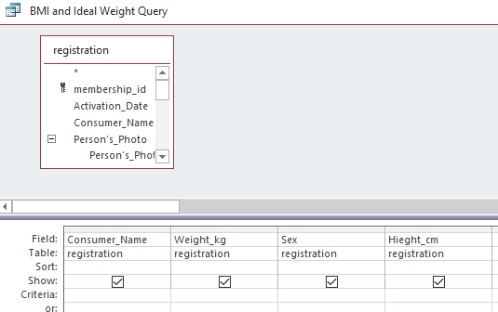

BMI can be calculated directly from the input data because of its number.

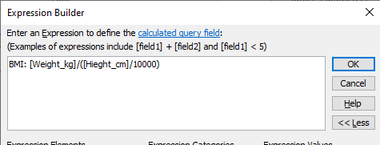

For calculating ideal weight the value must be determined based on the sex the person has

Function for getting the value of sex is created through VBA.

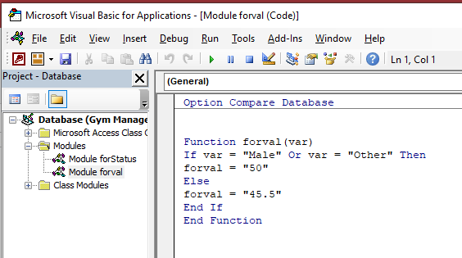

This function will return the value basis on given input from the form where it will satisfy the formula for calculating the ideal weight.

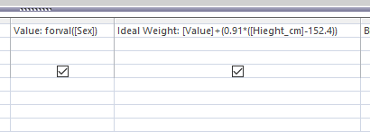

The Ideal weight is calculated.

Real-time calculator for BMI and Ideal weight using parameter input.

Parameter value has been declared which will be asked directly

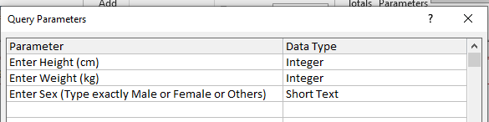

The formula has been applied to calculate





Running this query will ask the user for input and calculate the BMI and Ideal weight in real-time.

Creating a progress report for a single customer

For this query, the parameters input has been used. Where the in parameter the name of the customer is asked and then mentioned in the criterion of the cutomer_name.

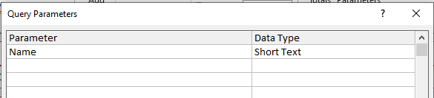

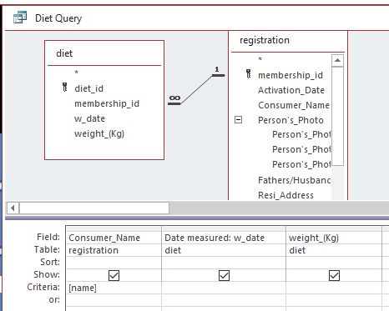

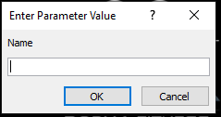

The reports have been created of the query and added into the main menu.

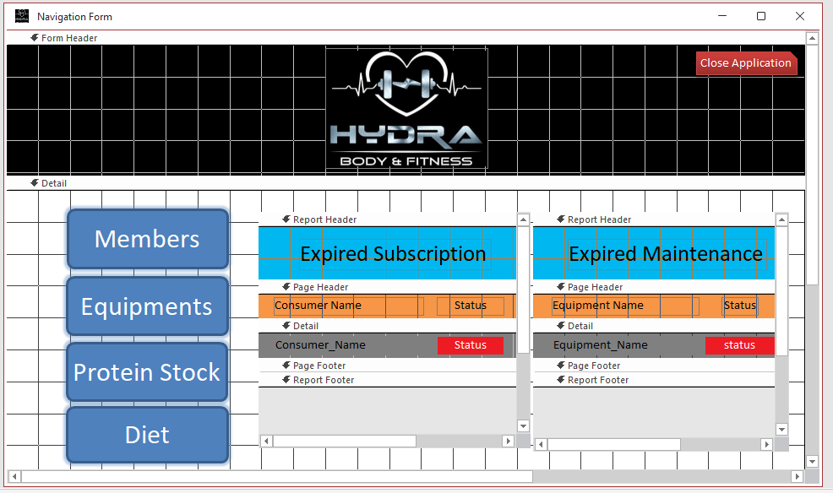

For preventing the user from accessing the query and tables which might create a malfunction in the application the navigation pane and full menu has been disabled.

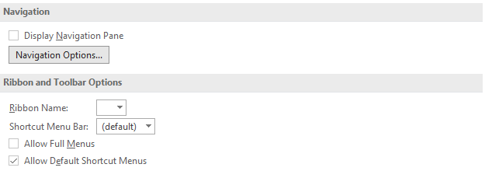

This prevents user to view or edit the raw application

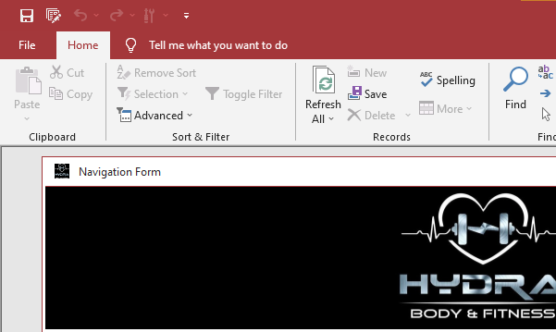

No tables are visible

Form can’t be viewed in design view

**Words: 1030**

**Bibliography**

***DateDiff function*. (n.d.). Microsoft Support.** [**https://support.microsoft.com/en-us/office/datediff-function-e6dd7ee6-3d01-4531-905c-e24fc238f85f**](https://support.microsoft.com/en-us/office/datediff-function-e6dd7ee6-3d01-4531-905c-e24fc238f85f)

***DateDiff function*. (n.d.). Microsoft Support.** [**https://support.microsoft.com/en-us/office/datediff-function-e6dd7ee6-3d01-4531-905c-e24fc238f85f**](https://support.microsoft.com/en-us/office/datediff-function-e6dd7ee6-3d01-4531-905c-e24fc238f85f)

***How to use Microsoft Access - Beginner Tutorial*. (2021, February 25). YouTube.** [**https://www.youtube.com/watch?v=ubmwp8kbfPc**](https://www.youtube.com/watch?v=ubmwp8kbfPc)

**(n.d.). YouTube.** [**https://www.youtube.com/watch?v=jvzpK7BcSGI**](https://www.youtube.com/watch?v=jvzpK7BcSGI)