Name:- Atharva R. Karkar

Class:- MCA(DS)

Subject:- DBMS

**Assignment - 01**

* **Workers Table :-**

create table worker(worker_id int(5) PRIMARY KEY, first_name varchar(10), last_name varchar(10), salary int(10), joining_date datetime, department varchar(10));

insert into worker values(001,"Monika","Arora",100000,2014-02-20,"HR"), (002,"Niharika","Verma",80000,2014-06-11,"Admin"), (003,"Vishal","Singhal",300000,2014-02-20,"HR"), (004,"Amithabh","Singh",500000,2014-02-20,"Admin"), (005,"Vivek","Bhati",500000,2014-06-11,"Admin"), (006,"Vipul","Diwan",200000,2014-06-11,"Account"), (007,"Satish","Kumar",75000,2014-01-20,"Account"), (008,"Geeteka","Chauhan",90000,2014-04-11,"Admin");

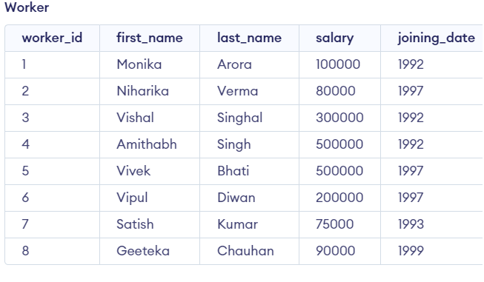

* **BONUS Table :-**

CREATE TABLE Bonus ( WORKER_REF_ID INT(5), BONUS_AMOUNT INT(10), BONUS_DATE DATETIME, FOREIGN KEY (WORKER_REF_ID) REFERENCES Worker(WORKER_ID) );

INSERT INTO Bonus (WORKER_REF_ID, BONUS_AMOUNT, BONUS_DATE) VALUES (001, 5000, '15-04-20'), (002, 3000, '15-08-11'), (003, 4000, '15-04-20'), (001, 4500, '15-04-20'), (002, 3500, '15-08-11');

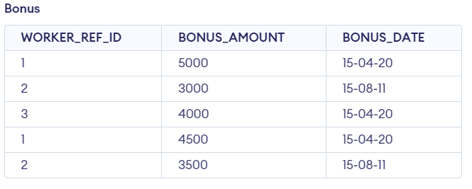

**TITLE :-**

CREATE TABLE Title ( WORKER_REF_ID INT, WORKER_TITLE CHAR(25), AFFECTED_FROM DATETIME, FOREIGN KEY (WORKER_REF_ID) REFERENCES Worker(WORKER_ID) );

INSERT INTO Title (WORKER_REF_ID, WORKER_TITLE, AFFECTED_FROM) VALUES (001, 'Manager', '2016-02-20 00:00:00'), (002, 'Executive', '2016-06-11 00:00:00'), (008, 'Executive', '2016-06-11 00:00:00'), (005, 'Manager', '2016-06-11 00:00:00'), (004, 'Asst. Manager', '2016-06-11 00:00:00'), (007, 'Executive', '2016-06-11 00:00:00'), (006, 'Lead', '2016-06-11 00:00:00'), (003, 'Lead', '2016-06-11 00:00:00');

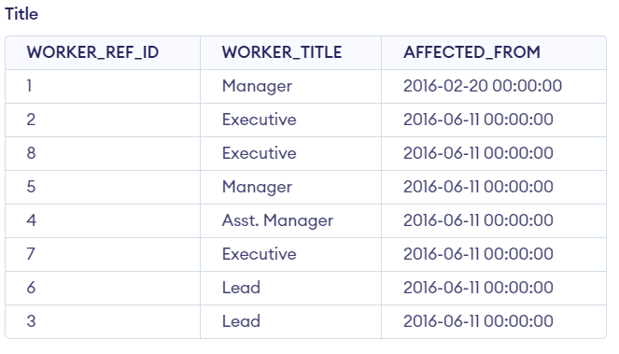

**Q.1 Write an SQL query for fetching “FIRST_NAME” from the WORKER table using as alias.**

Select FIRST_NAME AS WORKER_NAME from Worker;

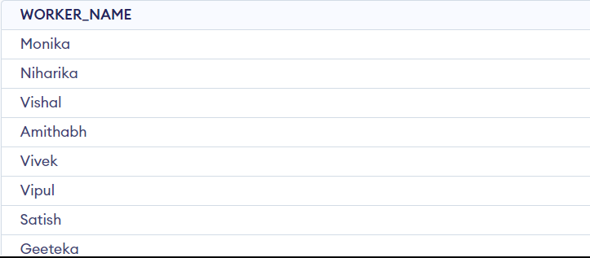

**Q.2 What is an SQL Query for fetching the “FIRST_NAME” from WORKER table in upper case?**

Select upper(FIRST_NAME) from Worker;

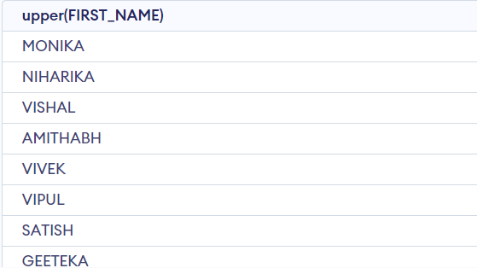

**Q.3 What is an SQL query for fetching the unique values of the column DEPARTMENT from the WORKER table?**

Select distinct DEPARTMENT from Worker;

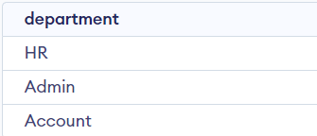

**Q.4 Write an SQL query for printing the first three characters of the column FIRST_NAME.**

Select substring(FIRST_NAME,1,3) from Worker;

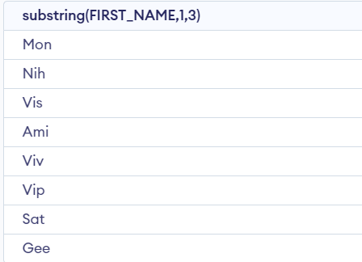

**Q.5 What is an SQL query for finding the position of the alphabet (‘A’) in the FIRST_NAME column of Amitabh?**

Select INSTR(FIRST_NAME, ‘a’) from Worker where FIRST_NAME = 'Amitabh';

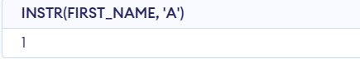

**Q.6 What is an SQL Query for printing the FIRST_NAME from Worker Table after the removal of white spaces from right side.**

Select RTRIM(FIRST_NAME) from Worker;

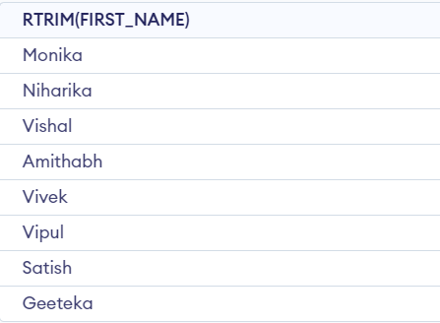

**Q.7 Write an SQL Query for printing the DEPARTMENT from Worker Table after the removal of white spaces from the left side.**

Select LTRIM(DEPARTMENT) from Worker;

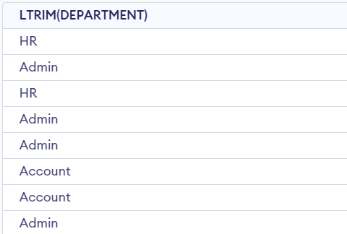

**Q.8 What is an SQL query for fetching the unique values from the DEPARTMENT column and thus printing is the length?**

Select distinct length(DEPARTMENT) from Worker;

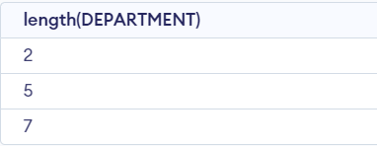

**Q.9 Write an SQL query for printing the FIRST_NAME after replacing ‘A’ with ‘a’.**

Select REPLACE(FIRST_NAME,'a','A') from Worker;

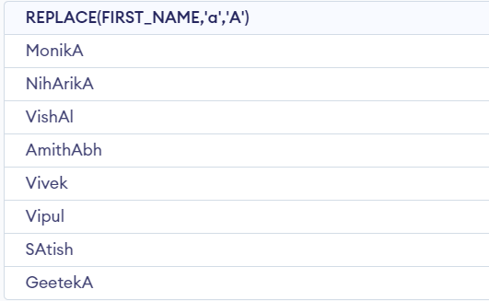

**Q.10 What is an SQL query for printing the FIRST_NAME and LAST_NAME into a column named COMPLETE_NAME? (A space char should be used)**

Select CONCAT(FIRST_NAME, ' ', LAST_NAME) AS 'COMPLETE_NAME' from Worker;

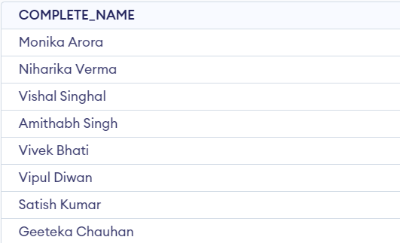

**Q.11 What is an SQL query for printing all details of the worker table which ordered by FIRST_NAME ascending?**

Select * from Worker order by FIRST_NAME asc;

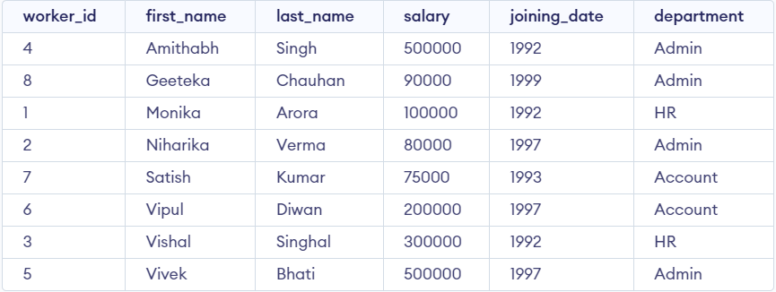

**Q.12 Write an SQL query for printing the all details of the worker table which ordered by FIRST_NAME ascending and the DEPARTMENT in descending**

Select * from Worker order by FIRST_NAME ASC , DEPARTMENT DESC;

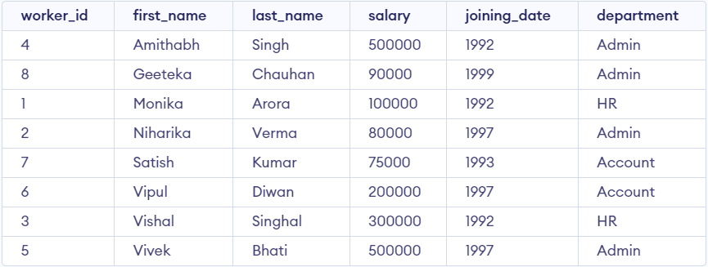

**Q.13 What is an SQL query to print the details of the workers ‘NIHARIKA’ and ‘PRIYANSHA’.**

Select * from Worker where FIRST_NAME in ('NIHARIKA','PRIYANSHA');



**Q.15 Write an SQL query for printing the details of DEPARTMENT name as “Admin”.**

Select * from Worker where DEPARTMENT like 'Admin%';

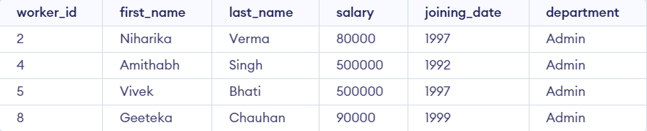

**Q.16 What is an SQL query for printing the details of workers whose FIRST_NAME Contains ‘A’?**

Select * from Worker where FIRST_NAME like '%a%';

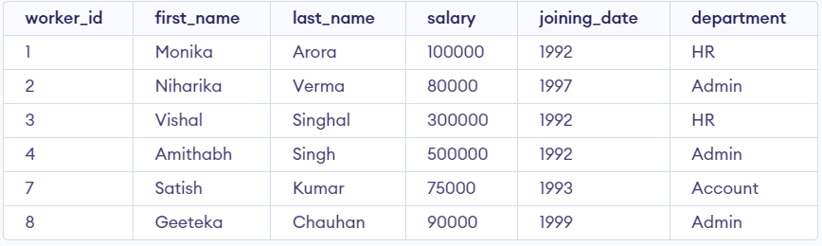

**Q.17 What is an SQL Query for printing the FIRST_NAME of workers whose name ends with ‘A’?**

Select * from Worker where FIRST_NAME like '%a';

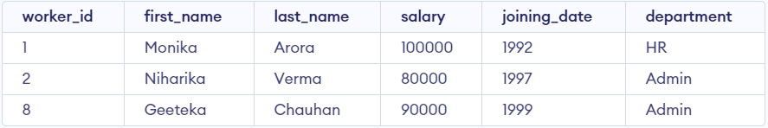

**Q.18 What is an SQL Query for printing the details of the workers whose FIRST_NAME ends with ‘H’ and contains six alphabets?**

Select * from Worker where FIRST_NAME like '_____h';



**Q.19 Write an SQL Query for printing the details of workers whose SALARY lies between 100000 and 500000.**

Select * from Worker where SALARY between 100000 and 500000;

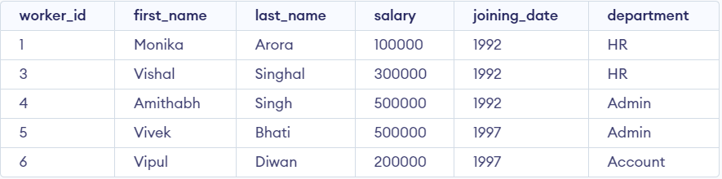

**Q.20 Write an SQL Query for printing the details of workers who joined inFeb’2014**

Select * from Worker where year(JOINING_DATE) = 2014 and month(JOINING_DATE) = 2;

**Q.21 Write an SQL Query for fetching the count of workers in DEOARTMENT with ‘Admin’.**

SELECT COUNT(*) FROM worker WHERE DEPARTMENT = 'Admin';

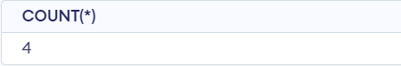

**Q.22 Write an SQL Query for fetching the details of workers with Salaries >= 5000 and <= 100000.**

SELECT CONCAT(FIRST_NAME, ' ', LAST_NAME) As Worker_Name, Salary FROM worker WHERE WORKER_ID IN (SELECT WORKER_ID FROM worker WHERE Salary BETWEEN 5000 AND 100000);

Or

SELECT FIRST_NAME || ' ' || LAST_NAME AS Worker_Name, SalaryFROM workerWHERE WORKER_IDIN (SELECT WORKER_ID FROM workerWHERE Salary BETWEEN 5000 AND 100000);

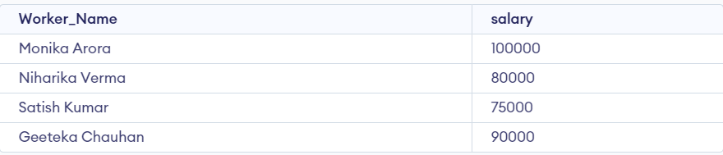

**Q.23 What is an SQL Query for fetching the no. of workers in each department in descending order?**

SELECT DEPARTMENT, count(WORKER_ID) No_Of_Workers FROM worker GROUP BY DEPARTMENT ORDER BY No_Of_Workers DESC;

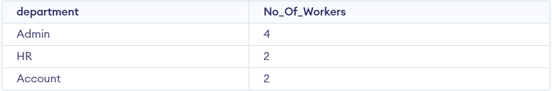

**Q.24 What is an SQL Query for printing the details of workers who are also managers?**

SELECT DISTINCT W.FIRST_NAME, T.WORKER_TITLE FROM Worker W INNER JOIN Title T ON W.WORKER_ID = T.WORKER_REF_ID AND T.WORKER_TITLE in ('Manager');

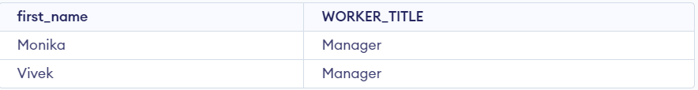

**Q.25 Write an SQL Query for fetching the details of duplicate records in some fields.**

SELECT WORKER_TITLE, AFFECTED_FROM, COUNT(*) FROM Title GROUP BY WORKER_TITLE, AFFECTED_FROM HAVING COUNT(*) > 1;

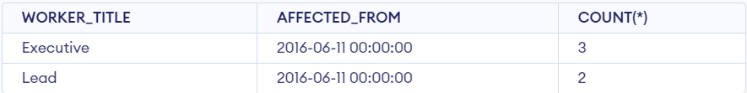

**Q.26 What is an SQL Query for only showing odd rows?**

SELECT * FROM Worker WHERE MOD (WORKER_ID, 2) <> 0;

Or

SELECT * FROM Worker WHERE WORKER_ID % 2 <> 0;

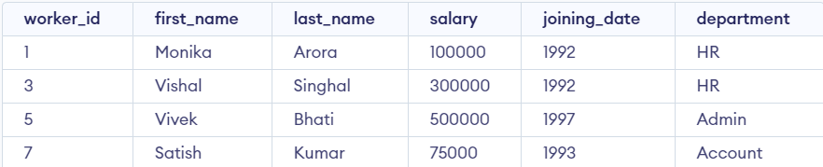

**Q.27 What is an SQL Query for only showing even rows?**

SELECT * FROM Worker WHERE MOD (WORKER_ID, 2) = 0;

Or

SELECT * FROM Worker WHERE WORKER_ID % 2 = 0;

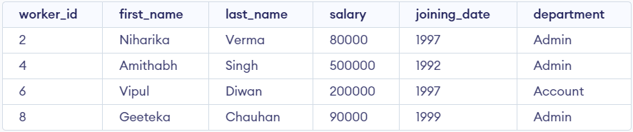

**Q.28 Write an SQL query to clone a new table from another table.**

CREATE TABLE WorkerClone AS SELECT * FROM Worker;

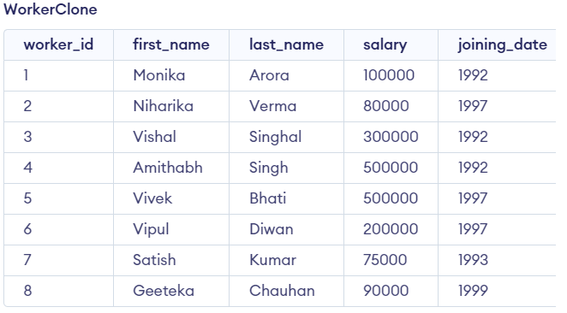

**Q.29 Write an SQL query to fetch intersecting records of two tables.**

SELECT worker_id FROM worker INTERSECT SELECT worker_ref_id FROM Bonus;

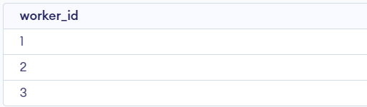

**Q.30 Write an SQL query to show records from one table that another table does not have.**

select * from worker where worker_id not in(select worker_ref_id from Bonus);

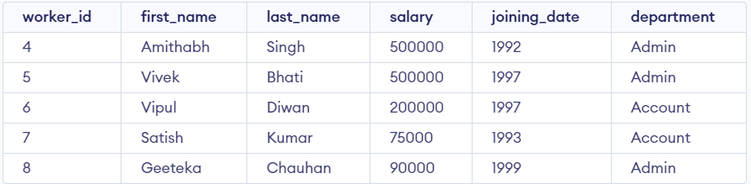

**Q.31 Write an sql query to show the current date and time.**

SELECT current_timestamp;



**Q.32 Write an sql query to show the top n (say 5) records of a table.**

SELECT worker_id, first_name FROM Worker LIMIT 5;

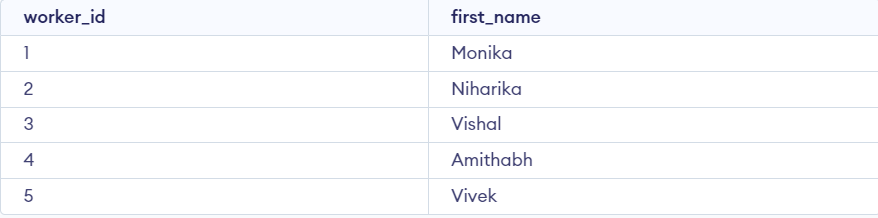

**Q.33. Write an sql query to determine the nth (say n=5) highest salary from a table.**

SELECT DISTINCT Salary FROM worker ORDER BY Salary DESC LIMIT 1 OFFSET 5-1;



**Q 34. Write an sql query to determine the 5th highest salary without using TOP or limit method.**

SELECT * FROM ( SELECT first_name, salary, DENSE_RANK() OVER (ORDER BY salary DESC) AS n FROM Worker ) AS subquery WHERE n = 5;



**Q 35. Write an sql query to fetch the list of employees with the same salary**

Select distinct W.worker_id, W.first_name, W.salary from Worker W, Worker W1 where W.salary = W1.salary and W.worker_id != W1.worker_id;

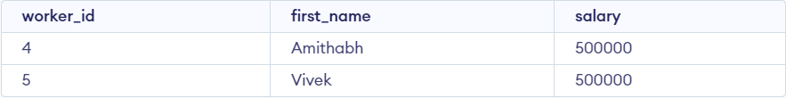

**Q. 36 Write an sql query to show the second highest salary from a table**

select * from Worker ORDER BY `salary` DESC limit 1,1;



**Q 37. Write an sql query to show one row twice in the results from a table**

select * from Worker as wid1 where wid1.department = "Admin" union all select * from Worker as wid2 where wid2.department = "Account"

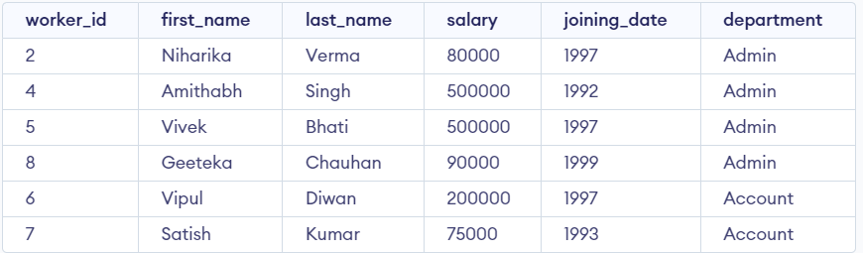

**Q 38. Write an sql query to fetch intersecting records of two tables.**

SELECT Worker.worker_id, Worker.first_name FROM Worker INNER JOIN Bonus ON Worker.worker_id = Bonus.worker_ref_id;

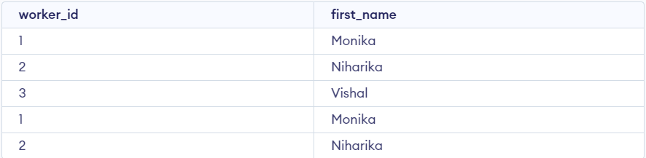

**Q 39. Write an sql query to fetch the first 50% records from a table.**

SELECT * FROM worker LIMIT (SELECT COUNT(*) FROM worker) / 2;

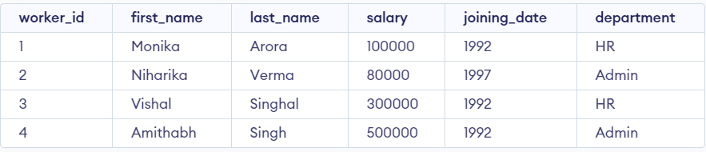

**Q 40. Write an sql query to fetch the departments that have less than five people in them**

select department, count(worker_id) as total_worker from Worker group by department having count(worker_id)>1;

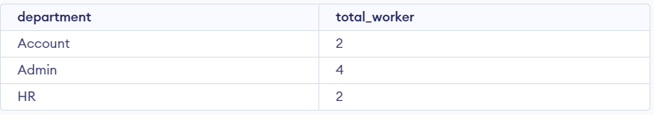

**Q.41. Write an SQL query to show all departments along with the number of people in there.**

SELECT worker_title, COUNT(*) AS NumberOfPeople FROM Title GROUP BY worker_title;

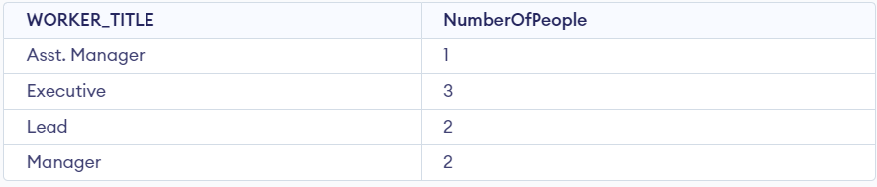

**Q-42. Write an SQL query to show the last record from a table.**

SELECT * FROM Worker ORDER BY worker_id DESC

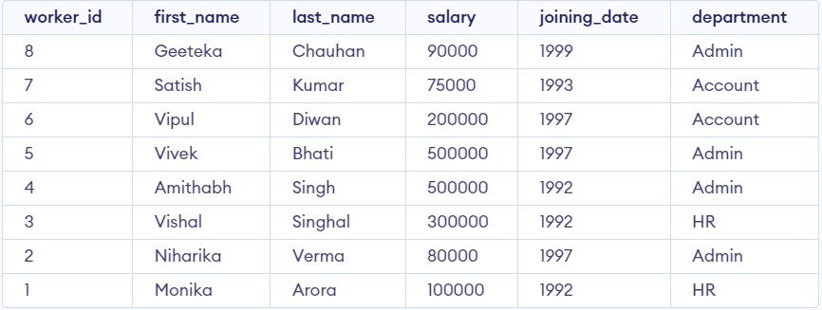

**Q-43. Write an SQL query to fetch the first row of a table.**

SELECT * FROM worker LIMIT 1;



**Q-44. Write an SQL query to fetch the last five records from a table.**

SELECT * FROM Worker ORDER BY worker_id DESC LIMIT 5;

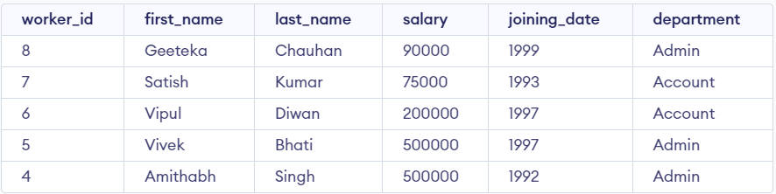

**Q-45. Write an SQL query to print the name of employees having the highest salary in each department.**

select first_name, worker_title, max(salary) from worker, title where title.worker_ref_id = worker.worker_id group by worker_title;

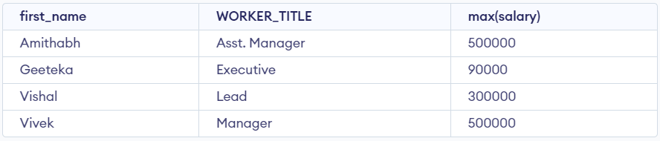

**Q-46. Write an SQL query to fetch three max salaries from a table.**

SELECT salary FROM Worker ORDER BY salary DESC limit 3;

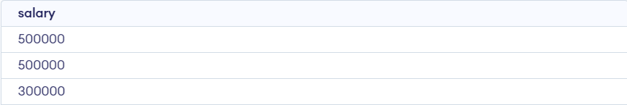

**Q-47. Write an SQL query to fetch three min salaries from a table.**

SELECT DISTINCT salary FROM Worker ORDER BY salary DESC Limit 3;

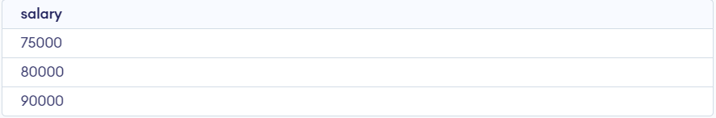

**Q-48. Write an SQL query to fetch nth max salaries from a table.**

SELECT salary FROM Worker ORDER BY salary

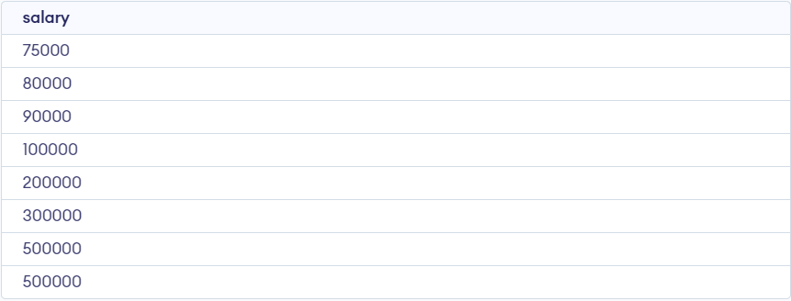

**Q-49. Write an SQL query to fetch departments along with the total salaries paid for each of them.**

select worker_title , total(salary) from title, worker where title.worker_ref_id = worker.worker_id group by worker_title;

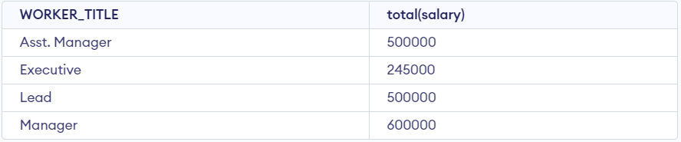

**Q-50. Write an SQL query to fetch the names of workers who earn the highest salary.**

SELECT first_name FROM worker WHERE salary = (SELECT MAX(salary) FROM worker)

