Name: Atharva Ratnakar Karkar

Roll number:08

Class : MCA(DS) SEM-1

Subject: DBMS

INTERNAL ASSIGNMENT (2-7)

Assignment 5 :

Q 5.1) **a. Create a table and get alternative odd records from it**

Ans : -- Create a sample table

CREATE TABLE odd_table (

id INT,

data VARCHAR(50)

);

-- Insert some sample data

INSERT INTO odd_table (id, data)

VALUES

(1, 'Record 1'),

(2, 'Record 2'),

(3, 'Record 3'),

(4, 'Record 4'),

(5, 'Record 5');

-- Retrieve odd records

SELECT * FROM odd_table WHERE id % 2 = 1;

Output :

Q 5.2) Create a table and get alternative even records from it

Ans -- Create a sample table

CREATE TABLE even_table (

id INT,

data VARCHAR(50)

);

-- Insert sample data all at once

INSERT INTO even_table (id, data)

VALUES

(1, 'Record 1'),

(2, 'Record 2'),

(3, 'Record 3'),

(4, 'Record 4'),

(5, 'Record 5'),

(6, 'Record 6'),

(7, 'Record 7'),

(8, 'Record 8'),

-- Retrieve alternative even records

SELECT * FROM even_table WHERE id % 2 = 0;

Output :

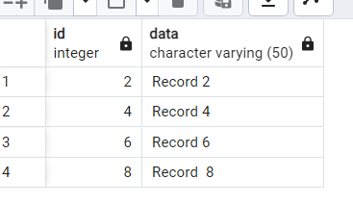

Q 5.3) Retrieve common records from 2 tables

Ans :

SELECT id, data FROM odd_table

INTERSECT

SELECT id, data FROM even_table;

Output :

