Dr D.Y. Patil School of Science and Technology

Tathawade, Pimpri-Chinchwad, Maharashtra - 411033

SOFTWARE DESIGN METHODOLOGY

Student Name | Atharva Kesare
Roll Number | BTCSD19
Class | Computer Science and Design – 3rd Year
Subject | Software Design Methodology
Professor | Prof. Nilkanth Deshpande
Academic Year | 2025 – 2026

INDEX

Sr. No. | Title | Page No.
1 | Software Requirements Specification (SRS) | 3
1.1 | Introduction & Purpose | 3
1.2 | Scope | 3
1.3 | Functional Requirements | 3
1.4 | Non-Functional Requirements | 4
1.5 | Assumptions | 4
2 | Use Case Model | 5
2.1 | Actors & Use Cases | 5
2.2 | Use Case Diagram | 5
3 | Domain Model & Class Diagram | 6
3.1 | Conceptual Classes & Relationships | 6
3.2 | Domain Model Diagram | 6
3.3 | Class Diagram | 6
4 | Interaction Diagrams | 7
4.1 | Sequence Diagram | 7
4.2 | Collaboration Diagram | 7
5 | State Chart & Activity Diagrams | 8
5.1 | State Chart – Exam Session Lifecycle | 8
5.2 | Activity Diagram – Proctoring and Exam Flow | 8
6 | Implementation | 9
6.1 | Technologies Used | 9
6.2 | Sample Code Snippets | 9

6.3 | Module Descriptions | 10
7 | Testing | 11
7.1 | Test Cases | 11
8 | Design Patterns | 12
8.1 | Three-Tier Architecture | 12
8.2 | Singleton Pattern | 12

- SOFTWARE REQUIREMENTS SPECIFICATION (SRS)

Introduction
The Cipher Proctored Coding Exam Platform is a web-based application that enables educational institutions to conduct secure online programming examinations with integrated anti- cheating measures.

Purpose of the System
    - Provide a secure coding environment for students to take programming exams remotely.
    - Enable real-time proctoring through browser-level enforcement mechanisms.
    - Support multiple programming languages with isolated code execution.
    - Prevent academic dishonesty through tab-switching detection and fullscreen enforcement.

Scope
The system covers three primary user roles: Student, Teacher/Admin, and System. It includes modules for user authentication, exam creation and management, code editor interface, proctoring engine, code execution service, and result management.

Functional Requirements

FR-ID | Requirement Description | Priority
FR-01 | User Registration & Login with JWT authentication | High
FR-02 | Exam creation with configurable duration and questions | High
FR-03 | Multi-language code editor with syntax highlighting | High
FR-04 | Fullscreen enforcement and violation detection | High
FR-05 | Tab switching detection and auto- logging | High
FR-06 | Navigation/back-button trapping | High
FR-07 | Secure code execution in isolated environment | High
FR-08 | Real-time instructor monitoring dashboard | Medium

FR-09 | Manual grading interface for teachers | Medium
FR-10 | Auto-submit on violation threshold exceeded | Medium

  - Non-Functional Requirements
    - Performance: System shall handle 100 concurrent exam sessions with response time < 2 seconds.
    - Security: All communications over HTTPS; passwords hashed using bcrypt; code execution sandboxed.
    - Availability: System uptime of 99.5% during exam periods.
    - Scalability: Three-tier architecture supporting horizontal scaling.

Assumptions
    - Users have access to a modern web browser with stable internet.
    - Students have basic understanding of programming concepts.
    - Instructors are pre-registered and authenticated by system admin.

USE CASE MODEL

Actors
    - Student: Takes programming exams, writes code, submits solutions, views results.
    - Teacher/Instructor: Creates exams, monitors live sessions, grades submissions.
    - Admin: Manages user accounts, configures system settings.
    - System: Handles proctoring enforcement, code execution, session management.

Use Cases

UC-ID | Use Case Name | Actor(s) | Description
UC-01 | Register / Login | Student, Teacher | User creates account or logs in.
UC-02 | Join Exam | Student | Enter join code and access exam.
UC-03 | Write & Submit Code | Student | Write code in editor and submit.
UC-04 | Run Code | Student | Execute code and view output.
UC-05 | Create Exam | Teacher | Configure exam settings and questions.
UC-06 | Monitor Session | Teacher | View live student status.
UC-07 | Grade Submission | Teacher | Manually review and assign scores.
UC-08 | Detect Violations | System | Track tab switches, fullscreen exits.
UC-09 | Auto-submit Exam | System | Force submit on violation threshold.

  - Use Case Diagram

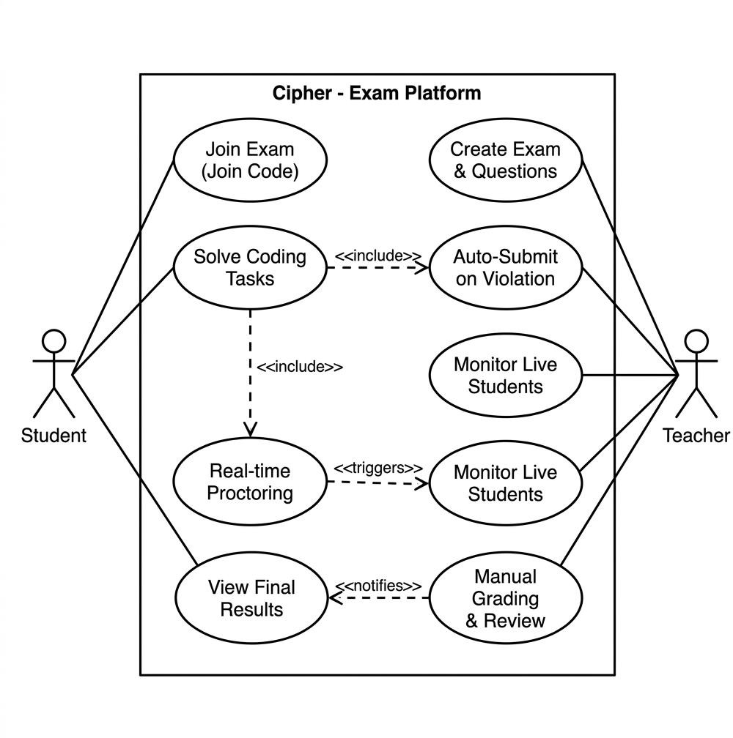

Figure 2.1: Use Case Diagram – Cipher Proctored Exam System

DOMAIN MODEL & CLASS DIAGRAM

Conceptual Classes
User: Represents any system user (Student, Teacher, Admin). Attributes: userID, name, email, password (encrypted), role.
    - Student: Extends User. Enrolls in exams, takes sessions, submits code.
    - Teacher: Extends User. Creates exams, monitors sessions, grades submissions.
Exam: Core entity representing a programming examination. Attributes: examID, title, subject, duration, warningLimit, joinCode.
ExamSession: Tracks student-exam interaction. Attributes: sessionID, studentID, examID, startTime, endTime, status, violationCount, score.
Submission: Code submitted by student. Attributes: submissionID, sessionID, questionID, code, language, output.
ProctorLog: Records behavioral violations. Attributes: logID, sessionID, violationType, timestamp.

Relationships
    - User creates Exams (1..* association for Teachers)
    - Exam contains Questions (1..* composition)
    - Student enrolls in Exams (*..* association)
    - ExamSession links Student and Exam (1..1 association)
    - ExamSession records ProctorLogs (1..* aggregation)

Domain Model Diagram

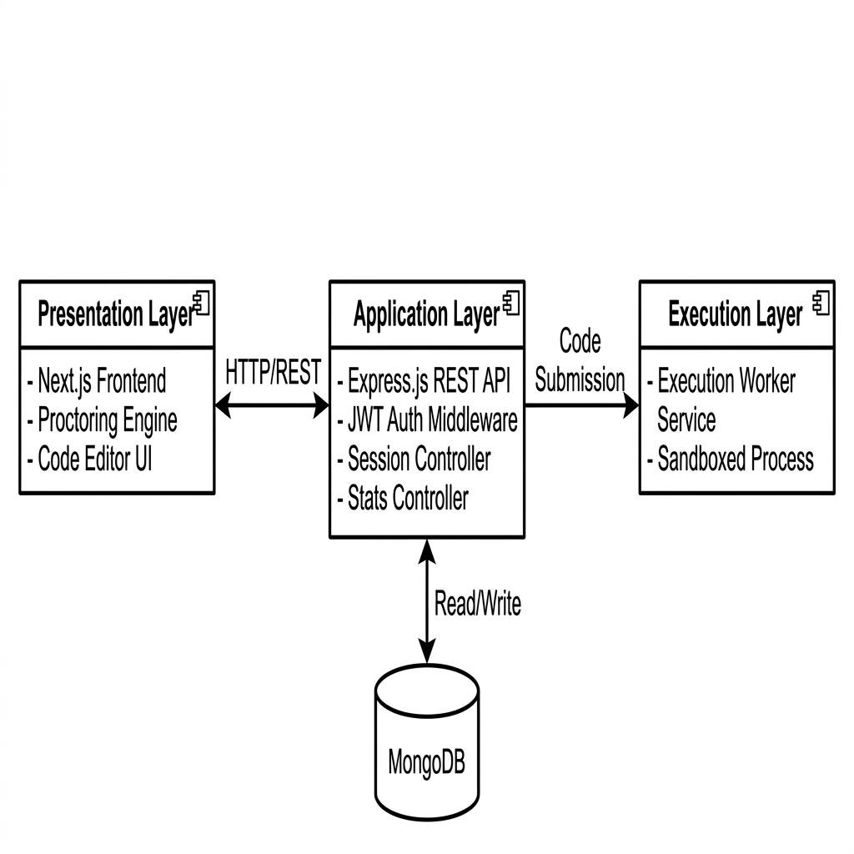
Figure 3.1: Domain Model – Three-Tier Architecture

Class Diagram

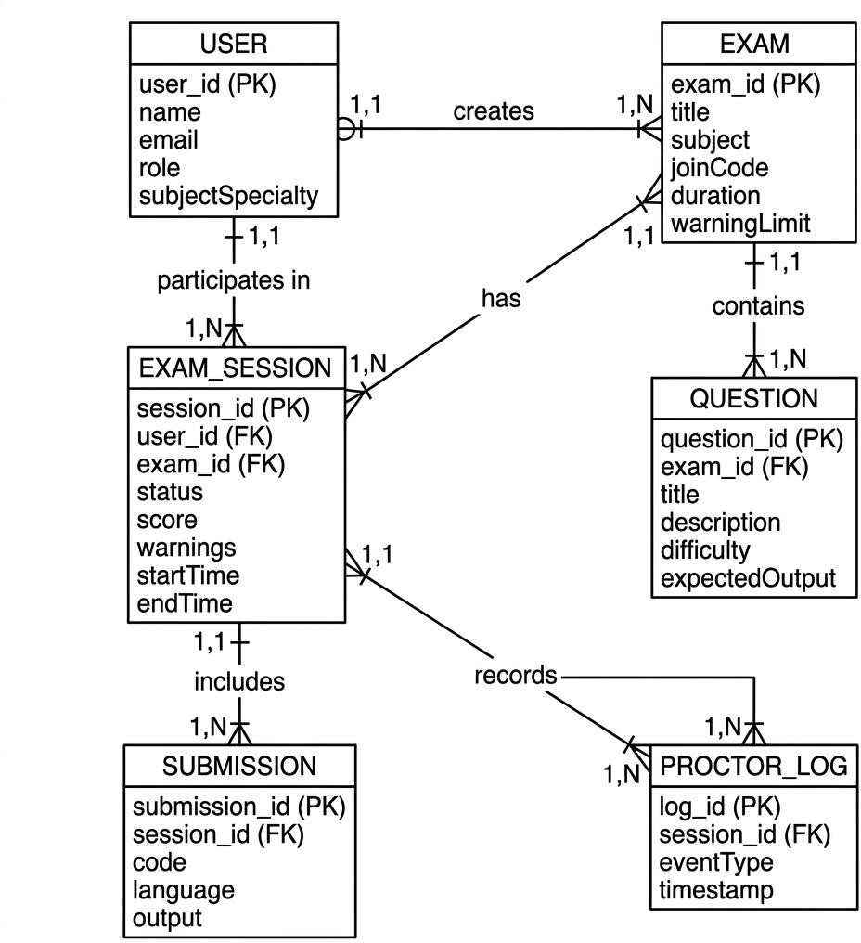
Figure 3.2: Class Diagram – Entity Relationships

INTERACTION DIAGRAMS

Sequence Diagram – Auto-Submit on Violation
The following sequence describes the message flow when a student violates exam policies and the system auto-submits the exam:
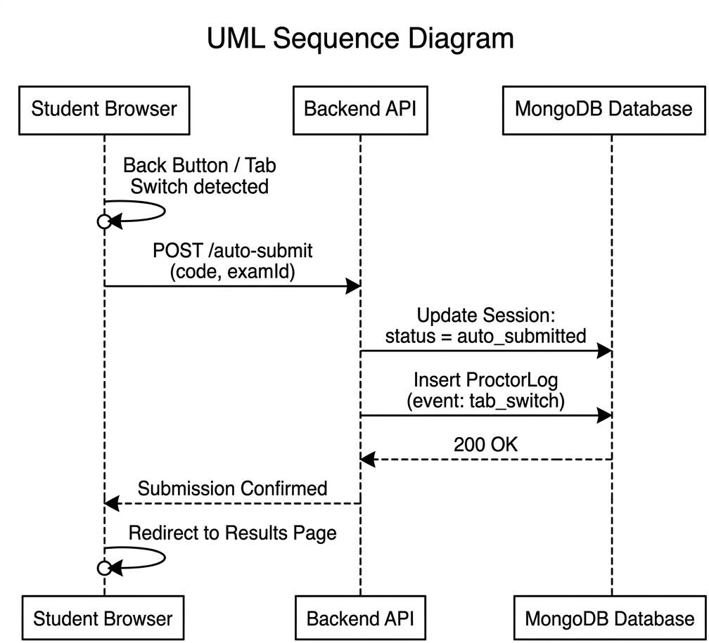

Figure 4.1: Sequence Diagram – Auto-Submit on Violation

Collaboration Diagram – Proctoring and Violation Handling
The collaboration diagram illustrates the structural relationships between objects involved in proctoring:
    - ProctoringEngine ↔ ExamSession: Monitors and logs violations.

    - ExamSession ↔ Student: Represents active student connection.
    - ProctoringEngine ↔ NotificationService: Sends alerts on violations.
    - ExamSession ↔ SubmissionService: Triggers auto-submit on threshold breach.

STATE CHART & ACTIVITY DIAGRAMS

State Chart – Exam Session Lifecycle

State | Triggered By | Description
not_started | Student enrolls | Exam assigned but session not initiated.
in_progress | Student starts exam | Active examination; proctoring enabled.
submitted | Student manually submits | Normal completion; awaiting grading.
auto_submitted | Violation threshold exceeded | Forced submission due to violation.
terminated | Teacher ends session | Session ended by external action.
graded | Teacher assigns score | Grading complete; results visible.

Figure 5.1: State Chart Diagram – Exam Session Lifecycle

Activity Diagram – Proctoring and Exam Flow
The activity diagram depicts the workflow from exam start to completion.
Figure 5.2: Activity Diagram – Proctoring and Exam Flow

IMPLEMENTATION

Technologies Used

Layer | Technology / Tool | Purpose
Frontend | Next.js + React + Tailwind CSS | Server-side rendering, responsive UI
Backend API | Node.js + Express.js | RESTful API server
Database | MongoDB (NoSQL) | Flexible schemas for exams
Authentication | JWT + bcrypt | Secure login and sessions
Code Execution | Docker + Python/Node sandbox | Isolated code execution
Real-time | WebSocket / Polling | Live monitoring dashboard
Editor | Monaco Editor (VS Code) | Syntax highlighting

  - Sample Code Snippets
Snippet 1: Fullscreen Enforcement (JavaScript / React)
useEffect(() => {
const handleFullscreenChange = () => { if (!document.fullscreenElement) {
violationCount++;
if (violationCount >= warningLimit) { autoSubmitExam();
}
}
};
document.addEventListener('fullscreenchange', handleFullscreenChange); return () => document.removeEventListener('fullscreenchange',
handleFullscreenChange);
}, []);

Snippet 2: Violation Logging (Node.js / Express)
router.post('/violations', async (req, res) => { const { sessionId, violationType } = req.body;
const log = new ProctorLog({ session: sessionId, type: violationType }); await log.save();

const session = await ExamSession.findById(sessionId); session.violationCount += 1;

if (session.violationCount >= session.warningLimit) { session.status = 'auto_submitted';

await autoSubmit(session);
}
await session.save();
res.json({ warningIssued: true });
});

Module Descriptions
    - Auth Module: User registration, login, JWT token generation.
    - Exam Module: Exam creation, session management, lifecycle.
    - Proctoring Module: Fullscreen enforcement, tab monitoring.
    - Code Execution Module: Docker-based code sandbox.
    - Grading Module: Manual review interface for instructors.

TESTING

Test Cases
Functional test cases for the Cipher Proctored Exam System:

TC-ID | Test Description | Input | Expected | Actual | Status
TC-01 | User Registration | Enter details, click Register | Account created | Pass | Pass
TC-02 | Login valid credentials | Enter email & password | User logged in | Pass | Pass
TC-03 | Login invalid password | Enter wrong password | Error displayed | Pass | Pass
TC-04 | Create exam | Fill title, duration, questions | Exam created | Pass | Pass
TC-05 | Join exam | Enter join code | Interface loaded | Pass | Pass
TC-06 | Fullscreen enforcement | Exit fullscreen | Warning issued | Pass | Pass
TC-07 | Tab switch detection | Switch tab | Violation logged | Pass | Pass
TC-08 | Auto-submit | Exceed warning limit | Auto-submit triggered | Pass | Pass

DESIGN PATTERNS

Three-Tier Architecture Pattern
The Cipher platform implements a three-tier architectural model separating presentation, business logic, and execution layers.
    - Security: Code execution isolation prevents malicious code from affecting the API or database.
    - Scalability: Each tier can be scaled independently based on load.
    - Maintainability: Changes in UI do not require backend modifications.

Tier | Responsibility
Presentation Layer | Next.js frontend, proctoring engine, code editor UI
Application Layer | Node.js/Express API, authentication, session management
Execution Layer | Docker-based code execution worker, isolated sandbox

Singleton Pattern
The Singleton pattern ensures only one instance throughout the application lifecycle.
    - Database Connection: Single MongoDB connection instance shared across modules.
    - Code Execution Worker Pool: Managed pool of sandbox containers.
    - WebSocket Manager: Single instance handling real-time dashboard updates.

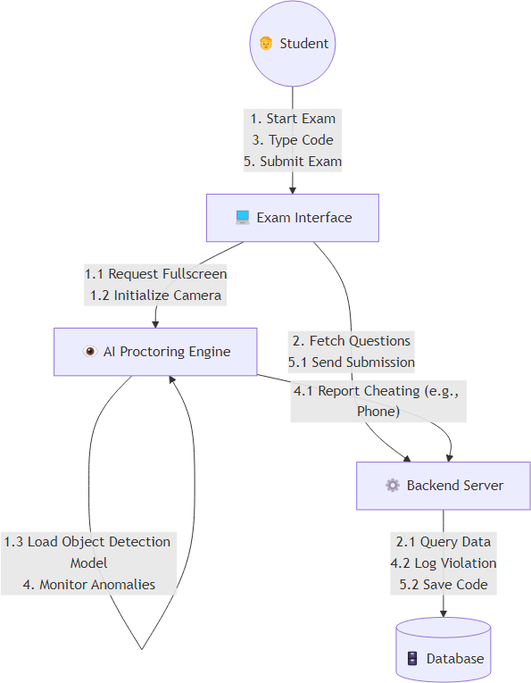

Figure 4.2: Collaboration Diagram – Proctoring and Violation Handling
