2> copy history of linux machine in file at every hour and then that file copy to specific s3 bucket

🡪Step1:- launch instance

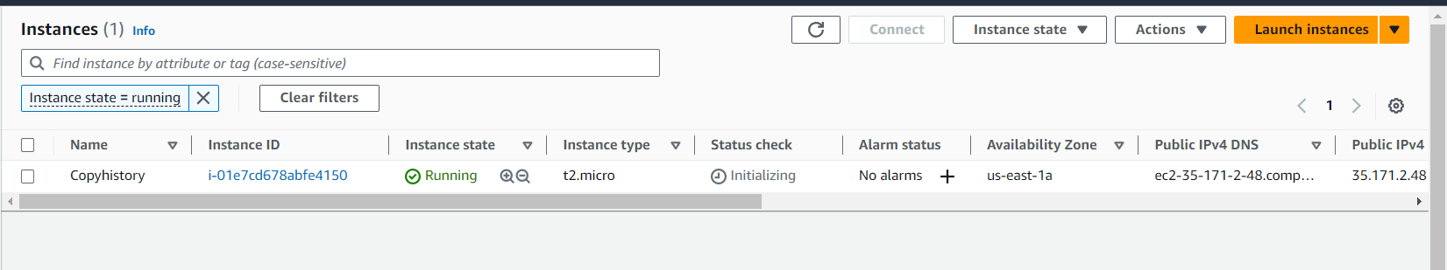

Step2:- take access of it via ssh and thn crate script.

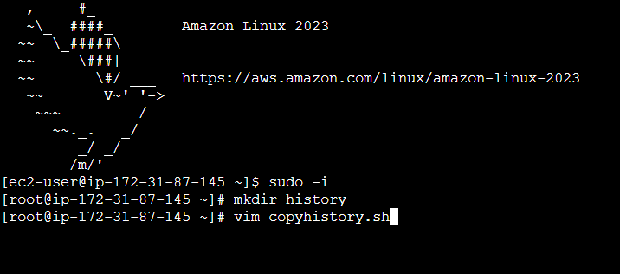

Step 3:- in that crated .sh file please copy and paste below script. And make changes according to you. Like s3 bucket name. and after that give 555 permission to this .sh file chmod 555 copyhistory.sh.

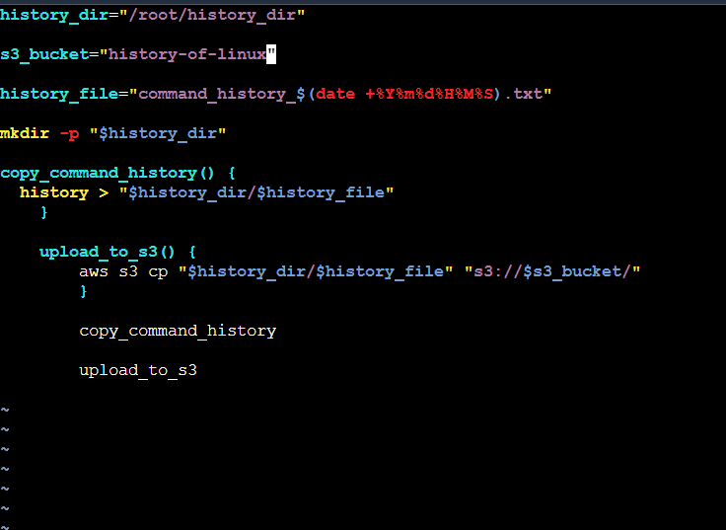

history_dir="/root/history_dir"

s3_bucket="history-of-linux"

history_file="command_history_$(date +%Y%m%d%H%M%S).txt"

mkdir -p "$history_dir"

copy_command_history() {

history > "$history_dir/$history_file"

}

upload_to_s3() {

aws s3 cp "$history_dir/$history_file" "s3://$s3_bucket/"

}

copy_command_history

upload_to_s3

Step 4:- now we have to apply s3 bucket role to it. Just shown like below pictures.

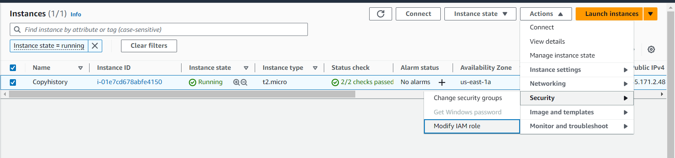

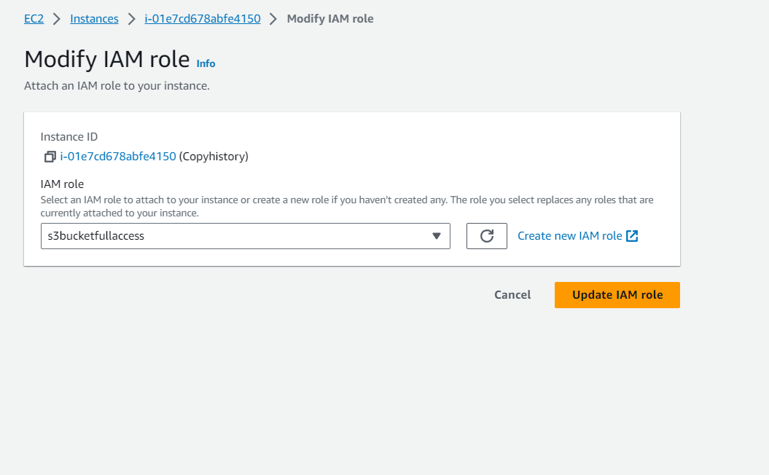

Step 5:- now we have to run this script every hour as per our question need so we have to setup crontab like shown in below picture.

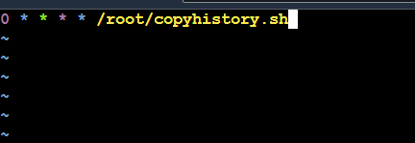

Step 6:- final output

