3> create a backup of rds mariadb database every 2nd and 4th Friday?

🡺

Step 1:- launch a instance.

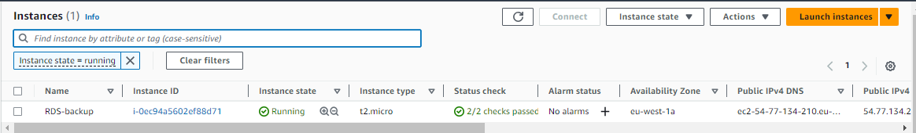

Step 2:- create rds databse so you have to get snapshot it on every 2nd and 4th Friday of each month. Now take access of instance via ssh. And create one .sh file and copy and paste below script. And make changes according to you like eplace with your RDS instance identifier and then aws region.

AWS region

RDS_INSTANCE_IDENTIFIER="my-database"

AWS_REGION="eu-west-1"

SNAPSHOT_IDENTIFIER="Snapshot-$(date +\%Y\%m\%d\%H\%M\%S)"

aws rds create-db-snapshot --db-instance-identifier "$RDS_INSTANCE_IDENTIFIER" --db-snapshot-identifier "$SNAPSHOT_IDENTIFIER" --region "$AWS_REGION"

# Print a message

echo "RDS snapshot created: $SNAPSHOT_IDENTIFIER"e I write following script.

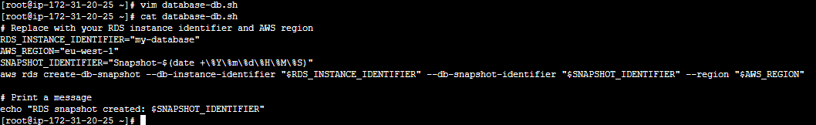

Step 3:-give 555 permission to that .sh file and then aws configure (configure that user which have appropriate access)

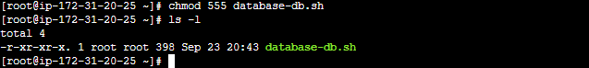

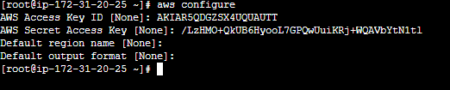

Step 4:- set a crontab job just shown like in below picture.

-