🧪 Virtual Lab Experiment – 8
🔄 Blue-Green Deployment using DevOps Tools

🎯 Objective
To implement Blue-Green Deployment strategy using:
- Jenkins
- Kubernetes
- Docker
- GitHub
- Terraform
- Ansible

🧠 Architecture: Blue-Green Deployment
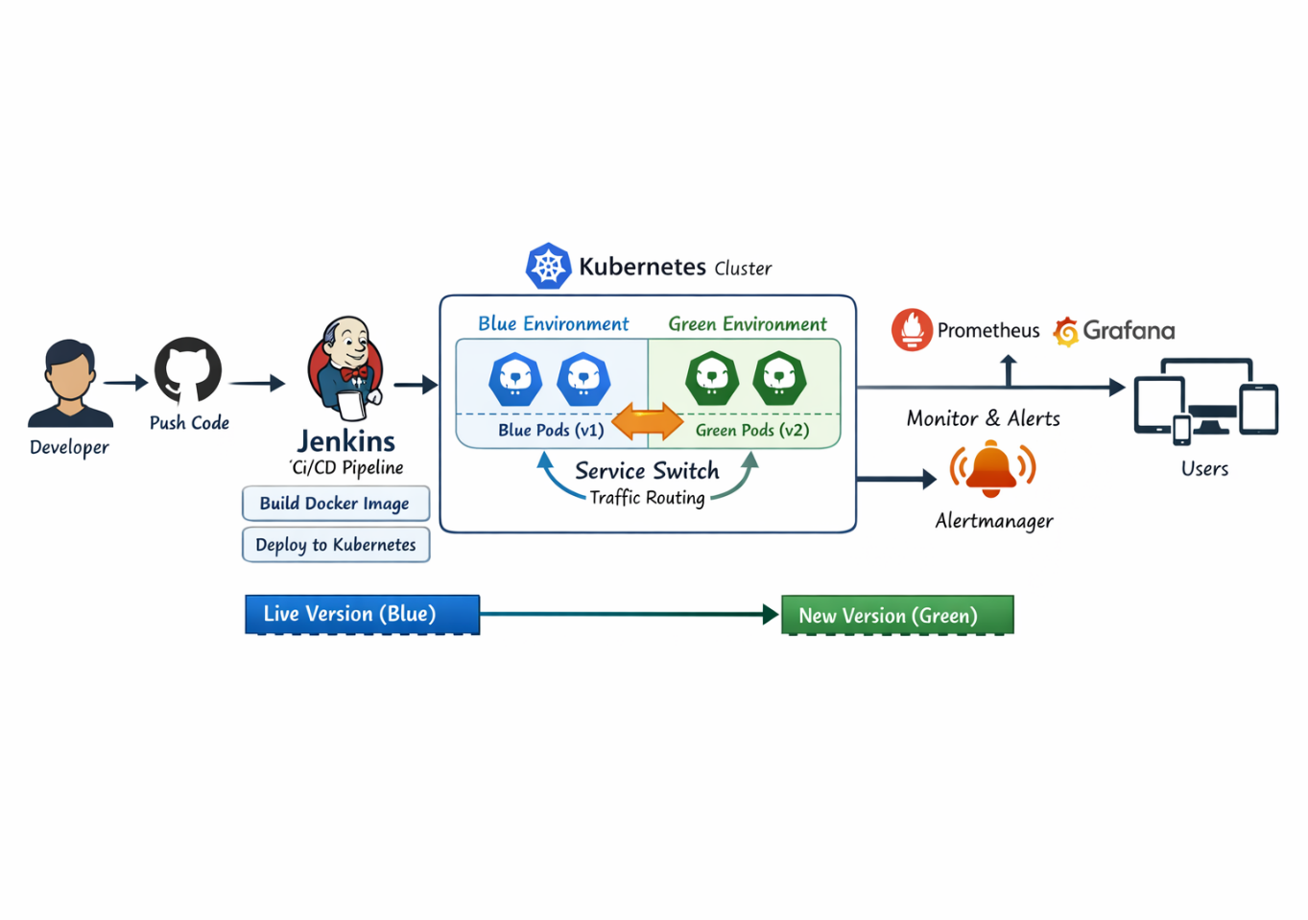
👉 Two identical environments:
- Blue → Current live version
- Green → New version
👉 Traffic is switched from Blue → Green after testing

🧰 Prerequisites
- AWS account
- Ubuntu EC2 instance
- Installed Docker, Jenkins, kubectl
- Kubernetes cluster (Minikube/EKS)

🪜 Step-by-Step Procedure

🔹 Step 1: Provision Infrastructure (Terraform)
Create main.tf:
provider "aws" {
region = "ap-south-1"
}

resource "aws_instance" "jenkins" {
ami = "ami-0abcdef12345"
instance_type = "t2.medium"
}
Run:
terraform init
terraform apply

🔹 Step 2: Configure Jenkins using Ansible
Create jenkins_setup.yml:
- hosts: all
become: yes
tasks:
- name: Install Docker
apt:
name: docker.io
state: present
Run:
ansible-playbook -i inventory.ini jenkins_setup.yml

🔹 Step 3: Prepare Application Code
- Clone repo from GitHub
- Create:
Dockerfile
FROM nginx
COPY . /usr/share/nginx/html

🔹 Step 4: Create Kubernetes Deployment Files
🔵 Blue Deployment
apiVersion: apps/v1
kind: Deployment
metadata:
name: myapp-blue
spec:
replicas: 2
selector:
matchLabels:
app: myapp
color: blue
template:
metadata:
labels:
app: myapp
color: blue
spec:
containers:
- name: myapp
image: myapp:v1

🟢 Green Deployment
apiVersion: apps/v1
kind: Deployment
metadata:
name: myapp-green
spec:
replicas: 2
selector:
matchLabels:
app: myapp
color: green
template:
metadata:
labels:
app: myapp
color: green
spec:
containers:
- name: myapp
image: myapp:v2

🔀 Service (Traffic Switch)
apiVersion: v1
kind: Service
metadata:
name: myapp-service
spec:
selector:
app: myapp
color: blue # Initially blue
ports:
- port: 80
targetPort: 80

🔹 Step 5: Deploy Blue Version
kubectl apply -f deployment-blue.yaml
kubectl apply -f service.yaml
👉 Application runs on Blue environment

🔹 Step 6: Deploy Green Version
kubectl apply -f deployment-green.yaml
👉 Green runs parallel (no traffic yet)

🔹 Step 7: Configure Jenkins Pipeline
Jenkinsfile:
pipeline {
agent any
stages {
stage('Build') {
steps {
sh 'docker build -t myapp:v2 .'
}
}
stage('Deploy Green') {
steps {
sh 'kubectl apply -f deployment-green.yaml'
}
}
stage('Switch Traffic') {
steps {
input "Switch to Green?"
sh '''
kubectl patch service myapp-service \
-p '{"spec":{"selector":{"app":"myapp","color":"green"}}}'
'''
}
}
}
}

🔹 Step 8: Switch Traffic (Blue → Green)
Manual:
kubectl patch service myapp-service \
-p '{"spec":{"selector":{"app":"myapp","color":"green"}}}'

🔹 Step 9: Rollback (if needed)
kubectl patch service myapp-service \
-p '{"spec":{"selector":{"app":"myapp","color":"blue"}}}'

📊 Expected Output
- Two environments running simultaneously
- Seamless traffic switch
- No downtime during deployment
- Easy rollback

