Requirements
Train Test validation split…?
Attributes | Description
Total number of images | 5234
Intra oral image Varieties | 8 classes
Images in each class | lower_left: 684 | lower_occlusal: 650 | upper_occlusal: 650 | lower_front: 650 | lower_right: 650 | upper_left: 650 | upper_front: 650 | upper_right: 650
Resolution | 224 x 224 (Standardized Resizing)
Dataset split up | 70% Training / 15% Validation / 15% Hold-out Testing
Training and testing images | 3,663 training images, 785 validation images, and 786 testing images
Hyperparameter | ResNet-50 | DenseNet-121 | EfficientNet-B2 | ConvNeXt-Tiny | Swin-Tiny
Dataset | Tooth Dataset (Balanced) | Tooth Dataset (Balanced) | Tooth Dataset (Balanced) | Tooth Dataset (Balanced) | Tooth Dataset (Balanced)
Input Image Size | 224 x 224 | 224 x 224 | 224 x 224 | 224 x 224 | 224 x 224
Model Initialization | ImageNet-1k Pretrained | ImageNet-1k Pretrained | ImageNet-1k Pretrained | ImageNet-1k Pretrained | ImageNet-1k Pretrained
Convolution Layers | 50 layers deep, bottleneck residual blocks | 121 layers deep, dense blocks with growth rate k=32 | MBConv blocks, compound-scaled depth/width/resolution | Modernized CNN blocks, patchify stem layer, depthwise convs | None (Shifted-Window Vision Transformer blocks)
Attention Mechanism | None | None | Squeeze-and-Excitation (SE) blocks | None | Shifted Window Multi-Head Self-Attention (W-MSA/SW-MSA)
Pooling Strategy | Global Average Pooling | Global Average Pooling | Global Average Pooling | Global Average Pooling | None (Patch Merging / LayerNorm)
Fully Connected Layers | Linear head (8 outputs) | Linear head (8 outputs) | Linear head (8 outputs) | Linear head (8 outputs) | Linear head (8 outputs)
Activation Function | ReLU | ReLU | Swish | GELU | GELU
Output Activation | Softmax (8 view classes) | Softmax (8 view classes) | Softmax (8 view classes) | Softmax (8 view classes) | Softmax (8 view classes)
Loss Function | Weighted Cross-Entropy | Weighted Cross-Entropy | Weighted Cross-Entropy | Weighted Cross-Entropy | Weighted Cross-Entropy
Optimizer | AdamW (lr_decay = 0.01) | AdamW (lr_decay = 0.01) | AdamW (lr_decay = 0.01) | AdamW (lr_decay = 0.01) | AdamW (lr_decay = 0.01)
Learning Rate | Phase 1: 1e-3, Phase 2: 1e-4 | Phase 1: 1e-3, Phase 2: 1e-4 | Phase 1: 1e-3, Phase 2: 1e-4 | Phase 1: 1e-3, Phase 2: 1e-4 | Phase 1: 1e-3, Phase 2: 1e-4
Batch Size | 32 | 32 | 32 | 32 | 32
Number of Epochs | 50 max (P1: 10, P2: 40) | 50 max (P1: 10, P2: 40) | 50 max (P1: 10, P2: 40) | 50 max (P1: 10, P2: 40) | 50 max (P1: 10, P2: 40)
Dropout Rate | 0.0 (None) | 0.0 (None) | 0.2 | 0.0 (None) | 0.0 (None)
Data Augmentation | Tier-based offline class-aware | Tier-based offline class-aware | Tier-based offline class-aware | Tier-based offline class-aware | Tier-based offline class-aware
Fine-Tuning | Two-stage gradual unfreezing | Two-stage gradual unfreezing | Two-stage gradual unfreezing | Two-stage gradual unfreezing | Two-stage gradual unfreezing
Evaluation Metrics | Accuracy, Macro F1, Precision, Recall | Accuracy, Macro F1, Precision, Recall | Accuracy, Macro F1, Precision, Recall | Accuracy, Macro F1, Precision, Recall | Accuracy, Macro F1, Precision, Recall

Data preprocessing:
1. Image Deduplication & Cleaning: Raw intraoral dental images were scanned and cleaned of duplicate and corrupted images using MD5 hashing, resulting in 2,450 unique clinical images.
2. Shape Standardization: All images were standard resized to 224x224 and normalized for deep learning compatibility.
3. Tier-Based Class-Aware Augmentation: A localized data-augmentation pipeline using Albumentations was executed to combat class imbalance. To maintain medical anatomical realism, vertical/horizontal flips were strictly avoided. We applied five tiers of safe transforms (rotations up to 15 degrees, light blur, brightness/contrast jitter) adapted to each class's initial size, balancing minority classes to 650 images each, while keeping the majority lower_left class at its original 684 unique images. This resulted in a balanced dataset of 5,234 images.
4. Partition Split: The final balanced dataset was partitioned into 70% Training (3,663 images), 15% Validation (785 images), and 15% Hold-out Testing (786 images) to guarantee robust and fair generalizability metrics.
…………………..

Feature Extraction

Model | Accuracy | Precision | Recall | F1-score
Swin-Tiny | 99.11% | 99.13% | 99.12% | 99.11%
ConvNeXt-Tiny | 99.11% | 99.11% | 99.11% | 99.11%
MobileNetV3-Small | 98.98% | 98.99% | 99.00% | 98.99%
DenseNet-121 | 98.98% | 98.98% | 98.98% | 98.98%
ResNet-50 | 98.85% | 98.86% | 98.85% | 98.85%
EfficientNet-B2 | 98.35% | 98.37% | 98.35% | 98.35%
EfficientNet-B3 | 97.46% | 97.48% | 97.46% | 97.46%
DINOv2-Small (ViT-S/14) | 94.78% | 95.21% | 94.77% | 94.81%

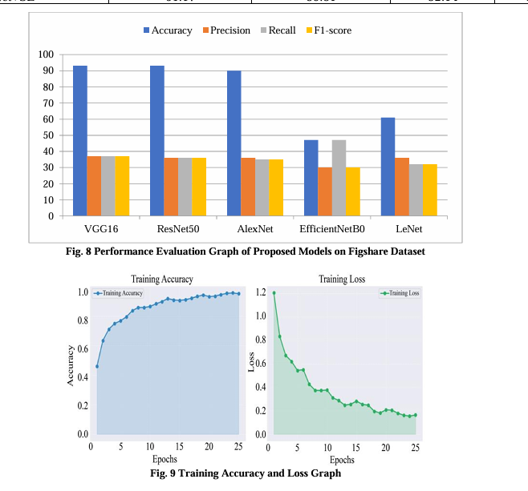
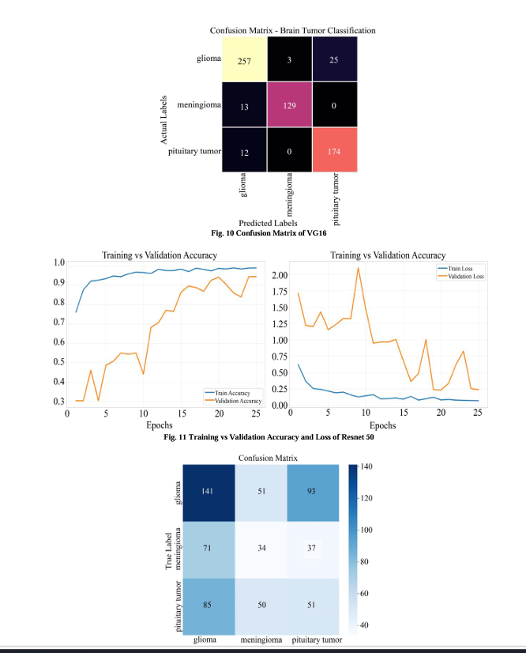

Dataset | K-folds | Accuracy % | Precision % | Recall % | F1-score %
Intraoral dataset | K=2 | 98.18% ± 0.10% | 98.20% ± 0.08% | 98.19% ± 0.10% | 98.18% ± 0.10%
 | K=3 | 99.04% ± 0.22% | 99.05% ± 0.22% | 99.05% ± 0.22% | 99.04% ± 0.22%
 | K=5 | 99.12% ± 0.29% | 99.14% ± 0.28% | 99.12% ± 0.29% | 99.12% ± 0.29%
 | K=7 | 99.39% ± 0.17% | 99.40% ± 0.17% | 99.39% ± 0.17% | 99.39% ± 0.17%
 | K=9 | N/A | N/A | N/A | N/A

System Flow
Dental image dataset -> Preprocessing (MD5 Deduplication + Resizing) -> Tier-based Offline Augmentation (Albumentations) -> Stratified Splitting (70% Train / 15% Val / 15% Test) -> Multi-Architecture Deep Learning Training (AdamW, lr = 1e-4) -> Standalone Performance Evaluation Suite -> Comparative Synthesis & Paper Asset Compilation

