**Name: Atharva Muley**

**Campus Id: GJ20497**

**AOS Project 1**

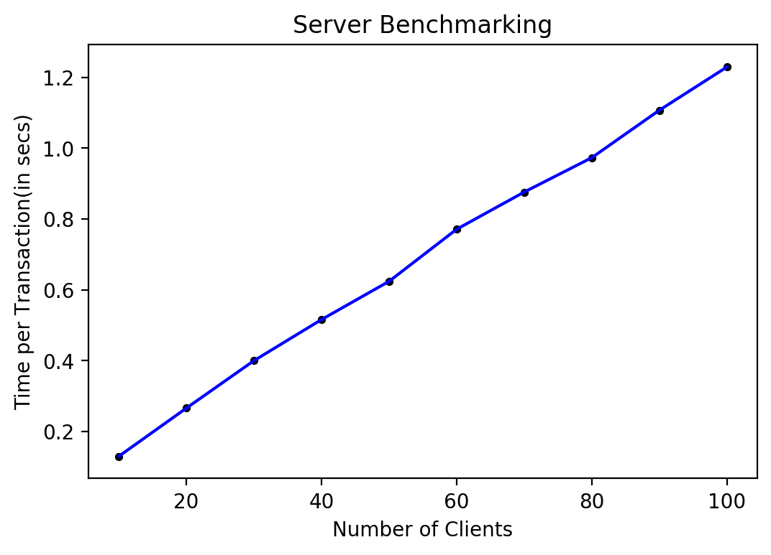

I have used time functionality to calculate the time required to execute N clients. Bash script file was used to spawn multiple threads at a time. This graph shows time taken per transaction as the number of clients are increased from 1 to 100. From graph it is evident that the sever scales linearly. This is a good indication that the server is executing requests concurrently and scaling as and when needed.