# CLOUD COMPUTING WITH REAL LIFE CASE STUDIES AND A NEW APPROACH OF

**SOLVING SECURITY ISSUES AND PUTTING DATA IN CLOUD**

**ATHARVA MURASKAR**

Computer Science and Engineering, Vishwaniketan iMEET, Khalapur, Maharashatra, India

## ABSTRACT

Now a day’s cloud computing plays a major role in IT. It is not used for business activities but it is now also used

for educational purposes. Cloud computing is just internet-based computing you can say it is another property of internet. customers plug into “cloud “and access applications, services which is priced and on demand. In this paper we will discuss some case studies of cloud computing and reasons why cloud computing came in IT market. We will also show benefits of cloud computing, security aspects of cloud computing and a new approach for providing security in cloud computing. The implementation part shows that how we reduce security problem in cloud computing.

**KEYWORDS:** Cloud Computing, Infrastructure, Software as a Service (SaaS), Platform as a Service (PaaS),

Infrastructure as a Service (IaaS), Denial of Service (dos)

## INTRODUCTION

Cloud is just a internet based: email exists some where on some machine, we do not know where the exist .We

have some servers that store email, videos, pictures, any thing else. where is that server and where exist we don’t know. That data is stored on cloud on some server or server of servers. When we want data just access the data with internet its available for me. this is the power of cloud. If we are using gmail, facebook, you tube…means we are using cloud. Cloud computing uses virtualization concept for increasing efficiency. Now hosting companies like amazon, google are provided cloud services, cloud storage and resources on the cloud environment.

Clouds are very beneficial for business activities. Business people uses cloud in minimum cost and they just pay

for storage use. Cloud computing combine the feature of virtualization and internet connectivity for accessing the services and applications. The problem with the cloud computing is security. How we safe our data from cloud provider thus there are problem of integrity, availability, authentication and confidentiality. Cloud computing is just extension of technology like grid computing which is developed before 20 years. in this paper we discuss a new techniques how we manage security after putting data in the cloud. cloud computing is a vast technology and very beneficial for peoples. In india for online tatkaal ticket booking is a major problem for peoples. Thus with the help of cloud computing we can solve these issues. Thus managing security is main challenges of cloud computing.

## CLOUD COMPUTING

Cloud computing means applications and services that runs on a distributed networks using virtualized resources and access by some common internet protocol standards and networking standards. Common internet protocol standards means web services description languge (wsdl),data exchange between services using some form of xml(scripting language),and communication between services using soap protocols. Cloud computing also means application and services delivered over the internet and the hardware and system software in the large data centers that provides these services.cloud computing is a distributed computing that is scalable and abstraction entity that provides a enormous level of services and also a encapsulated feature which is driven by economics of sale.

## SERVICES AND DEPLOYMENT MODELS OF CLOUD COMPUTING

* Cloud computing has a number of services and deployment models.
* Cloud services refered as :XaaS or”<something as a service>”.mainly services are three types:

### Infrastructure as a Service

This is base layer of cloud computing. Main concept used in this service is virtualiztion.eg amazon, goGrid,

rackspace.

### Plateform as a Service

It is plateform where software can be checked. software development life cycle can be operated on paas. some of

major cloud plateforms like GoogleApp., Microsoft azure.

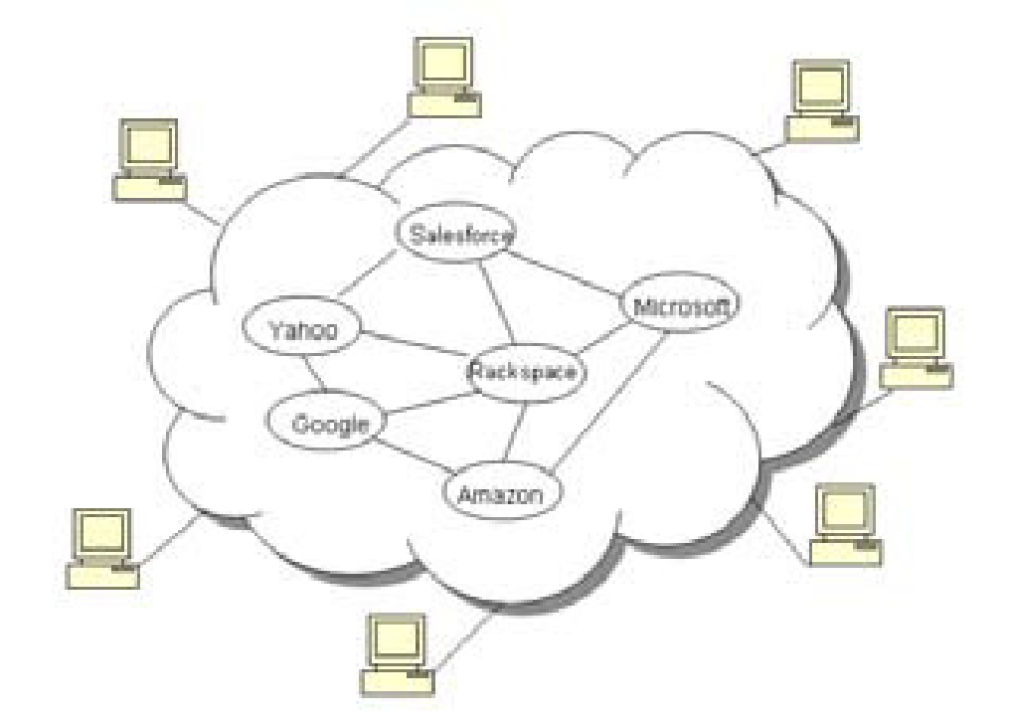

**Figure 1: Structure of Cloud Computing**

### Software as a Service

The service provider has admin control over applications for managing, directing, controlling and responsible for

updating , and maintaining security. eg.gmail is saas where google is provider and we are users.

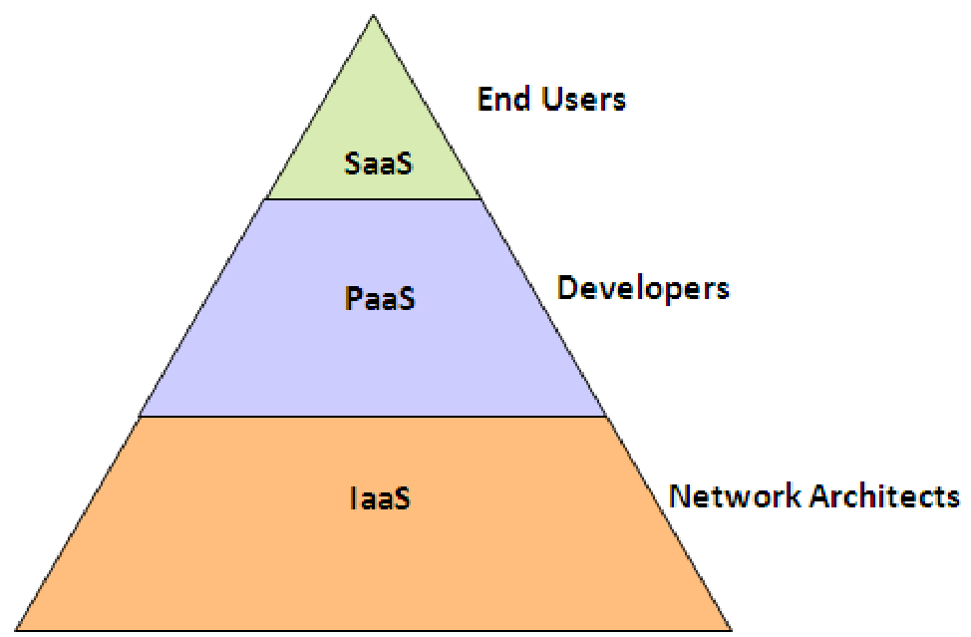

**Figure 2: Cloud Computing Service Models**

**Cloud Computing with Real Life Case Studies and a New Approach of Solving Security Issues and Putting Data in Cloud 151**

### Deployment Models

There are some types of deployment models.

**Private Cloud:** when organizations develop their applications and runs within own infrastructure called private cloud.

**Public Cloud:** when the applicationsis made available for all customers and pay per use basis called public cloud**.**

**Hybrid Cloud:** mixture of both public and private cloud is called hybrid cloud.

**Benefits of Cloud Computing:** some benefits of cloud computing is listed as:

* **Need Basis Scale up and Scale Down**: provided by infrastructure as a service. when you need resources ask your cloud provider.
* **Scalable and Elastic**: scalability means ability of growing or shrinking as time whereas elastic means how fast an application remove and add resources.
* **Uses Internet Technologies**

## REAL LIFE CASE STUDY (NEED OF CLOUD COMPUTING)

### IRCTC Online Tatkaal Ticket Booking from 10 Am To 12 Pm in India

* For tatkaal ticket booking in india, for booking of ticket in peak hours is 10 times higher than the rest of the day.
* The site of IRCTC www.irctc.co.in hits by users in 49 transaction/second and GOOGLE hits by users 42000 transaction/second
* IRCTC has a locking mechanism means one seat can not allotted to other people but GOOGLE can share same information to different peoples.
* Then how we manage these transactions, IRCTC provided a temporal solutions by barring agent login at peak times but it is not good approach.
* Other solution is that adding more thousand servers but buying these servers is very tough for companies which is already in tight budget.
* For some big companies if they buy thousand servers, but for managing peak hours traffic buying these servers is not right approach.
* So there is a need of cloud computing who can manage fluctuations.

### Providing Aadhar Card to Every People of India

* Bank account holders in india is 20% and large no. of peoples have their no identity.
* Providing aadhar card to 800+ billion peoples is a major project.
* Then this project may lead to no. of bank accounts,no. of debit cards/credit cards in rural areas.
* Then managing these things is obviously need of cloud computing.

**Security Issues in Cloud Computing**

Main issues in cloud computing is related to security.we shows some security issues in cloud computing**.**

### Confidentiality

In the case of cloud computing environment, confidentiality means how we secure our data from cloud providers

as well as other customers. customers outsourced their data on cloud servers which is managed by untrustworthy cloud providers. Outsourced means customers loss their physical control over data.

### Integrity

Integrity means data should not be modified or alterd. data are honestly stored on cloud servers. and data should

not be modified by cloud providers. if any fault occur then it will be detected as soon as possible.

### Availability

If we are looking for on demand service then it should be present. If the on demand service is no longer available,

customers will not believe in cloud system.

### Privacy

Privacy means information should not be shared with others like personal information. data are distributed on

cloud servers which are managed by cloud provider then there are issues related to privacy. business competitors want their data should be confidential and does not leak in public markets.

### Solution of these Issues

* **Threats for Confidentiality:** in the IaaS service some attacks arises in amazon elastic compute cloud(EC2) like data tampering and side channel attacks(VM to host or host to VM) and network evesdropping. For side channel attacks we need to add a VM on physical server machine.

**Solution for Confidentiality:** for solutions we need some defensive strategies

* Trusted cloud computing plateform
* Putting data control back to customer
* **Threats for Integrity:** in the cloud integrity some threats occurs like
* data modification
* wrong computation on cloud servers
* connection pooling and open direct

**Solutions for Integrity:** solutions for integrity is very big research area but we provide some solutions:

* trusted computing
* auditing means all activities stored in log file which is reviewed by auditor but hackers understand data better than auditor.
* **Threats for Availability**: the threats is done at service level agreement which is listed as:
* denial of service
* spoofing
* dictionary attack

#### Cloud Computing with Real Life Case Studies and a New Approach of Solving Security Issues and Putting Data in Cloud 153

**Solutions for Availability:** solution for availability is

* managing the new dos attack
* maintaining service level agreement**.**
* **Threats for Privacy**
* loss of physical control

### Solutions

* authentication of cloud provider
* trusted cloud provider

### Other Solution

The main issues about cloud computing is security. we are using facebook, gmail and youtube in real life means

we are working with cloud computing. Once we put our important data in gmail or facebook accout. after logout we do not know where my data is,and what kinds of computation is performed on my data. then there is a problem of authentication and privacy. how we can trust on cloud provider.

Cloud provider can modify our data. for this problem we developed a solution that befor keeping data in the cloud

first it provide a user id password account after login users can put their data safely in cloud and for decrypting same process will occurred.

**Steps:** if anybody want to keep their data in the cloud then follows these steps:

* login your account
* encryption
* login in cloud storage with valid id and passwords
* decryption
* logout from account

## CONCLUSIONS

Cloud computing is internet based technologies which provided on demand service, pay as you go method is used

for scale up and down resources. cloud computing usese virtualization concept for increasing efficiency. Virtualization is creation of something rather than “virtual”(rather than actual).in the physical server we install a small operating system called hypervisor.

The magic is that this very small highly efficient operating system allows you to install other guest operating

system beneath it .the hypervisor controls these other guest Os installations called (virtual servers) and allows them to share all resources without interrupting each other.

In the case of multiple physical servers, they were consolidated into one virtualized physical servers. this server

would then run multipal virtual servers instancs representing the original physical servers. The result is highly efficient server with a utilization of 80%-90%.thus in the paper we discussed about real life scenario of cloud computing , benefits and security issues in cloud computing and provide a better solutions for these issues.

## REFERENCES

1. Jensen, M. (2009, September). On Technical Security Issues in Cloud Computing. IEEE InternationaConference in Cloud Computing, 109-116.
2. P. Mell and T. Grance. The NIST Definition of Cloud Computing (Draft). [Online] Available:
3. G. Ateniese, R. Burns, R. Curtmola, J. Herring, L. Kissner, Z. Peterson, and D. Song, “Provable data possession at untrusted stores,” In ACM CCS, pages 598-609, 2007.
4. G. Ateniese, R. D. Pietro, L. V. Mancini, and G. Tsudik, “Scalable and efficient provable data possession,” SecureComm, 2008.
5. K.D. Bowers, A. Juels, and A. Oprea, “HAIL: A high-availability and integrity layer for cloud storage,” Proc. 16th ACM conference on Computer and communications security, 2009, pp. 187-198.
6. S. Kandula, D. Katabi, M. Jacob, and A. Berger, “Botz-4-sale: Surviving organized ddos attacks that mimic flash crowds,” In Proc. NSDI (2005).
7. A. Yaar, A. Perrig, and D. Song, “Fit: Fast internet traceback,” In Proc. IEEE Infocom (March 2005).
8. S. Staniford, V. Paxson, and N.Weaver, “How to own the internet in your spare time,” In Proc. USENIX Security (2002). Cisco data center infrastructure 2.5 design guide.
9. S. Arnold (2009, Jul.). “Cloud computing and the issue of privacy.” *KM World*, pp14-22. Available:

www.kmworld.com [Aug. 19, 2009]. A Platform Computing Whitepaper. “Enterprise Cloud Computing:

Transforming IT.” *Platform Computing*, pp6, 2010.

1. Global Netoptex Incorporated. “Demystifying the cloud. Important opportunities, crucial choices.” pp4-14. Available: http://www.gni.com [Dec. 13, 2009].
2. M. Klems, A. Lenk, J. Nimis, T. Sandholm and S. Tai. “What’s Inside the Cloud? An Architectural Map of the Cloud Landscape.” *IEEE Xplore*, pp 23-31, Jun. 2009.
3. C. Weinhardt, A. Anandasivam, B. Blau, and J. Stosser. “Business Models in the Service World.” *IT Professional*, vol. 11, pp. 28-33, 2009.
4. N. Gruschka, L. L. Iancono, M. Jensen and J. Schwenk. “On Technical Security Issues in Cloud Computing” In PROC 09 IEEE International Conference on Cloud Computing, 2009 pp 110-112.
5. N. Leavitt. “Is Cloud Computing Really Ready for Prime Time?” *Computer*, vol. 42, pp. 15- 20, 2009.
6. M. Jensen, J. Schwenk, N. Gruschka and L. L. Iacono, "On Technical Security Issues in Cloud Computing" in PROC IEEE ICCC, Bangalore 2009, pp. 109-116.

[View publication stats](https://www.researchgate.net/publication/235950351)