***CarpoolD App using Blockchain***

Submitted in partial fulfilment of the requirements of the degree of

BACHELOR OF COMPUTER ENGINEERING

by

Atharva More (22102109)

Atharva Patil (22102060)

Prachi Khanapurkar (22102185)

Rushikesh Pawar (22102183)

Subject In-charge:

**Prof. Ramya R.B.**



Department of Computer Engineering

A. P. SHAH INSTITUTE OF TECHNOLOGY, THANE

(2025-2026)

# ABSTRACT

This report explores the development of a decentralized carpooling system utilizing blockchain technology through a smart contract written in Solidity. By leveraging Ethereum’s decentralized nature, the system enables drivers to offer rides and passengers to book available seats without the need for an intermediary, ensuring efficiency and cost-effectiveness. The immutable nature of blockchain provides trust and transparency between all participants, ensuring that all transactions are secure. Additionally, it mitigates the risk of data manipulation or centralized control, offering an equitable platform for both drivers and passengers.

The smart contract automates key functions, such as creating rides, booking passengers, and marking rides as completed. It eliminates human error and fraud by enforcing programmed conditions, while the direct interaction between users ensures a tamper-proof system. This decentralized approach aims to reduce transaction costs and increase the efficiency of ride-sharing services by removing third-party oversight. Furthermore, the automation of payments and bookings enhances user experience, while smart contracts act as an unbiased mediator between parties, providing a robust framework for fairness.

Through the use of smart contracts, the platform ensures that both drivers and passengers fulfill their obligations, as rules and conditions are enforced programmatically. The automated payment transfers provide additional security by ensuring drivers are compensated immediately after booking, while passengers are guaranteed a ride once payment is confirmed. In summary, this project demonstrates the potential of blockchain technology to revolutionize ride-sharing services by offering a decentralized, transparent, and efficient alternative to traditional platforms, with added benefits of cost reduction, security, and Fairness.

# CONTENTS

1. Introduction ............................................................................................... 4
2. Problem Statement, Scope and Objectives ............................................... 5
3. Proposed System… ................................................................................... 6
4. Experimental Setup ................................................................................... 7
   * Hardware Requirements
   * Software Requirements
5. Results ................................................................................................... 8-13
6. Conclusion ............................................................................................... 15
7. Acknowledgement ................................................................................... 16

# INTRODUCTION

Blockchain technology has brought about a paradigm shift in how digital interactions are conducted, particularly through decentralized applications (DApps) that eliminate the need for intermediaries. In the ride-sharing industry, traditional platforms such as Uber and Lyft rely on centralized models, which involve third-party control, high service fees, and a lack of transparency. These issues have sparked interest in decentralized alternatives that provide a more efficient and cost-effective way for drivers and passengers to connect. A decentralized carpool system offers the potential to reduce these inefficiencies while enhancing trust between users through secure, transparent, and immutable smart contracts.

This report presents a decentralized carpooling solution built on the Ethereum blockchain using Solidity smart contracts. The primary goal of this system is to allow drivers to offer rides and passengers to book available seats in a trustless environment, without the need for intermediaries. The smart contract ensures automated handling of ride bookings, seat availability, and fare transactions directly between users. By utilizing blockchain technology, the system introduces an immutable, tamper-proof way to record and verify transactions, providing transparency and fairness in the interactions between drivers and passengers.

The key features of this decentralized carpool system include ride creation, where drivers can list available seats at a set fare, and ride booking, where passengers can secure seats by sending payments directly to the driver via the smart contract. Furthermore, the contract includes built-in enforcement mechanisms to ensure that only the designated driver can complete the ride, and payments are automatically transferred, reducing the chances of fraud or disputes. This eliminates reliance on third-party platforms, significantly lowering transaction costs and increasing operational efficiency.

**PROBLEM STATEMENT:**

Traditional ride-sharing platforms are centralized, meaning they rely on third-party intermediaries to connect drivers and passengers. While these platforms are effective, they come with significant drawbacks, including high service fees, lack of transparency, and limited control for users over transactions. Drivers often face reduced earnings due to platform commissions, while passengers pay inflated fares. Additionally, centralized systems can suffer from data security vulnerabilities and manipulation, as all transactions are controlled by a single authority. This reliance on a third party creates inefficiencies and trust issues, which could be addressed through a decentralized solution. The need arises for a carpooling system that allows direct, trustless interactions between drivers and passengers, reducing costs, enhancing security, and providing transparency, without the involvement of intermediaries.

**SCOPE / OBJECTIVES:**

* Decentralized Platform: Build a trustless carpooling system that operates without intermediaries, enabling direct interactions between drivers and passengers.
* Automated Transactions: Use smart contracts to handle ride creation, seat booking, and payment processing automatically and securely.
* Transparency and Security: Ensure all transactions and data are securely recorded on the blockchain, providing transparency and preventing fraud.
* Cost Efficiency: Lower costs for both drivers and passengers by eliminating platform fees and reducing operational overhead.
* Fairness and Control: Allow drivers to set fares and manage seats, ensuring passengers receive guaranteed service after payment.

# PROPOSED SYSTEM

The proposed decentralized carpooling system is designed to facilitate seamless interactions between drivers and passengers using a smart contract deployed on the Ethereum blockchain. This system addresses the inefficiencies and limitations of traditional ride-sharing platforms by offering a transparent, secure, and automated solution.

1. **Smart Contract Functionality**: The core of the system is a smart contract that manages the entire ride-sharing process. Drivers can create rides by specifying the fare and the number of available seats. Passengers can then book seats by sending the required fare directly to the driver via the smart contract, ensuring that all transactions are secure and automated.
2. **Decentralized Ledger**: All ride details, transactions, and interactions are recorded on the blockchain, providing an immutable and transparent ledger. This ensures accountability and allows both drivers and passengers to verify the legitimacy of their transactions without relying on a central authority.
3. **User Empowerment**: Drivers have the autonomy to set their own fares and manage seat availability, providing them with greater control over their earnings. Passengers benefit from a direct connection to drivers, allowing them to choose rides based on their preferences, such as fare, route, and availability.
4. **Automated Payment Process**: The system automates the payment process, transferring funds from passengers to drivers immediately upon successful booking. This eliminates delays and enhances trust, as both parties can rely on the smart contract to enforce payment conditions.
5. **Fairness and Trust**: By utilizing a decentralized approach, the system enhances fairness and trust among users. The built-in mechanisms ensure that drivers can only complete rides they have created, and passengers are guaranteed seats once they have paid. This trustless environment fosters a collaborative community for ride-sharing without the need for intermediaries.

# EXPERIMENTAL SETUP

**Hardware Requirements:**

1. **Processor**: Intel Core i5 or above, ensuring adequate processing power for running blockchain nodes, development environments, and smart contract simulations.
2. **RAM**: Minimum of 8GB (recommended 16GB) for smooth multitasking, efficient performance, and faster smart contract development and testing.
3. **Storage**: At least 256GB SSD (recommended 512GB) for better performance in handling operating systems, development tools, and blockchain data.
4. **Network**: Stable internet connection to interact with blockchain networks and for seamless access to development environments.
5. **Graphics**: A standard GPU is sufficient for developing the front-end interface, ensuring smooth rendering of web applications.

**Software Requirements:**

1. **Programming Languages**: The tech stack includes JavaScript (59.7%), Solidity (14.4%), HTML (13.9%), and CSS (12.0%) for developing smart contracts and the web interface.
2. **Operating System**: Windows 10, macOS, or a Linux distribution (e.g., Ubuntu) to support all necessary development environments.
3. **Development Tools**: Visual Studio Code as an Integrated Development Environment (IDE) for smart contract and web development.
4. **Node.js**: To manage dependencies and run JavaScript-based front-end applications.
5. **Hardhat**: A development framework to compile, test, and deploy Solidity smart contracts.
6. **Ganache**: A local blockchain simulator to test Ethereum contracts in a controlled development environment.
7. **Web3.js**: A JavaScript library to interact with the Ethereum blockchain and handle frontend blockchain interactions.
8. **MetaMask**: A browser extension wallet for facilitating Ethereum transactions and managing user accounts.

This setup allows developers to design, implement, test, and deploy the blockchain-based solution while ensuring the system runs efficiently on local hardware and can be scaled to live networks.

**RESULTS (SCREENSHOTS):**

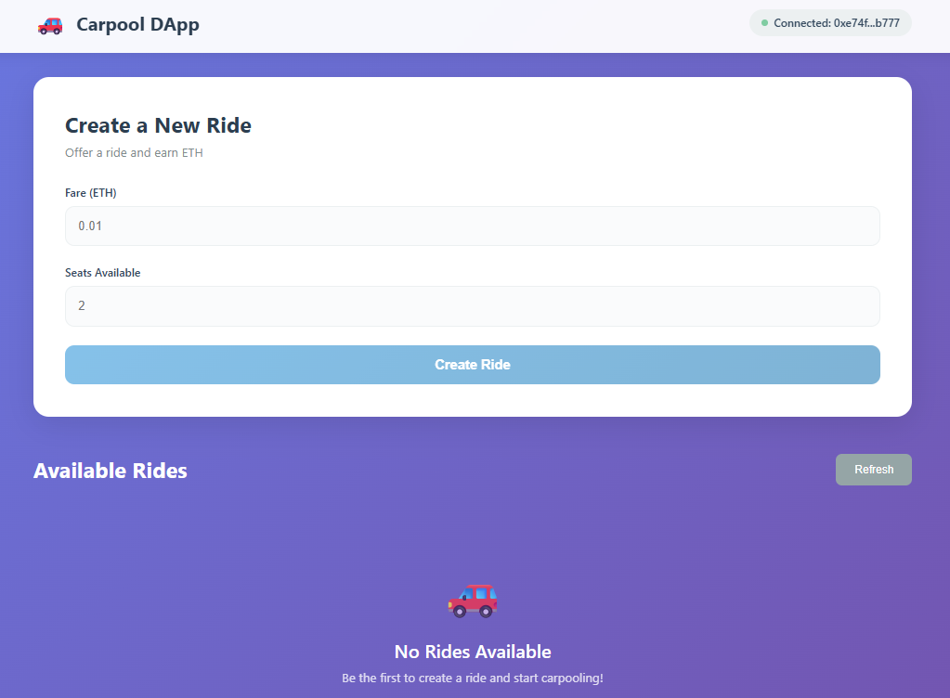

Fig 1.1 homepage

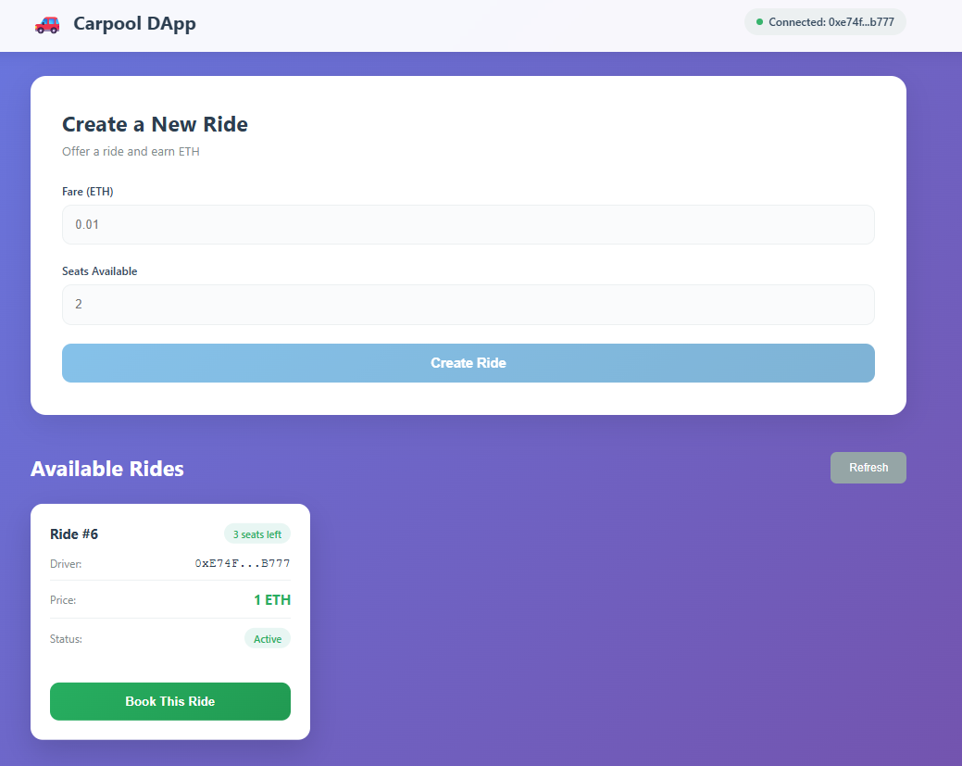

Fig 1.2 Create a Ride

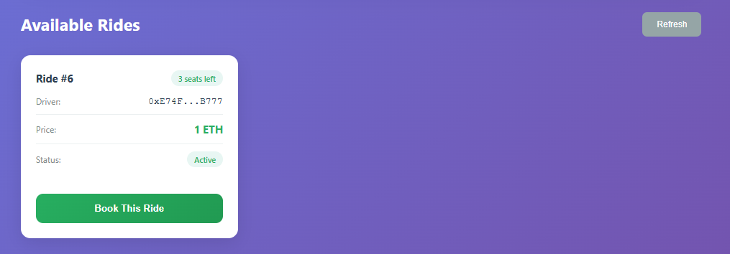

Fig 1.2 Available Rides

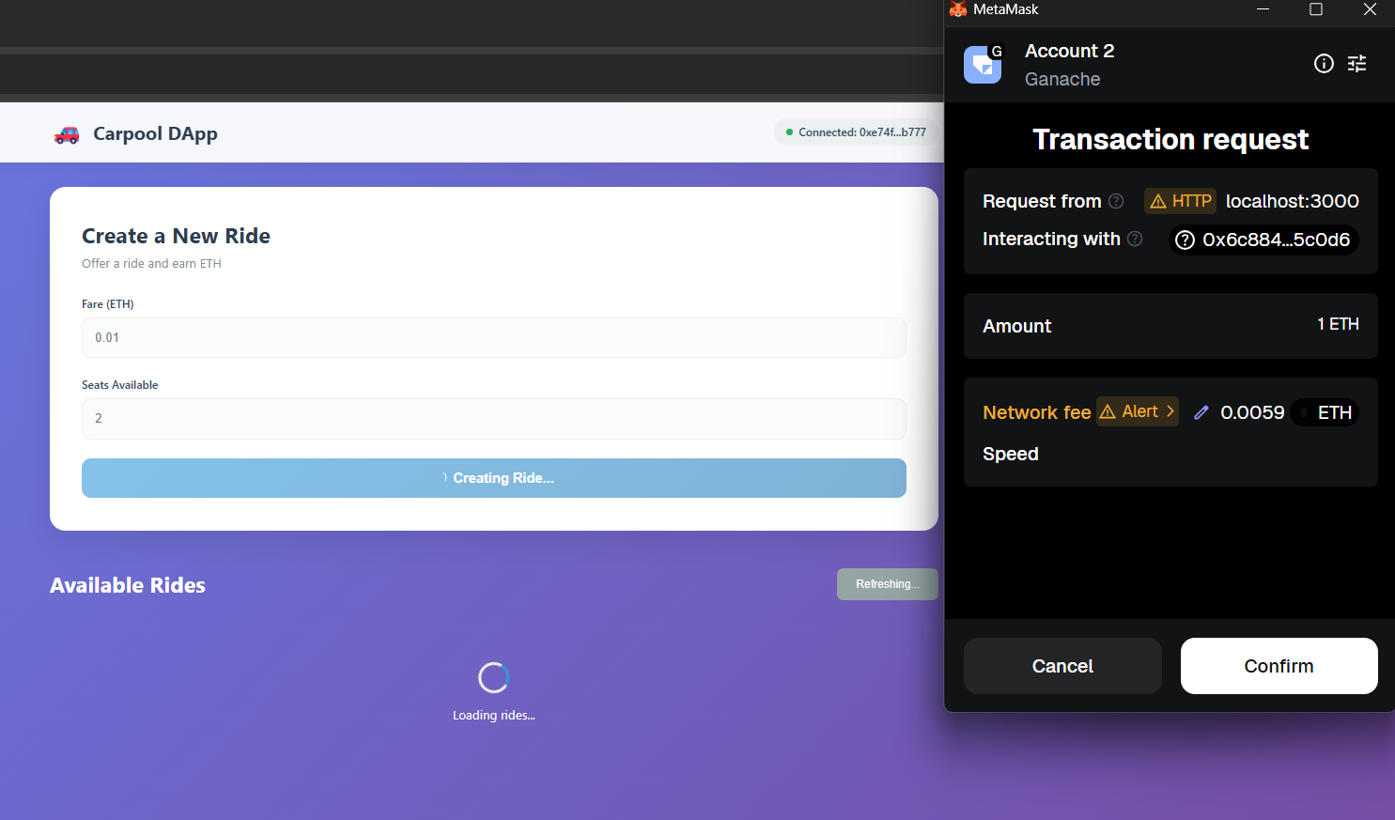

Fig 1.3 Ride Conformation

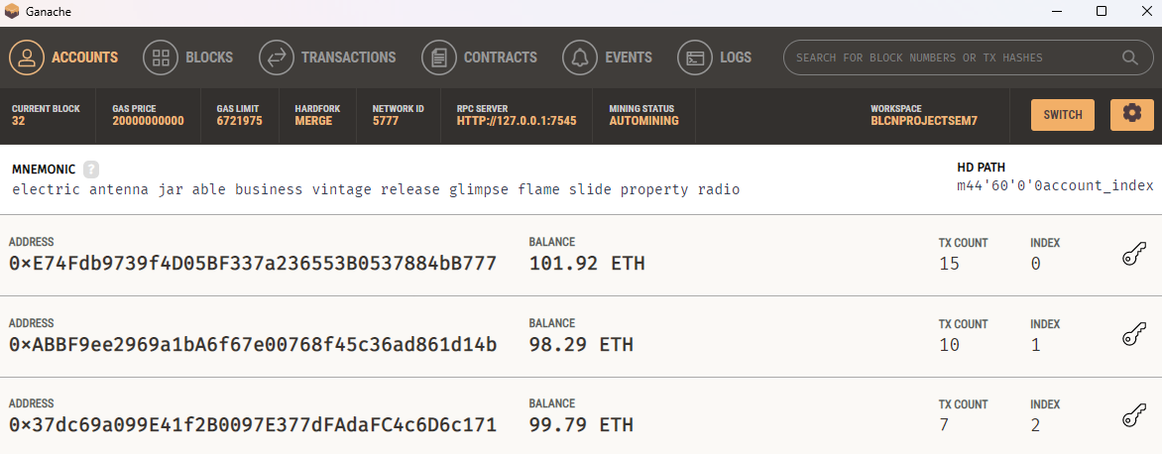

Fig 1.3 Ether Transaction in Ganache

**CODE SNIPPETS:**

1)Carpool.sol

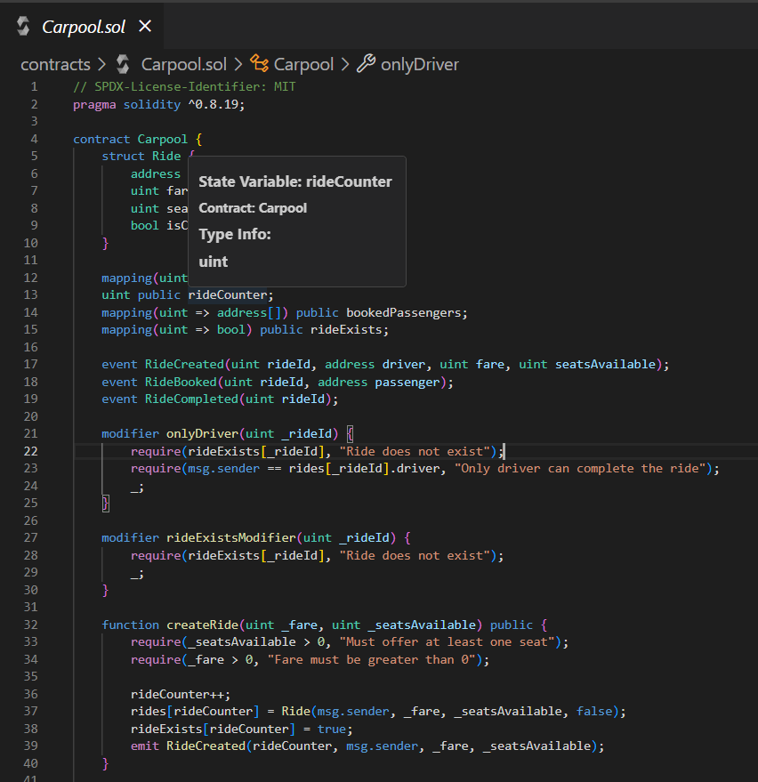

Carpool.sol

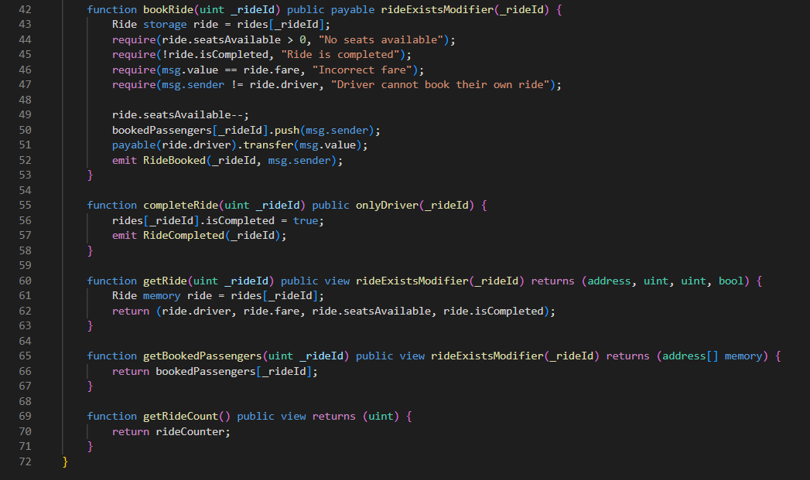

2)App.js

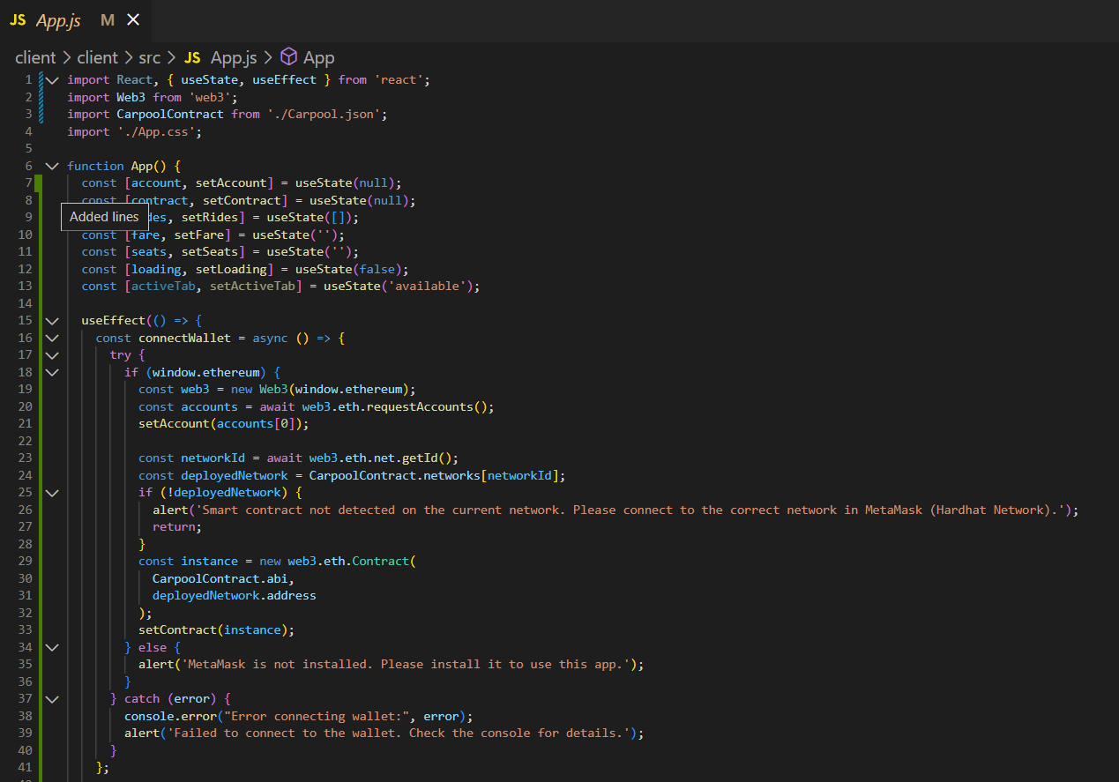

3)deployed-address.json

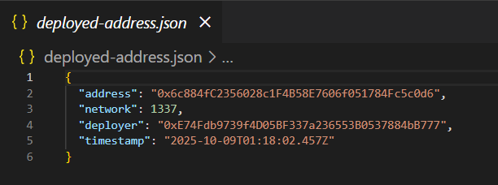

**CONCLUSION:**

The proposed decentralized carpooling system represents a transformative approach to ride-sharing by leveraging blockchain technology to create a more efficient, transparent, and user-centric platform. By removing intermediaries, the system empowers drivers and passengers to interact directly, facilitating a more cost-effective and streamlined experience. The use of smart contracts automates essential processes such as ride creation, seat booking, and payments, enhancing security and trust among users. This automation minimizes the potential for fraud and human error, ensuring that both parties fulfill their obligations. Furthermore, the platform promotes fairness by allowing drivers to set their own fares and manage seat availability while guaranteeing passengers secure service upon payment. Overall, the project highlights the potential of decentralized applications to revolutionize traditional industries, offering a scalable and innovative solution that could reshape the future of ridesharing. Overall, the project highlights the potential of decentralized applications to revolutionize traditional industries, offering a scalable and innovative solution that could reshape the future of ride-sharing services.

**ACKNOWLEDGEMENT:**

We would like to express our deepest gratitude to everyone who contributed to the successful development of the **CarpoolD App** project. We are immensely thankful to our mentor for their valuable guidance and encouragement throughout the project. We would also like to acknowledge our peers and team members for their constant support and collaboration, which played a crucial role in achieving our goals. Lastly, we extend our thanks to the open-source community for providing the essential tools and frameworks that made this project possible.

**Student 1: Atharva More (22102109)**

**Student 2: Atharva Patil (22102060)**

**Student 3: Prachi Khanapurkar (22102185)**

**Student 4: Rushikesh Pawar (22102183)**