PROJECT 1

**Observations:**

5000+ Resources

690 Contractors

Cost of contractors = 1.4 x Cost of permanent employees

Customers across 35 countries

Sectors BFSI, Healthcare, Retail, Public sector, Manufacturing, Travel, Entertainment etc.

Products DevOps bundle, cybersecurity, digital marketing

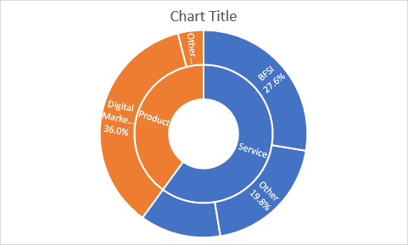

Year-on-year Margin 11% vs 26% for other companies

**MECE:**

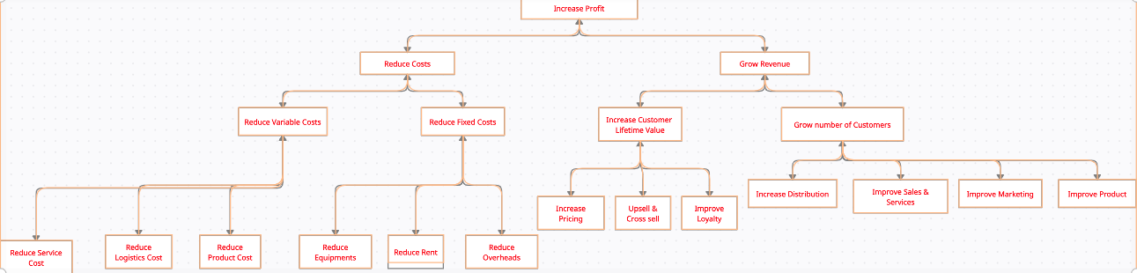

**Solutions:**

**Reduce costs:**

**Reduce Service Cost:**

To Reduce Costs, the company must reduce number of Contractors as they cost 1.4 times more than the permanent employees.

* + 1. Hire the contractors as permanent employees.
    2. This can be done by acquisition of companies with the skills that the original contractors had.
    3. Higher resources with the required skills.
    4. Build skills in permanent employees for which the contractors were employed.

Do one or more of above in a phased manner so that knowledge is not lost.

**Grow Revenue:**

**Improve Sales & Services:**

The Revenue of sectors like Retail, Public sector, Manufacturing, Travel, Entertainment is low so the company must focus on these sectors and acquire people with these skills.

**Improve Product:**

1. If the company sees potential in DevOps bundle and cybersecurity, but the revenue is extremely low, so acquiring people with these skills would be helpful.
2. Usually, Products have a higher scope for margin so the company must focus on its products.
3. If the goal is only increasing the profit, the company can focus on BFSI and US as the margin is particularly good there.
4. If overall the growth is needed, then the company must focus on increasing the revenue and margin in other sectors too. E.g., Europe, Retail
5. The company is looking forward to investing in India, US, and Europe. Since the cost in India is low so the company can increase number of employees in India and just keep required number of people in US and Europe.
6. But the margin in India is extremely low so selling in India would not be profitable. US and Europe are fine.