SOFTWARE REQUIREMENTS SPECIFICATION

1. INTRODUCTION

1.1 Purpose

This document defines the requirements for a Retail E-Commerce Price Tracker, which would be a web-based application designed to empower users with comprehensive price comparisons across leading online retailers.

1.2 Scope of Project

Develop a web-based application to compare prices of a specified product across multiple online retailers. Features include price scraping, data storage, price comparison algorithms, user-friendly interface. The project will focus on predefined websites, with considerations for legal and ethical scraping practices. Real-time inventory tracking, transaction processing, and advanced data analytics are out of scope. Timeline estimated at 2-3 months.

1.3 Intended Audience

Our application intends to cater the services of all people of all age-groups, who are eager to purchase products via online shopping. We intend to serve the users of all income-groups, preferably frequent price-sensitive and time-constrained online shoppers. As we intend to design a web-based application, the users should be aware of basic desktop usage.

2. OVERALL DESCRIPTION

2.1 Product Perspective

The price comparison application will operate independently, providing users with insights into product pricing across multiple retailers through a user-friendly interface. It will rely on external sources for price data retrieval while adhering to legal and ethical considerations. The application will be designed for scalability.

Our Retail E-Commerce Price tracker has the following perspectives -

- Value Proposition -

- Our web application has the perspective of giving value for the users’ money by having the prices of same products on different websites.

- Our application values the time of the user by reducing the hassle of going to different websites for the same product.

- Our application focuses on user-friendly interface and help them make informed decisions.

2.2 Product Features

Our application intends to have the following features -

- Detailed price comparison: Display prices from multiple retailers for the same product, leaving it to the user to choose from where they want to purchase the product.

- Comprehensive product search: Search for products across supported retailers.

- Price history tracking: Monitor price changes for specific products over time and receive alerts when prices drop.

2.3 User Class and Characteristics

The target users of the price comparison application are consumers seeking to make informed purchasing decisions online. They vary in age, income levels, and technical proficiency but share a common goal of finding the best deals across multiple retailers. They value simplicity, accuracy, and efficiency in the price comparison process and may use the application on various devices, including desktops, laptops, and mobile phones,etc.

2.4 Operating Environment

The price comparison application will operate in a web-based environment accessible via standard web browsers on desktop and mobile devices. It will rely on external sources for price data retrieval, adhering to legal and ethical considerations.

The operating environment for our Retail E-Commerce Price Tracker project is intended to be as follows -

- Client-Server Architecture - Our application intends to employ a client-server architecture, separating application interface, data acquisition, processing for efficient resource management and security purposes.

- Distributed Server -
We intend to make the server distributed , one of which will be a public server, and second will be a scrapping server.

Public server - The Client/frontend will be communicating/making requests to this server i.e. public server only and it does not have any access to the internal scrapping server. All the business logic related to request and response will be handled by the public server.

Scrapping server – This server would be isolated from real world and can be accessed from our public server. We intend to isolate this server because this server needs to do a lot of computational tasks to do and making it accessible to the user would impact its resources. As we are using public server as a middleware, it will make sure that all requests are legitimate, and if there are any unauthorised calls/requests, it will terminate there itself.

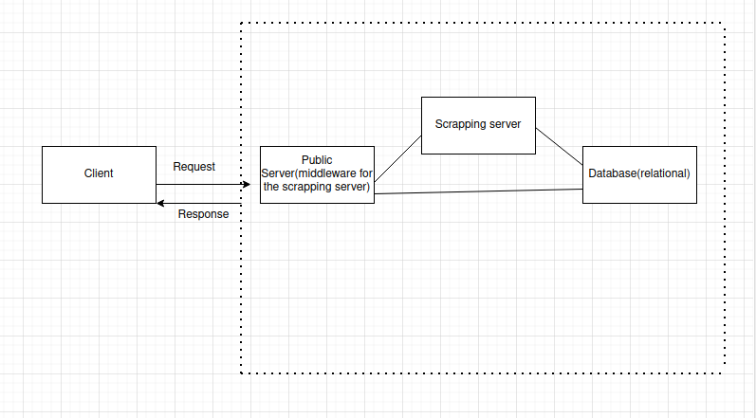

- Database – We intend to use a relational database (e.g. MySQL) where the products list will be stored.

2.5 Design and Implementation Constraints

- Data acquisition -

- Website structure and its changes – Adapting to variations in website layouts and data formats.

- Volume of data – Handling large number of websites.

- Ethical Scraping – The techniques must comply with website terms of service and keep in mind data privacy regulations.

- Client-side constraints -

- Offline users – Users not being logged in to the application.

- Synchronization of Data – We need to ensure the consistency of client-side and server-side data and ensure they are synchronized.

- Data processing -

- Optimization of performance – We need to process large datasets effectively without compromising speed.

2.6 Assumption and Dependencies

- User internet connectivity - Assumes users have stable internet connectivity to access the price tracker and utilize its functionalities.

- Data storage and accessibility – Assumption of sufficient and secure data storage options to handle the scraped data and processed information.

- Assumption of consistent website structures and data availability across selected retailers.

- Dependency on external sources for price data retrieval, subject to potential changes in website policies or data availability.

- Reliance on users' internet connectivity and device compatibility for accessing the application.

- Assumption of users' willingness to adhere to the application's terms of service and privacy policy.

3. SYSTEM FEATURES AND FUNCTIONAL REQUIREMENTS

1. Price Scraping:
- Automated Data Retrieval: Implement a mechanism to automatically retrieve prices of the specified product from designated online retailers.
- Website Compatibility: Ensure compatibility with various website structures to extract price data accurately.
- Error Handling: Handle errors gracefully, such as timeouts or website changes, to maintain data integrity.

2. Data Storage:
- Structured Database: Store scraped price data in a structured format in relational database (e.g., MySQL).
- Data Cleaning: Clean and preprocess the scraped data to ensure consistency and accuracy, addressing issues like missing values, formatting discrepancies, and duplicate entries.

3. Price Comparison:
- Algorithm Development: Develop algorithms to compare prices across multiple retailers.

4. User Interface:
- Intuitive Design: Design a user-friendly web interface that guides users through the price comparison process seamlessly.
- Input Form: Provide a form where users can input product details (e.g., name, model, brand) to initiate the price comparison.
- Comparison Results: Display comparison results in a clear and visually appealing format, including price listings from different retailers and any additional relevant information (e.g., product ratings, availability).

5. Additional Features:
- Price Trend Analysis: Implement functionality to analyse price trends over time, providing insights into fluctuations in product pricing.
- Price Alert Notifications: Allow users to set up price alerts for specific products, receiving notifications when prices drop below a specified threshold.
- Filtering Options: Offer filtering options based on user preferences, such as filtering by retailer, price range, shipping options, or product attributes.

9. Testing and Quality Assurance:
- Unit Testing: Conduct thorough unit testing of individual components to ensure functionality and identify potential bugs or issues.
- Integration Testing: Perform integration testing to validate interactions between system components and external dependencies.

10. Documentation:
- User Guide: Provide comprehensive documentation, including user guides and tutorials, to help users navigate the application effectively.
- Developer Documentation: Document the system architecture, APIs, and implementation details for developers to understand and extend the system.

