Softnerve Assignment 2
Question 1:
def find_leader(arr):
n = len(arr)
leader = arr[n-1]
leaders = [leader]

for i in range(n-2, -1, -1):
if arr[i] > leader:
leader = arr[i]
leaders.append(leader)

leaders.reverse()
return leaders

input_string = input("Enter elements of the array seperated by a space ")

elements = input_string.split()
print(elements)
arr = [int(num) for num in elements]

leaders = find_leader(arr)
print("Leaders in the array:", leaders)

Question 2:
def max_profit(prices):
n = len(prices)
if n <= 1:
return 0

max_profit = 0
min_price = prices[0]

for i in range(1, n):
if prices[i] < min_price:
min_price = prices[i]
current_profit = prices[i] - min_price
if current_profit > max_profit:
max_profit = current_profit

return max_profit

input_string = input("Enter the elements separated by space: ")

elements = input_string.split()
prices = [int(num) for num in elements]
print("Maximum profit:", max_profit(prices))
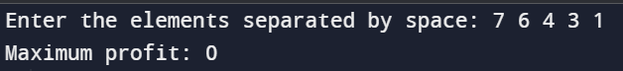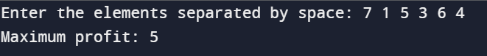

Question 3:
def subsetXORSum(nums):
def backtrack(index, subset_xor):
nonlocal total_xor
total_xor += subset_xor

for i in range(index, len(nums)):
backtrack(i + 1, subset_xor ^ nums[i])

total_xor = 0
backtrack(0, 0)
return total_xor

input_string = input("Enter the elements separated by space: ")

elements = input_string.split()

nums = [int(num) for num in elements]
print("Sum of all XOR totals:", subsetXORSum(nums))

