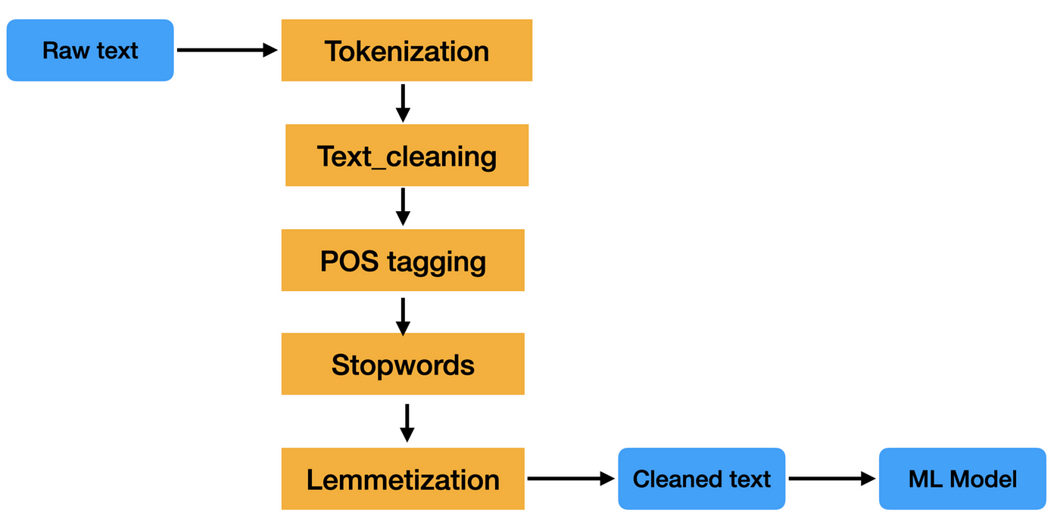

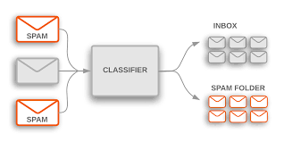

1. **Key Task 1: Text Classification**

Detailed Explanation:

Text classification involves categorizing or assigning predefined categories to a given document or piece of text. It is a supervised learning task where a model is trained on a labeled dataset.

Brief Summary:

Text classification is the process of assigning predefined categories to text documents using machine learning algorithms.

Working:

Algorithms like Support Vector Machines (SVM), Naive Bayes, and Decision Trees are commonly used for text classification.

The model learns patterns from labeled training data and generalizes to predict the category of unseen documents.

Examples:

Spam detection: Classifying emails as spam or not.

Sentiment analysis: Determining whether a movie review is positive or negative.

Applications:

Email filtering

Topic categorization

Sentiment analysis in social media

Limitations:

Relies on labeled training data.

May struggle with ambiguous or sarcastic language.

Real-World Tools:

Scikit-learn (Python library)

TensorFlow (Machine learning framework)

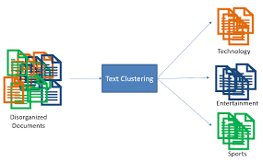

1. **Key Task 2: Clustering**

Detailed Explanation:

Clustering involves grouping similar documents together based on their content, without predefined categories. It's an unsupervised learning task.

Brief Summary:

Clustering is the process of grouping similar documents or texts without predefined categories.

Working:

K-means, Hierarchical Clustering, and DBSCAN are common algorithms for text clustering.

Documents with similar content are grouped together, forming clusters.

Examples:

Grouping news articles on similar topics.

Organizing customer reviews based on content similarity.

Applications:

Document organization

Customer segmentation

Limitations:

The number of clusters may need to be predefined.

Sensitivity to initial cluster centroids in K-means.

Real-World Tools:

NLTK (Natural Language Toolkit in Python)

Apache Mahout (Scalable machine learning library)

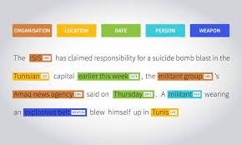

1. **Key Task 3: Named Entity Recognition (NER)**

Detailed Explanation:

NER involves identifying and classifying entities (such as names, locations, and organizations) in a text.

Brief Summary:

Named Entity Recognition is the process of identifying and categorizing entities in text.

Working:

Conditional Random Fields (CRF) and Recurrent Neural Networks (RNNs) are used for NER.

The model learns to recognize patterns and predict the entity type for each word.

Examples:

Extracting names and locations from news articles.

Identifying product names in reviews.

Applications:

Information extraction

Question answering systems

Limitations:

May struggle with ambiguous entities.

Sensitivity to variations in writing styles.

Real-World Tools:

spaCy (Python library)

Stanford NER

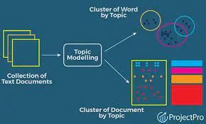

1. **Key Task 4: Topic Modeling**

Detailed Explanation:

Topic modeling identifies topics present in a collection of documents and assigns each document a distribution over these topics.

Brief Summary:

Topic modeling uncovers hidden topics in a collection of documents and assigns topics to each document.

Working:

Latent Dirichlet Allocation (LDA) is a popular algorithm for topic modeling.

It identifies words that frequently co-occur and groups them into topics.

Examples:

Identifying themes in a set of research papers.

Discovering trending topics in news articles.

Applications:

Content recommendation

Document summarization

Limitations:

Requires the assumption that each document is a mixture of topics.

Difficulties in evaluating the quality of topics.

Real-World Tools:

Gensim (Python library)

MALLET (MAchine Learning for LanguagE Toolkit)

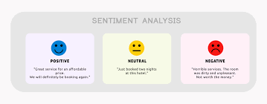

1. **Key Task 5: Sentiment Analysis**

Detailed Explanation:

Sentiment analysis involves determining the sentiment expressed in a piece of text, such as positive, negative, or neutral.

Brief Summary:

Sentiment analysis is the process of identifying and categorizing the sentiment expressed in a text.

Working:

Machine learning algorithms like Support Vector Machines and Recurrent Neural Networks are commonly used.

The model learns to associate patterns in text with sentiment labels.

Examples:

Analyzing social media posts for brand sentiment.

Evaluating product reviews for customer satisfaction.

Applications:

Brand monitoring

Customer feedback analysis

Limitations:

Difficulty in handling sarcasm and irony.

May be influenced by the training data's bias.

Real-World Tools:

VADER (Python library)

IBM Watson Natural Language Understanding

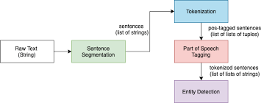

1. **Named Entity Recognition (NER)**

Detailed Explanation:

Named Entity Recognition (NER) is a natural language processing task that involves identifying and classifying entities, such as names of persons, organizations, locations, dates, and other specific categories, within a given text.

Brief Summary:

NER is the process of extracting and categorizing named entities from text.

Working:

NER involves using machine learning models like Conditional Random Fields (CRF) or deep learning architectures such as Bidirectional LSTMs.

The model learns to recognize patterns and contextual information to classify words into predefined entity categories.

Examples:

Identifying names of people, organizations, and locations in news articles.

Extracting dates and numerical values from legal documents.

Applications:

Information retrieval and extraction

Question answering systems

Entity linking in knowledge graphs

Limitations:

May struggle with ambiguous entities.

Sensitivity to variations in writing styles.

Real-World Tools:

spaCy (Python library)

Stanford NER

NLTK (Natural Language Toolkit in Python)

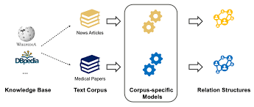

1. **Relation Extraction**

Detailed Explanation:

Relation Extraction is a natural language processing task that involves identifying and classifying relationships between entities mentioned in text.

Brief Summary:

Relation Extraction is the process of determining the connections or associations between named entities.

Working:

Relation Extraction often utilizes supervised learning approaches with labeled training data.

Algorithms, including Support Vector Machines (SVM) or neural networks, learn to recognize patterns that indicate relationships between pairs of entities.

Examples:

Identifying familial relationships in news articles.

Extracting "works for" relationships between individuals and organizations in resumes.

Applications:

Building knowledge graphs

Enhancing information retrieval systems

Identifying connections in biomedical texts for drug discovery

Limitations:

Difficulty in handling complex or indirect relationships.

Sensitivity to variations in language structure.

Real-World Tools:

OpenNRE (Open-source toolkit for relation extraction)

ReVerb (Stanford's relation extraction system)

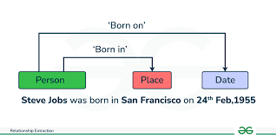

1. **Unsupervised Information Extraction**

Detailed Explanation:

Unsupervised Information Extraction involves extracting structured information from text without the use of labeled training data, relying on patterns, co-occurrences, and statistical methods.

Brief Summary:

Unsupervised Information Extraction is the process of deriving meaningful information from text without explicit supervision.

Working:

Techniques may include clustering algorithms like K-means or probabilistic models such as Latent Dirichlet Allocation (LDA).

The model identifies patterns and relationships within the text without pre-existing categories.

Examples:

Clustering news articles into topics without predefined categories.

Extracting key phrases or themes from unstructured text.

Applications:

Topic modeling for document organization

Identifying emerging trends in large text corpora

Summarizing content without predefined templates

Limitations:

Lack of labeled data may lead to less precise results.

Sensitive to noise in the data, potentially extracting irrelevant information.

Real-World Tools:

Gensim (Python library for topic modeling)

MALLET (MAchine Learning for LanguagE Toolkit)

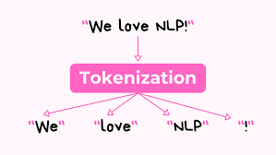

1. **Tokenization**

Detailed Explanation:

Tokenization is the process of breaking down a text into individual units, typically words or phrases, known as tokens. These tokens serve as the building blocks for further analysis in natural language processing.

Brief Summary:

Tokenization involves breaking down a text into its constituent tokens.

Working:

The text is split into smaller units (tokens) based on predefined rules, often involving spaces or punctuation.

Tokenization is a crucial step in various natural language processing tasks.

Examples:

Sentence: "Tokenization is essential in NLP."

Tokens: ["Tokenization", "is", "essential", "in", "NLP"]

Applications:

Text analysis in search engines

Building language models

Named Entity Recognition

Limitations:

Handling of certain linguistic nuances, like contractions, can be challenging.

Real-World Tools:

NLTK (Natural Language Toolkit in Python)

spaCy (Python library)

Tokenizer in TensorFlow

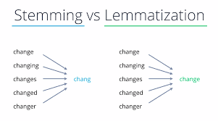

1. **Stemming**

Detailed Explanation:

Stemming is a text normalization technique that involves reducing words to their root or base form. The goal is to capture the core meaning of words by removing suffixes.

Brief Summary:

Stemming is the process of reducing words to their base or root form.

Working:

Commonly involves removing prefixes or suffixes from words to obtain the root.

The resulting stem may not always be a valid word.

Examples:

Original Word: "running"

Stem: "run"

Applications:

Information retrieval systems

Search engines

Text mining and analysis

Limitations:

Overstemming (aggressive reduction) can result in loss of meaning.

May produce stems that are not actual words.

Real-World Tools:

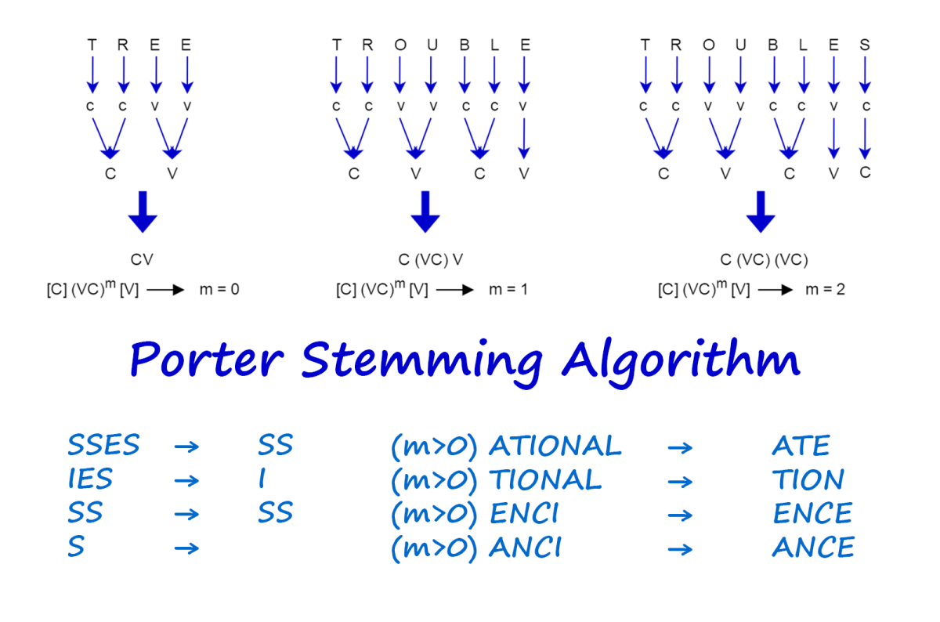

1. **Porter Stemmer (commonly used algorithm)**

Snowball Stemmer

NLTK and spaCy libraries in Python

Lemmatization

Detailed Explanation:

Lemmatization is another text normalization technique that involves reducing words to their base or dictionary form (lemma). Unlike stemming, lemmatization produces valid words.

Brief Summary:

Lemmatization is the process of reducing words to their base or dictionary form.

Working:

Involves removing inflections and variations to obtain the base form.

Utilizes dictionaries or morphological analysis for accuracy.

Examples:

Original Word: "running"

Lemma: "run"

Applications:

Information retrieval in databases

Text summarization

Machine translation

Limitations:

Computational complexity is higher than stemming.

Requires access to a comprehensive lexicon or dictionary.

Real-World Tools:

WordNet (lexical database used in lemmatization)

spaCy (Python library)

NLTK in Python

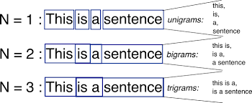

1. **N-Gram Modeling**

Detailed Explanation:

N-Gram Modeling is a statistical language modeling technique used to model the likelihood of a sequence of words or tokens in a given text. The "N" in N-Gram refers to the number of consecutive items considered as a unit (e.g., words, characters) in the sequence.

Brief Summary:

N-Gram Modeling involves analyzing the frequency and probability of sequences of N consecutive items in a given text.

Working:

An N-Gram is a contiguous sequence of N items (words, characters, etc.) from a given text.

The model estimates the probability of occurrence for each N-Gram based on observed frequencies in a training corpus.

N-Gram probabilities are often used in tasks such as language modeling, prediction, and information retrieval.

Examples:

For N=2 (bigram), the sentence "I love natural language processing" would be split into pairs: ["I love", "love natural", "natural language", "language processing"].

Applications:

Language Modeling: Predicting the likelihood of a sequence of words.

Speech Recognition: Recognizing spoken words based on probabilities.

Text Prediction: Predicting the next word in a sequence.

Limitations:

Sparsity: The frequency of many N-Grams can be low, leading to sparse data.

Memory Requirements: Storage of N-Gram models can be memory-intensive, especially for large N.

Real-World Tools:

Natural Language Toolkit (NLTK): Provides tools for N-Gram modeling in Python.

n-gram R package: Offers functions for N-Gram analysis in R.

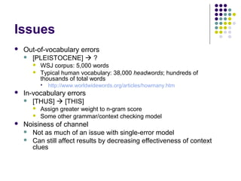

1. **N-Gram Modeling Problem**

Detailed Explanation:

One problem associated with N-Gram Modeling is the challenge of handling sparsity in language data. Sparsity arises when dealing with a large vocabulary, as not all possible N-Grams may be observed in the training data.

Brief Summary:

The sparsity problem in N-Gram Modeling refers to the scarcity of observed N-Grams in a language corpus.

Working:

In languages with large vocabularies, the number of possible N-Grams grows exponentially with N.

Many potential N-Grams are not observed in the training data, leading to sparse data issues.

Sparsity affects the accuracy of probability estimations for unseen N-Grams.

Examples:

In a language with a vast vocabulary, many possible word combinations may not occur frequently in the training data, leading to sparse N-Gram counts.

Applications:

Language Modeling: Accurate estimation of probabilities for unseen N-Grams is crucial for effective language modeling.

Speech Recognition: Sparse N-Gram data can impact the recognition accuracy of spoken words.

Limitations:

Probability Estimation: Estimating probabilities for unseen N-Grams is challenging due to sparse data.

Model Accuracy: Sparsity can lead to inaccurate language models, affecting prediction and recognition tasks.

Real-World Tools:

Tools for addressing the sparsity problem include techniques such as smoothing (e.g., add-one smoothing) to adjust probability estimates for unseen N-Grams.

# **n gram Numerical | Predict the probability of the sentence | natural Language Processing**

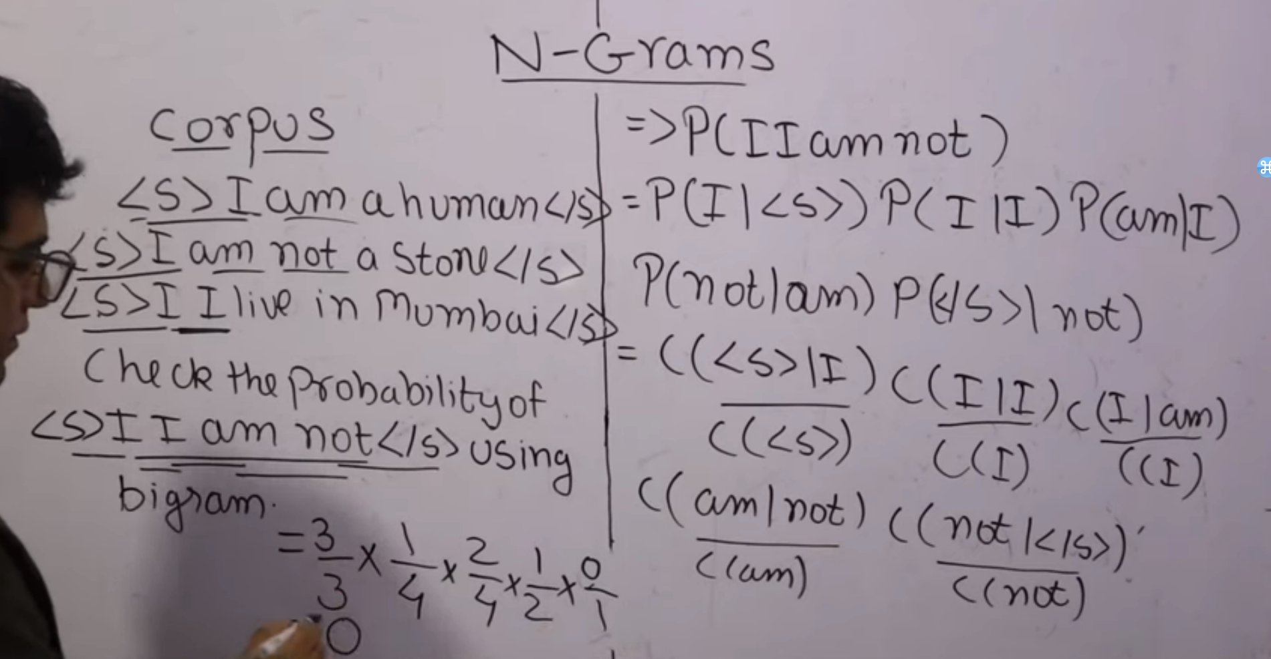

# **N gram Numerical | Predict the next word | Natural Language Processing**

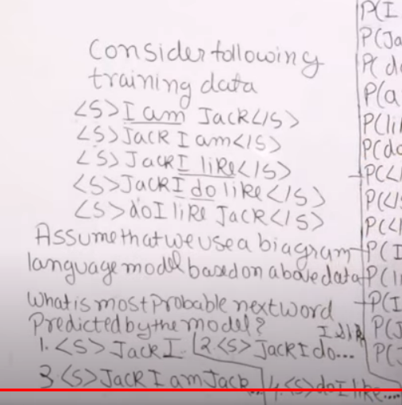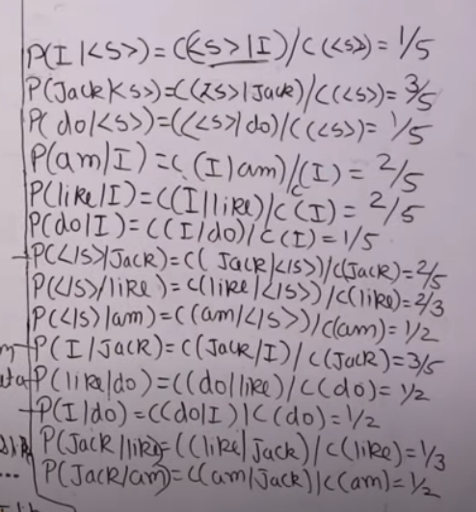

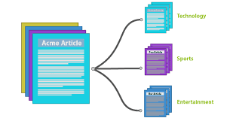

1. **Text Classification**

Detailed Explanation:

Text classification, also known as text categorization, is a natural language processing task that involves assigning predefined categories or labels to a given document or piece of text. It is a supervised learning task where a model is trained on a labeled dataset to classify unseen documents.

Brief Summary:

Text classification is the process of categorizing text documents into predefined categories using machine learning algorithms.

Working:

The process involves two main steps: training and prediction.

During training, a model learns patterns from a labeled dataset.

The model generalizes from the training data to classify new, unseen documents during prediction.

Examples:

Spam detection: Classifying emails as spam or not.

Sentiment analysis: Categorizing movie reviews as positive or negative.

Applications:

Email filtering

Topic categorization

Sentiment analysis in social media

Limitations:

Relies on labeled training data.

May struggle with ambiguous or sarcastic language.

Real-World Tools:

Scikit-learn: A machine learning library in Python.

TensorFlow and Keras: Deep learning frameworks with text classification capabilities.

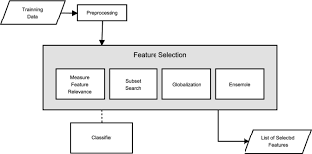

1. **Feature Selection in Text Classification**

Detailed Explanation:

Feature selection in text classification involves choosing the most relevant features or attributes from the input data to improve the model's efficiency and performance.

Brief Summary:

Feature selection is the process of choosing the most relevant attributes from the input data for text classification.

Working:

Features can include words, n-grams, or other linguistic elements.

Techniques include information gain, chi-square, and feature importance from models.

Examples:

Selecting the most informative words for sentiment analysis.

Identifying key phrases for topic categorization.

Applications:

Dimensionality reduction in large datasets.

Improved model interpretability.

Limitations:

Some information may be lost if important features are removed.

Highly dependent on the choice of feature selection method.

Real-World Tools:

Scikit-learn: Provides various feature selection methods.

NLTK and spaCy: Python libraries for natural language processing.

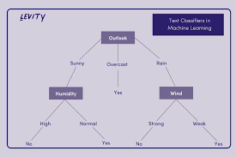

1. **Decision-Based Classifier**

Detailed Explanation:

Decision-based classifiers make decisions based on a set of rules or conditions. These rules are learned from the training data, and the model decides the category of a document by evaluating these conditions.

Brief Summary:

Decision-based classifiers make decisions using a set of predefined rules.

Working:

Rules are typically in the form of "if-then" statements.

The model applies these rules to the input data, leading to a decision or classification.

Examples:

Decision Tree classifiers: Using a tree structure to make decisions based on features.

Rule-based systems: Applying a set of rules to determine document categories.

Applications:

Medical diagnosis based on symptoms.

Fraud detection in financial transactions.

Limitations:

Limited expressiveness if the decision rules are too simplistic.

May struggle with complex relationships in data.

Real-World Tools:

Scikit-learn: Implements decision tree classifiers.

Orange: A visual programming tool for data analysis that includes decision tree classifiers.

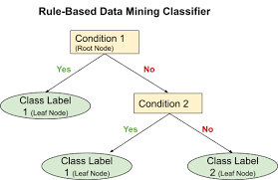

1. **Rule-Based Classifier**

Detailed Explanation:

Rule-based classifiers make decisions by applying a set of predefined rules to input data. These rules are often expressed as conditions that, when satisfied, lead to a particular classification.

Brief Summary:

Rule-based classifiers make decisions based on a set of predefined rules or conditions.

Working:

Rules are expressed in a human-readable form (e.g., "if-then" statements).

The model evaluates the input data against these rules to make a classification.

Examples:

Expert systems in medical diagnosis.

Spam filters using rules to identify spam characteristics.

Applications:

Expert systems for decision support.

Automated quality control in manufacturing.

Limitations:

May not handle complex relationships well.

Limited expressiveness if the rules are too simplistic.

Real-World Tools:

Rete Algorithm: Commonly used in rule-based systems.

Drools: A popular open-source rule engine for Java.

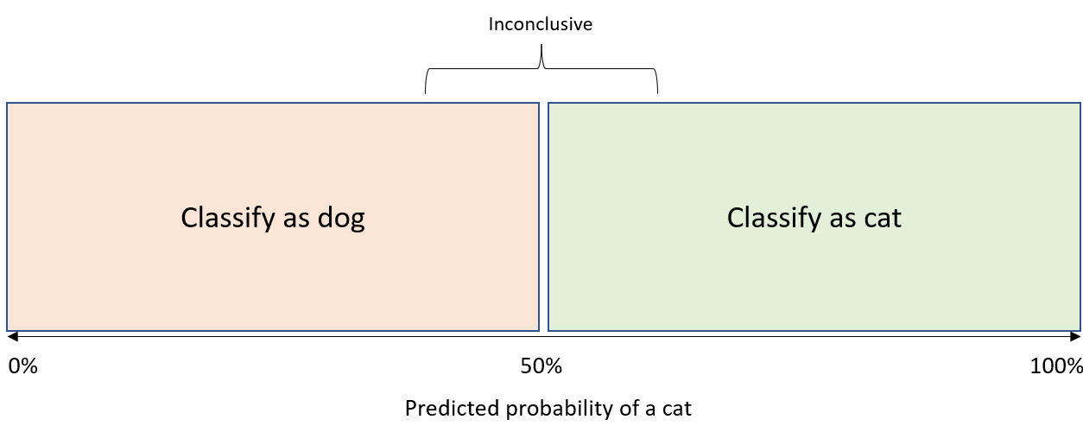

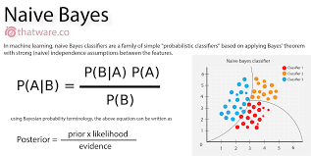

1. **Probabilistic-Based Classifier**

Detailed Explanation:

Probabilistic-based classifiers make decisions by estimating the probability of a document belonging to each category and selecting the category with the highest probability.

Brief Summary:

Probabilistic-based classifiers make decisions based on the probability of a document belonging to each category.

Working:

Probability distributions are estimated from training data.

Bayes' Theorem is often used to calculate probabilities and make classifications.

Examples:

Naive Bayes classifiers: Based on Bayes' Theorem, assuming independence between features.

Maximum Entropy classifiers: Assign probabilities to each category.

Applications:

Document categorization in information retrieval.

Spam detection based on probability distributions.

Limitations:

Assumption of feature independence may not always hold.

Sensitive to imbalances in the training data.

Real-World Tools:

Scikit-learn: Implements Naive Bayes classifiers.

NLTK: A Python library for natural language processing that includes probabilistic classifiers.

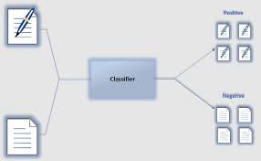

1. **Proximity-Based Classifier**

Detailed Explanation:

Proximity-based classifiers make decisions based on the similarity or proximity of a document to known examples in the training data. Documents close to each other are considered similar.

Brief Summary:

Proximity-based classifiers make decisions based on the proximity or similarity of a document to known examples.

Working:

Distance metrics, such as cosine similarity, are often used.

The model assigns a document to the category of its nearest neighbors.

Examples:

k-Nearest Neighbors (k-NN) classifiers: Assigning a category based on the categories of the k-nearest training examples.

Support Vector Machines (SVM) with a radial basis function (RBF) kernel.

Applications:

Collaborative filtering in recommendation systems.

Image categorization based on visual features.

Limitations:

Computationally expensive for large datasets.

Sensitivity to irrelevant features.

Real-World Tools:

Scikit-learn: Implements k-NN classifiers.

WEKA: A popular tool for machine learning tasks, including proximity-based classification.

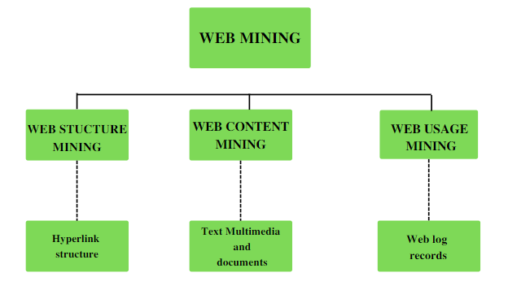

1. **Web Mining**

Detailed Explanation:

Web Mining involves extracting valuable knowledge and patterns from web data. It comprises three main categories: Web Content Mining, Web Structure Mining, and Web Usage Mining.

Brief Summary:

Web Mining is the process of extracting insights and patterns from web data, encompassing content, structure, and usage.

Working:

Web Content Mining: Extracts information from web pages, including text, images, and multimedia.

Web Structure Mining: Analyzes the relationships between web pages, such as links and hierarchies.

Web Usage Mining: Examines user interaction patterns on the web, including clicks and navigation.

Examples:

Analyzing web pages to extract product reviews (Web Content Mining).

Identifying influential pages based on link structures (Web Structure Mining).

Understanding user behavior on an e-commerce website (Web Usage Mining).

Applications:

Improving search engine results

Personalized recommendation systems

User behavior analysis for website optimization

Limitations:

Privacy concerns in Web Usage Mining.

Dynamic and constantly changing nature of web data.

Real-World Tools:

Beautiful Soup and Scrapy: Python libraries for web scraping (Web Content Mining).

NetworkX: Python library for network analysis (Web Structure Mining).

Google Analytics: A widely used tool for Web Usage Mining.

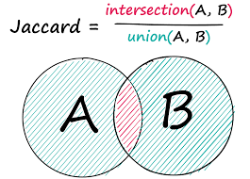

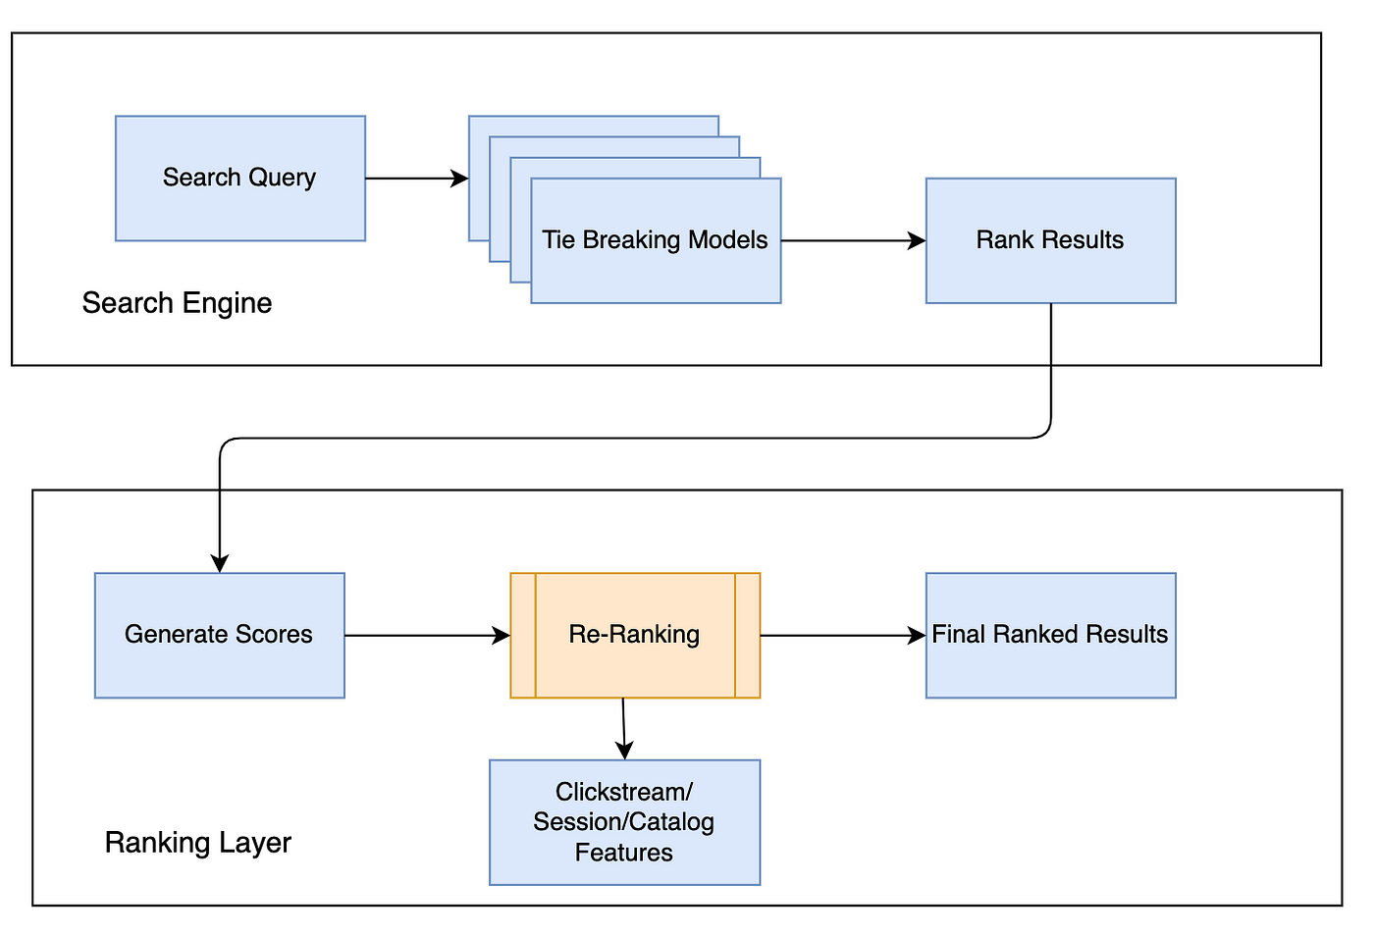

1. **Searching: Similarity Score and Rank Position**

Detailed Explanation:

Searching in the context of web mining involves retrieving relevant information from a large dataset, often measured by similarity scores and rank positions.

Brief Summary:

Web searching aims to retrieve relevant information, utilizing similarity scores and rank positions.

Working:

Similarity Scores: Measure the similarity between a query and documents in a dataset. Common methods include cosine similarity and Jaccard similarity.

Rank Position: Ranks documents based on relevance to a query, with the most relevant appearing first.

Examples:

Search engine results displaying pages based on similarity to a search query.

Recommender systems ranking products based on user preferences.

Applications:

Information retrieval in search engines.

Personalized content recommendation.

Limitations:

Sensitivity to query formulation.

Challenges in handling semantic meaning.

Real-World Tools:

Elasticsearch and Solr: Search engines with similarity score and ranking capabilities.

TF-IDF (Term Frequency-Inverse Document Frequency): Commonly used for scoring and ranking documents based on term relevance.

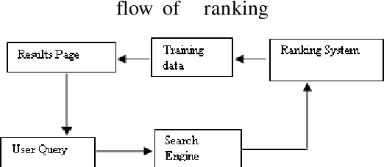

1. **Ranking**

Detailed Explanation:

Ranking in web mining refers to the process of arranging items in a specific order based on their relevance or importance.

Brief Summary:

Ranking involves ordering items based on their relevance or importance.

Working:

Algorithms assess various factors, such as similarity scores, user behavior, or popularity.

The ranked list is then presented to users, with the most relevant items at the top.

Examples:

Search engine results ranking pages based on relevance to a query.

E-commerce platforms ranking products based on customer reviews and preferences.

Applications:

Search engine result pages

Recommender systems

Content curation on social media platforms

Limitations:

Dynamic nature of web content requires constant re-ranking.

Challenges in handling personalized preferences.

Real-World Tools:

PageRank: Google's algorithm for ranking web pages.

Collaborative Filtering: Used in recommender systems for personalized ranking.

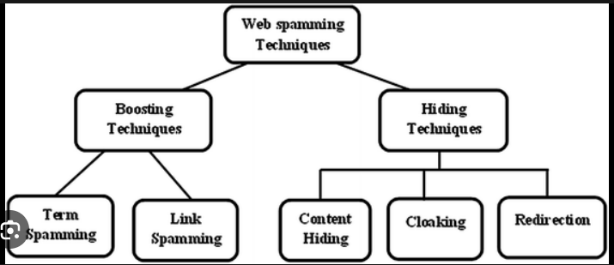

1. **Web Spamming**

Detailed Explanation:

Web spamming involves manipulating search engine rankings by employing deceptive techniques to make a website appear more relevant or authoritative than it actually is.

Brief Summary:

Web spamming is the use of deceptive techniques to manipulate search engine rankings.

Working:

Techniques include keyword stuffing, cloaking, link spamming, and hidden text.

The goal is to trick search engines into assigning higher rankings to a web page.

Examples:

Stuffing a webpage with irrelevant keywords to increase search visibility.

Creating fake backlinks to artificially boost a site's authority.

Applications:

Unethical promotion of websites for higher search rankings.

Limitations:

Risk of penalties and blacklisting from search engines.

Negative impact on the user experience and search engine relevance.

Real-World Tools:

Google Search Console: Helps identify and rectify issues related to web spam.

SpamAssassin: An open-source tool for detecting email spam, but principles can be applied to web content.