Contents

1. Introduction 2

1.1. Background: 2

1.2. Objectives: 2

1.3. Purpose, Scope and Applicability 2

1.3.1. Purpose: 2

1.3.2. Scope 2

1.3.3. Applicability 2

1.4. Project Products 2

2. Survey of Technologies 3

3. Requirements and Analysis 4

3.1. Problem Definition 4

3.2. Requirement Specification 4

3.3. Planning and Scheduling 5

3.4. Software and Hardware Requirements 5

3.5. Preliminary Product Description 5

3.6. Conceptual Models 6

4. System Design 7

4.1. Use Case Diagrams: 7

4.2. User Interface: 8

# Introduction

## Background:

Many colleges have their own websites that support large screen devices such as PC’s and Laptops only. When they are opened in mobile devices, they either lack in design or resolution support. The notices posted in the website are jumbled too and not properly sorted.

To solve this issue for mobile devices and app named MyCollege app will be developed. The MyCollege app will be a mobile application available to android user. The app will provide access to all sorts of notices with easy navigation that are displayed on the college website in one click. The app will allow the users to download the particular notices and view them on the go. It is not only for the students but for the Professors too. Professors can upload notices on the app from anywhere anytime which will be also reflected on the website.

## Objectives:

The main objective of this project is to provide ease to students while accessing their college notices and save time. The MyCollege app is expected to:

* Provide a user-friendly interface to access their account and view notices.
* Function in simple and initiative manner.

## Purpose, Scope and Applicability

## Purpose:

This project is under taken to help students in finding and downloading the notices in proper and well organised format as compared to the current website that they are using to view notices in their mobile devices.

## Scope

This project will solve the issues of viewing and downloading the notices in mobile devices and will give the professors flexibility of upload notices through their mobile devices with and ease.

## Applicability

With the help of MyCollege app students and professors can view and download any notices on the go without any hesitation or without facing the problems that they encounter while surfing on the website.

This application also gives professors flexibility to post any notices on the go, rather than visiting the data center and uploading the notice.

The notices uploaded through the mobile device will also be reflected on the website.

## Project Products

The following products will be handed will the Project:

* Training Manual: Will be shown on Start as the User Registers and will be an in-app module.
* Mobile Applications: Final product that will run on both Android OS and iOS.

# Survey of Technologies

For this project we are using “Flutter” Platform which uses “Dart” languages. Apps developed on Flutter are light weight and run on Android OS and iOS simultaneously. The competitors of Flutter are Kiwi which uses Python, Android Kotlin/Java, Swift.

The libraries of Kiwi are not as developed as that of others so the UI’s made on it are not good and pleasing to others, on the other hand Kotlin/Java can only be used to make applications that run on Android OS and this increases the work of developer as he needs to again develop code for other platforms. Same goes in case of Swift it only supports iOS development.

The benefits of Flutter are:

* **Extremely Fast App Development:** With features like Hot-reload, code changes in Flutter are reflected as soon as the alterations are made. The Hot-reload usually doesn’t take more than milliseconds, which in turn, helps developers to maintain high speeds and dynamicity for mobile app development. Flutter widgets assist in the creation of native interfaces within few minutes.
* **Faster Running of Applications:** Flutter apps provide smooth and seamless scrolling experiences while in use, without much hangs or cuts.
* **Reduced Efforts of Testing:** Since Flutter apps are cross-platform, the testers do not always require to run the same set of tests on different platforms, such as iOS and Android, for the same app. Cross-platform application development enables applications to run on multiple platforms by writing the programming code only once (follows the WORA concept). This saves the time of the testing team. Thus, Flutter is used extensively by every mobile app developer, Utah**,** for faster testing, delivery and deployment of mobile applications.
* **Access of Native Features:** It is extremely simple to set-up Flutter. Application developers can easily have access to native features of low-level machines where Flutter is initiated. Since it is cross-platform in nature, codes written in existing Swift, Java, Objective-C, etc. can be reused again and again.
* **Excellent User Interfaces:** With built-in design-centric widgets, high-end development tools, advanced APIs, scrolling and navigation features, etc., Flutter helps in the creation of stunning and expressive user interfaces.
* **Reactive Framework:** With reactive framework, the developers do not need to update UI contents manually. Once the variables are updated, the UI changes will be visible automatically.
* **Good for MVP:** Flutter is good for developing MVP (Minimum Viable Product) apps due to its speedy development process and cross-platform nature. The cross-platform concept also aids in reducing costs when apps are developed with Flutter. Many modern undertakings and SMEs are thus employing flutter to increase development speeds and get the maximum outputs at lower costs.

The Flutter framework is organized into a series of layers, with each layer building upon the previous layer.

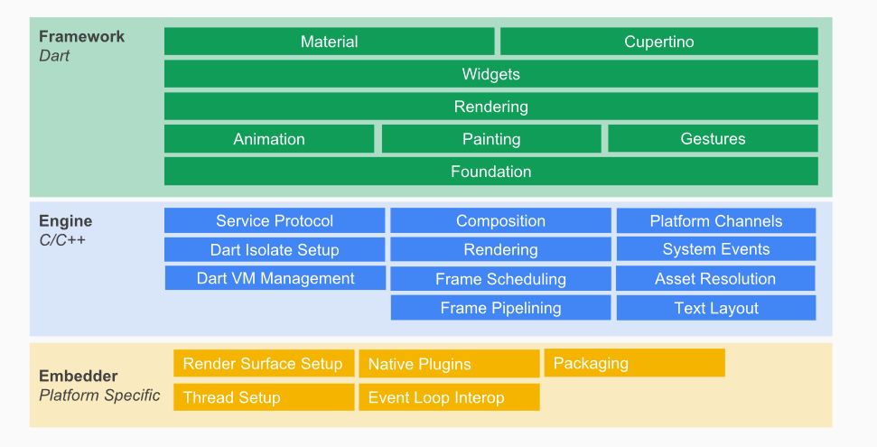

The upper layers of the framework are used more frequently than the lower layers.

The goal of this design is to help you do more with less code. For example, the Material layer is built by composing basic widgets from the widgets layer, and the widgets layer itself is built by orchestrating lower-level objects from the rendering layer.

The layers offer many options for building apps. Choose a customized approach to unlock the full expressive power of the framework, or use building blocks from the widgets layer, or mix and match. You can compose the ready-made widgets Flutter provides, or create your own custom widgets using the same tools and techniques that the Flutter team used to build the framework.

Nothing is hidden from you. You reap the productivity benefits of a high-level, unified widget concept, without sacrificing the ability to dive as deeply as you wish into the lower layers.

# Requirements and Analysis

## Problem Definition

Vision method

## Requirement Specification

Login Module:

* User name
* Password

Registration Module:

* College name
* Email ID
* Full Name
* Contact no.
* Email Verification
* New Password
* Confirm Password

Notice Module

* Notice Name
* Date of Upload
* Uploader’s name
* Time Limit
* Tags

## Planning and Scheduling

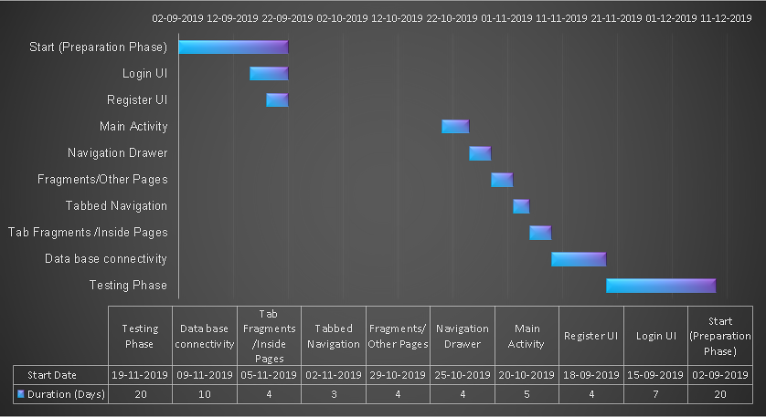

## Software and Hardware Requirements

Client-Side Requirements:

* Require a smart phone with either Android OS or iOS.
* Require Internet Connection.
* Android version 5.1.0+ and iOS version 6+.

Developer Side Requirements:

* PC/Laptop with min Ram of 4gb.
* Local Host or Web hosting.
* Emulator or physical device with Android version 5.1.0 or higher and iOS version 6 or higher.

## Preliminary Product Description

It is going to have 1 login screen and 1 registration screen. Once the user logins successfully he will be automatically logged in each time he opens the app. The app will have auto sync after every 5 minutes. App will have Notice board section consisting of 3 tabs namely: General, Admissions, Scholarship. It will have Results, Timetable and Profile section. Results will have further 3 sections i.e. Regular, ATKT and Revaluation and Timetable will have 2 Regular and Exams timetable.

The Profile section will have all the details of the student which will be inevitable. The app will have settings tab so set the font and skin of app and a share button to share the app.

## Conceptual Models

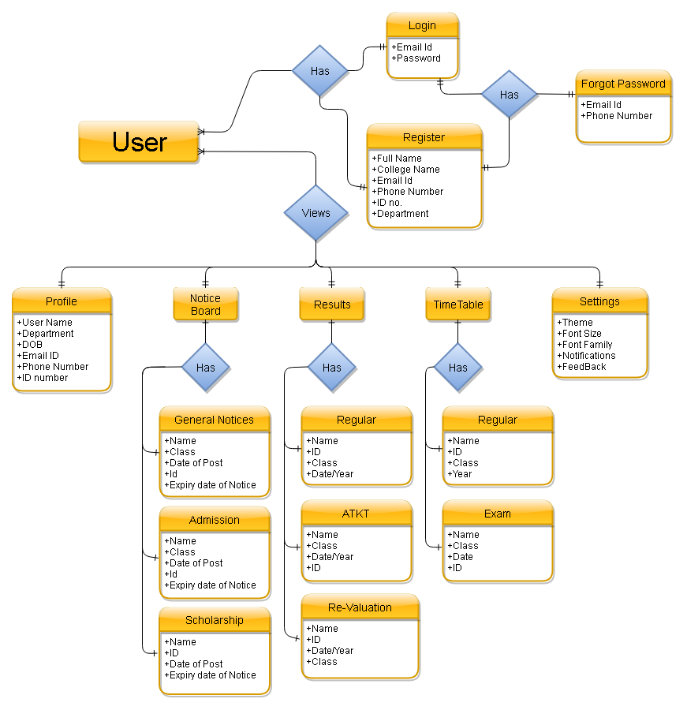

# System Design

## Use Case Diagrams:

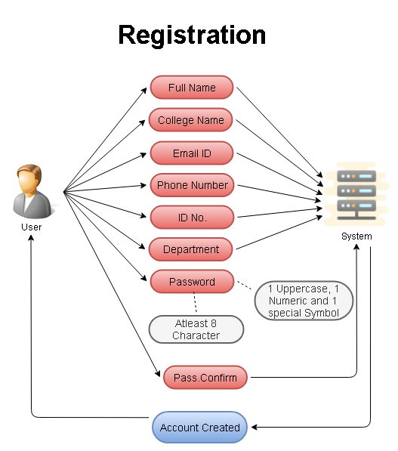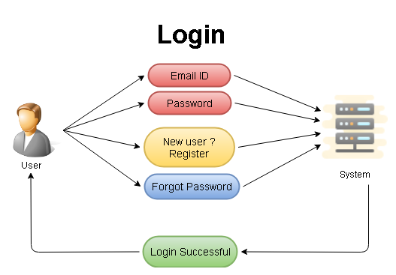

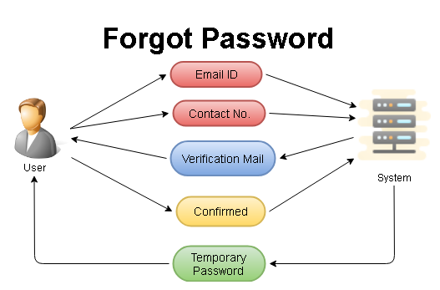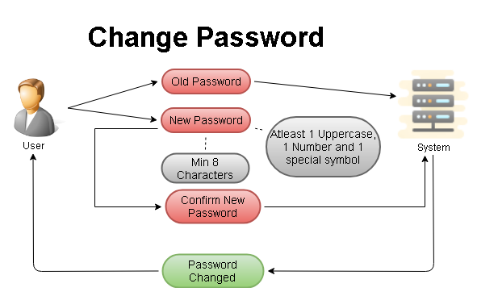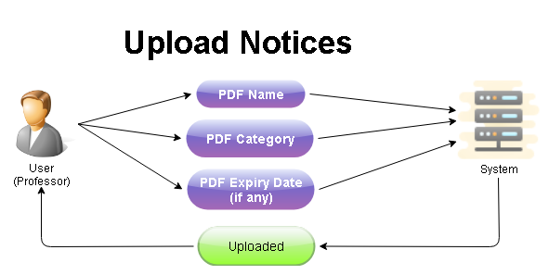

## User Interface: