**K.J SOMAIYA COLLEGE OF SCIENCE AND COMMERCE**



**Python Project**

**2018-2019**

**Date: 10/10/2018 Time: 9:30**

**Name Of Student : Atharva Bipin Pradhan**

**Roll No. : 53**

**Class : SYIT**

**Seat No. : 18-6553**

**Subject : Python**

**Topic : POS ( Point of Sales )**

**NAME OF FACULTY STAMP AND SIGNATURE**

About the Project

The project is a POS application. Here the user selects the item he wants from the menu, sets the quantity of the selected item and then proceeds for the bill. When the bill button is clicked a popup occurs asking for payment through Cash/Card. If the user clicks on Cash option the bill is immediately generated and the data is saved in the database. If the user click on card option another window popups asking for card details. If the user clicks on the cancel button he is again reverted back to the previous popup. If the user want to add more item at that time he can simply click the cancel button again and go and select required items. If the user click on the cancel button that is beside the buy button the data i.e. the item that he has selected are being removed from the Cart.

Outputs of the code

Here are some of the outputs of the code

Initial page ( Start page/Index):

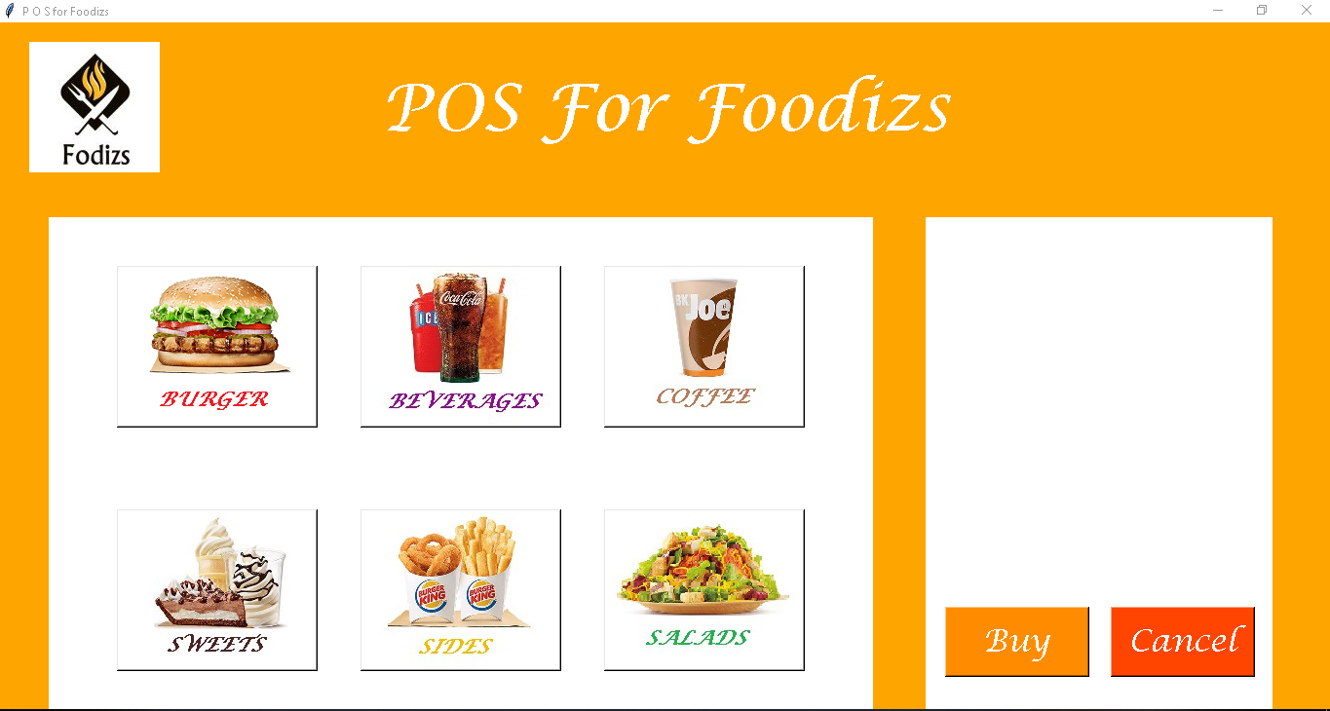

When you select an item/product

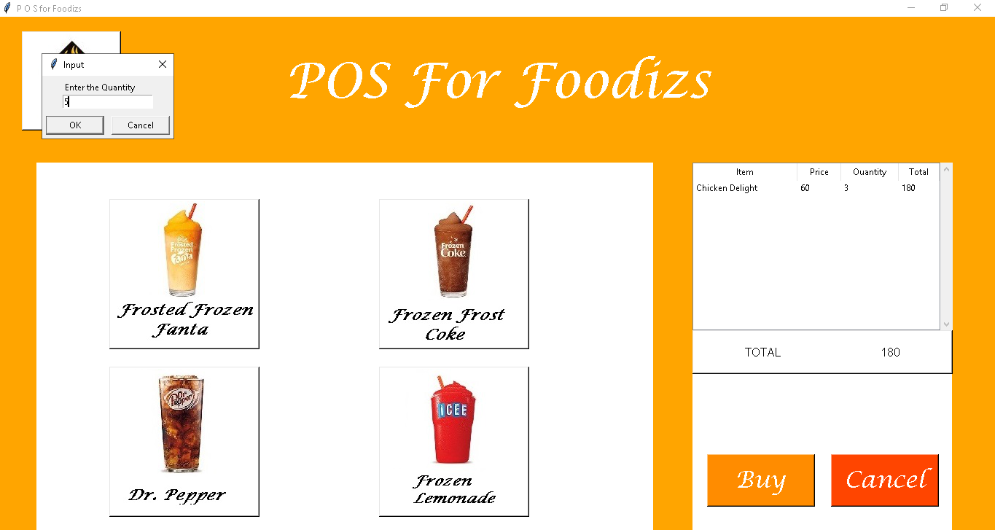

When you click on buy button

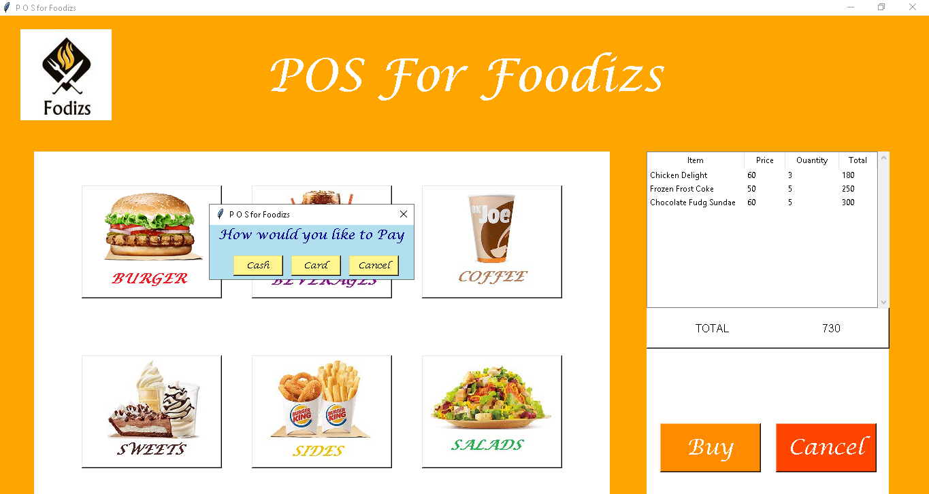

When you click on Cash button/Cancel Button

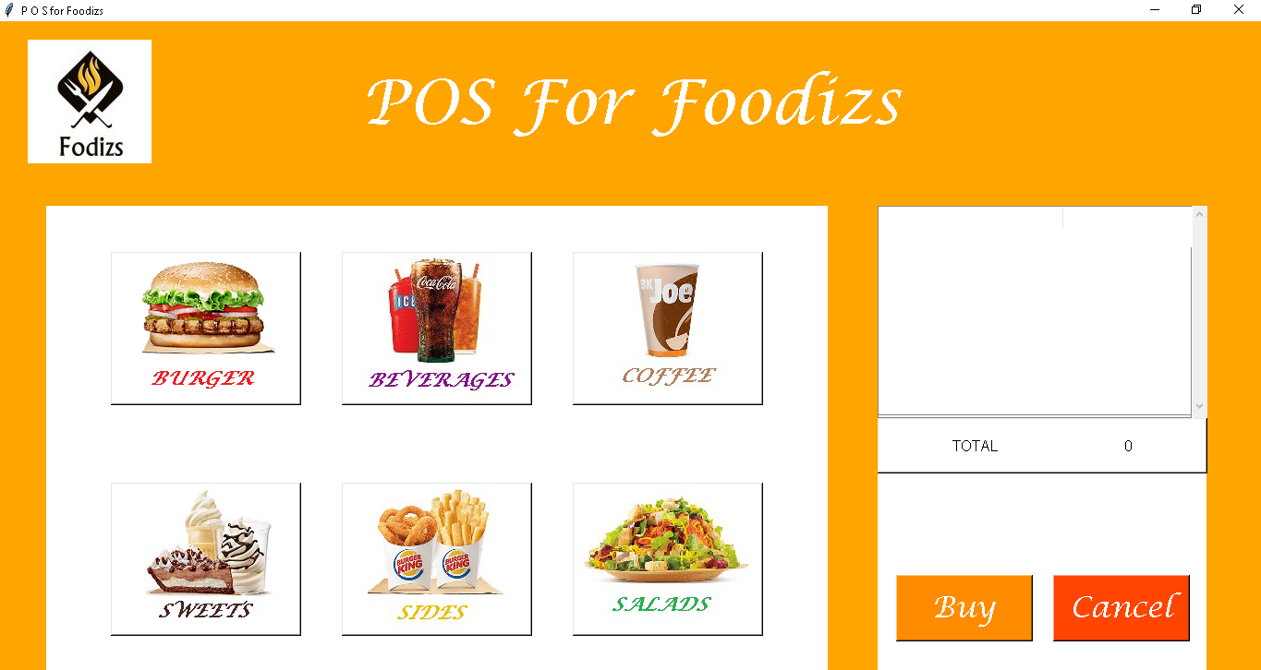

When You click on Card Button

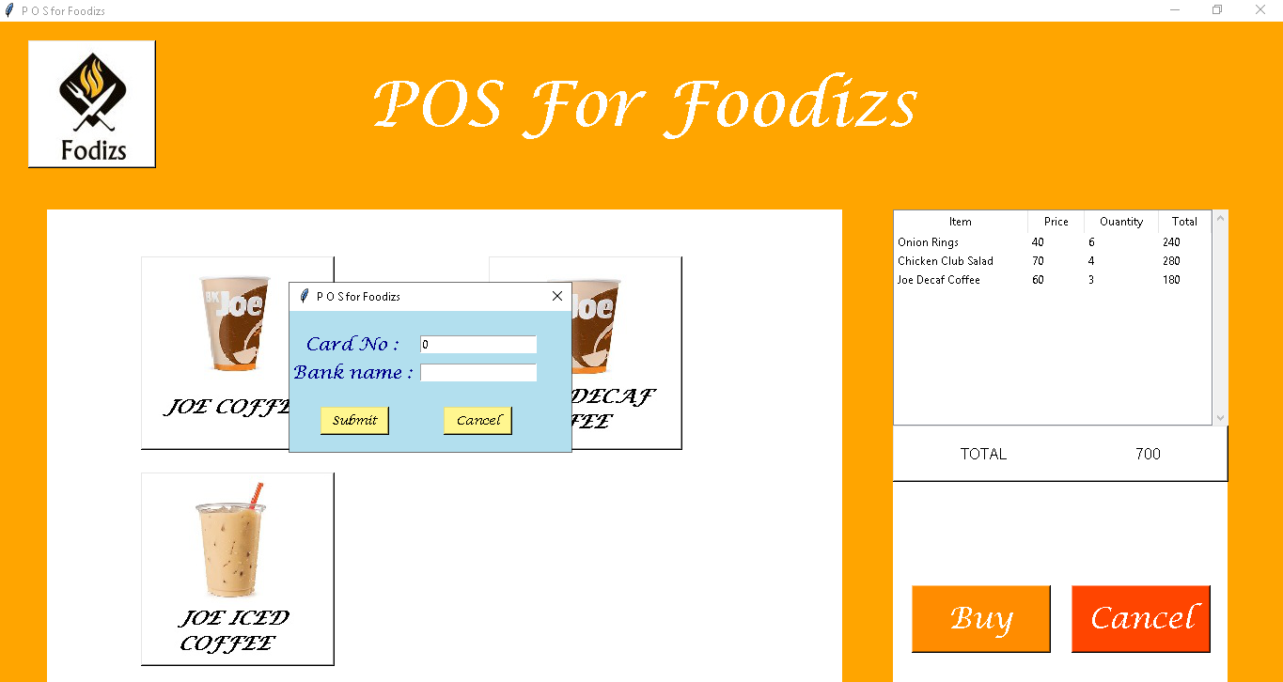

Project Code

import tkinter as tk

from PIL import Image, ImageTk

from tkinter.ttk import *

from tkinter import simpledialog

import sqlite3

import tkinter.ttk as ttk

import tkinter.font as tkFont

#from tkinter import scrolledtext

from tkinter import messagebox

import time

import datetime

lf= ("Lucida Calligraphy", 50)

lf2= ("Lucida Calligraphy", 24)

lf3= ("Lucida Calligraphy", 14)

lf4 = ("Lucida Calligraphy",10)

class Mainwindow(tk.Tk):

def __init__(self): # initalized main window

tk.Tk.__init__(self) # initalized Tkinter

container = tk.Frame(self)

container.pack(side="top", fill="both", expand = True) # fill fills in the limits & expand is beyond limits

container.grid_rowconfigure(0, weight=10)

container.grid_columnconfigure(0, weight=10)

self.frames = {}

for F in (StartPage, PageOne, PageTwo, PageThree, PageFour, PageFive, PageSix):

frame = F(container, self)

self.frames[F] = frame

frame.grid(row=0, column=0, sticky="nsew") # north south east west

self.show_frame(StartPage)

def show_frame(self, cont):

frame = self.frames[cont]

frame.tkraise()

orderlist = []

banklist = []

heading = ['Item','Price','Ouantity','Total']

def recall(self,xi,xi1,yi,zi): #data1, data2 , tree , answer(qty)

ai = 0

total_value = 0

aaa = xi[0] # Product name

aab = xi[1]+xi[2] # Product-id + Sub-Product-id

bbb = xi1[0] # Quantity

bbb1 = bbb[0] # Selling Price

ccc = bbb1 * zi # Total = qty * price

ccd = (aaa,aab,bbb1,zi,ccc) # Pr_name, Pr_id, SP ,Qty, Total

Mainwindow.orderlist.append(ccd)

for col in Mainwindow.heading:

yi.heading(col,text=col.title()) # Creating Tile display for Headings

yi.column(col, width=tkFont.Font().measure(col.title())) # Adjusting it in a box

while ai <len(Mainwindow.orderlist):

x = Mainwindow.orderlist[ai]

cce = (x[0],x[2],x[3],x[4]) # Item , Price , Quantity , Total

total_value = total_value + x[4]

yi.insert('', 'end', values=cce)

yi.column(Mainwindow.heading[0],width=120)

ai = ai+1

listbx=tk.Label(self,text ='TOTAL '+str(total_value),

width=39,height=3,bg='white',relief= tk.RAISED,font = 16)

listbx.place(x=950,y=430)

def myy(self,x1,x2,x3):

conn = sqlite3.connect('master.db')

c = conn.cursor()

if x1==1:

answer = simpledialog.askinteger("Input", "Enter the Quantity",minvalue=1, maxvalue=100)

if answer is None:

self.destroy

else:

def select_my_table(answer,item_x,cd):

c.execute("SELECT Sub_r_name,Pr_id,Sub_pr_id FROM sub_product_id WHERE Sub_pr_id = (?) AND Pr_id = (?)",(item_x,cd))

data = c.fetchone()

c.execute("SELECT SP,Tax FROM pr_price WHERE Sub_pr_id = (?) AND Tax > (?)",(item_x,0))

data_2 = c.fetchall()

conn.commit()

tree = ttk.Treeview(self,columns = Mainwindow.heading,show = 'headings')

vsb = ttk.Scrollbar(orient="vertical",command=tree.yview)

tree.configure(yscrollcommand=vsb.set)

tree.place(x=950,y=200,height=230,width=340)

vsb.place(x=1290,y=200,height=230)

self.recall(data,data_2,tree,answer)

select_my_table(answer,x2,x3)

c.close()

conn.close()

def reset(self):

del Mainwindow.orderlist[0:]

tree = ttk.Treeview(self,columns = Mainwindow.heading,show = 'headings')

vsb = ttk.Scrollbar(orient="vertical",command=tree.yview)

tree.configure(yscrollcommand=vsb.set)

tree.insert('', 'end', values=Mainwindow.orderlist)

tree.place(x=950,y=200,width=340)

vsb.place(x=1290,y=200,height=225)

listbx=tk.Label(self,text ='TOTAL '+str(0),

width=39,height=3,bg='white',relief= tk.RAISED,font = 16)

listbx.place(x=950,y=430)

def popup(self):

Popup(self)

def bank(self):

Bank(self)

def buy1(self,x,y):

Mainwindow.banklist.append(x)

Mainwindow.banklist.append(y)

def buy(self,cc1):

conn = sqlite3.connect('transaction.db')

c = conn.cursor()

c.execute("SELECT MAX(Bill_no) FROM Total_Sales")

no = c.fetchone()

#print(no)

billno = no[0]

#print(billno)

billno=billno+1

ai = 0

unix = time.time()

dt = str(datetime.datetime.fromtimestamp(unix).strftime('%d-%m-%y '))

t = str(datetime.datetime.fromtimestamp(unix).strftime('%H:%M:%S'))

#print(dt,t)

aad1 = 0

flag = 0

while ai < len(Mainwindow.orderlist):

aaa = Mainwindow.orderlist[ai]

aad = aaa[4] # individual value

aad1 = aad1+aad

ai=ai+1

aae=aad1

print(aae)

def billinfo(billno,dt,t,c,conn):

aad1 = 0

ai = 0

while ai < len(Mainwindow.orderlist):

aaa = Mainwindow.orderlist[ai]

aab = aaa[1] # Pr_cd

aac = aaa[3] # total qty

aad = aaa[4] # individual value

aad1 = aad1+aad # total value

c.execute("INSERT INTO Bill_info VALUES (?, ?, ?, ?, ?, ?, ?, ?)",('T12035', billno, 'T001', dt, t, aab, aac, aad))

conn.commit()

ai=ai+1

if cc1==2:

self.bank()

try:

cd_no = Mainwindow.banklist[0]

bk_n = Mainwindow.banklist[1]

del Mainwindow.banklist[0:]

except IndexError:

flag = 1

if flag == 0:

c.execute("INSERT INTO Total_Sales VALUES (?, ?, ?, ?, ?, ?, ?)",(billno,dt,t,aad1,cc1,cd_no,bk_n))

conn.commit()

billinfo(billno,dt,t,c,conn)

else:

c.execute("INSERT INTO Total_Sales (Bill_no,Date,Time,Amt,Cash_Card) VALUES(?, ?, ?, ?, ?)",(billno,dt,t,aad1,cc1))

conn.commit()

billinfo(billno,dt,t,c,conn)

c.close()

conn.close()

self.reset()

class Bank(tk.Toplevel):

def __init__(self, master):

tk.Toplevel.__init__(self, master)

self.geometry('300x150+300+300')

label = tk.Label(self,height = self.winfo_screenheight(),width = self.winfo_screenwidth(),bg='LightBlue2',)

label.place(x=0,y=0)

tk.Label(self,bg='LightBlue2').grid(row=1)

tk.Label(self,text="Card No : ",bg='LightBlue2',fg='blue4',font=lf3).grid(row=3)

tk.Label(self,text="Bank name : ",bg='LightBlue2',fg='blue4',font=lf3).grid(row=5)

tk.Label(self,bg='LightBlue2').grid(row=6)

var = tk.IntVar()

tk.Entry(self,textvariable=var).grid(row = 3,column = 2)

var1 = tk.StringVar()

tk.Entry(self, textvariable=var1).grid(row = 5,column = 2)

B1 = tk.Button(self, text="Submit",width = 7,bg = 'khaki1',font=lf4,command=lambda:checkout(var.get(),var1.get()))

B1.grid(row = 15,column = 0)

B2 = tk.Button(self, text="Cancle",width = 7,bg = 'khaki1',font=lf4,command=lambda:rollbk())

B2.grid(row = 15,column = 2)

def checkout(x,y):

self.destroy()

master.buy1(x,y)

def rollbk():

self.destroy()

master.popup()

self.transient(master) #set to be on top of the main window

self.grab_set() #hijack all commands from the master (clicks on the main window are ignored)

master.wait_window(self) #pause anything on the main window until this one closes (optional)

class Popup(tk.Toplevel):

def __init__(self, master):

tk.Toplevel.__init__(self, master)

self.geometry('300x80+300+300')

label = tk.Label(self, text="How would you like to Pay",width = self.winfo_screenwidth(),bg='LightBlue2',fg='blue4',font=lf3)

label.pack()

tk.Label(self,height = self.winfo_screenheight(),width = self.winfo_screenwidth(),bg='LightBlue2').pack(side='bottom')

B1 = tk.Button(self, text="Cash",width = 7,bg = 'khaki1',font=lf4,command=lambda:situation(1))

B1.place(x = 35 ,y = 45)

B2 = tk.Button(self, text="Card",width = 7,bg = 'khaki1',font=lf4,command=lambda:situation(2))

B2.place(x = 120 ,y = 45)

B2 = tk.Button(self, text="Cancle",width = 7,bg = 'khaki1',font=lf4,command=self.destroy)

B2.place(x = 205 ,y = 45)

def situation(x):

if x==1:

self.destroy()

master.buy(1)

else:

self.destroy()

master.buy(2)

self.transient(master) #set to be on top of the main window

self.grab_set() #hijack all commands from the master (clicks on the main window are ignored)

master.wait_window(self) #pause anything on the main window until this one closes (optional)

class StartPage(tk.Frame):

def __init__(self, parent, controller):

tk.Frame.__init__(self,parent)

f1 = textgradiant(self)

f1.pack(side="top", fill="both", expand = True)

ll = tk.Label(self,height = self.winfo_screenheight(),width = self.winfo_screenwidth(),bg='orange',fg='white')

ll.pack(side='top',fill='both')

ll2 = tk.Label(self,height = 50, width = 120,bg='white',fg='white')

ll2.place(x=50,y=200)

ll3 = tk.Label(self,height = 50, width = 50,bg='white',fg='white')

ll3.place(x=950,y=200)

load = Image.open("D:\\Python\\project_py\\fodiz.jpg")

render = ImageTk.PhotoImage(load)

img = tk.Label(self, image= render,width=130,bg='white')

img.image = render

img.place(x=30,y=20)

load1 =Image.open("D:\\Python\\project_py\\mainburger.png")

render1 =ImageTk.PhotoImage(load1)

img1 = tk.Label(self, image= render1)

img1.image = render1

load2 = Image.open("D:\\Python\\project_py\\Beverages.jpg")

render2 = ImageTk.PhotoImage(load2)

img2 = tk.Label(self, image= render2)

img2.image = render2

load3 = Image.open("D:\\Python\\project_py\\coffee.jpg")

render3 = ImageTk.PhotoImage(load3)

img3 = tk.Label(self, image= render3)

img3.image = render3

load4 = Image.open("D:\\Python\\project_py\\Sweets.jpg")

render4 = ImageTk.PhotoImage(load4)

img4 = tk.Label(self, image= render4)

img4.image = render4

load5 = Image.open("D:\\Python\\project_py\\Sides.jpg")

render5 = ImageTk.PhotoImage(load5)

img5 = tk.Label(self, image= render5)

img5.image = render5

load6 = Image.open("D:\\Python\\project_py\\Salads.jpg")

render6 = ImageTk.PhotoImage(load6)

img6 = tk.Label(self, image= render6)

img6.image = render6

button = tk.Button(self, image=img1.image, height=160, width=200,borderwidth=2,bg='white',

command=lambda: controller.show_frame(PageOne))

button.place(x = 120, y = 250)

button2 = tk.Button(self, image=img2.image, height=160, width=200,borderwidth=2,bg='white',

command=lambda: controller.show_frame(PageTwo))

button2.place(x = 370, y = 250)

button3 = tk.Button(self, image=img3.image, height=160, width=200,borderwidth=2,bg='white',

command=lambda: controller.show_frame(PageThree))

button3.place(x = 620, y = 250)

button4 = tk.Button(self, image=img4.image, height=160, width=200,borderwidth=2,bg='white',

command=lambda: controller.show_frame(PageFour))

button4.place(x = 120, y = 500)

button5 = tk.Button(self, image=img5.image, height=160, width=200,borderwidth=2,bg='white',

command=lambda: controller.show_frame(PageFive))

button5.place(x = 370, y = 500)

button6 = tk.Button(self, image=img6.image, height=160, width=200,borderwidth=2,bg='white',

command=lambda: controller.show_frame(PageSix))

button6.place(x = 620, y = 500)

tk.Button(self, text = "Buy", bg="dark orange", fg="white",height=1,width=6, font=lf2, command=lambda:controller.popup()).place(x=970,y=600)

tk.Button(self, text = "Cancle", bg="orange red", fg="white",height=1,width=6, font=lf2, command=lambda:controller.reset()).place(x=1140,y=600)

class PageOne(tk.Frame):

def __init__(self, parent, controller):

tk.Frame.__init__(self,parent)

f1 = textgradiant(self)

f1.pack(side="top", fill="both", expand = True)

ll = tk.Label(self,height = self.winfo_screenheight(), width = self.winfo_screenwidth(),bg='orange',fg='white')

ll.pack(side='top',fill='both')

tk.Label(self,height = 50, width = 120,bg='white',fg='white').place(x=50,y=200)

tk.Label(self,height = 50, width = 50,bg='white',fg='white').place(x=950,y=200)

load = Image.open("D:\\Python\\project_py\\fodiz.jpg")

render = ImageTk.PhotoImage(load)

img = tk.Label(self, image= render)

img.image = render

load1 =Image.open("D:\\Python\\project_py\\burger\\burger1.png")

render1 =ImageTk.PhotoImage(load1)

img1 = tk.Label(self, image= render1)

img1.image = render1

load2 = Image.open("D:\\Python\\project_py\\burger\\burger2.jpg")

render2 = ImageTk.PhotoImage(load2)

img2 = tk.Label(self, image= render2)

img2.image = render2

load3 = Image.open("D:\\Python\\project_py\\burger\\burger3.jpg")

render3 = ImageTk.PhotoImage(load3)

img3 = tk.Label(self, image= render3)

img3.image = render3

load4 = Image.open("D:\\Python\\project_py\\burger\\burger4.jpg")

render4 = ImageTk.PhotoImage(load4)

img4 = tk.Label(self, image= render4)

img4.image = render4

button0 = tk.Button(self,width= 130, image=img.image,borderwidth=2,bg='white',command=lambda: controller.show_frame(StartPage))

button0.place(x=30,y=20)

button = tk.Button(self,image=img1.image, height=200, width=200,bg='white',command=lambda:controller.myy(1,1,100))

button.place(x = 150, y = 250)

button2 = tk.Button(self, image=img2.image, height=200, width=200,bg='white',command=lambda:controller.myy(1,2,100))

button2.place(x = 520, y = 250)

button3 = tk.Button(self, image=img3.image, height=200, width=200,bg='white',command=lambda:controller.myy(1,4,100))

button3.place(x = 150, y = 480)

button4 = tk.Button(self, image=img4.image, height=200, width=200,bg='white',command=lambda:controller.myy(1,3,100))

button4.place(x = 520, y = 480)

tk.Button(self, text = "Buy", bg="dark orange", fg="white",height=1,width=6, font=lf2, command=lambda:controller.popup()).place(x=970,y=600)

tk.Button(self, text = "Cancle", bg="orange red", fg="white",height=1,width=6, font=lf2, command=lambda:controller.reset()).place(x=1140,y=600)

class PageTwo(tk.Frame):

def __init__(self, parent, controller):

tk.Frame.__init__(self,parent)

f1 = textgradiant(self)

f1.pack(side="top", fill="both", expand = True)

ll = tk.Label(self,height = self.winfo_screenheight(), width = self.winfo_screenwidth(),bg='orange',fg='white')

ll.pack(side='top',fill='both')

tk.Label(self,height = 50, width = 120,bg='white',fg='white').place(x=50,y=200)

tk.Label(self,height = 50, width = 50,bg='white',fg='white').place(x=950,y=200)

load = Image.open("D:\\Python\\project_py\\fodiz.jpg")

render = ImageTk.PhotoImage(load)

img = tk.Label(self, image= render)

img.image = render

load1 =Image.open("D:\\Python\\project_py\\beverages\\bev1.jpg")

render1 =ImageTk.PhotoImage(load1)

img1 = tk.Label(self, image= render1)

img1.image = render1

load2 = Image.open("D:\\Python\\project_py\\beverages\\bev2.jpg")

render2 = ImageTk.PhotoImage(load2)

img2 = tk.Label(self, image= render2)

img2.image = render2

load3 = Image.open("D:\\Python\\project_py\\beverages\\bev3.jpg")

render3 = ImageTk.PhotoImage(load3)

img3 = tk.Label(self, image= render3)

img3.image = render3

load4 = Image.open("D:\\Python\\project_py\\beverages\\bev4.jpg")

render4 = ImageTk.PhotoImage(load4)

img4 = tk.Label(self, image= render4)

img4.image = render4

button0 = tk.Button(self,width= 130, image=img.image,borderwidth=2,bg='white',command=lambda: controller.show_frame(StartPage))

button0.place(x=30,y=20)

button = tk.Button(self, image=img1.image, height=200, width=200,bg='white',command=lambda:controller.myy(1,5,101))

button.place(x = 150, y = 250)

button2 = tk.Button(self, image=img2.image, height=200, width=200,bg='white',command=lambda:controller.myy(1,6,101))

button2.place(x = 520, y = 250)

button3 = tk.Button(self, image=img3.image, height=200, width=200,bg='white',command=lambda:controller.myy(1,7,101))

button3.place(x = 150, y = 480)

button4 = tk.Button(self, image=img4.image, height=200, width=200,bg='white',command=lambda:controller.myy(1,8,101))

button4.place(x = 520, y = 480)

tk.Button(self, text = "Buy", bg="dark orange", fg="white",height=1,width=6, font=lf2, command=lambda:controller.popup()).place(x=970,y=600)

tk.Button(self, text = "Cancle", bg="orange red", fg="white",height=1,width=6, font=lf2, command=lambda:controller.reset()).place(x=1140,y=600)

class PageThree(tk.Frame):

def __init__(self, parent, controller):

tk.Frame.__init__(self,parent)

f1 = textgradiant(self)

f1.pack(side="top", fill="both", expand = True)

ll = tk.Label(self,height = self.winfo_screenheight(), width = self.winfo_screenwidth(),bg='orange',fg='white')

ll.pack(side='top',fill='both')

tk.Label(self,height = 50, width = 120,bg='white',fg='white').place(x=50,y=200)

tk.Label(self,height = 50, width = 50,bg='white',fg='white').place(x=950,y=200)

load = Image.open("D:\\Python\\project_py\\fodiz.jpg")

render = ImageTk.PhotoImage(load)

img = tk.Label(self, image= render)

img.image = render

load1 =Image.open("D:\\Python\\project_py\\coffee\\cc1.jpg")

render1 =ImageTk.PhotoImage(load1)

img1 = tk.Label(self, image= render1)

img1.image = render1

load2 = Image.open("D:\\Python\\project_py\\coffee\\cc2.jpg")

render2 = ImageTk.PhotoImage(load2)

img2 = tk.Label(self, image= render2)

img2.image = render2

load3 = Image.open("D:\\Python\\project_py\\coffee\\cc3.jpg")

render3 = ImageTk.PhotoImage(load3)

img3 = tk.Label(self, image= render3)

img3.image = render3

button0 = tk.Button(self,width= 130, image=img.image,borderwidth=2,bg='white',command=lambda: controller.show_frame(StartPage))

button0.place(x=30,y=20)

button = tk.Button(self, image=img1.image, height=200, width=200,bg='white',command=lambda: controller.myy(1,9,102))

button.place(x = 150, y = 250)

button2 = tk.Button(self, image=img2.image, height=200, width=200,bg='white',command=lambda: controller.myy(1,10,102))

button2.place(x = 520, y = 250)

button3 = tk.Button(self, image=img3.image, height=200, width=200,bg='white' ,command=lambda: controller.myy(1,11,102))

button3.place(x = 150, y = 480)

tk.Button(self, text = "Buy", bg="dark orange", fg="white",height=1,width=6, font=lf2, command=lambda:controller.popup()).place(x=970,y=600)

tk.Button(self, text = "Cancle", bg="orange red", fg="white",height=1,width=6, font=lf2, command=lambda:controller.reset()).place(x=1140,y=600)

class PageFour(tk.Frame):

def __init__(self, parent, controller):

tk.Frame.__init__(self,parent)

f1 = textgradiant(self)

f1.pack(side="top", fill="both", expand = True)

ll = tk.Label(self,height = self.winfo_screenheight(), width = self.winfo_screenwidth(),bg='orange',fg='white')

ll.pack(side='top',fill='both')

tk.Label(self,height = 50, width = 120,bg='white',fg='white').place(x=50,y=200)

tk.Label(self,height = 50, width = 50,bg='white',fg='white').place(x=950,y=200)

load = Image.open("D:\\Python\\project_py\\fodiz.jpg")

render = ImageTk.PhotoImage(load)

img = tk.Label(self, image= render)

img.image = render

load1 =Image.open("D:\\Python\\project_py\\sweets\\sw1.jpg")

render1 =ImageTk.PhotoImage(load1)

img1 = tk.Label(self, image= render1)

img1.image = render1

load2 = Image.open("D:\\Python\\project_py\\sweets\\sw2.jpg")

render2 = ImageTk.PhotoImage(load2)

img2 = tk.Label(self, image= render2)

img2.image = render2

load3 = Image.open("D:\\Python\\project_py\\sweets\\sw3.jpg")

render3 = ImageTk.PhotoImage(load3)

img3 = tk.Label(self, image= render3)

img3.image = render3

load4 = Image.open("D:\\Python\\project_py\\sweets\\sw4.jpg")

render4 = ImageTk.PhotoImage(load4)

img4 = tk.Label(self, image= render4)

img4.image = render4

button0 = tk.Button(self,width= 130, image=img.image,borderwidth=2,bg='white',command=lambda: controller.show_frame(StartPage))

button0.place(x=30,y=20)

button = tk.Button(self, image=img1.image, height=200, width=200,bg='white',command=lambda: controller.myy(1,12,103))

button.place(x = 150, y = 250)

button2 = tk.Button(self, image=img2.image, height=200, width=200,bg='white',command=lambda: controller.myy(1,13,103))

button2.place(x = 520, y = 250)

button3 = tk.Button(self, image=img3.image, height=200, width=200,bg='white',command=lambda: controller.myy(1,14,103))

button3.place(x = 150, y = 480)

button4 = tk.Button(self, image=img4.image, height=200, width=200,bg='white',command=lambda: controller.myy(1,15,103))

button4.place(x = 520, y = 480)

tk.Button(self, text = "Buy", bg="dark orange", fg="white",height=1,width=6, font=lf2, command=lambda:controller.popup()).place(x=970,y=600)

tk.Button(self, text = "Cancle", bg="orange red", fg="white",height=1,width=6, font=lf2, command=lambda:controller.reset()).place(x=1140,y=600)

class PageFive(tk.Frame):

def __init__(self, parent, controller):

tk.Frame.__init__(self,parent)

f1 = textgradiant(self)

f1.pack(side="top", fill="both", expand = True)

ll = tk.Label(self,height = self.winfo_screenheight(), width = self.winfo_screenwidth(),bg='orange',fg='white')

ll.pack(side='top',fill='both')

tk.Label(self,height = 50, width = 120,bg='white',fg='white').place(x=50,y=200)

tk.Label(self,height = 50, width = 50,bg='white',fg='white').place(x=950,y=200)

load = Image.open("D:\\Python\\project_py\\fodiz.jpg")

render = ImageTk.PhotoImage(load)

img = tk.Label(self, image= render)

img.image = render

load1 =Image.open("D:\\Python\\project_py\\sidesk\\ss1.jpg")

render1 =ImageTk.PhotoImage(load1)

img1 = tk.Label(self, image= render1)

img1.image = render1

load2 = Image.open("D:\\Python\\project_py\\sidesk\\ss2.jpg")

render2 = ImageTk.PhotoImage(load2)

img2 = tk.Label(self, image= render2)

img2.image = render2

load3 = Image.open("D:\\Python\\project_py\\sidesk\\ss3.jpg")

render3 = ImageTk.PhotoImage(load3)

img3 = tk.Label(self, image= render3)

img3.image = render3

load4 = Image.open("D:\\Python\\project_py\\sidesk\\ss4.jpg")

render4 = ImageTk.PhotoImage(load4)

img4 = tk.Label(self, image= render4)

img4.image = render4

button0 = tk.Button(self,width= 130, image=img.image,borderwidth=2,bg='white',command=lambda: controller.show_frame(StartPage))

button0.place(x=30,y=20)

button = tk.Button(self, image=img1.image, height=200, width=200,bg='white',command=lambda: controller.myy(1,16,104))

button.place(x = 150, y = 250)

button2 = tk.Button(self, image=img2.image, height=200, width=200,bg='white',command=lambda: controller.myy(1,17,104))

button2.place(x = 520, y = 250)

button3 = tk.Button(self, image=img3.image, height=200, width=200,bg='white',command=lambda: controller.myy(1,18,104))

button3.place(x = 150, y = 480)

button4 = tk.Button(self, image=img4.image, height=200, width=200,bg='white',command=lambda: controller.myy(1,19,104))

button4.place(x = 520, y = 480)

tk.Button(self, text = "Buy", bg="dark orange", fg="white",height=1,width=6, font=lf2, command=lambda:controller.popup()).place(x=970,y=600)

tk.Button(self, text = "Cancle", bg="orange red", fg="white",height=1,width=6, font=lf2, command=lambda:controller.reset()).place(x=1140,y=600)

class PageSix(tk.Frame):

def __init__(self, parent, controller):

tk.Frame.__init__(self,parent)

f1 = textgradiant(self)

f1.pack(side="top", fill="both", expand = True)

ll = tk.Label(self,height = self.winfo_screenheight(), width = self.winfo_screenwidth(),bg='orange',fg='white')

ll.pack(side='top',fill='both')

tk.Label(self,height = 50, width = 120,bg='white',fg='white').place(x=50,y=200)

tk.Label(self,height = 50, width = 50,bg='white',fg='white').place(x=950,y=200)

load = Image.open("D:\\Python\\project_py\\fodiz.jpg")

render = ImageTk.PhotoImage(load)

img = tk.Label(self, image= render)

img.image = render

load1 =Image.open("D:\\Python\\project_py\\salads\\sal1.jpg")

render1 =ImageTk.PhotoImage(load1)

img1 = tk.Label(self, image= render1)

img1.image = render1

load2 = Image.open("D:\\Python\\project_py\\salads\\sal2.jpg")

render2 = ImageTk.PhotoImage(load2)

img2 = tk.Label(self, image= render2)

img2.image = render2

load3 = Image.open("D:\\Python\\project_py\\salads\\sal3.jpg")

render3 = ImageTk.PhotoImage(load3)

img3 = tk.Label(self, image= render3)

img3.image = render3

button0 = tk.Button(self,width= 130, image=img.image,borderwidth=2,bg='white',command=lambda: controller.show_frame(StartPage))

button0.place(x=30,y=20)

button = tk.Button(self, image=img1.image, height=200, width=200,bg='white',command=lambda: controller.myy(1,20,105))

button.place(x = 150, y = 250)

button2 = tk.Button(self, image=img2.image, height=200, width=200,bg='white',command=lambda: controller.myy(1,21,105))

button2.place(x = 520, y = 250)

button3 = tk.Button(self, image=img3.image, height=200, width=200,bg='white',command=lambda: controller.myy(1,22,105))

button3.place(x = 150, y = 480)

tk.Button(self, text = "Buy", bg="dark orange", fg="white",height=1,width=6, font=lf2, command=lambda:controller.popup()).place(x=970,y=600)

tk.Button(self, text = "Cancle", bg="orange red", fg="white",height=1,width=6, font=lf2, command=lambda:controller.reset()).place(x=1140,y=600)

class textgradiant(tk.Canvas):

def __init__(self,parent):

tk.Canvas.__init__(self,parent)

label2 = tk.Label(self,text="POS For Foodizs",font=lf,bg='orange',fg='white',height=2)

label2.pack(side='bottom',fill='both',expand = True)

app = Mainwindow()

app.geometry('1366x700+0+0')

app.title('P O S for Foodizs')

app.mainloop()

#pip install Pillow==5.2.0