Strategic Reflections
When I look at the most dominant organizations today, I realize their success rarely comes from being good at everything. Instead, they usually do exactly one thing better than anyone else, and they build their entire operational logic around defending and exploiting that single strength. I wanted to see how this plays out in practice across vastly different sectors, so I looked closely at how Costco, Netflix, and Nestle apply their core strengths to outmaneuver rivals and adapt to unforgiving markets.
I started with Costco because their model upends traditional retail logic. Unlike a standard grocer that tries to maximize the margin on every item, Costco’s true product is access. Their core strength is an extraordinarily disciplined supply chain that keeps costs so low that customers gladly pay a recurring fee just to walk in the door (Figure 1). They aren't really selling bulk paper towels; they are selling the membership itself.
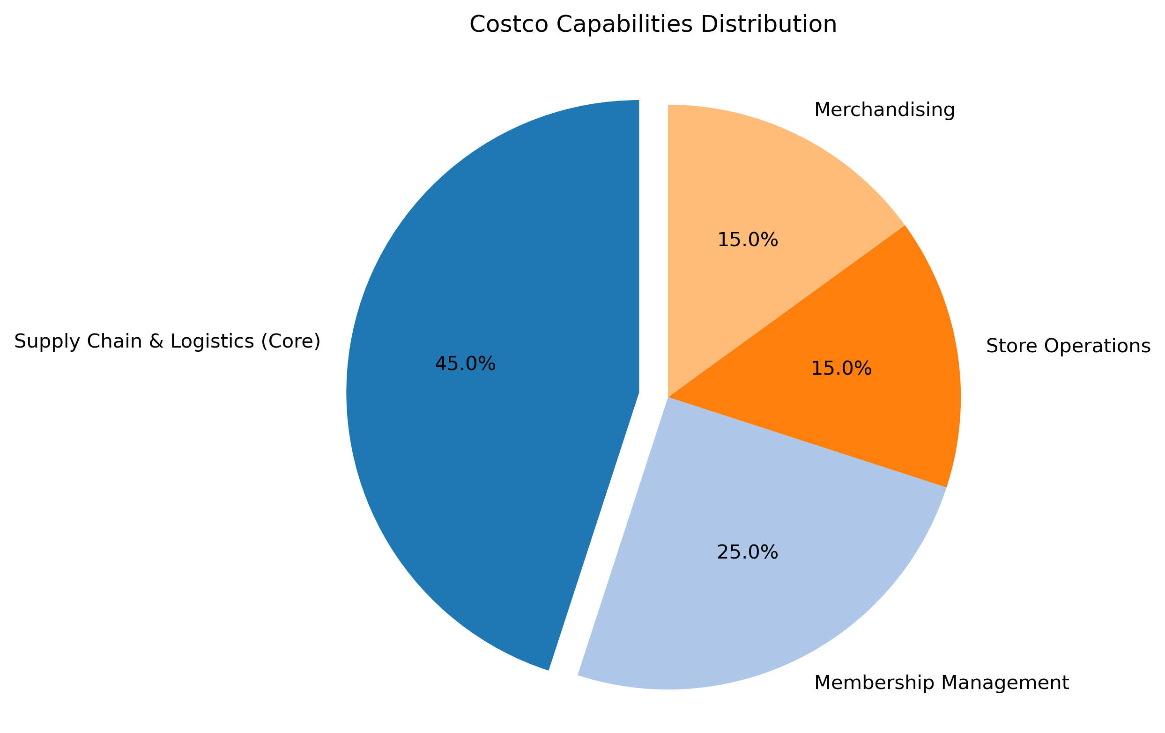
Figure 1: Capability pie highlighting Costco’s core focus on supply chain and membership retention.
This intense focus on volume gives them an almost unreasonable level of leverage over the manufacturers who stock their shelves. In traditional retail, a massive consumer goods company holds all the cards. But Costco strips the variety out of the equation. Because they only carry a few thousand items—compared to tens of thousands at a typical supermarket—winning a spot on a Costco pallet means moving staggering amounts of product. This dynamic flips the usual power structure (Figure 2). When Costco buyers sit down with a vendor, they dictate the packaging size, the price point, and the delivery terms, because the vendor simply cannot afford to walk away from that volume.
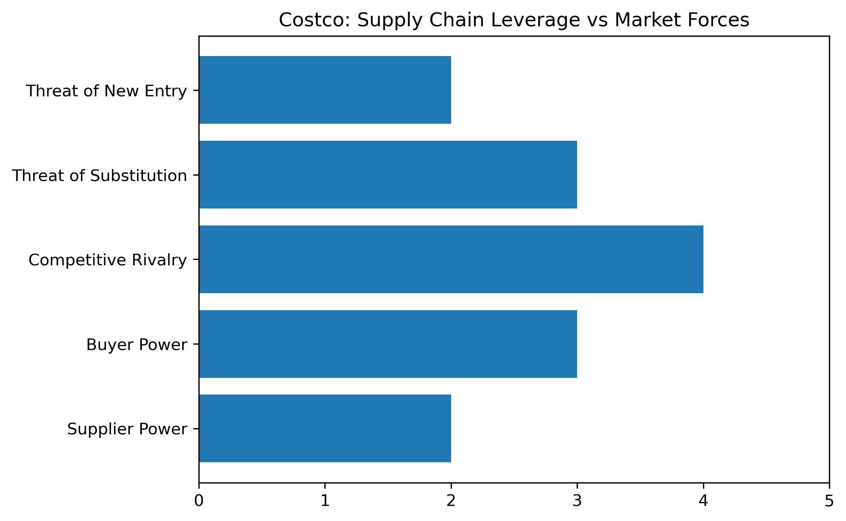
Figure 2: Upstream supplier lock-in and margin defense against traditional market forces.
And if a vendor refuses to meet those terms, Costco deploys a structural weapon: they bypass the vendor entirely and make the product themselves. Most supermarkets have private labels, but they are usually positioned as cheap alternatives. Costco built Kirkland Signature differently, positioning it as equal to or better than national brands. By stepping directly into the manufacturing arena when third-party prices get too high, they keep their external partners honest. It works astonishingly well: in 2023, Kirkland Signature generated approximately $58 billion in sales, accounting for a massive chunk of their overall revenue (Figure 3). This isn't just about offering a cheaper product; it is a structural ceiling they place on the market to ensure they never lose their pricing authority.
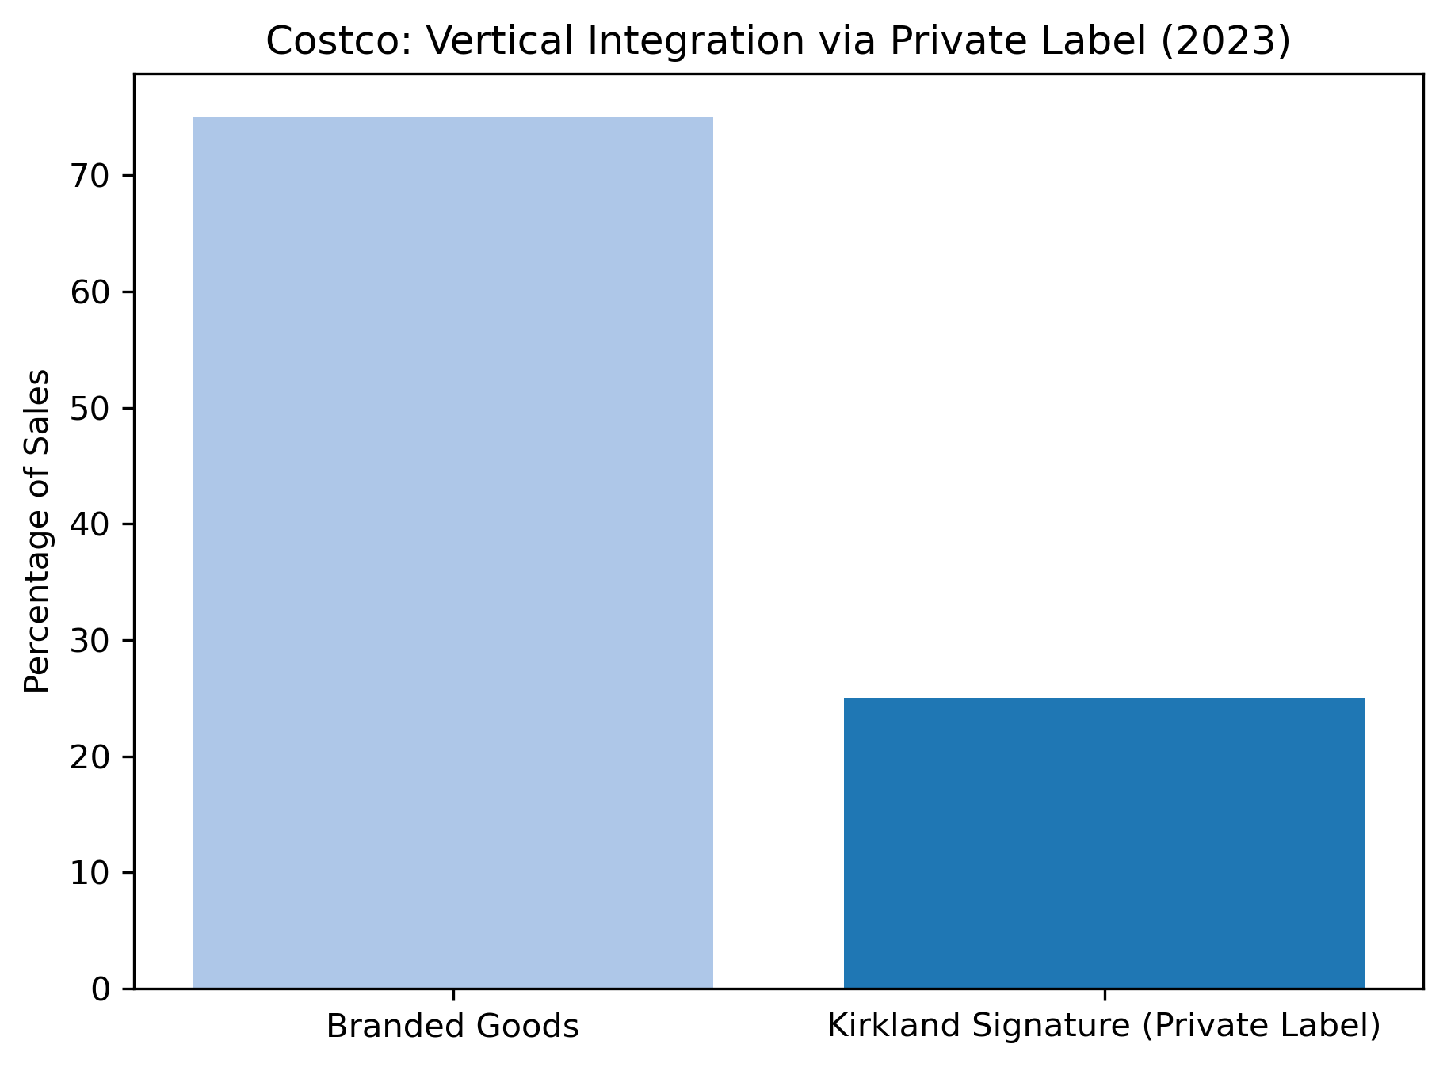
Figure 3: Revenue expansion via internal private label operations limiting vendor leverage.
Moving from retail to technology, I looked at Netflix. If Costco’s strength is physical volume, Netflix’s capability is entirely digital: reading massive amounts of consumer data to deliver content with precision (Figure 4). What fascinates me about Netflix is not just their current dominance, but how ruthlessly they cannibalized their own profitable business to survive a changing world.
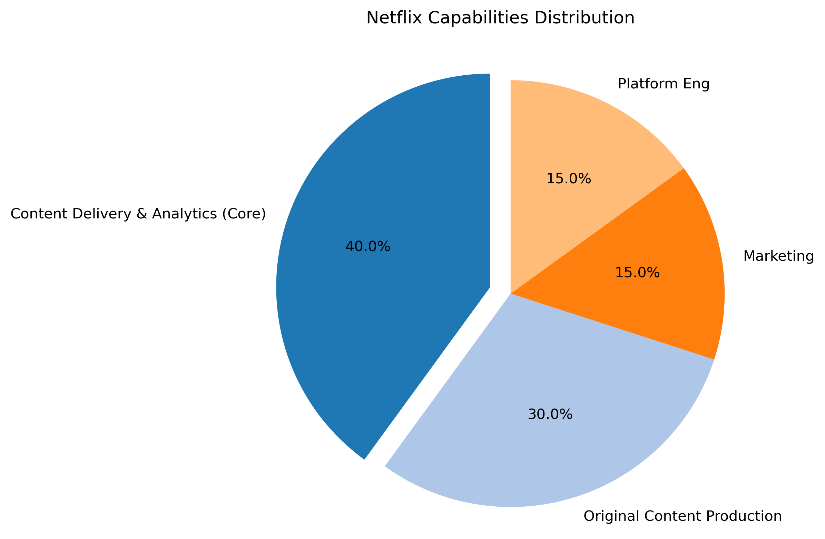
Figure 4: Capability pie highlighting Netflix’s core data and delivery platform.
In 2007, Netflix was a highly successful DVD-by-mail operation. But they saw that broadband infrastructure was quietly improving. Rather than milking the DVD profits until a competitor built a streaming service, they launched their own, completely upending their delivery model to match the new technological reality (Figure 5). They fundamentally understood that they were in the business of delivering entertainment, not mailing plastic discs.
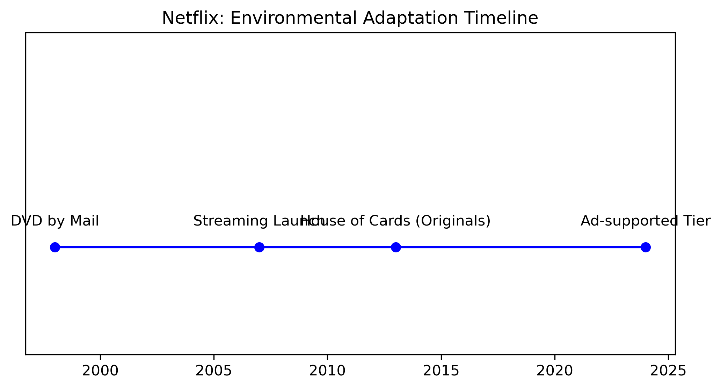
Figure 5: Adaptation of operational model in response to technological broadband shifts.
But owning the digital pipe eventually created a new vulnerability. As they grew, the legacy Hollywood studios realized they were licensing their most valuable assets to a platform that was stealing their viewers. When those studios started pulling their shows to launch their own streaming services, Netflix didn't just try to negotiate harder. They fundamentally changed their operating structure. They moved aggressively upstream into the actual creation of shows and movies (Figure 6). By committing $17 billion to original content in 2024, they ensured that they would never be entirely reliant on suppliers who also wanted to be their competitors. They bought their independence.
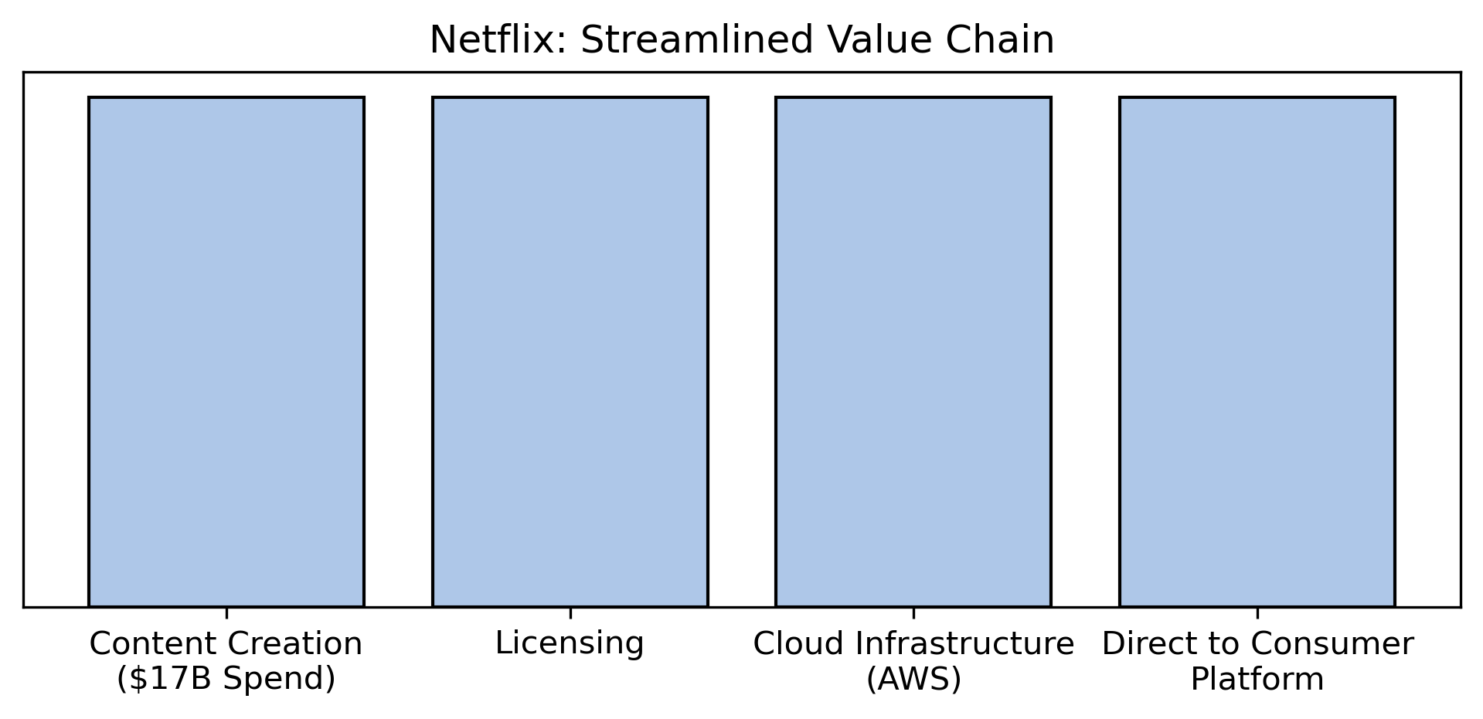
Figure 6: Upstream integration to secure independent content production.
Finally, I looked at Nestle, a giant in the fast-moving consumer goods sector. Nestle is not defined by a single product, but by an extraordinary capability to manage a vast, global portfolio of brands (Figure 7). Their survival depends entirely on where they place their chips—knowing when to pour money into a winner and when to walk away from a loser.
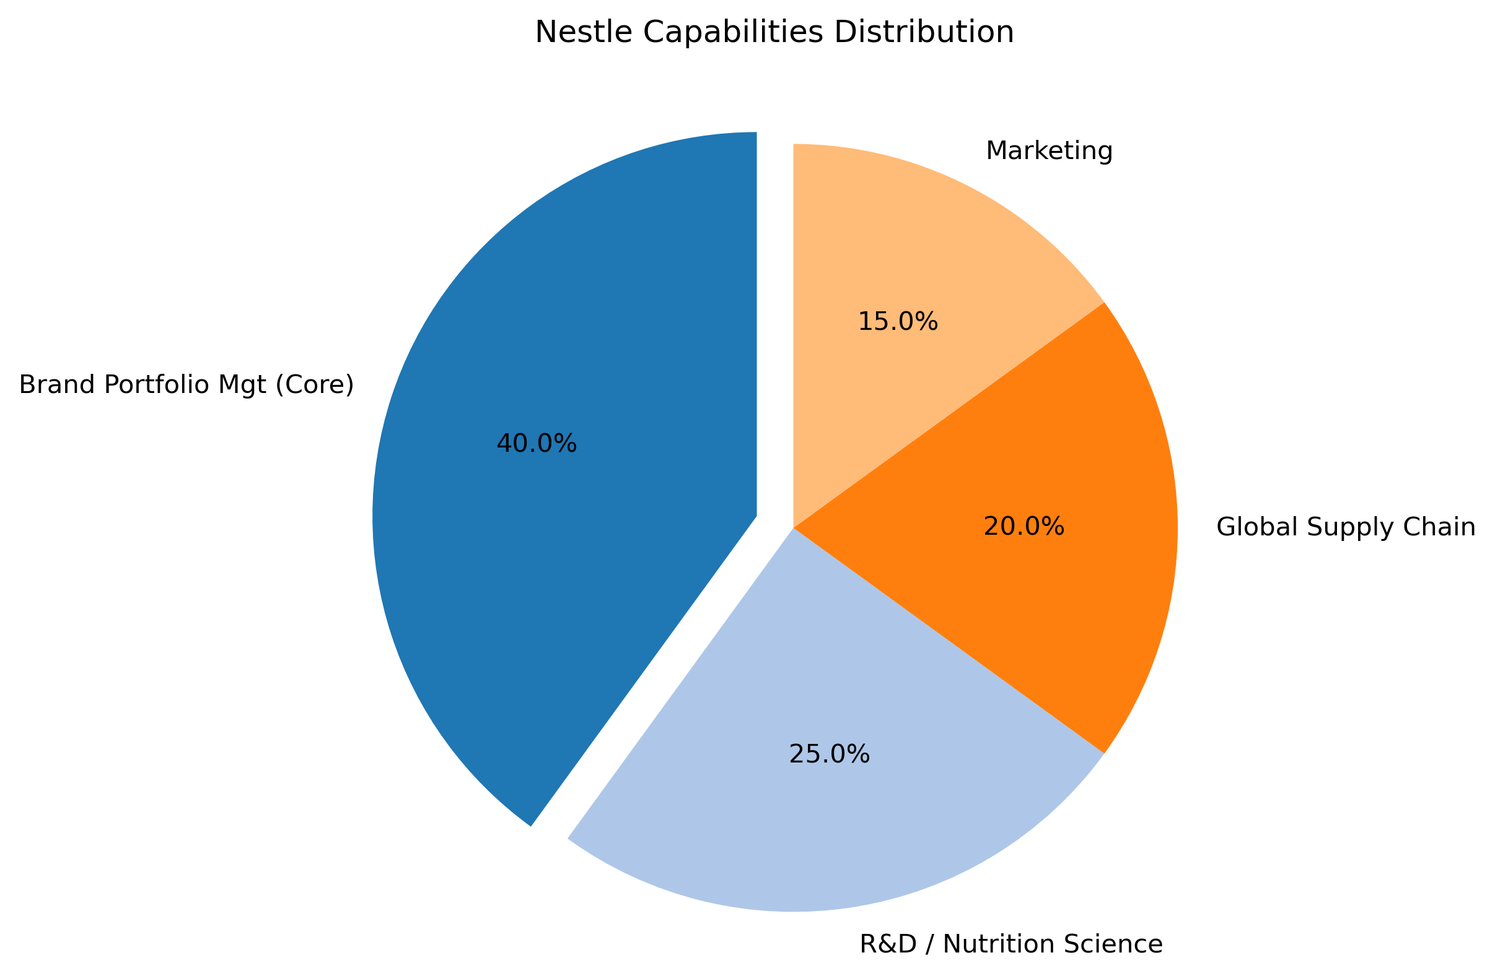
Figure 7: Capability pie highlighting Nestle’s core focus on global brand portfolio management.
In 2018, I watched them make a brutally pragmatic decision. They sold their entire U.S. candy business, including iconic names like Butterfinger and Baby Ruth, to Ferrero for $2.8 billion. To the outside world, a chocolate company selling chocolate seemed bizarre. But inside their portfolio logic, it made perfect sense. The U.S. candy division was bleeding market share to Mars and Hershey; it was a cash drain with bleak growth prospects (Figure 8). By cutting it loose, they freed up billions in capital and management attention to focus on categories where they actually held a dominant, highly profitable position, like coffee and pet care.
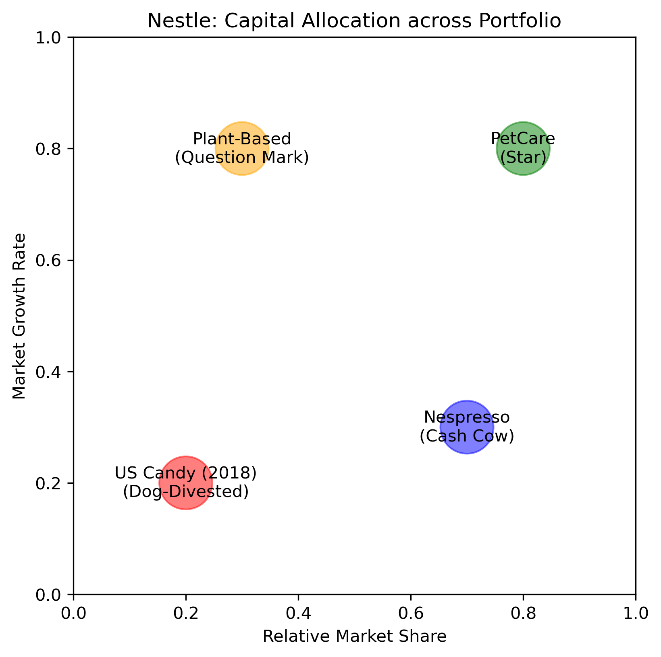
Figure 8: Capital reallocation highlighting divestment of underperforming units.
They took that capital and deployed it in a completely new direction. Standard grocery aisles were becoming fiercely competitive with razor-thin margins, so Nestle looked for adjacent markets with higher barriers to entry. In 2020, they acquired Aimmune Therapeutics for $2.6 billion, stepping directly into the medical nutrition space (Figure 9). They weren't just creating a new flavor of an existing product; they were buying their way into a specialized, high-margin market—peanut allergy treatments—that fundamentally shifted where they compete.
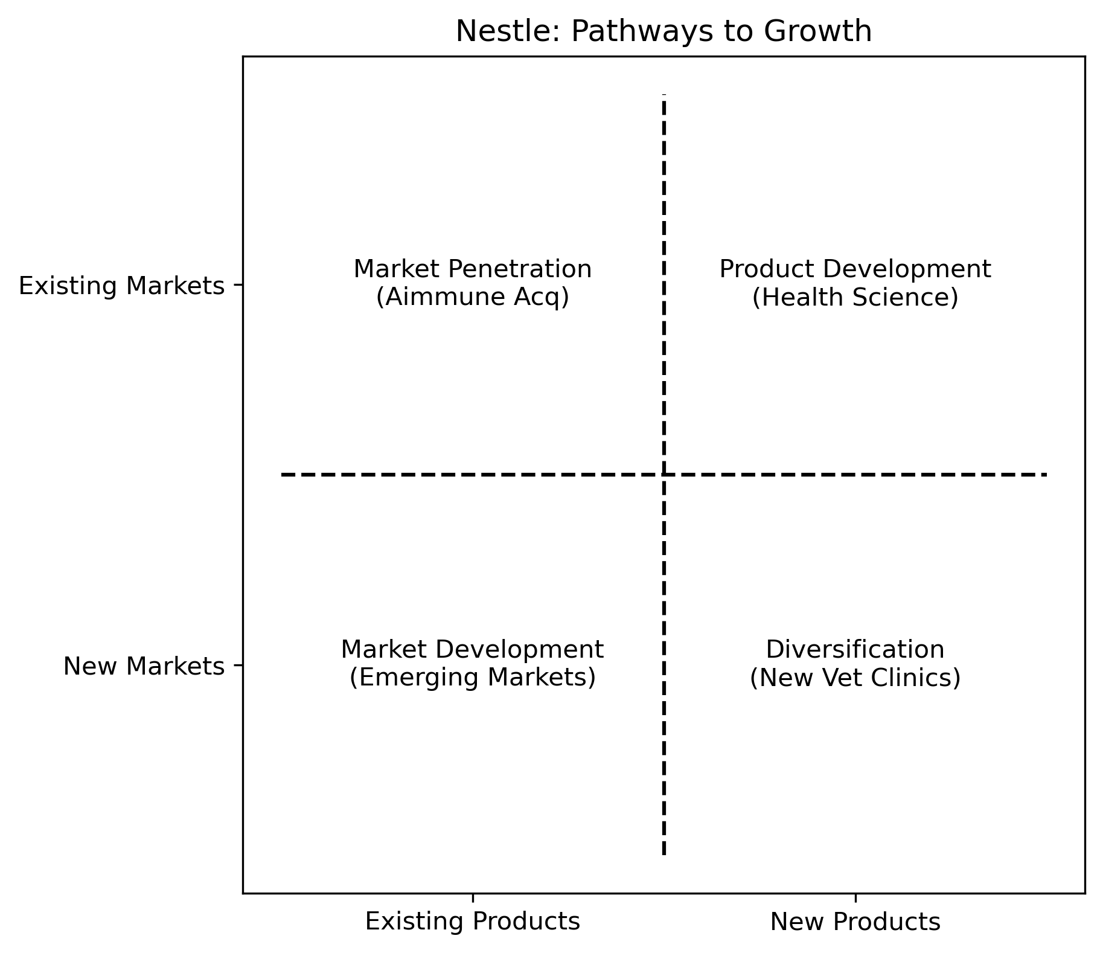
Figure 9: Expansion into high-margin medical nutrition adjacencies.
Looking across all three companies, a clear pattern emerges. None of them rely on a generic strategy or hope that their brand name alone will protect them. Costco uses sheer volume to dominate suppliers. Netflix continually rebuilds its entire infrastructure to prevent being held hostage by its environment. Nestle ruthlessly prunes its history to fund its future. They all survive by understanding exactly what they do best, and relentlessly architecting the market around it.

