Practical 6
Name | Atharva Dhobale
Section | A6-B1
Roll no | 08

Aim: Construction of OBST
Task 1:
A)Succesful
Code:
def OBST(p):
n = len(p)
C = [[0] * (n + 2) for _ in range(n + 2)]
R = [[0] * (n + 1) for _ in range(n + 1)]

for i in range(1, n + 1):
C[i][i - 1] = 0
C[i][i] = p[i - 1]
R[i][i] = i
C[n + 1][n] = 0

for d in range(1, n):
for i in range(1, n - d + 1):
j = i + d
minval = float('inf')
for k in range(i, j + 1):
cost = C[i][k - 1] + C[k + 1][j]
if cost < minval:
minval = cost
kmin = k
R[i][j] = kmin
summ = sum(p[i - 1:j])
C[i][j] = minval + summ

return C[1][n], R

p = [0.1, 0.2, 0.4, 0.3]
min_cost, root = OBST(p)
print(f"{min_cost:.4f}")
Output:
B)Successful and Unsuccessful
Code:
import sys

n = 4
keys = [10, 20, 30, 40]
p = [0.1, 0.2, 0.4, 0.3]
q = [0.05, 0.1, 0.05, 0.05, 0.1]

e = [[0] * (n + 2) for _ in range(n + 2)]
w = [[0] * (n + 2) for _ in range(n + 2)]
root = [[0] * (n + 1) for _ in range(n + 1)]

for i in range(1, n + 2):
e[i][i - 1] = q[i - 1]
w[i][i - 1] = q[i - 1]

for length in range(1, n + 1):
for i in range(1, n - length + 2):
j = i + length - 1
e[i][j] = sys.float_info.max
w[i][j] = w[i][j - 1] + p[j - 1] + q[j]

for r in range(i, j + 1):
t = e[i][r - 1] + e[r + 1][j] + w[i][j]
if t < e[i][j]:
e[i][j] = t
root[i][j] = r

print(f"Minimum expected cost of OBST: {e[1][n]:.4f}")

Output:
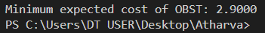

Task 2:
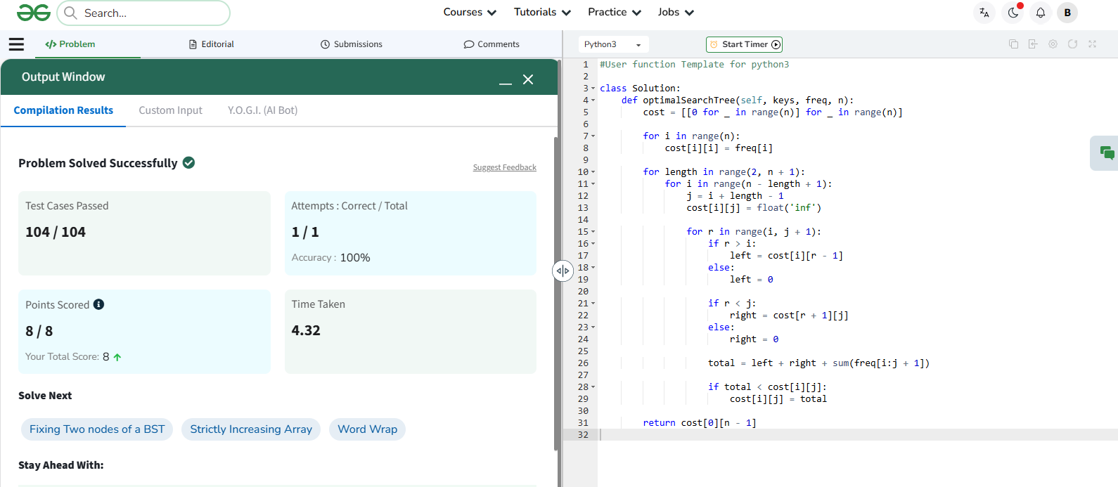
Link:https://www.geeksforgeeks.org/problems/optimal-binary-search-tree2214/1

