/\*

Experiment No. : 11

Statement : To test all IOs on ESP8266 Witty Cloud Development Board.

Date of Exp. : xx/xx/xxxx

Author : Atharva Ramesh Navghare(A-14)

\*/

#define led 2

#define red 15

#define green 12

#define blue 13

#define ldr A0

void setup() {

// put your setup code here, to run once:

pinMode (led,OUTPUT);

pinMode (red,OUTPUT);

pinMode (green,OUTPUT);

pinMode (blue,OUTPUT);

Serial.begin(9600);

}

void loop() {

// put your main code here, to run repeatedly:

digitalWrite (led,HIGH);

delay(1000);

digitalWrite (led,LOW);

delay(1000);

digitalWrite (red,HIGH);

delay(1000);

digitalWrite (red,LOW);

delay(1000);

digitalWrite (green,HIGH);

delay(1000);

digitalWrite (green,LOW);

delay(1000);

digitalWrite (blue,HIGH);

delay(1000);

digitalWrite (blue,LOW);

delay(1000);

Serial.println(analogRead (ldr));

}

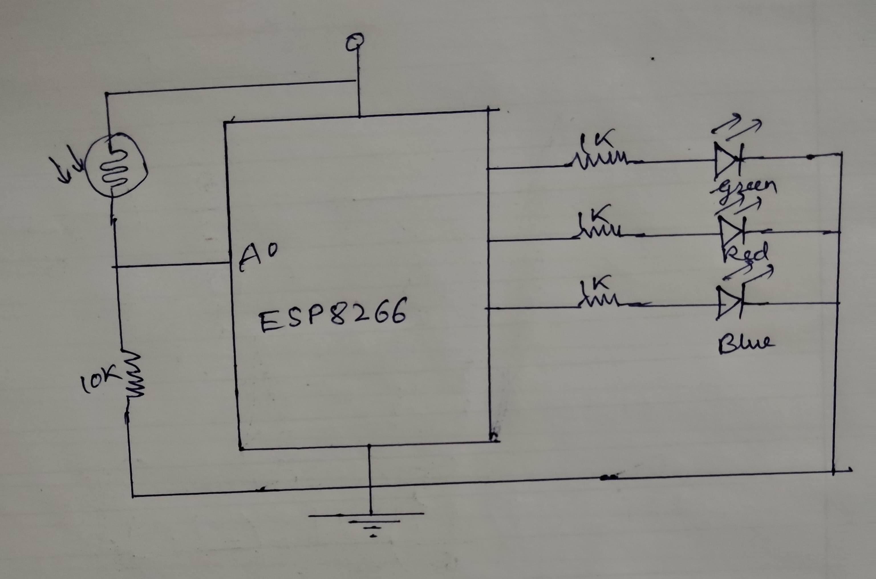

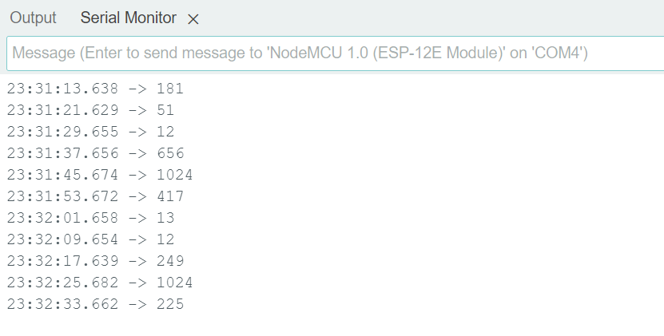

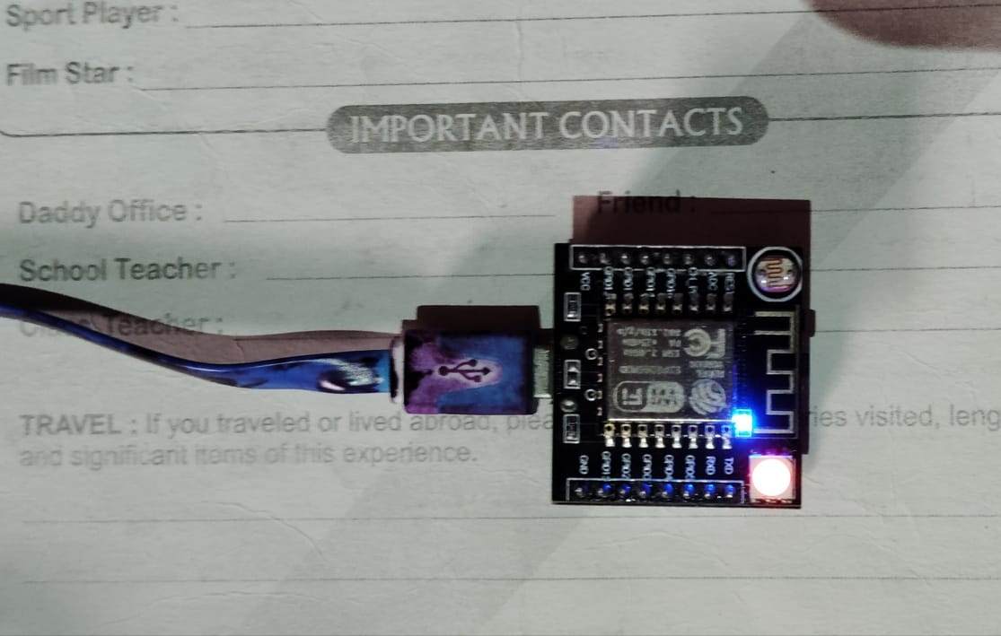

//Red Colour

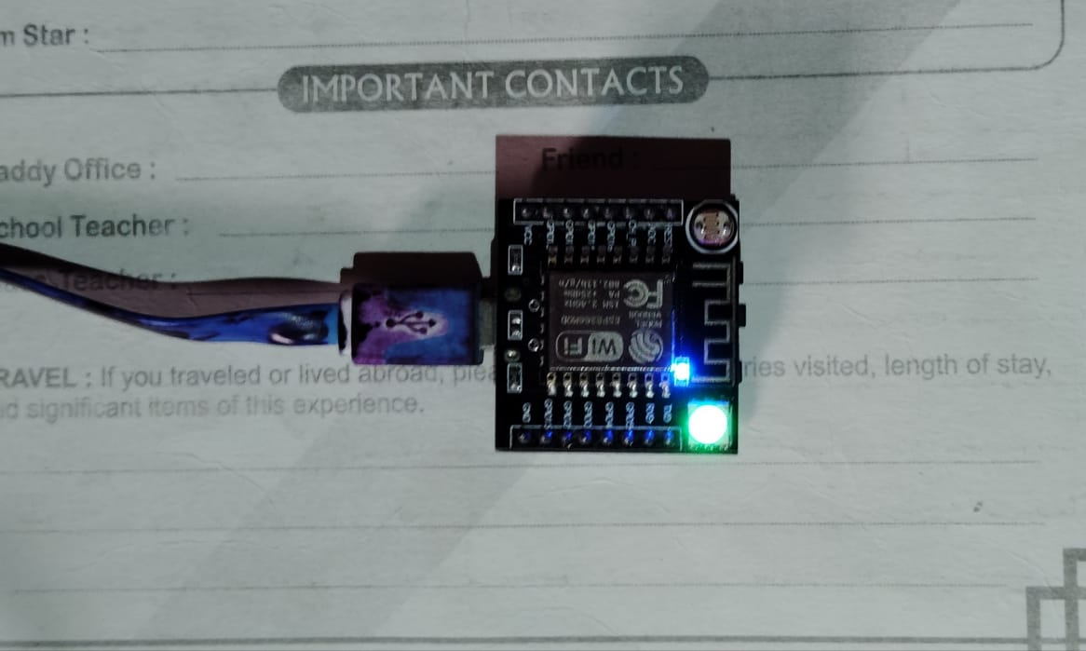

//Green Colour

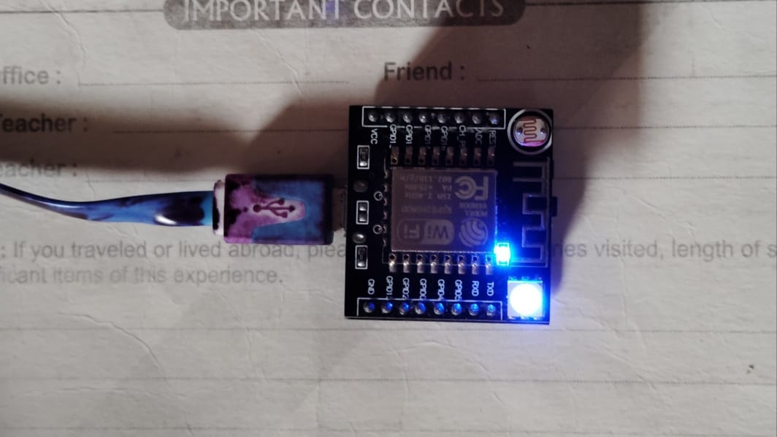

// Blue Colour