**Instructions – CYGWIN Installation**

* Run the CYGWIN_setup-x86_64.exe application provided (for windows 64 bit).
* For Mac OS download the CYGWIN application from internet (Open Source).
* Follow the below steps for the installation.

Step-1

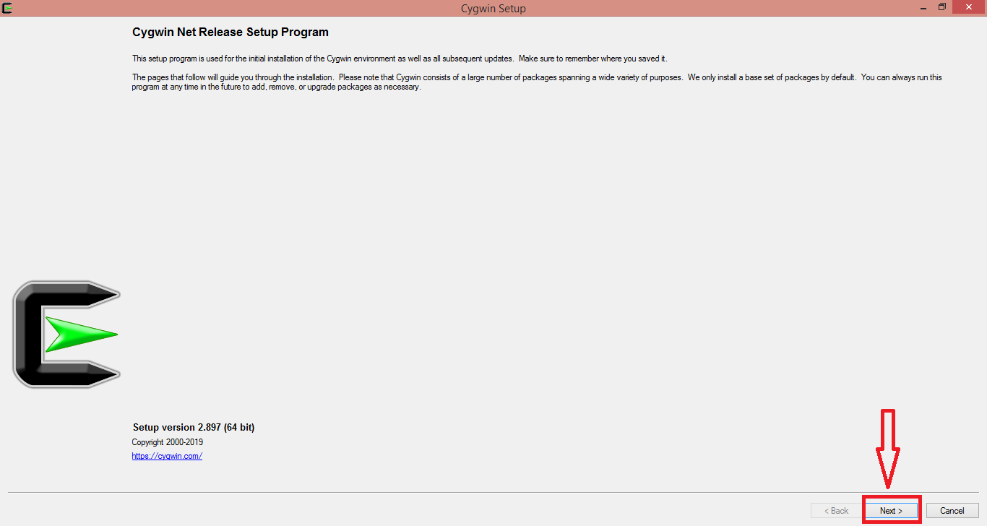

Step-2

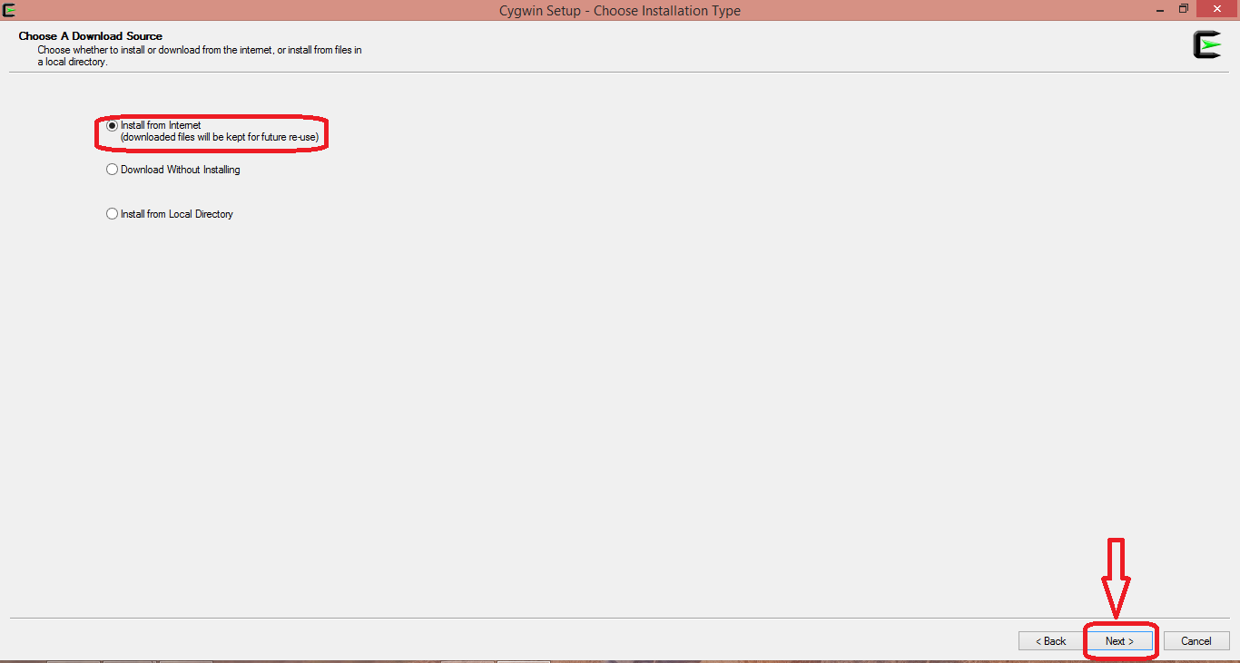

Step-3

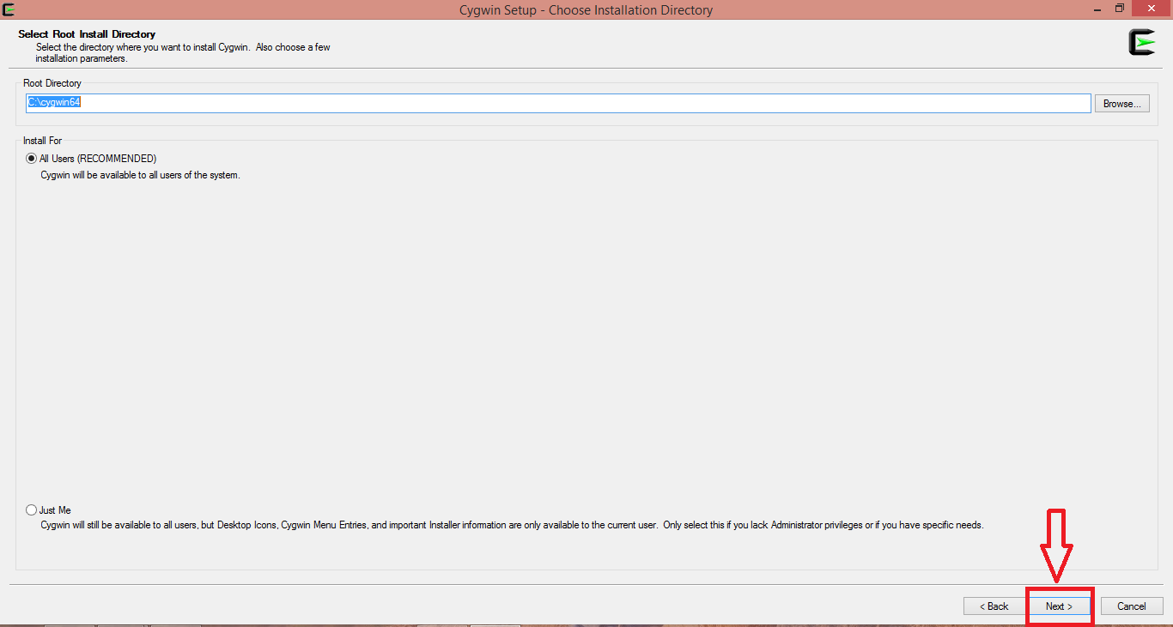

Step-4

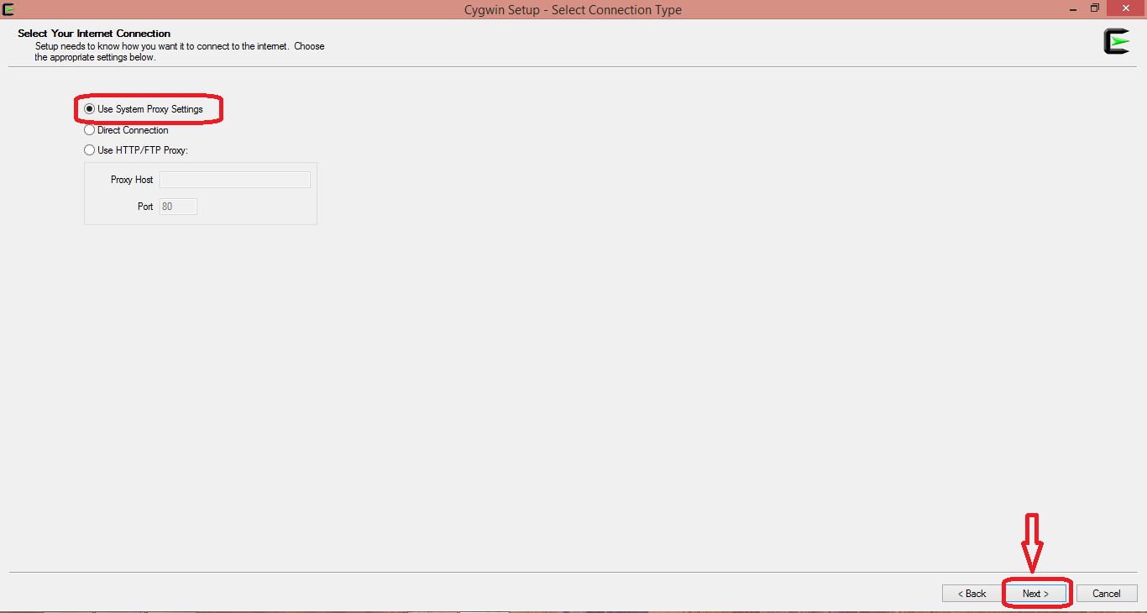

Step-5

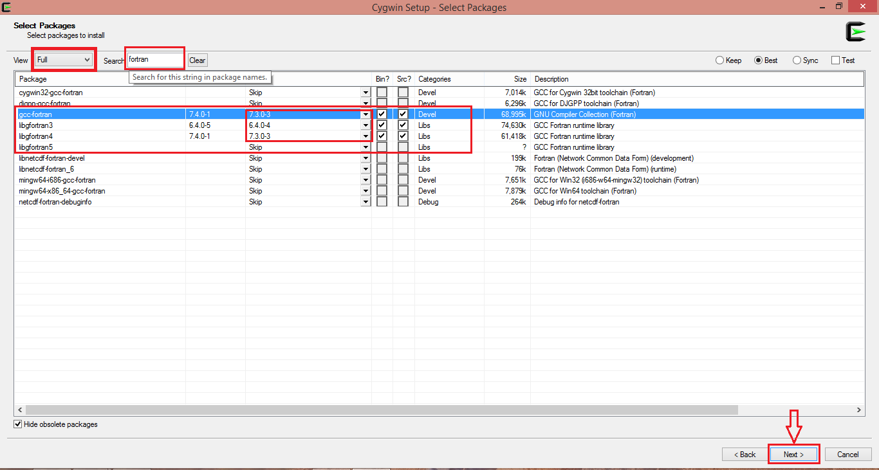

**Multall Commands:**

1. TO CHANGE DIRECTORY

$ cd /cygdrive/D/Multall/AxialCompressor (Directory Name)

To run and create meangen file

$ gfortran -o5 meangen-17.4.f -o meangen-17.4.x

To input data/open ‘.x’ file

$ ./meangen-17.4.x

To run and create stagen file

$ gfortran -o5 stagen-17.3.f -o meangen-17.3.x

To run stagen

$ ./stagen-17.3.x < stagen.dat

To run and create multall file

$ gfortran -o5 multall-open-17.5.f -o multall-open-17.5.x

TO run multall Simulation

$ ./multall-open-17.5.x < stage_new.dat