Enhanced Road Detection System

A project report submitted in partial fulfilment of the requirements for the degree of Bachelor in Science (Computer Science)

By
[Saniya Salunkhe (SP04210115)]
[Divya Pansare (SP04210090)]
[Shraddha Pansare (SP04210092)]

Department of Computer Science
T.Y.B.Sc.(Computer Science)

Guide
Renuka Lakhangaonkar

Sir Parashurambhau College (Autonomous) Pune,
2023-24

Index
1. Acknowledgement 1
2. Introduction 2
2.1 Motivation 3
2.2 Problem Statement 4
3. System Analysis 5
3.1 Existing System 5
3.2 Scope & Limitations of Existing Systems 6
3.3 Project Scope 7
4. Requirement Analysis 8
4.1 Fundamental Requirements 8
4.2 Performance Requirements 8
4.3 Software Requirements 8
4.4 Hardware Requirements 9
5. Feasibility Study 10
6. System Design 11
6.1 ERD And Normalization 11
6.2 UML Diagrams 12
6.3 User Interface – Screens 16
7. Implementations Details 18
7.1 Software Specifications 18
7.2 Hardware Specifications 18
8. Test Cases 20
9. Conclusion & Recommendation 24
9.1 Conclusion 24
9.2 Recommendations 24
10. Limitation 26
11. Future Scope 27
12. Bibliography & References 28

Acknowledgement

I take this opportunity to thank all the teachers whose constant encouragement has made it possible for me to take up the challenge of doing this project. I am grateful to Mrs. Renuka Lakhngaonkar ma’am for her support, valuable guidance, encouragement and consistent help without which it would have been difficult for me to complete this project work. She has been a constant source of inspiration and information to me. I consider myself fortunate enough to have worked under her guidance.
I express my gratitude towards our honourable head of the department, Mr. Dipak Londe Sir for his constant encouragement.
Last but not the least; I would like to thank the entire staff of BSc computer science department for their timely help and guidance at various stages of the project.

Introduction

Enhanced Road Detection represents a significant advancement in road safety and traffic management through the integration of advanced computer vision and deep learning technologies. In today's fast-paced world, where road networks are becoming increasingly complex and congested, the need for intelligent systems to enhance road detection capabilities has never been more crucial.
At its core, Enhanced Road Detection utilizes advanced computer vision techniques, such as object detection and image analysis, to identify and classify various elements of the road. By leveraging techniques like YOLO (You Only Look Once), the project aims to detect road features in real-time, providing valuable insights for safer driving.
One of the primary goals of Enhanced Road Detection is to enhance lane detection capabilities. This involves detecting lane markings and boundaries to help drivers stay within their lanes, reducing the risk of accidents.
Furthermore, the project focuses on identifying road hazards like potholes. While perfect accuracy may not always be achievable, our system aims to detect potential hazards and alert drivers to their presence, allowing them to take appropriate action. This proactive approach to hazard detection can help prevent damage to vehicles and improve overall road safety.
Recognizing Zebra crossings and traffic signals is another key aspect of Enhanced Road Detection. It aims to detect the features reliably enough to provide useful information to drivers. By alerting drivers to the presence of crossings and upcoming traffic signals, the system helps improve safety and reduce the likelihood of accidents at intersections.
In summary, Enhanced Road Detection represents a significant step forward in road safety and traffic management. While perfect accuracy may not always be feasible, our system aims to provide reliable detection of key road features, helping to improve safety and efficiency on our roads.

Motivation

The motivation behind the Enhanced Road Detection project is deeply rooted in addressing critical issues within modern transportation systems. Despite advancements in vehicle safety technology, road accidents persist as a significant threat to public safety worldwide. The utilization of technologies such as computer graphics and YOLO (You Only Look Once) object detection, as demonstrated in the provided code snippets, exemplifies the project's commitment to leveraging cutting-edge tools for improved road safety.
The driving force behind the Enhanced Road Detection project is to enhance road safety and streamline traffic management by focusing on key areas: zebra crossings, pothole detection, traffic signal recognition, and lane identification.
Lane recognition is critical for maintaining orderly traffic flow and preventing accidents. By accurately detecting lane markings and boundaries, the system can assist drivers in staying within their lanes, reducing the risk of lane departure accidents and improving overall road safety.
Zebra crossings are crucial for pedestrian safety, providing designated areas for pedestrians to cross roads safely. By accurately detecting zebra crossings, the system can alert drivers to slow down and yield to pedestrians, reducing the risk of accidents and ensuring pedestrian safety. Traffic signal recognition is essential for ensuring safe and efficient traffic flow. By identifying traffic signals such as the system can provide timely information to drivers, promoting adherence to traffic regulations and reducing the risk of collisions.
Potholes pose a significant hazard to drivers, leading to vehicle damage and accidents. Detecting and identifying potholes in real-time allows for timely repairs and maintenance, ensuring smoother road surfaces and preventing accidents caused by pothole-related hazards.
The Enhanced Road Detection project aims to revolutionize road safety and traffic management. Through real-time monitoring and analysis, the system can provide valuable insights and alerts to drivers, helping to prevent accidents, mitigate hazards, and improve overall road safety for all road users.

Problem Statement

Lane Detection: Enhancing lane detection systems to accurately identify lane markings, particularly in challenging conditions such as curved roads, to ensure robust performance and reliability.
Pothole Detection: Developing efficient and reliable pothole detection methods to enable timely identification of road hazards, ensuring robust vehicle protection and road safety.
Zebra Crossing Recognition: Improving zebra crossing recognition systems to enhance driver awareness and promote pedestrian safety, ensuring robust detection and timely response to pedestrian crossings.
Traffic Signal Recognition: Advancing traffic signal recognition systems to ensure accurate detection of traffic signals, facilitating robust traffic management and safe driving experiences for all road users.

System Analysis

Existing System

Lane Detection Systems: Traditional lane detection systems utilize techniques like image processing algorithms to identify lane markings on roads. These systems often follow a sequential approach. Thus, these systems are not capable of producing the required output for further usage. Also, the reliability is on lower side for tradition systems.
Pothole Detection Systems: Existing pothole detection systems employ various approaches, including image processing, vibration sensors, and GPS-based methods. Image processing techniques analyse road surface images to detect irregularities and anomalies indicative of potholes. Vibration sensors mounted on vehicles detect sudden changes in vehicle dynamics caused by driving over potholes. GPS-based systems use location data and road quality maps to identify areas prone to potholes. However, existing systems may face challenges in accurately detecting potholes, especially in urban environments with high traffic volumes and complex road geometries.
Zebra Crossing and Traffic Signal Recognition Systems: Zebra crossing and traffic signal recognition systems rely on computer vision algorithms to identify road markings, traffic signs, and signals. Traditional approaches involve edge detection, contour analysis, and pattern recognition to detect zebra crossings, stop signs, traffic lights, and pedestrian signals. Advanced systems may utilize deep learning models, such as convolutional neural networks (CNNs), for more accurate and robust detection. Challenges in recognition include variations in road surface textures, lighting conditions, signal designs, occlusions, weather conditions, and complex urban landscapes.

Scope & Limitations of Existing Systems

Lane Detection
Scope: The existing lane detection system allows for the detection of lane markings in videos, providing valuable insights into lane positioning and vehicle trajectory. It enables lane departure warnings and can assists in maintaining the lanes.
Limitations: Camera Calibration Dependency: The need to calibrate the camera for the first instance. Each camera has its own distortion coefficient which needs to be calibrated before implementing the results. If the camera for car is change the code needs to be modified for new camera calibration.
Environmental Variability: The system's performance may degrade under challenging environmental conditions, such as poor lighting, adverse weather, and road surface variations.
Pothole Detection
Scope: The current pothole detection system demonstrates efficacy in identifying potholes in videos, facilitating proactive maintenance and repair efforts to improve road safety.
Limitations: Dataset Dependency - The reliance on a small dataset for training may limit the system's generalizability across a wide range of video footage. It may struggle to detect potholes effectively in diverse road environments, hindering its applicability in real-world settings.
Environmental Variability: The system's performance may degrade under challenging environmental conditions, such as poor lighting, adverse weather, and road surface variations
Zebra Crossing and Traffic Signal Recognition
Scope: The zebra crossing and traffic signal recognition system offer potential benefits in enhancing pedestrian safety and traffic regulation through accurate detection of road markings and signals.
Limitations: Limited Dataset - The system's performance heavily relies on the training dataset, which may not encompass diverse environmental conditions, such as different weather conditions, lighting variations, and urban landscapes
Environmental Sensitivity: Factors like weather conditions, lighting variations, and occlusions may impact the system's performance, leading to erroneous detections or missed signals.

Project Scope

The project aims to develop an Enhanced Road Detection System incorporating three key components: Lane Detection, Pothole Detection, and Zebra Crossing/Traffic Signal Recognition.
- Lane Detection:
  - Utilizes computer vision algorithms to detect lane markings in input videos.
  - Provides lane departure warnings and assists in lane maintenance for enhanced driving safety.
- Pothole Detection:
  - Implements machine learning techniques to identify potholes from video footage.
  - Facilitates proactive maintenance and repair efforts to improve road safety.
- Zebra Crossing/Traffic Signal Recognition:
  - Employs image processing algorithms for accurate detection of zebra crossings and traffic signals.
  - Enhances pedestrian safety and traffic regulation.
The Enhanced Road Detection System project aims to enhance road safety and traffic management through the integration of intelligent detection systems. By addressing challenges, the system will provide insights to aid drivers, authorities, and maintenance teams in ensuring safer and more efficient road networks.

Requirement Analysis

Fundamental Requirements

Fundamental requirement for Enhanced Road Detection System project are as follows
- Data input: The system should allow users to give input data in video formats.
- Data Output: The system should generate the output in video format and should store at a particular location. Also, it should display it to the end user.
- Data storage: The system must store and retrieve data according to requirement.
- User interface: The system should have a user interface that facilitates easy interaction of input and output data.

Performance Requirements

Performance requirement for Enhanced Road Detection System project are as follows
- Response time: The system should respond to user requests and should intimate user about the process start or stop status.
- Throughput: The system should be able to handle multiple videos from a single input.
- Scalability: The system should be able to accommodate an increasing number input videos for further usage and scalability.

Software Requirements

Operating System Compatibility: The system should be compatible with Windows 10 or later.
- Programming Language: Utilize programming languages such as Python for development.
- Development Environment: Use integrated development environments (IDEs) such as PyCharm, Visual Studio Code for coding and debugging.
- Libraries and Frameworks: Utilize computer vision libraries/frameworks such as OpenCV, for image processing and YOLO for machine learning tasks. Utilize libraries for video processing, such as FFmpeg, for handling video streams.
- Database Management System: Implement a database management system (PostgreSQL) for storing potholes data for further usage.
- Graphical User Interface (GUI): Implement a GUI framework (Tkinter) for user interaction and visualization of detection results.
- Web Integration: Implement HTML and CSS for web-based interfaces.

Hardware Requirements

- Processor: Intel Core i5 or AMD Ryzen 5 (or equivalent) for optimal performance.
- Memory (RAM): Minimum 8GB RAM for smooth operation; 16GB or higher recommended for processing-intensive tasks.
- Storage: Solid State Drive (SSD) with sufficient capacity for storing software, datasets, and videos.
- Graphics Processing Unit (GPU): NVIDIA GeForce GTX 1060 or AMD Radeon RX 580 (or equivalent) for accelerated image processing and machine learning tasks. GPUs with CUDA or OpenCL support are preferred.

Feasibility Study

The purpose of this feasibility study is to assess the viability of implementing an Enhanced Road Detection System. This system aims to enhance road safety by providing assistance to drivers in maintaining their lanes and preventing lane departure accidents.
- Technical Feasibility:
  - Hardware Requirements: Modern vehicles are equipped with onboard computers capable of processing video streams in real-time. Additionally, compact cameras suitable for lane detection are readily available and can be easily integrated into vehicles.
  - Software Development: The development of software for lane detection can be achieved using programming languages like Python along with libraries such as OpenCV for image processing and YOLO for real time detection.
- Financial Feasibility:
  - Initial Investment: The initial investment would include costs for software development, algorithm refinement, and hardware integration. This would involve hiring skilled developers and purchasing necessary equipment.
  - Operational Costs: Once implemented, operational costs would primarily involve maintenance, software updates, and possibly licensing fees for proprietary software components. However, these costs are expected to be relatively low compared to the initial investment.
  - Return on Investment (ROI): The ROI would depend on factors such as the market demand for lane detection systems, potential partnerships with automotive manufacturers, and the effectiveness of the system in reducing accidents and improving road safety.
- Market Feasibility:
  - Market Demand: There is a growing demand for advanced driver assistance systems (ADAS) that enhance driver safety and convenience. Lane departure warning systems are becoming increasingly common in new vehicle models, indicating a market demand for lane detection technology.

System Design

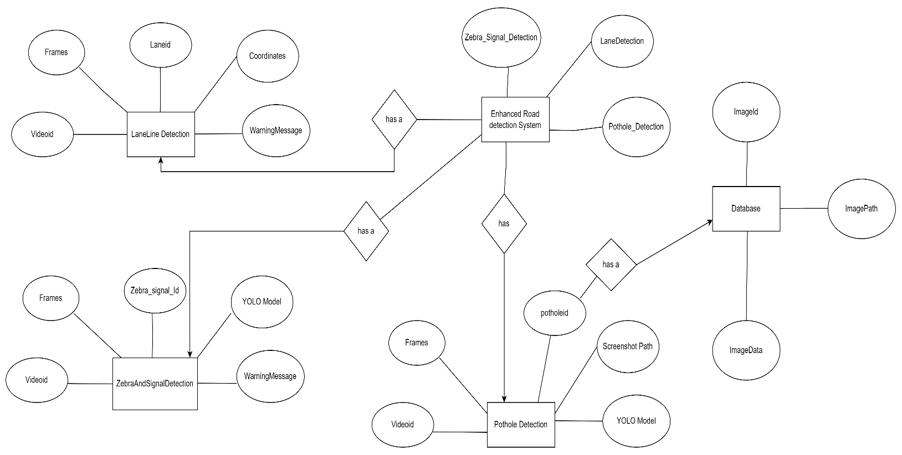
ERD And Normalization

Figure 1: ERD And Normalization

UML Diagrams

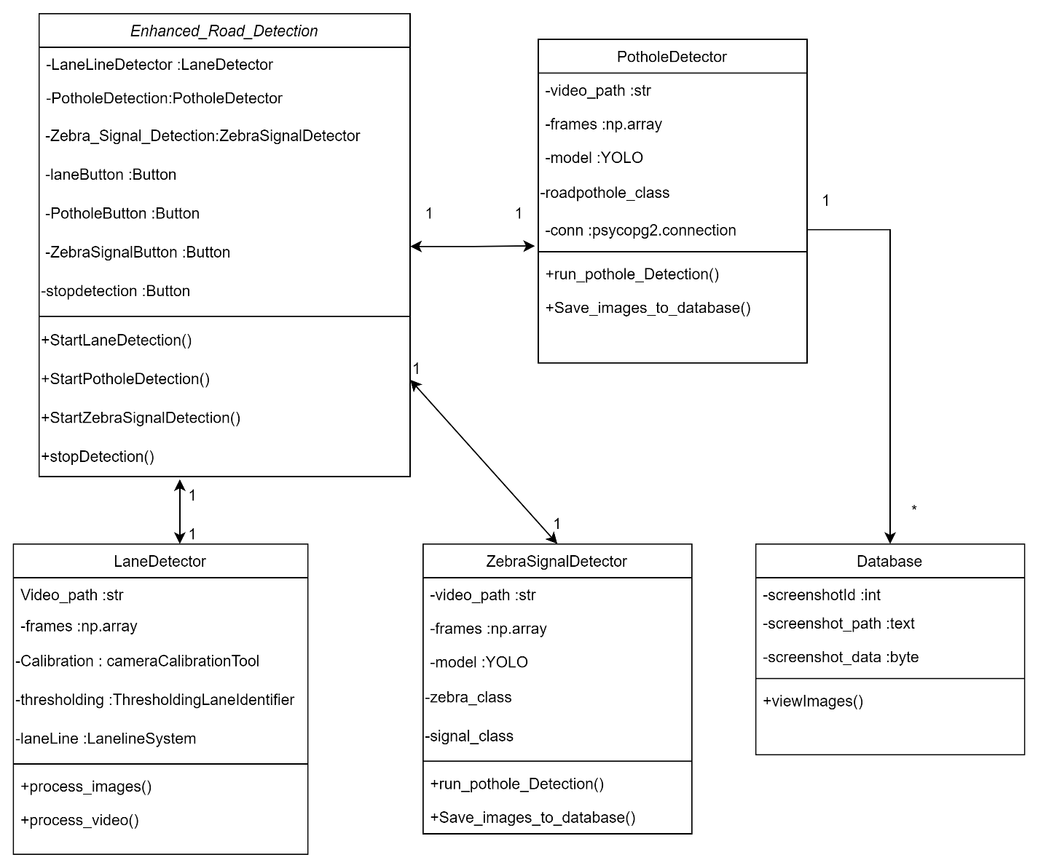
Figure 2: Class Diagram

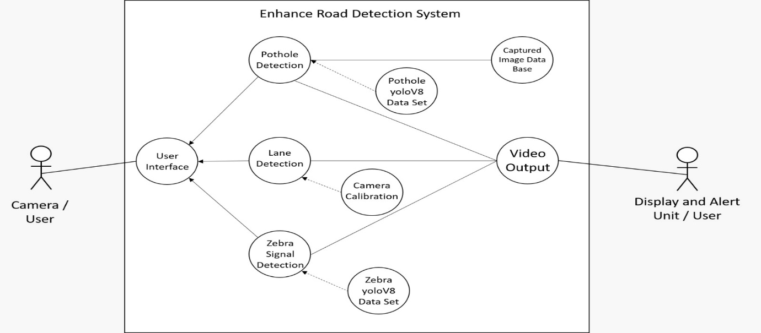
Figure 3: Use Case Diagram
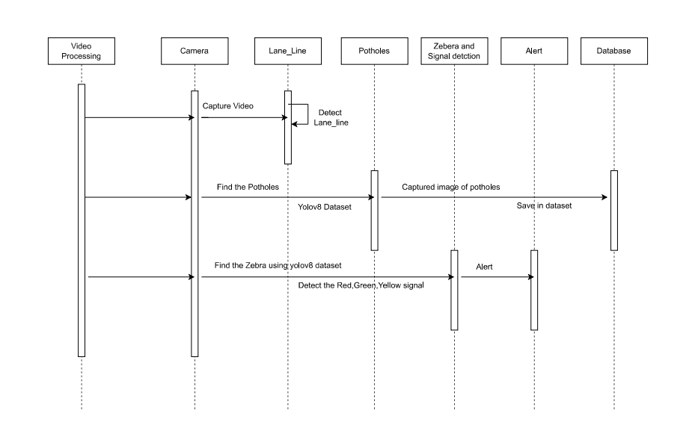
Figure 4: Sequence Diagram
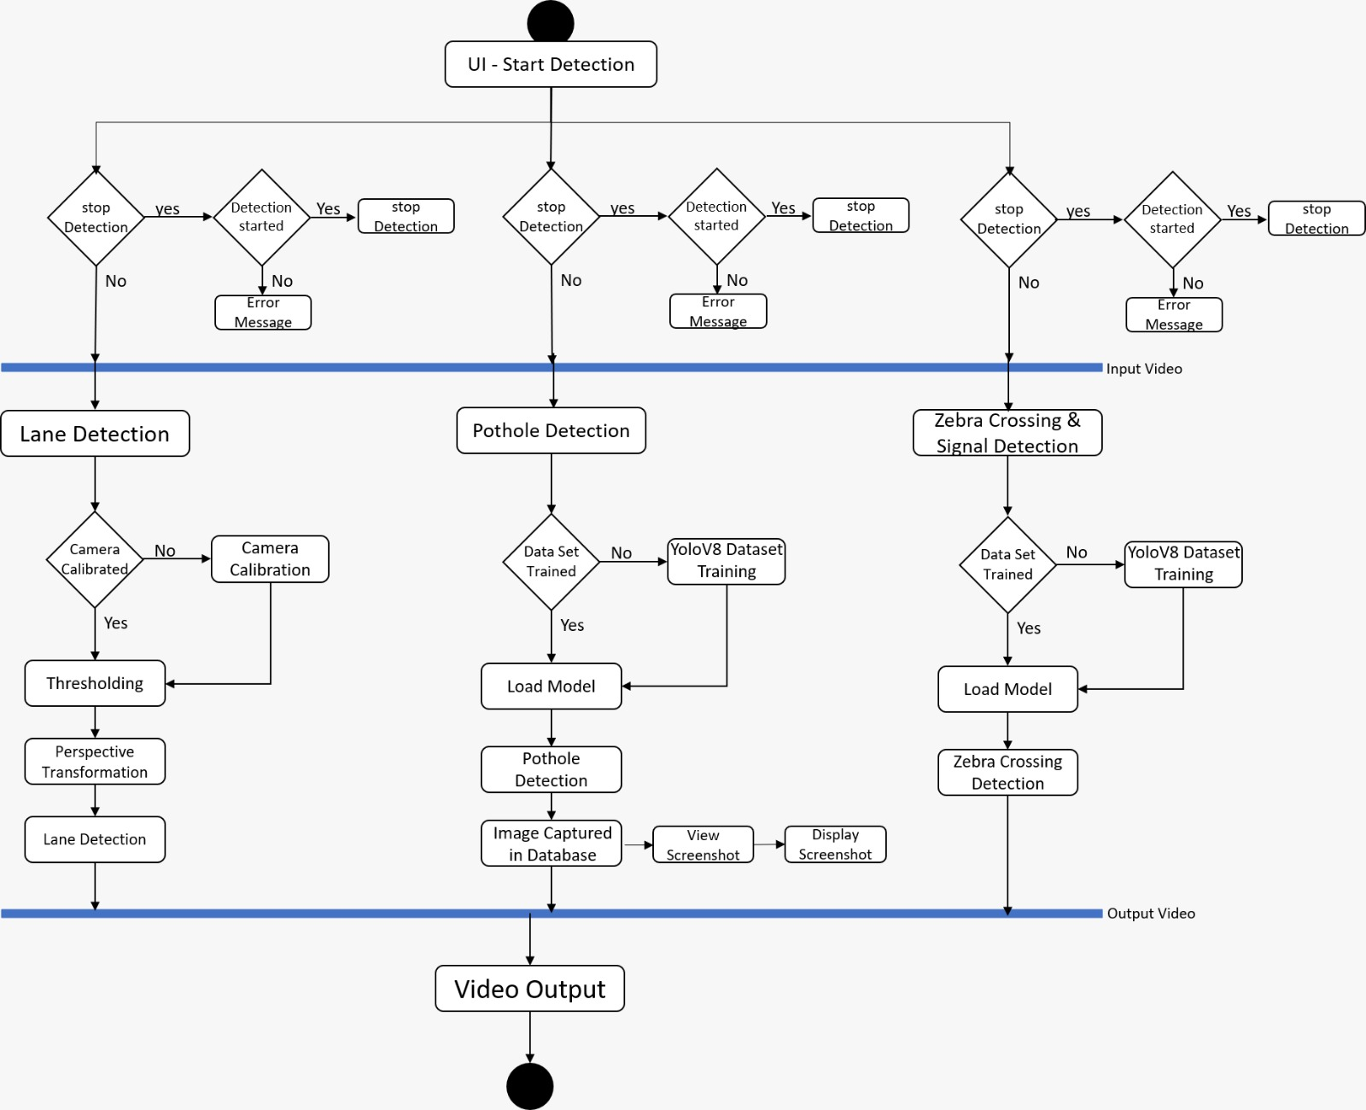
Figure 5: Activity Diagram

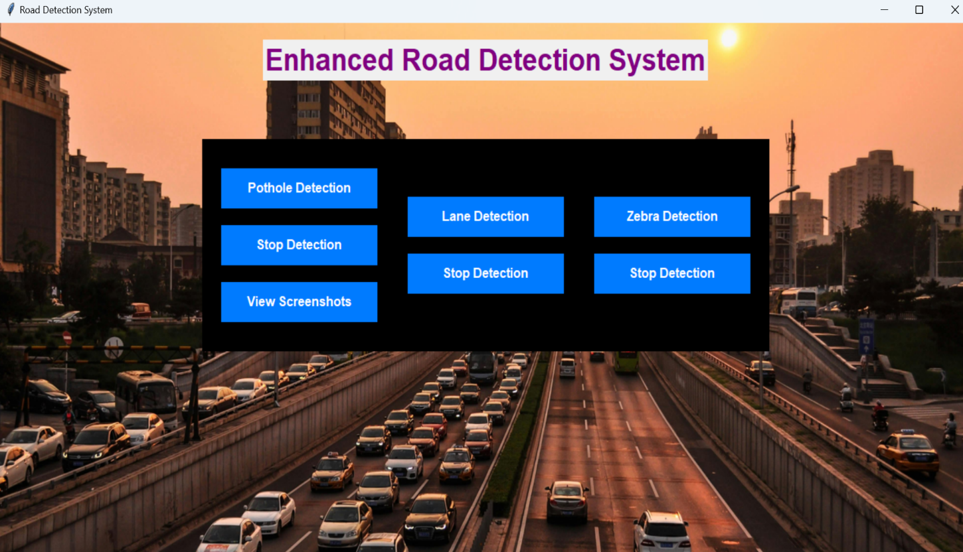
User Interface – Screens
Figure 6: User Interface
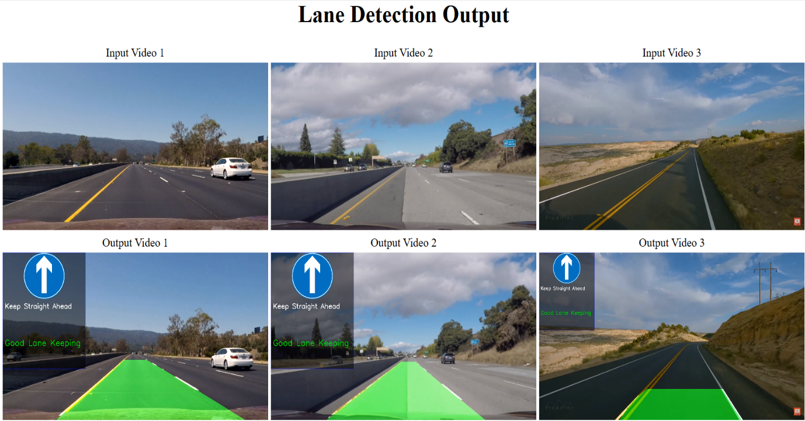
Figure 7: Lane Detection Output Interface
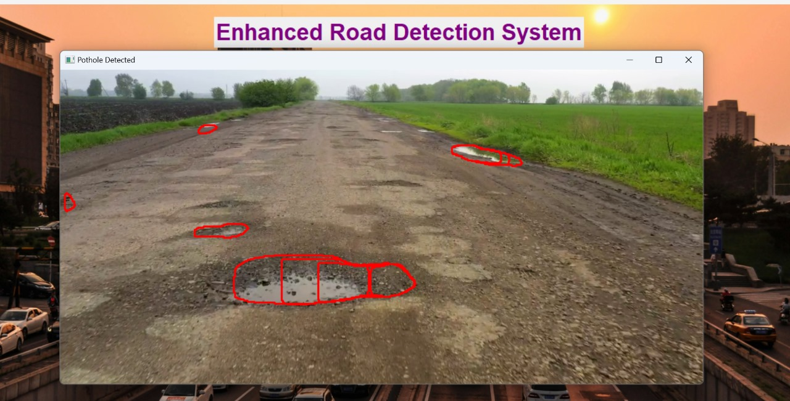
Figure 8: Pothole Detection Output Interface
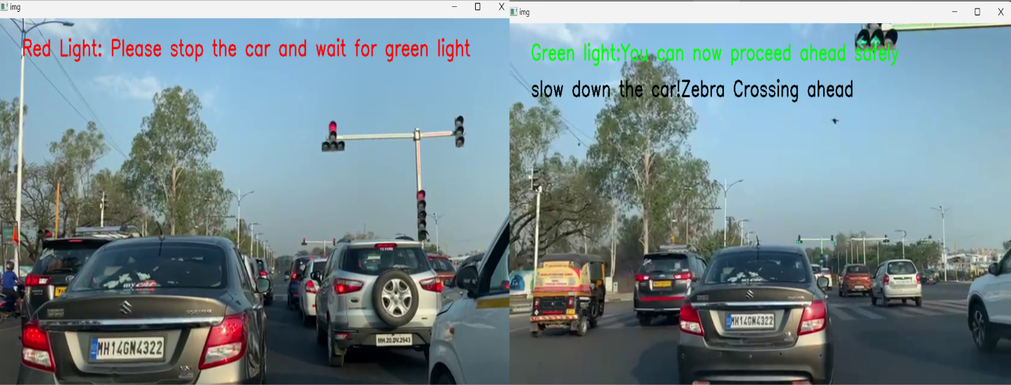
Figure 9: Signal Detection Output Interface

Implementations Details

Software Specifications
- Operating System: The system is developed to be compatible with various operating systems, including Windows, and macOS.
- Programming Language: The implementation primarily utilizes Python programming language due to its versatility and extensive libraries for machine learning and computer vision tasks.
- Libraries and Tools:
  - OpenCV: OpenCV is used for image and video processing tasks, including reading, preprocessing, and analysing images and videos.
  - NumPy: NumPy is employed for numerical computations and array manipulation, providing efficient data structures and functions for working with multidimensional arrays.
  - Ultralytics YOLO: Ultralytics YOLO is utilized for real-time object detection tasks, leveraging deep learning models for detecting and localizing objects within images and video frames.
  - psycopg2: psycopg2 facilitates interaction with PostgreSQL databases from Python applications, offering functions and classes for executing SQL queries and managing database transactions.
  - Tkinter: Tkinter is utilized for developing graphical user interfaces (GUIs) in Python, allowing users to interact with the software through windows, buttons, menus, and other graphical elements.

Hardware Specifications
- Processor: The performance of the object detection system may vary depending on the CPU capabilities. A multi-core processor is preferable for faster processing, especially during real-time video analysis.
- Graphics Processing Unit (GPU): Utilization of GPU acceleration can significantly enhance the performance of deep learning-based tasks such as object detection. However, the project doesn't specify GPU usage explicitly.
- Memory (RAM): Sufficient RAM is essential for handling image/video data and running deep learning models efficiently.
- Storage: Adequate storage space is required for storing video files, images captured during detection, and database storage.

Test Cases

Lane Line Detection
Test Scenario ID: LaneDetection-1
Test Case Description: Lane Detection - Positive test case. A sample road video is used for lane detection.
Pre-Requisite: The lane detection module (main.py) is installed and configured correctly. The necessary dependencies, including OpenCV, Matplotlib, and Docopt, are installed.
Table 1 : Lane Line Detection Test Case
Sr No | Action | Inputs | Test Case ID | Test Priority | Expected Output | Actual Output | Result | Comments
1 | Setup | - | LD-1 | High | Lane detection module and dependencies are properly configured. | Dependencies configured successfully. | Pass | Dependencies configured without errors
2 | Input Video Selection | Sample road video | LD-1 | High | A suitable sample road video is selected for testing. | Sample video selected successfully. | Pass | Sample video successfully loaded.
3 | Execution | Selected video | LD-1 | High | Lane detection module is executed with the sample video as input. | Lane lines detected successfully. | Pass | Lane lines detected accurately.
4 | Validation of Output | Detected lane lines | LD-1 | High | Detected lane lines are accurately overlaid on the original video. | Detected lane lines match ground truth markings. | Pass | Lane lines overlaid precisely on the original video.
5 | Assertion | Detected lane lines | LD-1 | High | Detected lane lines match the ground truth lane markings. | Assertion successful. | Pass | Ground truth lane markings matched by detected lines
6 | Feedback | Discrepancies/issues | LD-1 | High | Any discrepancies or issues observed during testing are documented. | No discrepancies found. | Pass | No discrepancies noted during testing
7 | Regression Testing | Multiple sample videos | LD-1 | High | Test is repeated with multiple sample videos for consistency. | Multiple videos tested successfully. | Pass | Regression testing ensured continued accurate detection of lane lines.

Pothole Detection
Test Scenario ID: PotholeDetection-1
Test Case Description: Pothole Detection - Positive test case. A sample road video is used for pothole detection.
Pre-Requisite: The pothole detection module (test.py) is installed and configured correctly. The necessary dependencies, including OpenCV and NumPy, are installed.
Table 2 : Pothole Detection Test Case
Sr No | Action | Inputs | Test Case ID | Test Priority | Expected Output | Actual Output | Result | Comments
1 | Setup | - | PD-1 | High | Pothole detection module and dependencies are properly configured. | Dependencies configured successfully. | Pass | Dependencies configured smoothly.
2 | Input Video Selection | Sample road video | PD-1 | High | A suitable sample road video is selected for testing. | Sample video selected successfully. | Pass | Sample video input processed without issues.
3 | Execution | Selected video | PD-1 | High | Pothole detection module is executed with the sample video as input. | Potholes detected successfully. | Pass | Potholes detected effectively.
4 | Validation of Output | Detected potholes | PD-1 | High | Detected potholes are accurately marked or highlighted in the video. | Potholes marked correctly in the video. | Pass | Potholes marked accurately in the video.
5 | Assertion | Detected potholes | PD-1 | High | Detected potholes match the ground truth pothole locations. | Assertion successful. | Pass | Ground truth pothole locations matched by detected ones.
6 | Feedback | Discrepancies/issues | PD-1 | High | Any discrepancies or issues observed during testing are documented. | No discrepancies found. | Pass | Testing revealed no discrepancies or issues.

Zebra and Signal Detection
Test Scenario ID: ZebraSignalDetection-1
Test Case Description: Zebra Crossing and Signal Detection - Positive test case. A sample road video is used for detecting zebra crossings and traffic signals.
Pre-Requisite: The Zebra and Signal detection module (zebra.py) is installed and configured correctly. The necessary dependencies, including OpenCV and NumPy, are installed.
Table 3 : Zebra and Signal Detection Test Case
Sr No | Action | Inputs | Test Case ID | Test Priority | Expected Output | Actual Output | Result | Comments
1 | Setup | - | ZSD-1 | High | Zebra and signal detection modules and dependencies are properly configured. | Dependencies configured successfully. | Pass | Dependencies set up correctly.
2 | Input Video Selection | Sample road video | ZSD-1 | High | A suitable sample road video is selected for testing. | Sample video selected successfully. | Pass | Sample video selection completed successfully.
3 | Execution | Selected video | ZSD-1 | High | Zebra and signal detection modules are executed with the sample video as input. | Zebra and signals detected successfully. | Pass | Zebra crossings and signals detected with accuracy.
4 | Validation of Output | Detected zebra and signals | ZSD-1 | High | Detected zebra crossings and signals are accurately marked or highlighted in the video. | Zebra crossings and signals marked correctly in the video. | Pass | Zebra crossings and signals highlighted precisely in the video.
5 | Assertion | Detected zebra and signals | ZSD-1 | High | Detected zebra crossings and signals match the ground truth locations. | Assertion successful. | Pass | Detected zebra crossings and signals aligned with ground truth locations.
6 | Feedback | Discrepancies/issues | ZSD-1 | High | Any discrepancies or issues observed during testing are documented. | No discrepancies found. | Pass | No issues or discrepancies identified during testing.

Conclusion & Recommendation

Conclusion

In conclusion, the development of the Enhanced Road Detection System project marks a significant step towards enhancing road safety and traffic management. Through the implementation of advanced computer vision algorithms and machine learning techniques, the project aims to address key challenges faced on roads, including lane deviations, pothole hazards, pedestrian safety, and traffic regulation.
The lane detection system provides valuable insights into lane positioning and vehicle trajectory, facilitating lane departure warnings and assisting drivers in maintaining their lanes. The pothole detection system offers proactive maintenance and repair efforts, thereby mitigating risks associated with road damage and enhancing overall road safety. The zebra crossing and traffic signal detection system contribute to pedestrian safety and efficient traffic flow by accurately identifying road markings and signals.
By integrating these subsystems into a cohesive project, we have laid the foundation for an Enhanced Road Detection System capable of detecting and addressing various road hazards in real-time. This project demonstrates the feasibility and effectiveness of leveraging computer vision and machine learning technologies for enhancing road safety and traffic management.

Recommendations

Continuous Improvement: Continuously refine and optimize the algorithms and models used in each subsystem to improve detection accuracy and robustness.
Dataset Expansion: Expand the datasets used for training and testing to encompass diverse environmental conditions, road scenarios, and geographic regions, thereby enhancing the generalizability and reliability of the detection systems.
Real-World Testing: Conduct extensive field testing of the project in real-world road environments to validate its performance under different lighting conditions, weather conditions, and traffic scenarios.
Integration with Vehicles: Explore opportunities for integrating the detection systems with vehicle onboard systems to provide real-time feedback and assistance to drivers, enhancing vehicle safety and automation capabilities.
Collaboration with Authorities: Collaborate with transportation authorities, road maintenance agencies, and urban planners to deploy the project in strategic locations and integrate it into existing traffic management systems.
By implementing these recommendations, we can further enhance the effectiveness and impact of the project, ultimately contributing to safer and more efficient road networks for all users.

Limitation

Manual intervention is required to set up coordinates for lane line detection in each input video due to variations in camera setups. As the camera configuration may differ for each video, setting up the coordinates manually ensures accurate detection of lane lines.
The detection capabilities for potholes, lane lines, zebra crossings, and traffic signals are constrained by the size and diversity of the training datasets. Currently, the datasets used for training are relatively small, which can result in reduced accuracy and generalization capabilities, particularly in varied road conditions.

Future Scope

Advanced Detection Techniques: Explore and integrate advanced detection techniques such as 3D object detection to improve the accuracy and robustness of the detection systems.
Multi-Modal Sensing: Investigate the use of multi-modal sensing technologies, including LiDAR, radar, and infrared sensors, to complement visual-based detection systems and enhance their performance in challenging environmental conditions.
Dynamic Road Marking Detection: Develop algorithms capable of dynamically detecting and interpreting temporary road markings, construction zones, and lane diversions to provide timely alerts to drivers and improve road safety during construction activities.
Predictive Analytics: Incorporate predictive analytics capabilities to forecast potential road hazards, traffic congestion, and infrastructure maintenance needs based on historical data and real-time observations, enabling proactive intervention and planning.
Integration with Autonomous Vehicles: Explore opportunities to integrate the detection systems with autonomous vehicle platforms to enhance their perception capabilities and enable safer and more reliable autonomous driving in diverse road environments.
Crowdsourced Data Collection: Implement mechanisms for crowdsourced data collection, allowing users to contribute real-time observations and feedback to improve the accuracy and coverage of the detection systems.
Smart City Integration: Integrate the detection systems with smart city infrastructure and traffic management systems to enable data-driven decision-making, optimize traffic flow, and enhance overall urban mobility.
Augmented Reality Interfaces: Develop augmented reality (AR) interfaces for drivers and pedestrians, overlaying real-time detection results and safety alerts onto their field of view to provide intuitive guidance and enhance situational awareness.
Global Deployment: Scale up the deployment of the project to cover a broader geographic area, including both urban and rural regions, to address diverse road infrastructure needs and improve road safety worldwide.
By pursuing these avenues of research and development, the project can continue to evolve and adapt to emerging technologies and societal needs, ultimately contributing to safer, smarter, and more sustainable transportation systems in the future.

Bibliography & References

- https://app.roboflow.com/potholesproject-afkvq/pothole_detection-lragw/settings
- https://app.roboflow.com/shraddha-pansare-0hlpi/yolov8-ozdbl/settings
- https://docs.opencv.org/4.x/d6/d00/tutorial_py_root.html
- https://numpy.org/doc/
- https://matplotlib.org/stable/api/image_api.html
- https://ipython.readthedocs.io/en/stable/api/generated/IPython.display.html
- https://pypi.org/project/moviepy/
- https://docs.opencv.org/4.x/dc/dbb/tutorial_py_calibration.html
- https://docs.python.org/3/library/glob.html
- https://docs.python.org/3/library/tk.html

