Server Starting
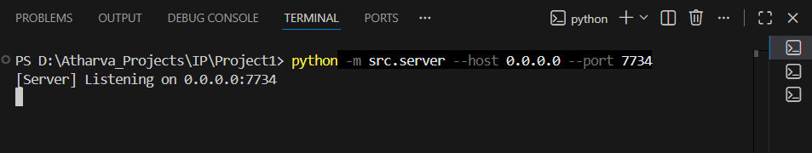
Peer A connecting
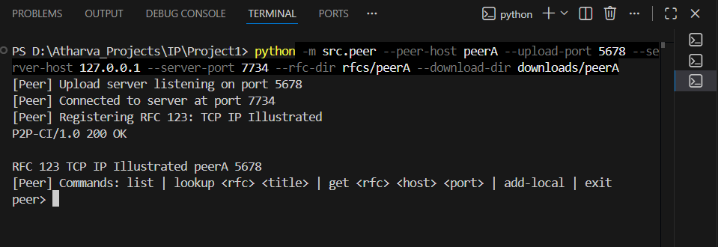
Peer B connecting
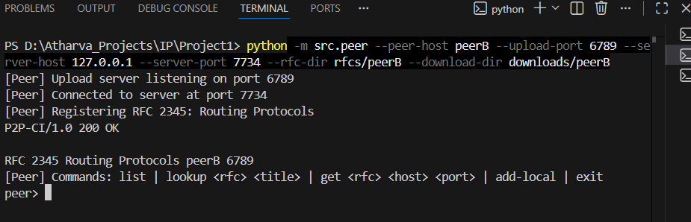
Peer C connecting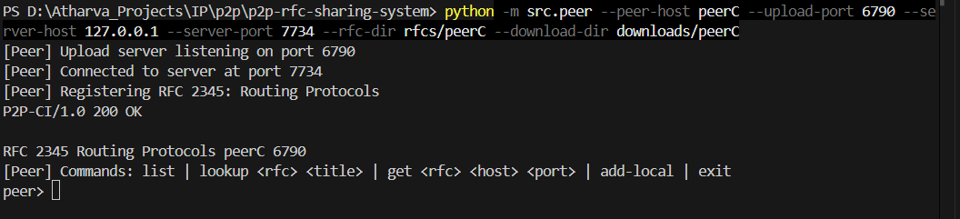

Server terminal with both peers connected and RFCs added
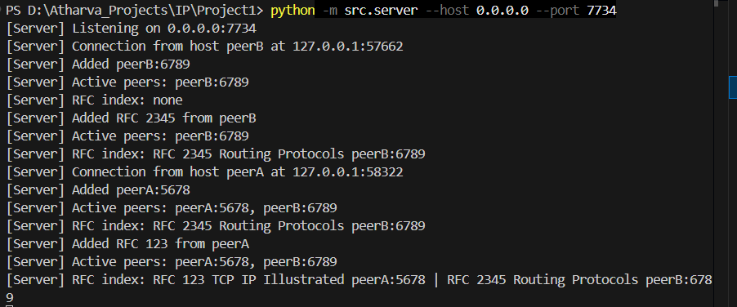
List Command
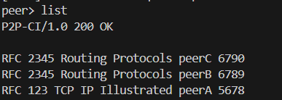

Lookup
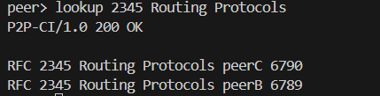

Get command
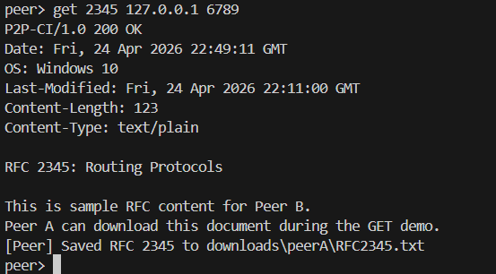

Checking if download is successful
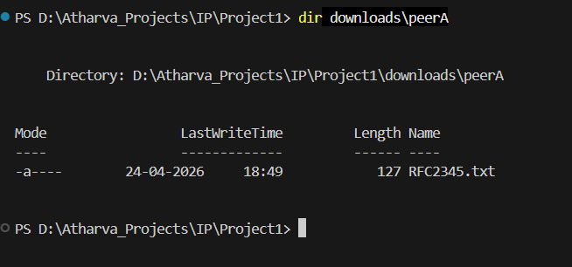
Removal for Peer C from Server

400 BAD Request

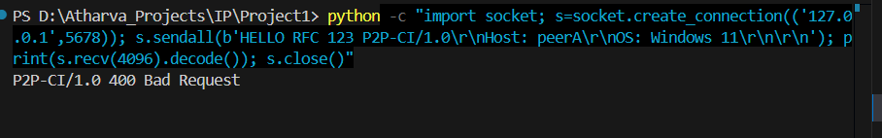
404 Not Found
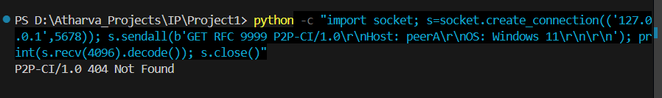
505
