SPÉCIALISÉ PRODUCTS Pvt. LTD.

USER MANUAL

Ink Printer

This is a user manual for Laser Scribing Machine designed by Spécialisé Products Pvt. Ltd. (SPPL). This is a private document. End Users cannot copy, share or modify the document without the permission from SPPL

1. Introduction
The Ink Machine is a precision-controlled system designed for accurate liquid ink printing and marking applications on various surfaces. It delivers controlled ink flow for patterns, text, and graphics with reliable repeatability and consistency.
All machine operations are managed through an integrated user interface (UI), allowing full control of setup, calibration, and job execution without the need for an external computer or additional software.

2. Machine Overview
- X-axis Travel: 0 – 50 mm
- Y-axis Travel: 0 – 50 mm
- Z-axis Travel: 0 – 50 mm
- User Interface: Built-in software UI for job preparation and execution
- Supported File Types: G-code, SVG, STL,

3. Communication
When the UI first opens, you will see a vertical toolbar on the left side with several icons (Home, Settings, Syringe Flushing Cycle, Programs, Print, Connect, Information).
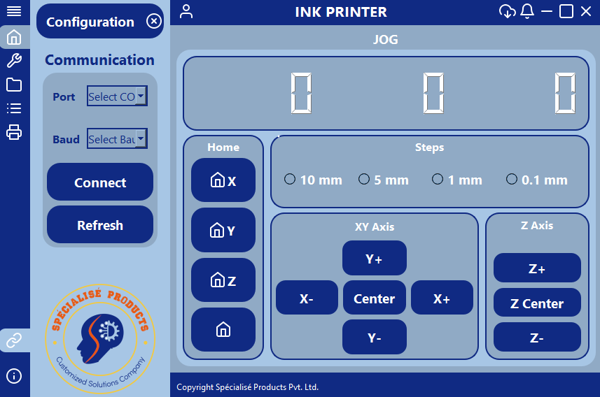

3.1 Connect Icon
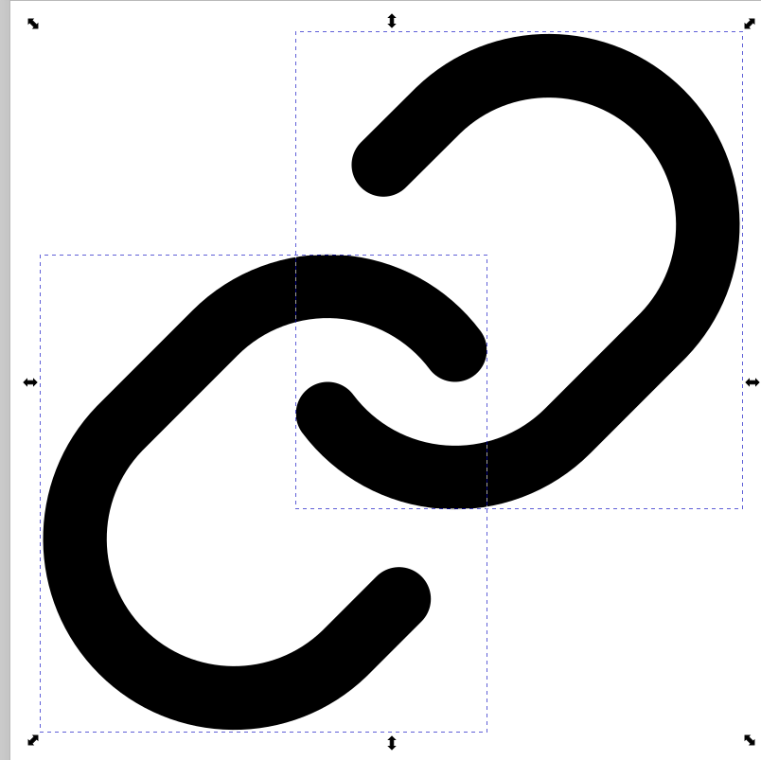
- The Connect icon looks like this:
- When you click this icon, the Communication Page opens.

3.2 Communication Settings
On this page, you will see:
- Port → Drop-down to select available COM port.
- Baud rate → Drop-down to select baud rate (e.g., 115200).
- Connect → Manually connect to the chosen COM port.
- Refresh → Update the list of available COM ports.

3.3 Auto-Connect Feature
- When you open the Connect page, a pop-up appears asking:
“Do you want to auto-connect?”
- If you select YES, the machine automatically connects to the COM port.
- If you select NO, you must manually select Port + Baud rate and press Connect.

4. Movement Control.

Jog Control
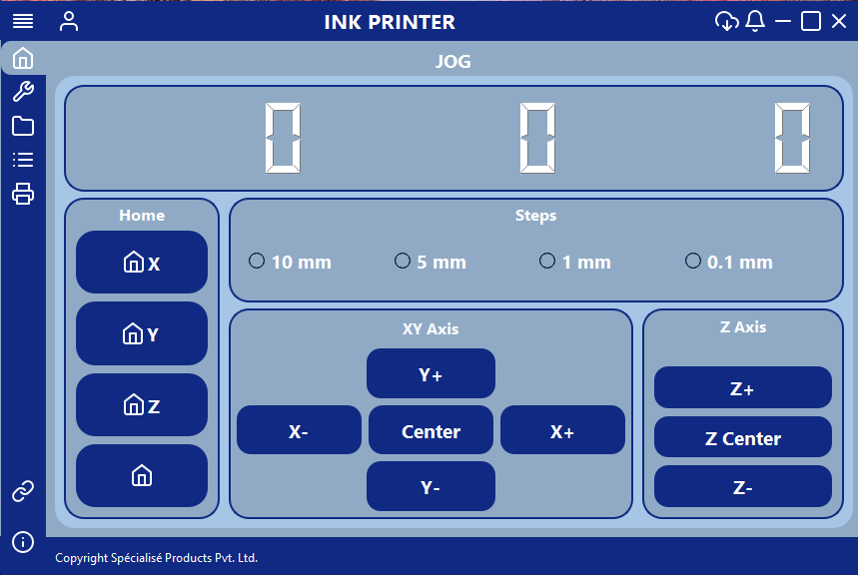

To manually position the laser head or the workpiece, click on the “JOG” tab in the INK software.
This page is divided into the following functional sections:
- Position Display
  - The top section shows the current X, Y, and Z axis positions in millimeters.
- Home Controls
  - Dedicated Home buttons are provided for X, Y, and Z axes.
  - Clicking a Home button will return that axis to its origin.
  - The Home All button moves all axes back to their starting positions, ensuring subsequent operations begin from a known reference point.
- Step Size Selection
  - Operators can select the jog step size: 10 mm, 5 mm, 1 mm, or 0.1 mm.
  - Smaller step sizes allow fine adjustments, while larger steps provide quick positioning.
- XY Axis Movement
  - Use X+ / X- / Y+ / Y- buttons to move along the XY plane.
  - Center button repositions the XY stage to the central point of its range.
- Z Axis Movement
  - Use Z+ / Z- buttons to move the laser head vertically.
  - Z Center returns the Z axis to its mid-point for balanced adjustment.

5.Machine Operation

5.1 Setting Page
The Setting Page is used to adjust the Z-level and set the X–Y index position of the machine accurately.
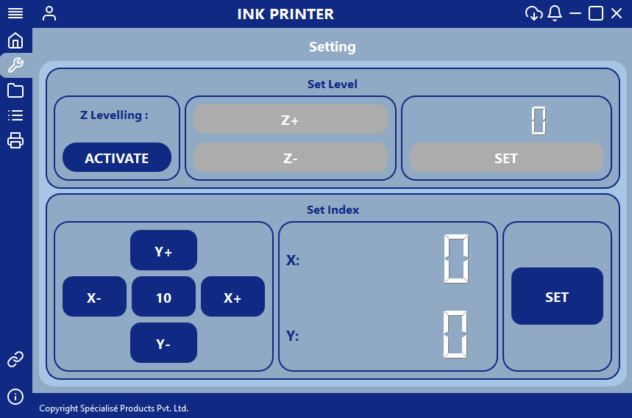

Z Levelling Procedure

Step 1: Activate Z Levelling
- Press the ACTIVATE button under Z Levelling.
- This enables manual Z-axis adjustment mode.

Step 2: Adjust Z Level
- Use the Z+ and Z- buttons to move the nozzle up or down in increments of 0.1 mm.
- Adjust the nozzle according to actual machine height requirements.
- Ensure the nozzle is positioned correctly relative to the bed surface.

Step 3: Save Z Level
- Once the desired height is set, press the SET button.
- The Z-level value will be saved in the system.

Set X–Y Index Position
After Z-level is set, proceed to configure the X and Y index.

Step 4: Move Nozzle to Index Position
- Use the direction buttons:
  - X+ / X- to move horizontally
  - Y+ / Y- to move vertically
- Move the nozzle to the exact position that should be used as the index reference.
- The movement step value (e.g., 10, 5, 1, 0.1) defines how much the nozzle moves per press.

Step 5: Set Index Position
- Once positioned correctly, press the SET button in the Set Index panel.
- The system records the X–Y index position.

NOTE : Index Boundary Validation (Safety Check)
If the entered index position is outside the printable bed area, the system will display the following pop-up message:
Nozzle offset out of bed area!
Allowed X range: {bed_xmin} – {bed_xmax}Allowed Y range: {bed_ymin} – {bed_ymax}
Tried: X = {x_final}, Y = {y_final}

Corrective Action
- Adjust X and Y values so they fall within the allowed bed limits.
- Re-press SET after correcting the nozzle position.

5.2 Syringe Flushing Cycle Page
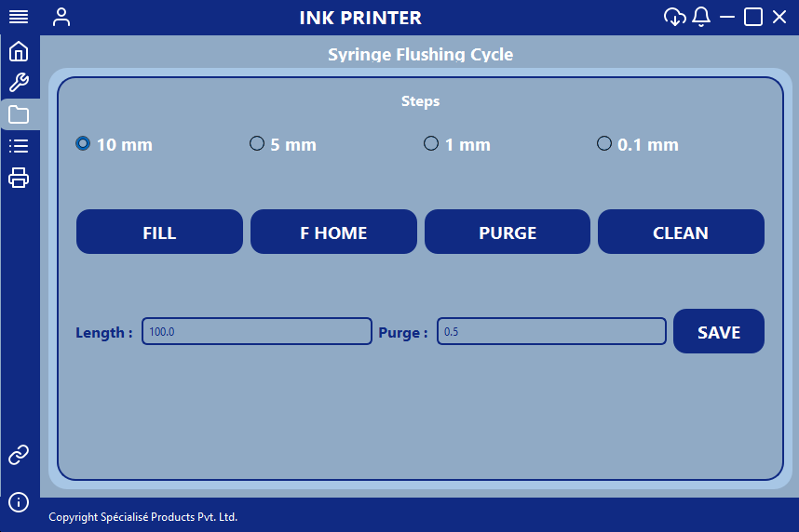

The Syringe Flushing Cycle Page is used to control the syringe pump for ink filling, purging, homing, and automatic cleaning operations. It allows the operator to control the movement of the syringe pump by selecting different step sizes and configuring the ink dispensing and purging parameters.
Functions:
1. Steps Selection
- The step selection options (10 mm, 5 mm, 1 mm, and 0.1 mm) define the movement distance of the syringe pump.
- Select the required step size before pressing the FILL or PURGE button.
- Larger step sizes allow faster syringe movement, while smaller step sizes provide more precise control.
2. FILL
- Press the FILL button to move the syringe pump and fill the ink into the syringe/needle.
- The pump moves according to the selected step size.
- This operation is used to prepare the ink system for printing.
3. F HOME (Syringe Pump Home)
- Press the F HOME button to move the syringe pump to its home position.
- This returns the syringe pump to its reference position.
4. PURGE
- Press the PURGE button to remove or discharge ink from the syringe/needle.
- The syringe pump moves according to the selected step size.
- This operation is used to remove excess ink and clear the ink line when required.
5. CLEAN (Automatic Cleaning)
The CLEAN button performs an automatic syringe and needle cleaning cycle using a dilute solution.
Cleaning Procedure:
- Press the CLEAN button to start the automatic cleaning process.
- The system first purges all the existing ink from the needle.
- Once the initial purging is completed, a confirmation pop-up appears:
Popup Message:
- Title: Purge Done
- Message: "Purging is complete. Please put the dilute solution for filling.
After putting, please press on Yes."
- Add the dilute solution to the ink system as instructed.
- Press Yes on the pop-up to continue the cleaning process.
- The syringe pump automatically starts filling the dilute solution.
- After filling, the system performs another purging operation.
- Once the complete cleaning cycle is finished, the following confirmation message appears:
Popup Message:
- Title: Cleaning Done
- Message: "Cleaning is done."
6. Length Parameter
- The Length field is used to configure the syringe pump movement/ink dispensing length during printing.
- Enter the required length value in the input field.
- The configured length determines the amount of ink to be dispensed during the printing process according to the print file's commands.
7. Purge Parameter
- The Purge field is used to configure the amount of ink to be purged during the printing process.
- Enter the required purge value in the input field.
- The configured value determines how much ink the syringe pump should purge when the corresponding purge operation is triggered during printing.
8. SAVE
- After entering the required Length and Purge values, press the SAVE button.
- The system saves the configured parameters for the printing process.
- These saved values are used during print execution according to the operations defined in the print file.

5.3 Program Page
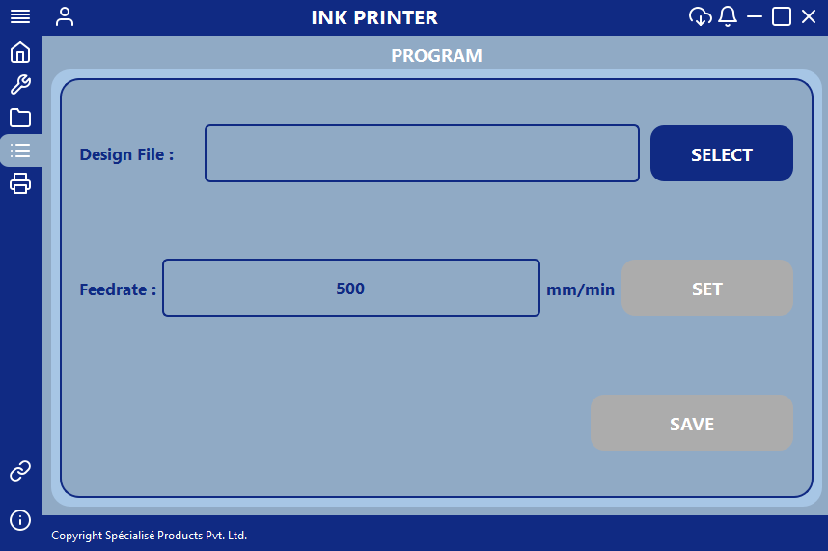

Functions:
- Design File:
  - Press SELECT to load the required design file from the PC.
  - Supported file formats:
SVG
- Feedrate :
  - Enter the printing speed in mm/min.
  - Press SET to apply the entered value.
- Save :
  - Press SAVE to store the current job configuration, including:
  - Selected design file
  - Feedrate value

NOTE : If the drawing exceeds the printable bed area after applying offsets, the system will display the following warning message:
Out of Bed Range
Drawing exceeds bed area!
X: {finalMinX} → {finalMaxX} (Bed: {bedXmin} → {bedXmax})
Y: {finalMinY} → {finalMaxY} (Bed: {bedYmin} → {bedYmax})
Please re-adjust the offsets.

Corrective Action
- Modify the X–Y offset values so the design fits within the allowed bed area.
- Press SAVE button on program page again after adjusting the offsets.

5.4 Print Page
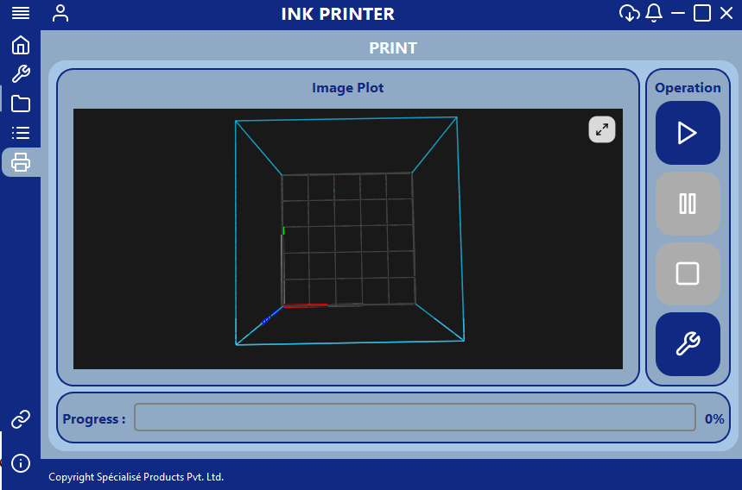

Functions:
- Image Plot Viewer:
  - Displays 3D preview of tool path.
  - Confirms correct file before running.
- Operation Buttons:
  - ▶ Start → Begin execution
  - || Pause → Pause file (laser turns OFF automatically)
  - ► Resume → Continue execution from paused state
  - ■ Stop → Abort file immediately
- Progress Bar:
  - Shows percentage completion of the file
  - ■ Stop → Abort file immediately
- Parameter Page:
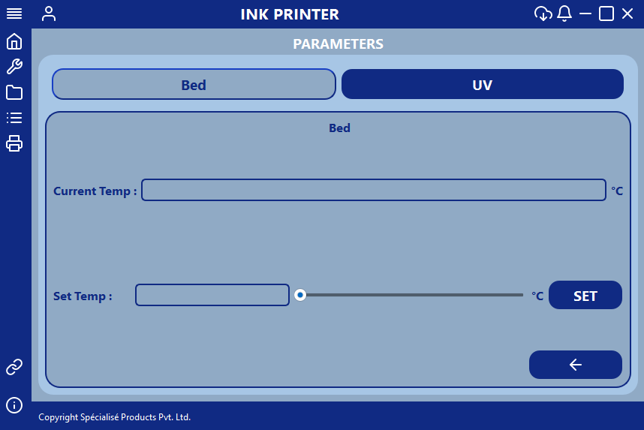
1. Bed Temperature

Functions:
1. Current Temp
- Displays the current bed temperature in real time.
- The temperature is displayed in degrees Celsius (°C).
- This field allows the operator to monitor the actual bed temperature.
2. Set Temp
- Used to configure the desired bed temperature.
- The operator can set the temperature in two ways:
  - Manual Input: Enter the required temperature directly into the input box.
  - Slider Control: Move the slider to adjust and select the desired temperature.
- The input box and slider allow the operator to select the required bed temperature.
3. SET Button
- After entering or selecting the required temperature, press the SET button.
- The system applies the selected temperature as the bed temperature target.
4. Back Button (←)
- Press the left-arrow button to return to the Print Page.
- It allows the operator to navigate back to the printing interface after configuring the bed temperature.

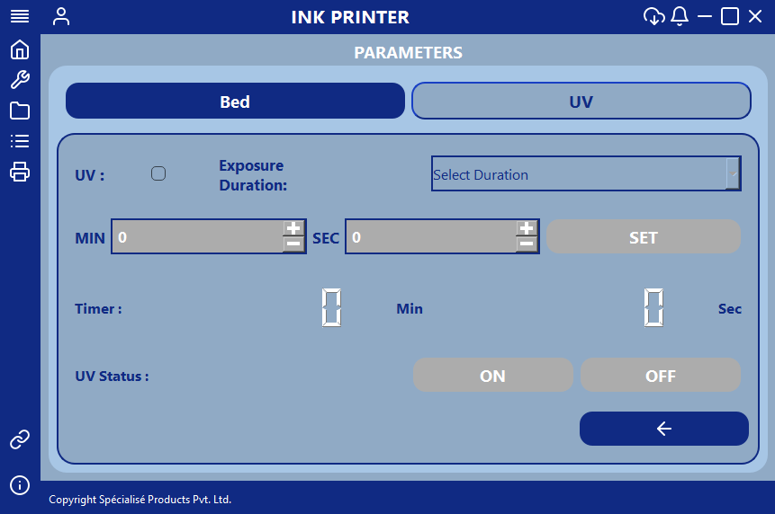
2. UV Page
Functions:
1. UV Enable Checkbox
- The UV checkbox is used to enable or disable the UV exposure function.
- Select the checkbox to activate UV operation after the printing process is completed.
- If enabled, the UV process starts according to the selected exposure duration mode.
2. Exposure Duration
- This drop-down menu allows the operator to select the UV exposure mode.
- Two operating modes are available:
  - Manual: The UV light remains ON after printing is completed until the operator manually switches it OFF.
  - Timer: The UV light remains ON for the configured duration and automatically switches OFF when the timer reaches zero.
3. MIN and SEC Settings
- These fields are used to configure the UV exposure time in minutes and seconds.
- Enter the required exposure duration in the respective fields.
- These settings are applicable when Timer Mode is selected.
4. SET Button
- After entering the required minutes and seconds, press the SET button.
- The system saves the configured UV exposure duration.
- Once printing is completed, the UV light turns ON and the countdown begins according to the saved timer settings.
- When the configured time expires, the UV light automatically turns OFF.
5. Timer Display
- Displays the remaining UV exposure time in minutes and seconds.
- During Timer Mode, the countdown starts after the printing process is completed.
- The display allows the operator to monitor the remaining exposure duration.
6. UV Status – ON / OFF
These buttons are used to control the UV light manually.
- ON: Press the ON button to switch ON the UV light.
- OFF: Press the OFF button to switch OFF the UV light.
In Manual Mode, the operator must use the OFF button to stop UV exposure after the required duration.
In Timer Mode, the UV light switches OFF automatically when the configured exposure time is completed.
7. Back Button (←)
- Press the left-arrow button to return to the Print Page.
- It allows the operator to navigate back to the printing interface after configuring the UV settings.

6. Job Execution Workflow
Follow the steps below to operate the Ink Printer safely and correctly.

1. Communication Setup
- Open the Communication Page.
- Select the COM Port and Baud Rate (115200).
- Press Connect or select YES for auto-connect.
- Ensure the machine is connected.

2. Setting Page
- Press ACTIVATE to enable Z levelling.
- Use Z+ / Z- to adjust the nozzle height.
- Press SET to save the Z level.
- Move the nozzle using X+ / X- / Y+ / Y- to set the index position.
- Press SET to save the X–Y position.
- If the position is outside the bed area, adjust it and set again.

3. Syringe Flushing Cycle
- Press CLEAN to start automatic cleaning. Add the dilute solution when the Purge Done message appears and press YES.
- After cleaning is completed, enter the Length and Purge values and press SAVE.

4. Program Page
- Press SELECT to load the SVG design file.
- Enter the printing speed in mm/min.
- Press SET to apply the feedrate.
- Press SAVE to save the job settings.
- If the design is outside the bed area, adjust the offsets and save again.

5. Parameter Settings
A. Bed Temperature
- Open the Parameters Page and select Bed.
- Enter the required temperature or adjust it using the slider.
- Press SET to apply the temperature.
B. UV Settings (If Required)
- Select the UV tab and enable the UV checkbox.
- Select Manual or Timer mode.
- In Timer Mode, enter the required minutes and seconds and press SET.
- In Manual Mode, switch OFF the UV manually after exposure.
- In Timer Mode, the UV automatically switches OFF when the timer ends.

6. Preview File
- Open the Print Page.
- Check the design in the Image Plot Viewer before printing.

7. Start Printing
- Press ▶ Start to begin printing.
- The machine automatically homes before execution.
- Monitor the printing process using the progress bar.

8. Pause / Resume
- Press || Pause to pause printing.
- Press ► Resume to continue printing.

9. Stop or Finish
- Printing stops automatically when progress reaches 100%.
- Press ■ Stop to stop printing manually.
- If UV is enabled, the UV process starts after printing according to the selected mode.

10. Shutdown
- Ensure printing and UV operations are completed.
- Switch OFF the machine safely.

7. Maintenance Guidelines
- Nozzle Cleaning
Clean the ink nozzles regularly using approved cleaning solution and lint-free cloth to prevent ink clogging.
- Ink System Check
Ensure ink tanks or cartridges are filled and there is no air bubble in the ink lines.
- Bed Cleaning
Clean the print bed to remove dust, ink residue, and debris for proper print adhesion.
- Axis Calibration
Periodically verify X, Y, and Z movement for smooth travel and accuracy.
- Mechanical Components
Check belts, rails, and screws regularly for proper alignment and tightening.
- Electrical Connections
Inspect cables and connectors for loose connections or damage.

8. Troubleshooting
Issue | Solution
Printer not starting | Check main power switch and power cable
No ink printing | Check ink level, clean nozzles
Print not aligned | Reset and set X–Y Index again
Ink smudging | Adjust Z-level and drying time
Bed out of range error | Re-set index within bed area
Communication failed | Check USB/COM connection
Job stops suddenly | Restart UI and reload file

9. Safety Notes
- Do not touch the printhead while in operation.
- Wear gloves when refilling ink cartridges.
- Avoid contact with ink on skin and eyes.
- Keep liquids away from control panel and electronics.
- Ensure proper ventilation when using solvent ink.
- Do not operate with loose cables or open covers.
- Perform test printing before full production run.
- Switch OFF power before maintenance work.

