**TABLE OF CONTENTS**

PROJECT SYNOPSIS 1

CHAPTER 1: EDLC

1.1 Need 4

1.2 Conceptualization/concept scope 4

1.3Targeted end user 4

1.4Analysis 4

1.4.1 Functional Requirement 4

1.4.2 Non-Functional Requirement 4

1.5 Circuit diagram 5

CHAPTER 2: INTRODUCTION

2.1 BACKGROUND 12

2.2 OBJECTIVES 12

2.3 PURPOSE, SCOPE AND APPLICABILITY 12

2.3.1 PURPOSE 12

2.3.2 SCOPE 12

2.4 ACHIEVEMENTS 12

CHAPTER 3: SURVEY OF TECHNOLOGY 13

CHAPTER 4: REQUIREMENTS AND ANALYSIS

4.1 Problem definition: 14

4.1.1 Problem description: 14

4.1.2 Sub-problems: 14

4.2 Requirement specification: 14

4.2.1 Requirement Gathering: 15

4.2.2 Requirement analysis: 16

4.3 planning and scheduling 19

4.3.1 Activity table 19

4.3.2 Gantt chart 20

CHAPTER 5: SYSTEM DESIGN

5.1 Data Flow Diagram (DFD): 21

Level 0 (Context level DFD): 22

Level 1 DFD: 22

5.2 Activity Diagram- 23

5.3 State-chart Diagram 25

5.4 Test cases 28

CHAPTER 6: BIBLIOGRAPHY

6.1 Book Reference 29

6.2 Website Reference 29

6.3 Referred for uml diagram 29

**List of Figures**

|  |  |  |
| --- | --- | --- |
| **No.** | **Diagram name** | **Page number** |
| 1. | Architecture | 2 |
| 1.1 | Arduino Uno | 6 |
| 1.2 | Ultrasonic sensor | 6 |
| 1.3 | Soil moisture sensor | 7 |
| 1.4 | Resistors | 7 |
| 1.5 | Light Dependent Resistor | 8 |
| 1.6 | Buzzers | 9 |
| 1.7 | GPS NEO 6M | 9 |
| 1.8 | ESP8266 NodeMCU | 10 |
| 1.9 | Jumper wires | 10 |
| 1.10 | Circuit diagram of Arduino uno | 11 |
| 1.11 | Circuit diagram of wifi module | 11 |
| 4.1 | Requirement gathering | 16 |
| 4.2 | Gantt chart | 20 |
| 5.1 | Level 0 DFD | 22 |
| 5.2 | Level 1 DFD | 22 |
| 5.3 | Systems Activity diagram | 24 |
| 5.4 | State chart diagram obstacle detection | 26 |
| 5.5 | State chart diagram water detection | 26 |
| 5.6 | State chart diagram Insufficient light detection | 27 |
| 5.7 | State chart diagram location | 27 |

**List of Tables**

|  |  |  |
| --- | --- | --- |
| **Table. No.** | **Table Name** | **Page No.** |
| 4.1 | Activity Table | 19 |
| 5.1 | DFD diagram Notations | 21 |
| 5.2 | Activity diagram Notations | 23 |
| 5.3 | State diagram Notations | 25 |
| 5.4 | Test cases | 28 |

**SYNOPSIS**

* **Title:**

SMART BLIND STICK

* **Statement:**

The project will basically detect the obstacles in front of them, water also &insufficient light. It has feature of GPS tracking which is used for the persons caretaker or parents to track location.

* **Why this project?**

In our country there are many blind person and they typically use the white colour stick to navigate and detect obstacle with the help of physical touch to that obstacle. But this device is useful for them to detect the obstacle with the specific range and the sensors which are used in this system i.e ultrasonic sensors, soil moisture sensor, light dependent resistor sensor will help to detect if water is ahead and insufficient light and main feature is GPS tracking which is used to track the location of that visually impaired person and from the safety point of view also .so this will be the modern type of stick which is more useful or more advanced than the earlier one.

* **Objective or scope of object:**

Smart blind stick is specially designed to detect obstacles whether its solid or water in front of visually impaired person which may help to navigate freely like sighted person and from the safety point of view of GPS tracking used.

Scope:

From this project visually impaired person can walk freely like sighted person. And the persons parents or caretaker can track the location so they will also don’t have to worry about that person with the help of SMS to authenticated device.

* **Methodology for developing project:**

EDLC Model and SDLC Model

* **SDLC Model**

In this system I am going to use iterative model.

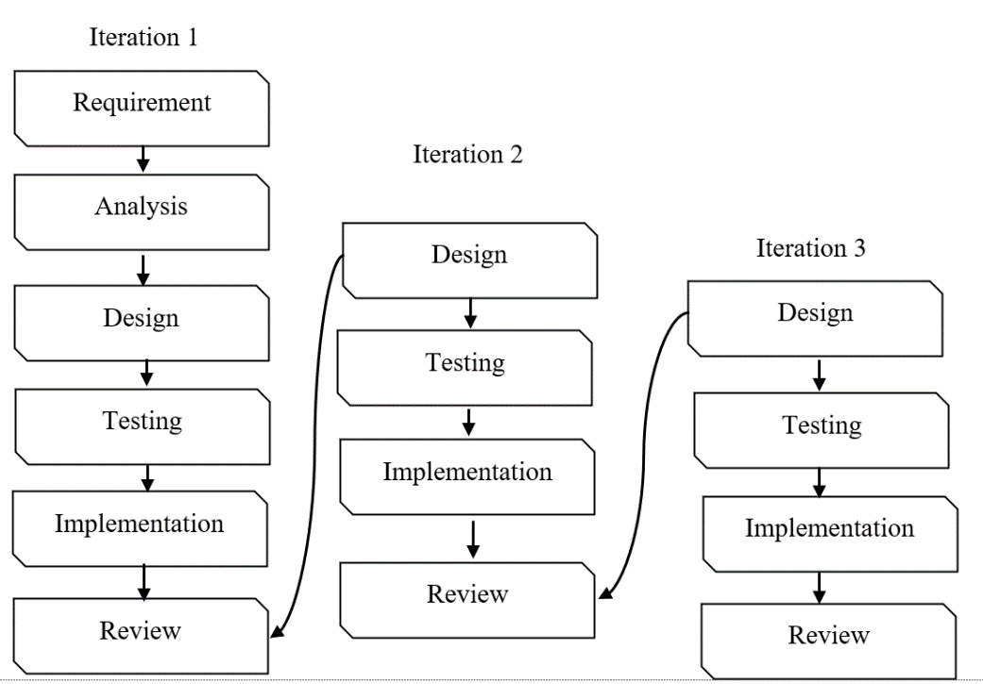

***Fig 1 Architecture***

* **Proposed architecture of project:**

Standalone project

* **Requirements:**

1. Software requirements:

Operating system :Windows 7,8,10 or Mac OS, Arduino IDE for coding, Arduino software, Blynk app.

1. Hardware requirements:

Arduino uno, ultrasonic sensor, LDR, Soil moisture sensor, resistor, breadboard, GPS module, Node MCU Esp8266, power supply.

* **Platform required:**

Arduino IDE

* **Contribution of society:**

With this project the visually impaired person can walk with the confidence as sighted person and main feature is the GPS location through Blynk app.

**1.1 Need:**

In our country the people who are visually impaired have the the blind stick which can detect obstacle by only physical touch, but this system which I am developing through sensors it can detect obstacle, water, & insufficient light and main feature is live location through Blynk app for the visually impaired persons parents or caretaker so that they can walk freely like sighted person .

**1.2 Conceptualization/concept scope:**

From this project visually impaired person can walk freely like sighted person and person’s parents or caretaker can track the live location so they don’t have to worry about that person. It is all possible through sensors.

**1.3 Targeted end user:**

Visually impaired person

**1.4 Analysis:**

1. Functional requirements:
2. The system should detect the obstacles in front of them with the help of sensors
3. The system should track the live location of person with the help of Blynk app.
4. While tracking the location, systems wifi or network should be on.
5. While doing this things system should have the stable power supply.
6. Non functional requirements:
7. The system should be secured
8. It should be reliable and accurate also easy to use.
9. It should be easy to maintain.

**1.5 Circuit diagram:**

### 1.5.1 Arduino Uno

The Arduino UNO is an open-source microcontroller board based on the MicrochipATmega328P microcontroller and developed by Arduino cc. The board is equipped with sets of digital and analog input/output (I/O) pins that may be interfaced to various expansion boards (shields) and other circuits. The board has 14 Digital pins, 6 Analog pins, and programmable with the Arduino IDE (Integrated Development Environment) via a type B USB cable. It can be powered by a USB cable or by an external 9 volt battery, though it accepts voltages between 7 and 20 volts. It is also similar to the Arduino Nano and Leonardo. The hardware reference design is distributed under a Creative Commons Attribution Share-Alike 2.5 license and is available on the Arduino website. Layout and production files for some versions of the hardware are also available.

"Uno" means one in Italian and was chosen to mark the release of Arduino Software (IDE) 1.0.The Uno board and version 1.0 of Arduino Software (IDE) were the reference versions of Arduino, now evolved to newer releases. The Uno board is the first in a series of USB Arduino boards, and the reference model for the Arduino platform. The ATmega328 on the Arduino Uno comes preprogrammed with a boot loader that allows uploading new code to it without the use of an external hardware programmer. It communicates using the original STK500 protocol The Uno also differs from all preceding boards in that it does not use the FTDI USBto-serial driver chip. Instead, it uses the Atmega16U2 (Atmega8U2 up to version R2) programmed as a USB-to-serial converter.

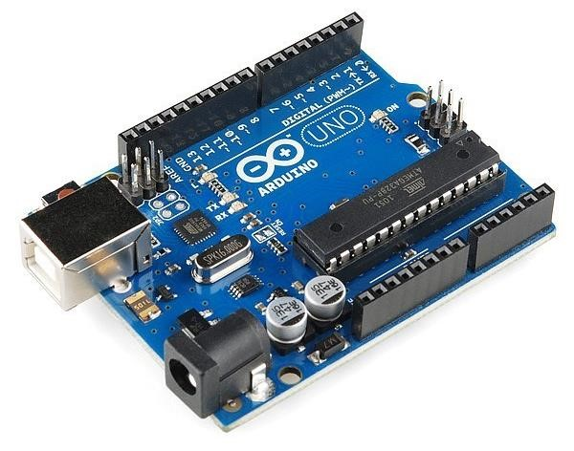

***Fig 1.1 Arduino Uno***

### 1.5.2 Ultrasonic Sensor

An ultrasonic sensor is an electronic device that measures the distance of a target object by emitting ultrasonic sound waves, and converts the reflected sound into an electrical signal. Ultrasonic waves travel faster than the speed of audible sound. Ultrasonic sensors have two main components: the transmitter (which emits the sound using piezoelectric crystals) and the receiver (which encounters the sound after it has travelled to and from the target).

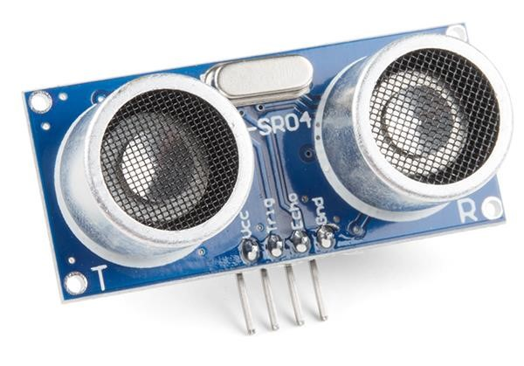

***Fig 1.2 Ultrasonic sensor***

### 1.5.3 Soil Moisture Sensor

Soil moisture sensors measure or estimate the amount of water in the soil. These sensors can be stationary or portables such as handheld probes. Stationary sensors are placed at the predetermined locations and depths in the field, whereas portable soil moisture probes can measure soil moisture at several locations.

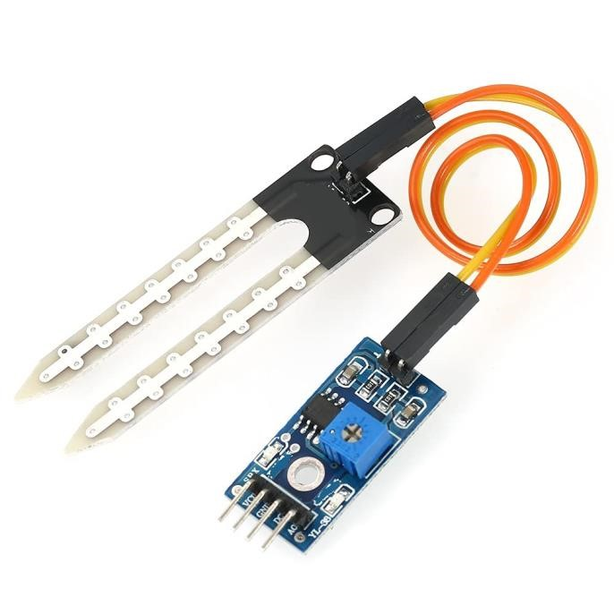

***Fig 1.3 Soil moisture sensor***

### 1.5.4 Resistors

It is a device having resistance to the passage of an electric current A resistor is an electrical component that limits or regulates the flow of electrical current in an electronic circuit.

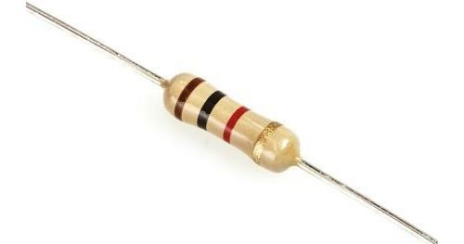

***Fig 1.4 Resistors***

### 1.5.5 LDR (Light Dependent Resistor)

An LDR is a component that has a (variable) resistance that changes with the light intensity that falls upon it. This allows them to be used in light sensing circuits A photoresistor is a light-controlled variable resistor. The resistance of a photoresistor decreases with increasing incident light intensity; in other words, it exhibits photoconductivity. A photoresistor can be applied in light-sensitive detector circuits, and light-activated and darkactivated switching circuits. Working Principle of LDR.

This resistor works on the principle of photo conductivity. It is nothing but, when the light falls on its surface, then the material conductivity reduces and also the electrons in the valence band of the device are excited to the conduction band.

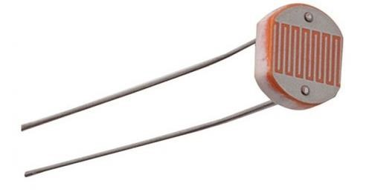

***Fig 1.5 Light Dependent Resistor***

### 1.5.6 Buzzers

A buzzer or beeper is an audio signaling device,[which may be mechanical, electromechanical, or piezoelectric (piezo for short). Typical uses of buzzers and beepers include alarm devices, timers, and confirmation of user input such as a mouse click or keystroke.

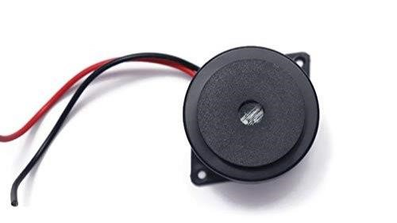

***Fig 1.6 Buzzers***

### 1.5.7 GPS NEO 6M

GPS stands for Global Positioning System by which anyone can always obtain the position information anywhere in the world. GPS receiver module gives output in standard (National Marine Electronics Association) NMEA string format. It provides output serially on Tx pin with default 9600 Baud rate. This NMEA string output from GPS receiver contains different parameters separated by commas like longitude, latitude, altitude, time etc. Each string starts with ‘$’ and ends with carriage return/line feed sequence.

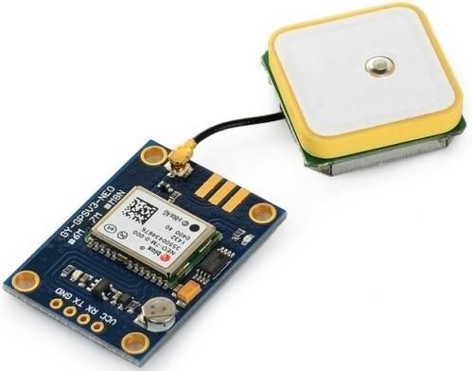

***Fig 1.7 GPS NEO 6M***

### 1.5.8 ESP8266 NodeMCU

The NodeMCU (*N*ode *M*icro*C*ontroller *U*nit) is an open-source software and hardware development environment built around an inexpensive System-on-a-Chip (SoC) called the ESP8266. The ESP8266, designed and manufactured by Espressif Systems, contains the crucial elements of a computer: CPU, RAM, networking (WiFi), and even a modern operating system and SDK.

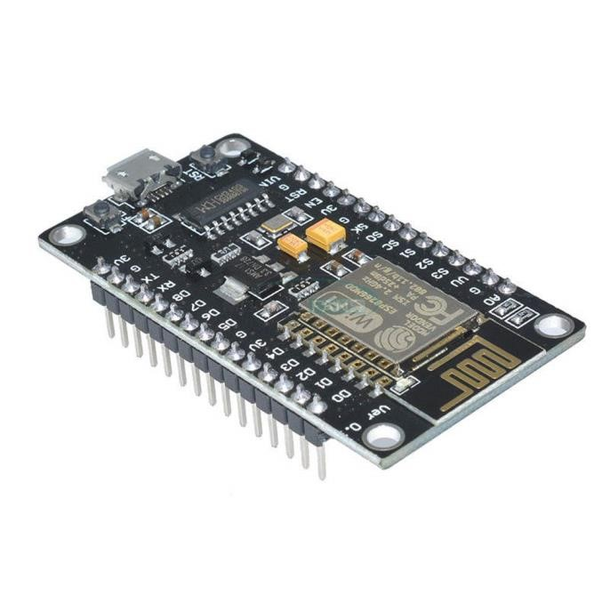

***Fig 1.8******ESP8266 NodeMCU***

### 1.5.9 Jumper wires

A wire is a single, usually cylindrical, flexible strand or rod of metal. Wires are used to bear mechanical loads or electricity and telecommunications signals. Wire is commonly formed by drawing the metal through a hole in a die or draw plate. Wire gauges come in various standard sizes, as expressed in terms of a gauge number. The term wire is also used more loosely to refer to a bundle of such strands, as in "multi stranded wire", which is more correctly termed a wire rope in mechanics, or a cable in electricity.

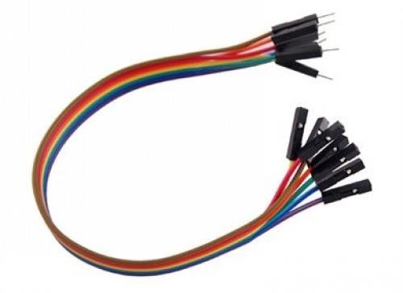

***Fig 1.9 Jumper wires***

**Circuit diagram of Arduino uno:**

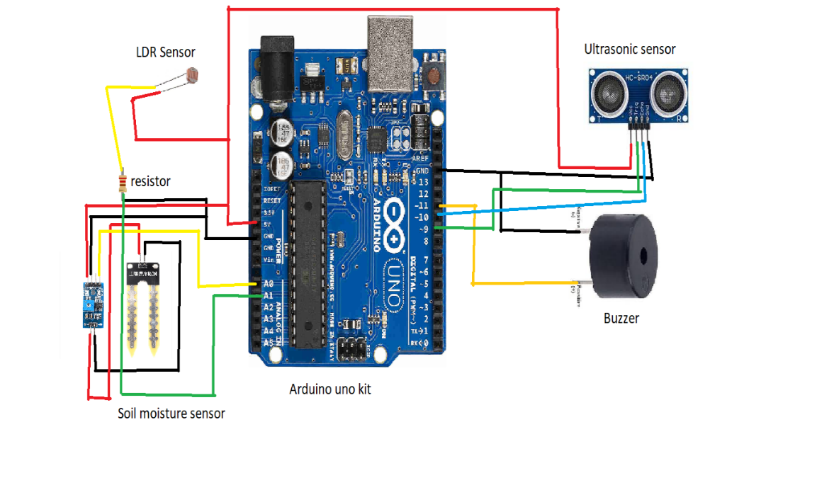

***Fig 1.10 Circuit diagram of Arduino uno***

**Circuit diagram of wifi module:**

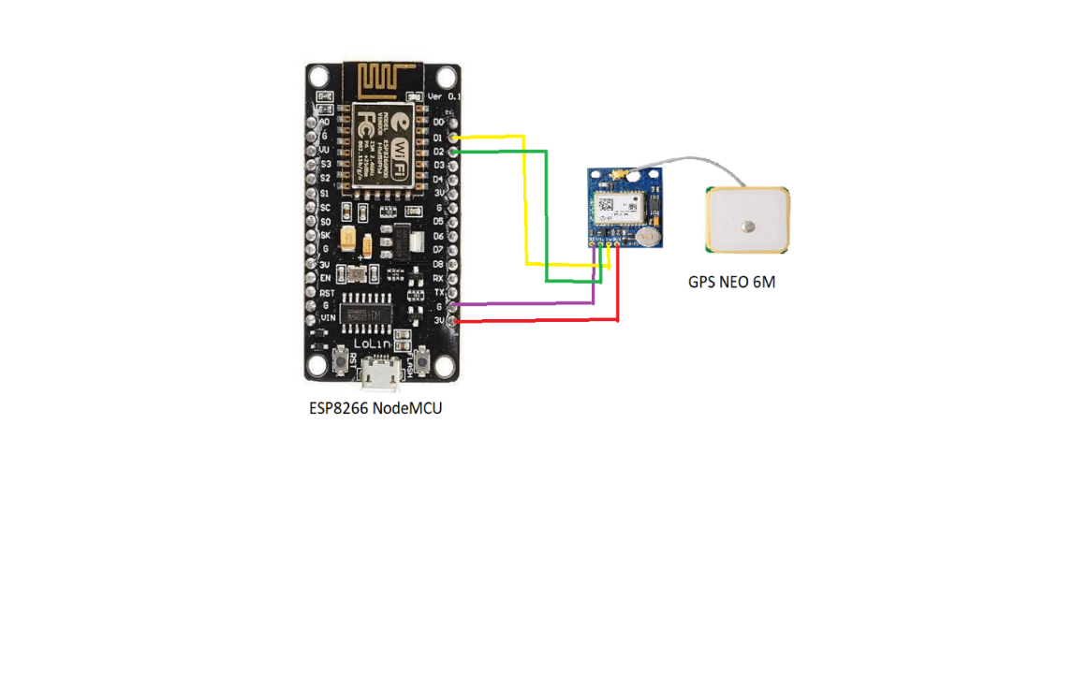

***1.11 circuit diagram of wifi module***

**2.1 Background:**

The previous blind stick which is in use is just a simple and foldable stick which can detect the obstacle by physical touch only and some modern blind sticks made from IOT can detect obstacle in front from sensor. The smart blind stick can detect obstacle from front other than that water , and insufficient light with the help of sensors and main feature is live GPS location to the person who is authentic (parents or caretaker).

**2.2 Objective:**

This system is specially designed to detect obstacles whether its solid, water in front of visually impaired person which may help to navigate freely like sighted person and from the safety concern there is GPS tracking is used.

**2.3 Purpose , scope, applicability:**

2.3.1 Purpose:

In our country the people who are visually impaired have the blind stick which can detect obstacle by only physical touch. But in this system there are sensors which can detect obstacle, water and insufficient light and main feature is the live location through GPS, people can view like sighted person through this system.

2.3.2 Scope:

From this project visually impaired person can walk freely like sighted person and persons parents or caretaker can track the live location so they don’t have to worry about that person .

* + 1. Applicability:

By implementing this project the visually impaired person can walk freely like sighted person. The main use of this project is for the visually impaired person in our society.

**2.4 Achievements :**

In Smart Blind Stick the input stage is consist of 3 sensors; i.e. Ultrasonic sensors, Soil Moisture sensor and LDR sensor which senses the obstacle, water and light respectively. A C Program is loaded into microcontroller. The live location is shared so it will be easier for caretaker to track the live location of the person.

* **Arduino** : Arduino is the leading company on the iot market that produces electronic devices and software for them. They are having software products and represented by Arduino ide, Arduino cloud, iot cloud remote and coding is done in c.
* **Flutter:** Another hardware product for iot solution is flutter a programmable processor core. It’s based on Arduino. It has complete kit , solar panel ,3D printed parts for device parts. For device dart language is used.
* **Raspberry pi**: It’s formerly known as Raspbian .It’s official operating system for raspberry pi hardware and programming are done in python.
* **Kinoma**: It’s open source software and hardware product for iot and embedded solutions. kinoma create, kinoma studio(IDE),kinoma connect(for android ios) are products.
* **Node-red**: It’s a free programming tool based on node.js .It works primarily in linux environment but can be installed on android and windows.as well. You will need linux subsystem for windows.
* **Eclipse Iot** :A wide range of open source project for iot development is gathered under eclipse umbrella. They include software development platforms framework ,tools and many more. It uses java language.

**Technology I am going to use for this project is:** Arduino

**Reason for selecting this technology:**

The Arduino software is easy to use for beginners and it runs on mac, windows, and linux. The main reason for selecting this technology is it’s inexpensive, cross platform support ,simple clear programming environment , open source and extensible hardware.

4.1 **Problem definition:**

Smart blind stick is specially designed to detect obstacles whether it’s solid or water in front and also insufficient light which help visually impaired person to navigate freely like sighted person. And for the safety point of view of that person GPS tracking system is also used with the help of Blynk app.

**4.1.1** **Problem Description:**

This stick will help the blind person to walk freely like sighted person, as it detect obstacles, water, insufficient light with the help of sensors and main feature of it is that it can track the live location of person also.

**4.1.2 sub problems :**

1. obstacle detection
2. water detection
3. insufficient light detection
4. GPS tracking
5. Obstacle detection : In this with the help of ultrasonic sensor obstacle detection is done with the help of this we can detect the obstacle in front by 1 to 25 feet of range before.
6. Water detection: If the water is present in front of the person it will beep, for that soil moisture sensor is used.
7. Insufficient light detection: If there is absence of light particular room or on that specific road or lane also.It will beep so that person will not go in that area.It is done using light dependent resistor(LDR) sensor.
8. GPS tracking : For the safety point of view the feature of GPS tracking is there it can give the current location of that person to the authorized device with the help of Blynk app.

**4.2 Requirement specification:**

For my system I have used google forms to collect feedback from users and according to the responses I have added the functional , non-functional and system requirements for the system.

4.2.1 Requirement Gathering:

The link of the google form that I provided to the users is given below:

<https://docs.google.com/forms/d/1YxGAKoBTpvLbhDwQ49kYo5k1PchBtLSVXWYTSUfATIs/edit>

Based on the responses I got from the users, I may conclude that:

According to the response 58.1% people think that blind people may navigate properly. Almost 61.3% people think that blind people can’t recognize potholes during the rainy days.90.3% people think that it will be good if it is done with the help of sensors.96.8%people think that the live GPS tracking feature can be helpful.

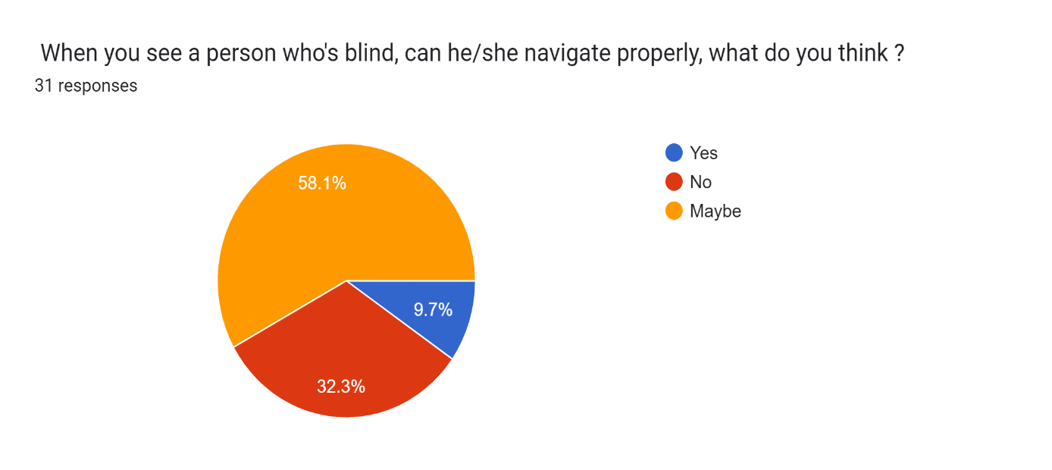

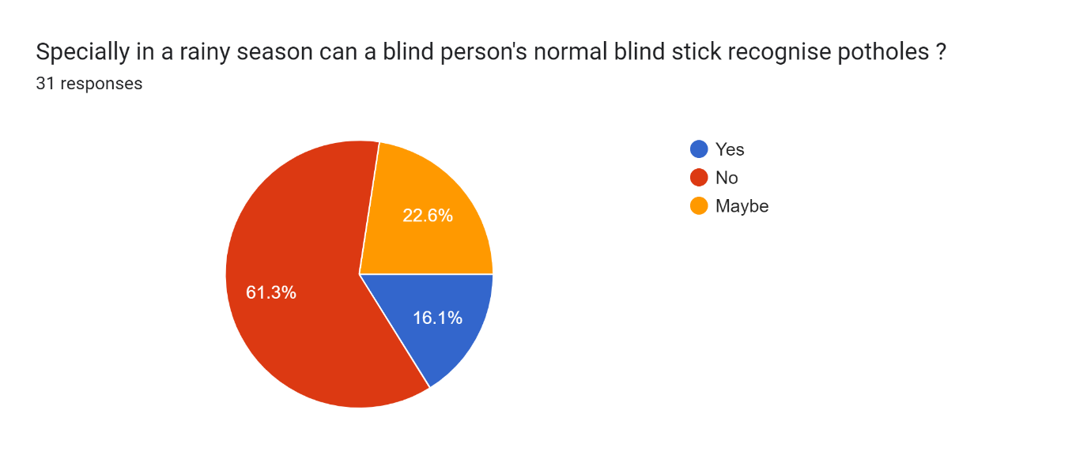

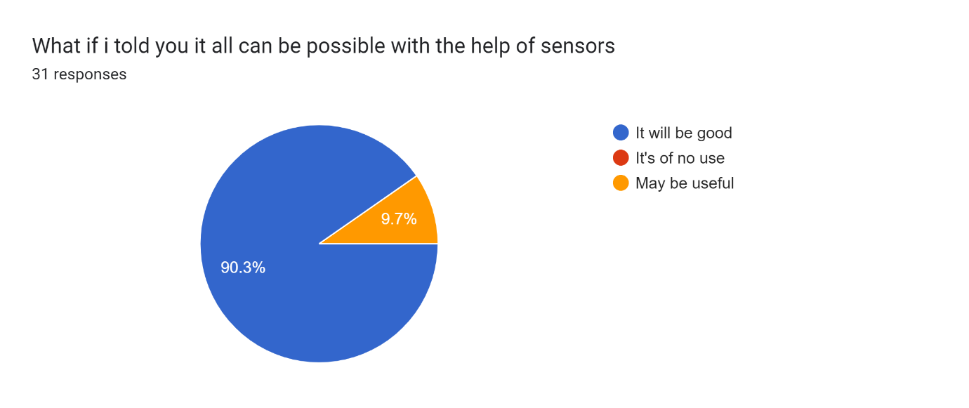

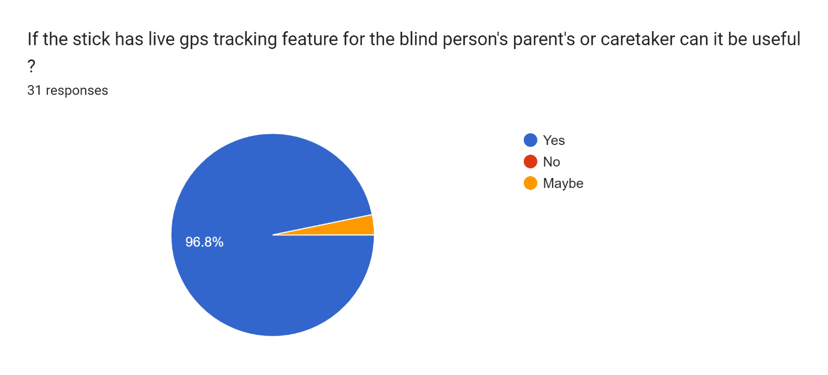

***Fig 4.1 Requirement gathering***

**4.2.2 Requirement Analysis:**

4.2.2.1 Functional Requirements:

The system should detect the obstacles in front with the help of sensors. The system should track the live location of the person with the help of Blynk app. While tracking the location , systems wifi or network should be on.

While doing this things system should have power supply.

4.2.2.2 Non Functional Requirements:

The system should be secured. It should be reliable and accurate and easy to use. It should be easy to maintain. Sensors should detect the respected obstacle correctly in to the person.

**4.2.2.3** **System Requirement:**

* **Obstacle detection:**

**Input:** Any object which is physically present.

**Source**: sensors

**Output**: beep sound will be generated.

**Destination**: user will get alerted through beep sound.

**Action**: After detection user will get alerted.

**Pre-condition**: user must have to walk.

**Post-condition:** User should skip or go by another way.

* **Water detection:**

**Input:** water is present ahead.

**Source**: sensors

**Output**: beep sound will be generated.

**Destination**: user will get alerted through beep sound.

**Action**: After detection user will get alerted.

**Pre-condition**: user must have to walk.

**Post-condition:** User should skip or go by another way.

* **Insufficient light detection :**

**Input:** if insufficient light is there

**Source**: sensors

**Output**: beep sound will be generated.

**Destination**: user will get alerted through beep sound.

**Action**: After detection user will get alerted.

**Pre-condition**: -

**Post-condition:** User should skip or go by another way.

* **GPS Tracking:**

**Input:** From GPS mdoule.

**Source**: Blynk app

**Output**: show current location on Blynk app.

**Destination**: users caretaker or parent will get the current location of

that person.

**Action**: parents get live location after of the person after tracking.

**Pre-condition**: Network connection should be on.

**Post-condition:** -

* **Sound beep while detecting :**

**Input:**sensors.

**Source**: obstacle detection.

**Output**: it will beep.

**Destination**: with the help of sensors obstacle detected.

**Action**: -

**Pre-condition**: Network connection and power supply should be on.

**Post-condition:** -

* 1. **Planning and scheduling**

**4.3.1 Activity table:**

|  |  |  |
| --- | --- | --- |
| Task | Start date | End date |
| Synopsis | 01/06/22 | 20/06/22 |
| EDLC | 20/06/22 | 27/06/22 |
| Introduction | 20/06/22 | 27/06/22 |
| Survey of Technologies | 20/06/22 | 27/06/22 |
| Requirements and Analysis  problem definition  requirement specification | 27/06/22 | 04/07/22 |
| System Requirements | 11/07/22 | 18/07/22 |
| Planning and scheduling | 18/07/22 | 25/07/22 |
| System Design  Data flow diagram  Circuit diagram  Activity diagram  State diagram | 18/08/22  25/08/22  12/09/22  12/09/2022 | 25/08/22  02/09/2002  19/09/22  19/09/2022 |
| Test cases | 19-09-2022 | 26-09-2022 |

***Table 4.1 Activity table***

**4.3.2 Gantt chart:**

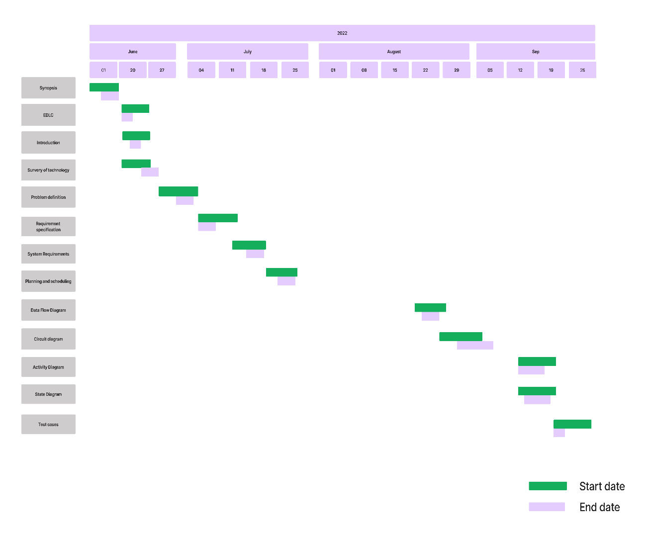

***Fig 4.2 Gantt chart***

**5.1 Data Flow Diagram:**

Data flow diagrams are used to graphically represent the flow of data in a business information system. DFD describes the processes that are involved in a system to transfer data from the input to the file storage and reports generation. Data flow diagrams can be divided into logical and physical. The logical data flow diagram describes flow of data through a system to perform certain functionality of a business. The physical data flow diagram describes the implementation of the logical data flow.

|  |  |  |
| --- | --- | --- |
| **Name** | **Symbol** | **Description** |
| Process |  | A process transforms incoming data flow into outgoing data flow. |
| Data Store |  | Data stores are repositories of data in the system. |
| Data Flow |  | Data flows are pipelines through which packets of information flow. Label the arrows with the name of the data that moves through it. |
| External Entity |  | External entities are objects outside the system, with which the system communicates |

***Table 5.1 DFD diagram Notations***

**Notation Reference:** <https://www.lucidchart.com>/

**DFD level 0 :**

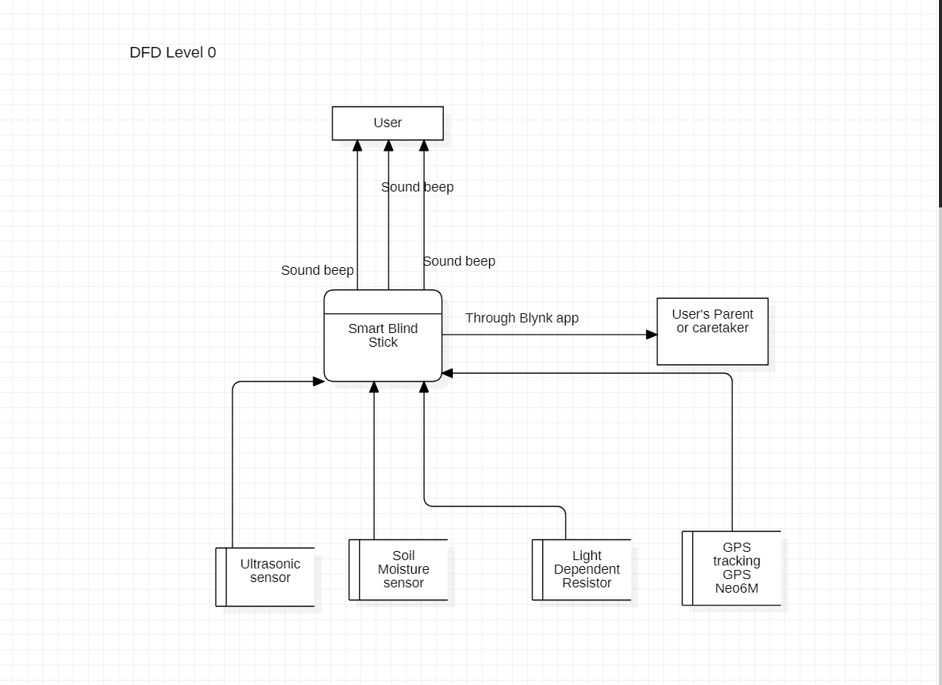

***Fig 5.1 Level 0 DFD***

**DFD level 1:**

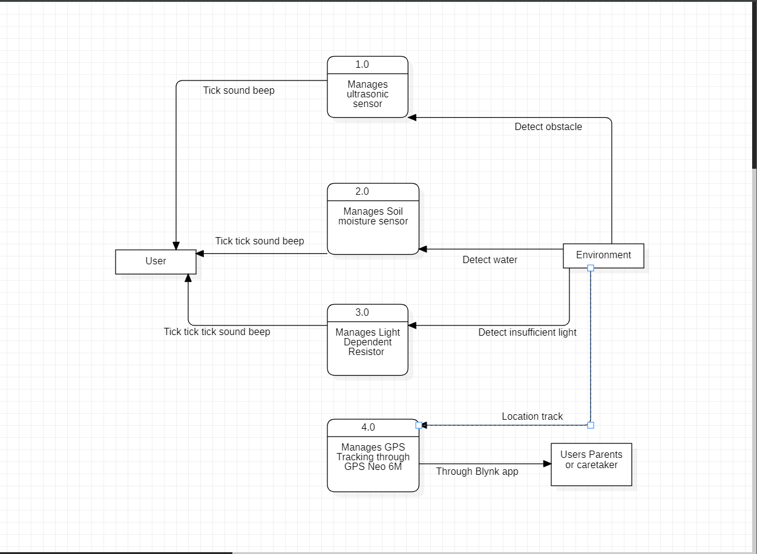

***Fig 5.2 Level 1 DFD***

**5.2 Activity Diagram:**

Activity diagram is another important diagram in UML to describe the dynamic aspects of the system. Activity diagram is basically a flowchart to represent the flow from one activity to another activity. The activity can be described as an operation of the system. The control flow is drawn from one operation to another. This flow can be sequential, branched, or concurrent. Activity diagrams deal with all type of flow control by using different elements such as fork, join, etc.

|  |  |  |
| --- | --- | --- |
| **Name** | **Symbol** | **Description** |
| Initial state |  | This shows the starting point or first activity of the flow. |
| Final state |  | The end of the Activity diagram, also called as a final activity. |
| Action |  | It represents the activity to be performed. |
| Decision |  | A logic where a decision is to be made is depicted by a diamond. |
| Synchronization |  | It combines or splits two activity flows. |
| Transition |  | A transition link represents control flow between nodes. |

***Table 5.2 Activity diagram notations***

**Notation Reference:** <https://www.lucidchart.com>/

**System:**

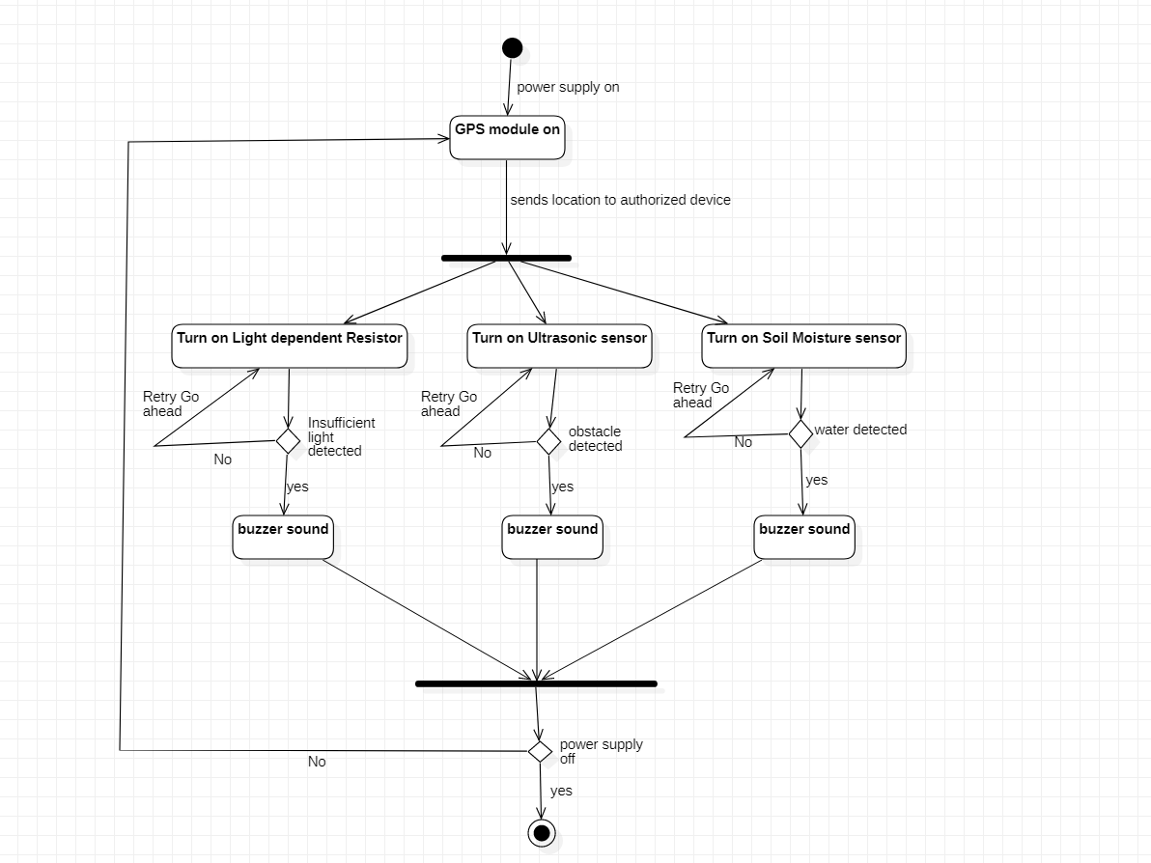

***Fig 5.3 System Activity Diagram***

**5.3 State chart diagram:**

A state diagram is used to represent the condition of the system or part of the system at finite instances of time. It’s a behavioral diagram and it represents the behavior using finite state transitions. State diagrams are also referred to as State machines and State-chart Diagrams. These terms are often used interchangeably. So simply, a state diagram is used to model the dynamic behavior of a class in response to time and changing external stimuli.

|  |  |  |
| --- | --- | --- |
| **Name** | **Symbol** | **Description** |
| Initial state |  | This represents the starting of the state diagram. |
| Final state |  | This represents the final state or end of the state diagram. |
| Transition |  | This represents the change of one state into another state. |
| State |  | This represents the state of the activity. |

***Table 5.3 State chart diagrams notations***

**Notation Reference:** <https://www.lucidchart.com/>

**Obstacle detection:**

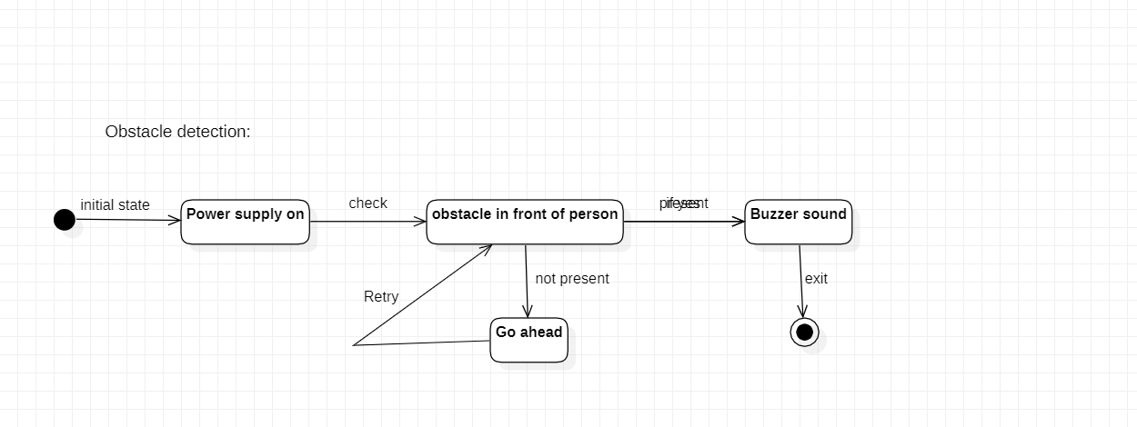

***Fig 5.4 State chart diagram obstacle detection***

**Water detection:**

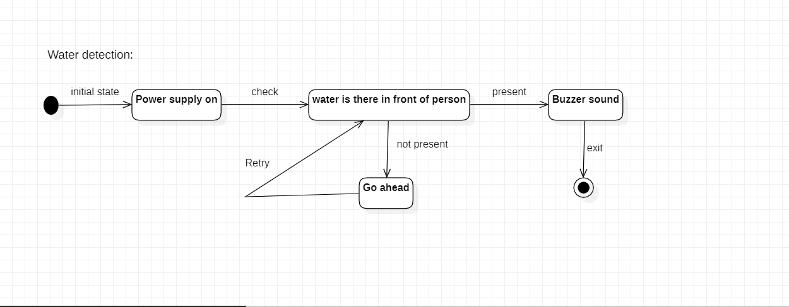

***Fig 5.5 State chart diagram water detection***

**Insuffcient light detection:**

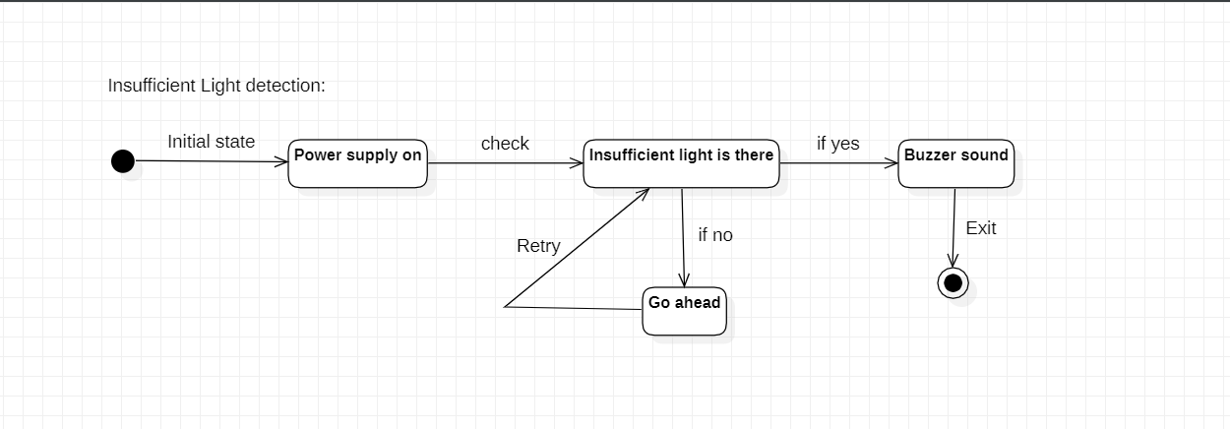

***Fig 5.6 State chart diagram insufficient light detection***

**Location :**

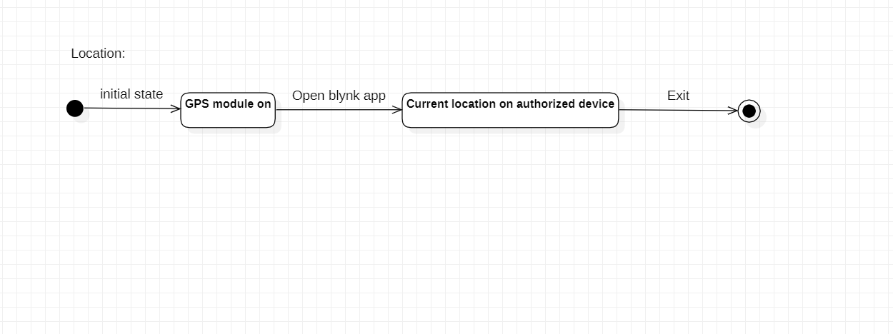

***Fig 5.7 State chart diagram location***

**5.4 Test cases:**

|  |  |  |  |  |
| --- | --- | --- | --- | --- |
| **Test case no** | **Name** | **Expected output** | **Actual output** | **Remark** |
| 1 | Obstacle detection | Beep sound need to be generated |  |  |
| 2 | Water detection | Beep sound need to be generated |  |  |
| 3 | Insufficient light detection | Beep sound need to be generated |  |  |
| 4 | GPS Tracking | Need to show current location on Blynk app |  |  |
| 5 | Sound beep while detecting | Need to beep at that time |  |  |

***Table 5.4 Test cases***

**6.1 Book References:**

Introduction to Embedded system ‘Shibu K V’ McGrew hill education.

Software Engineering, “Ian Somerville”, 8th Edition, Pearson Education.

**6.2 Website References :**

Referred from 14/06/22 to 25/06/22

<https://online>[-journals.org/index.php/i-joe/article/view/7565](https://online-journals.org/index.php/i-joe/article/view/7565) <https://www.tandfonline.com/doi/full/10.1080/23311916.2019.1692468>[https://www.maxbotix.com/articles/how-ultrasonic-sensorswork.htm#:~:text=An%20ultrasonic%20sensor%20is%20an,information%20about%2 0an%20object's%20proximity.](https://www.maxbotix.com/articles/how-ultrasonic-sensors-work.htm#:~:text=An%20ultrasonic%20sensor%20is%20an,information%20about%20an%20object's%20proximity)

Referred from 11/07/22 to 24/07/22

<https://extension.umn.edu/irrigation/soil>[-moisture-sensors-irrigation-scheduling](https://extension.umn.edu/irrigation/soil-moisture-sensors-irrigation-scheduling) <https://lastminuteengineers.com/neo6m-gps-arduino-tutorial/><https://randomnerdtutorials.com/esp8266-pinout-reference-gpios/><https://blynk.io/><https://play.google.com/store/apps/details?id=cc.blynk&hl=en_IN&gl=US>

**6.3 Referred for uml diagram:**

Referred from 15/07/22 to 22/07/22

<https://www.lucidchart.com>