Deployment document for
Windchill AI Chatbot for BOM
Created For:
Bajaj Electrical
Date: 29 May 2026

Revision 1.0

Submitted By:
Actin Technologies (I) Pvt. Ltd.
5th Floor, Suma Center,
opposite Himali Society,
Vakil Nagar,Erandwane, Pune,
Maharashtra 411004
+91 97307-36285

Document History:

Version | Author | Date | Comments
1.0 | Prajakta Darekar | 24/03/2026 | First Release

Contents
1 Objective: 3
2 Deployment Procedure: 3
A) Multi-Level BOM Extraction Deployment 3
2.1. Java Utility Deployment 3
2.2. REST Domain Configuration: 3
B) Chatbot Integration on Windchill Homepage 4
3. UI Customization Steps 4
3.1 Add “Chat with PLM” Patch in Home Page 4
3.2 Add Custom Chatbot Utility File 4
3.3 Add Chatbot Logo 4
3.4 Compilation & Server Restart 4
4. Result 4

Objective:
To develop and deploy a scalable Windchill customization capable of recursively extracting multi-level Bill of Materials (BOM) for multiple part numbers in a single execution, with full metadata enrichment and REST API exposure.
To modify the Windchill homepage and enable a “Chat with PLM” feature that opens a custom chat window, allowing users to ask questions related to Parts and BOMs, reducing dependency on manual PLM search.

Deployment Procedure:

A) Multi-Level BOM Extraction Deployment

2.1. Java Utility Deployment
- Source Location:
Windchill/codebase/ext/DataExtractCB
- Java Class File:
BomRemoteService.class
LastModifiedPartsToday.class
- Steps Performed:
- Placed the Java file under the specified package directory [Windchill/src/ext/DataExtractCB]
- Verified package structure and imports.

2.2. REST Domain Configuration:
REST Registration Location:
<Windchill_Home>/codebase/rest/custom/domain/MultiLevelBom
<Windchill_Home>/codebase/rest/custom/domain/MultiLevelBom.json
<Windchill_Home>/codebase/rest/custom/domain/MultiLevelBom/v1/import.js
<Windchill_Home>/codebase/rest/custom/domain/MultiLevelBom/v1/import.json

File Details:
Sr. No | File Name | Purpose
1 | MultiLevelBom.json | Domain configuration file
2 | import.js | Action execution logic binding
3 | import.json | Parameter and return type definition
Steps Performed:
- Created custom REST domain under Custom/Domain.
- Registered OData action with required parameters.
- Configured action mapping in import.js.
- Defined return type as JSON string.
- Verified REST action registration.

B) Chatbot Integration on Windchill Homepage

3. UI Customization Steps

3.1 Add “Chat with PLM” Patch in Home Page
File Updated:
F:\ptc\Windchill_12.0\Windchill\codebase\WEB-INF\jsp\netmarkets\homepage.jsp
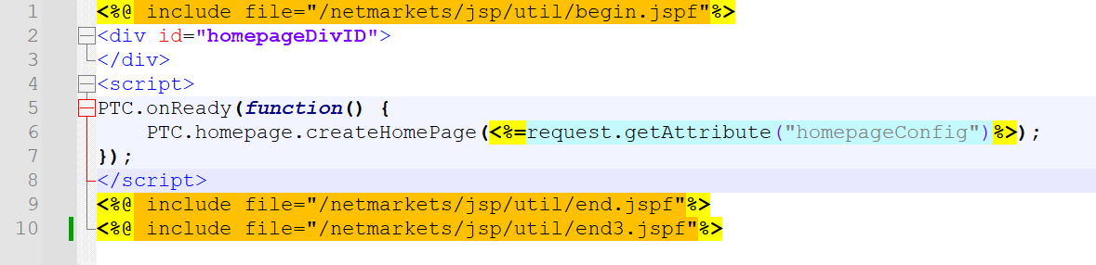

3.2 Add Custom Chatbot Utility File
Custom File Added:
F:\ptc\Windchill_12.0\Windchill\codebase\netmarkets\jsp\util\end3.jspf

3.3 Add Chatbot Logo
File Path:
F:\ptc\Windchill_12.0\Windchill\codebase\netmarkets\images\chatbot_logo.png

3.4 Compilation & Server Restart
Restart Windchill:
windchill stop
windchill start

4. Result 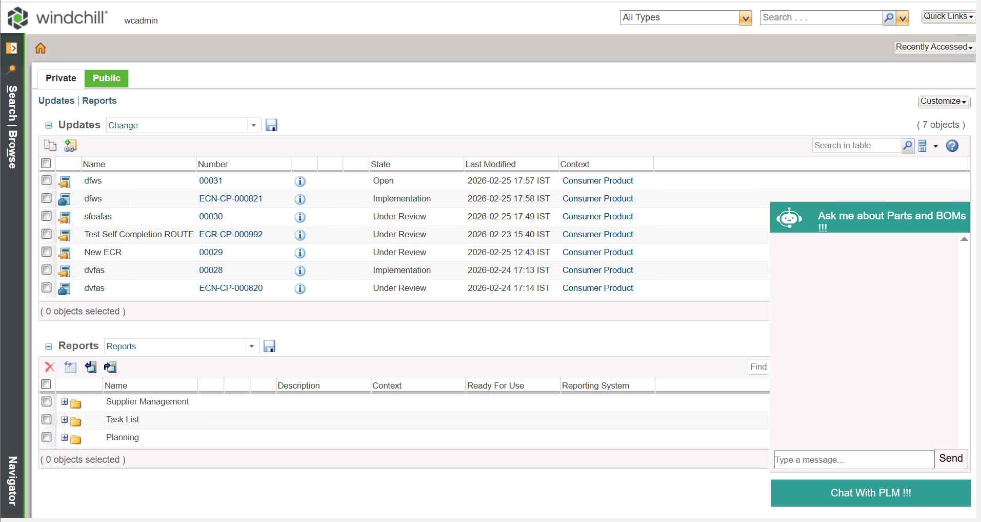
- "Chat with PLM" button visible on homepage
- Chat window opens on click
- User can ask Application Code related questions
- AI responses shown in same chat window
- UI integrated without affecting default Windchill screens

