Standard Operating Procedure (SOP)

Title: Accessing PAM Console and Requesting Server Access

Department: IT Infrastructure / Security
Prepared By: Goutham
Version: Version V9.0.0-230420
Purpose
This SOP outlines the standard procedure for accessing the Iraje PAM (Privileged Access Management) console and requesting server access in a secure and compliant manner

Scope
This SOP applies to all users who require privileged access to servers through the PAM console within the organization

Prerequisites
Before beginning the process, ensure the following:
- Access to the internal network (Ivanti VPN)
- Administrator rights to update host file
- Shared credentials for PAM login

Procedure

Step 1: Update Host File
Add the following entries to your system’s host file:
- IP Address: 10.5.1.11
- URL: https://pim1.bajajelectricals.com/Home/Login
This step is necessary for resolving the PAM URL internally.

Step 2: Access the PAM Console
- Open a web browser.
- Go to: https://pim1.bajajelectricals.com/Home/Login
- Log in using the shared credentials provided by the AD(Yatish) team
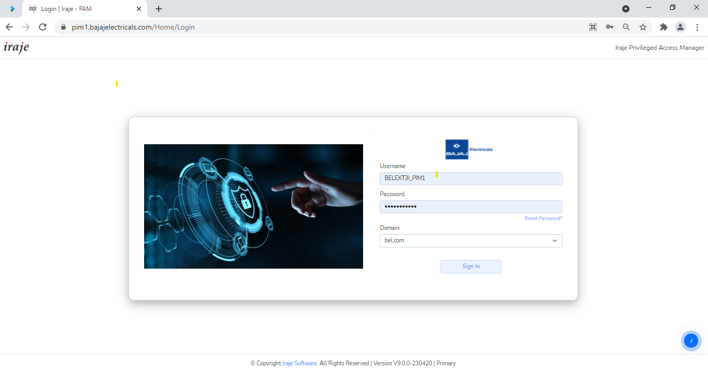

Step 3: Install the Iraje Plugin
- After login, navigate to the top-right corner of the PAM console.
- Click the option to install the Iraje Plugin.
- Complete the installation

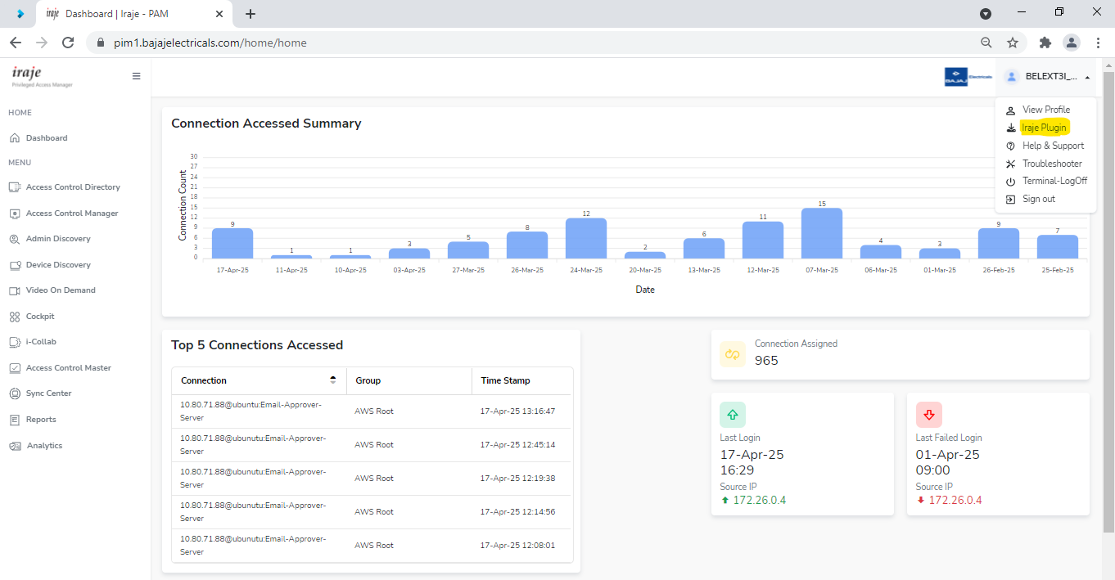
Step 4: Navigate to Access Control Directory
- After installing the plugin, return to the PAM console.
- Go to the Access Control Directory.
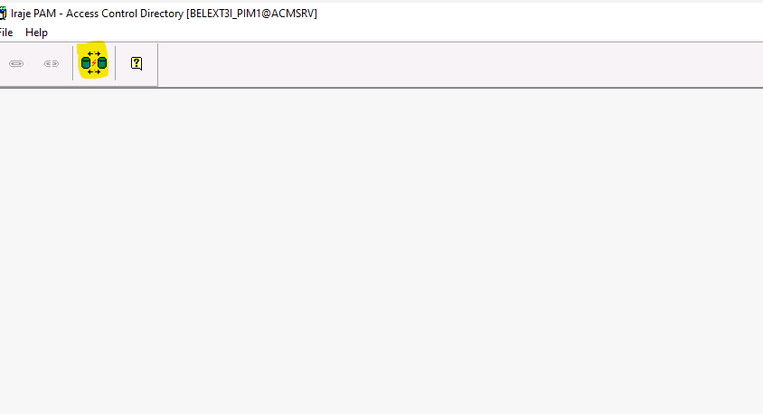
- Click on Directory Access

Step 5: Identify the Required Server Group
- Within the Directory Access page, locate the Group column.
- Identify the group associated with the server you need access to
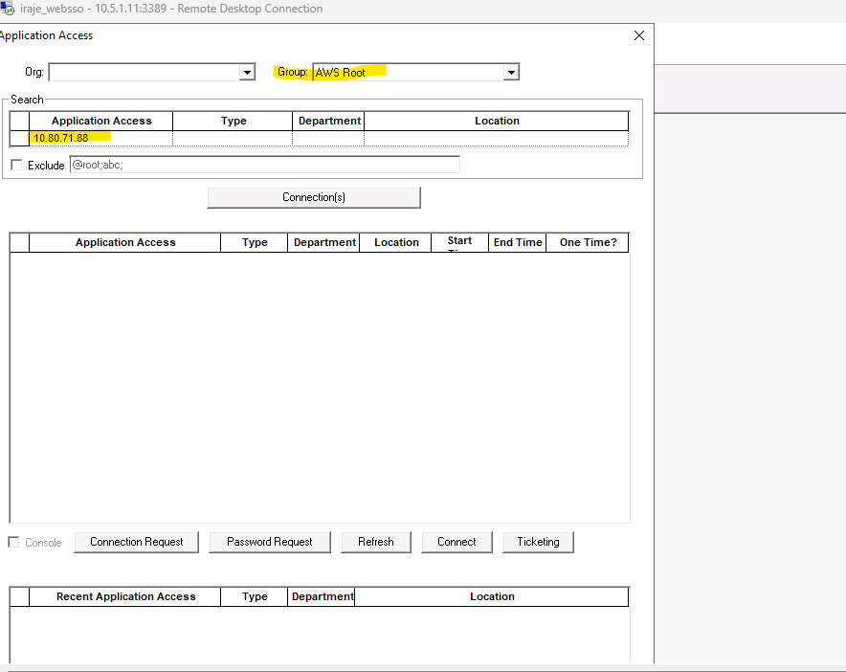
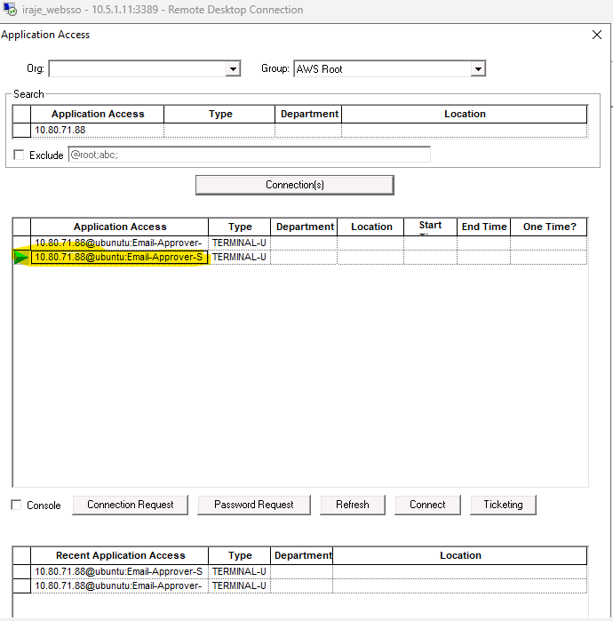
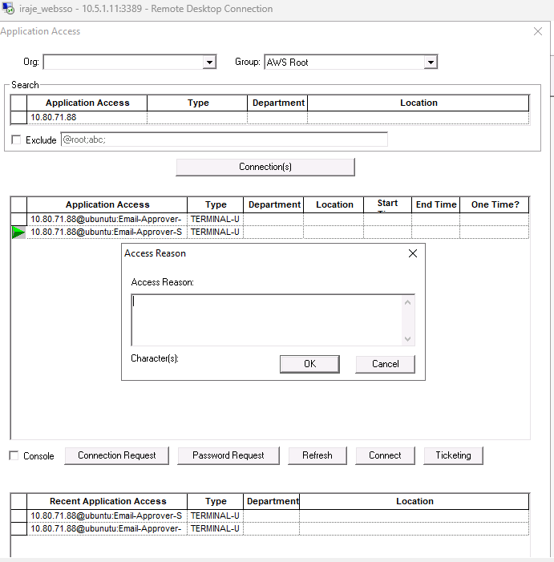
Write Reason for server access minimum 10 Words

Note: If a user does not access the system for 10 minutes, the server will enter idle mode. At that point, the server will prompt for a password. Please do not enter any password. Instead, log off from the terminal and access the server again
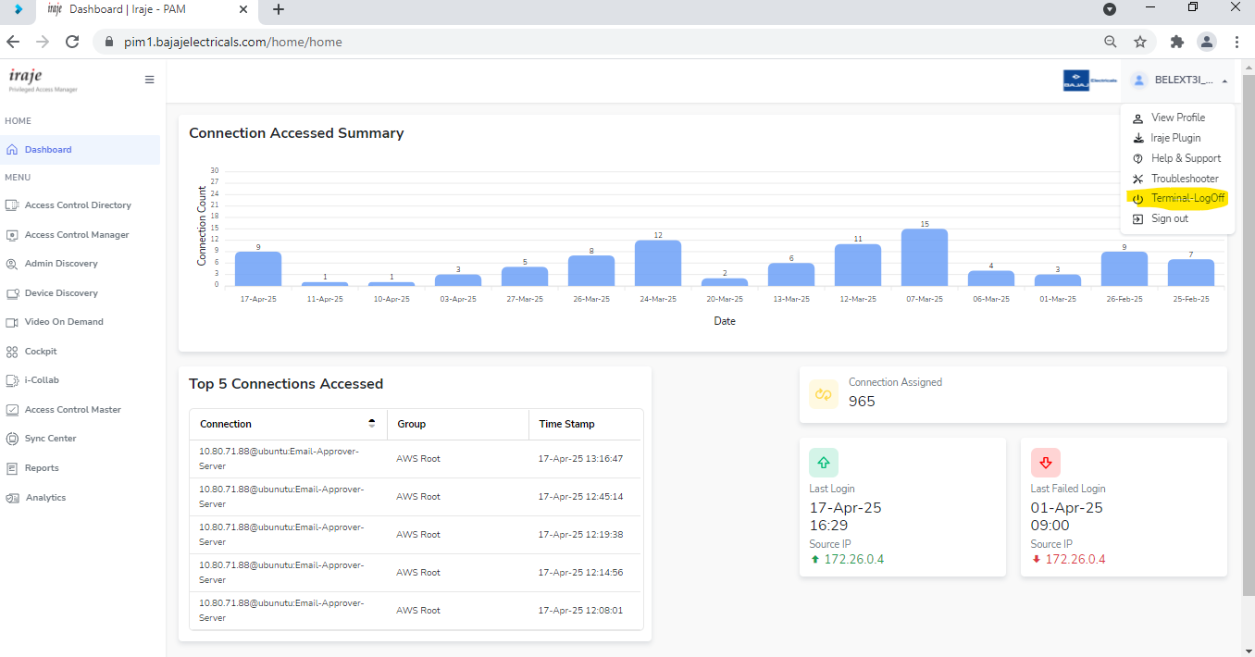
------------------------------------------------------------- The End ------------------------------------------------------------

