Solution Architecture
Provider Contract Change Validation Engine (CMS-855I)

Document: Architecture v1.0
Status: Draft for review
Date: June 2026
Pattern: Collate Rules → Build Rulebook → Decision Engine
Related: BRD v1.0, Tech Spec v1.0

Table of Contents

1. Architectural Overview
The solution is a deterministic, explainable decision system organized as a three-stage pipeline behind a Streamlit interface. It follows the Collate Rules → Build Rulebook → Decision Engine pattern: validation rules are collated from CMS standards into an editable rulebook, and a layered engine evaluates each provider-contract change against that rulebook to produce a single, traceable outcome.
There are three cooperating engines — a Tag Engine, a Rule Engine, and a Decision Engine — fed by typed data loaders and exposed through a reviewer UI and a batch scorer.
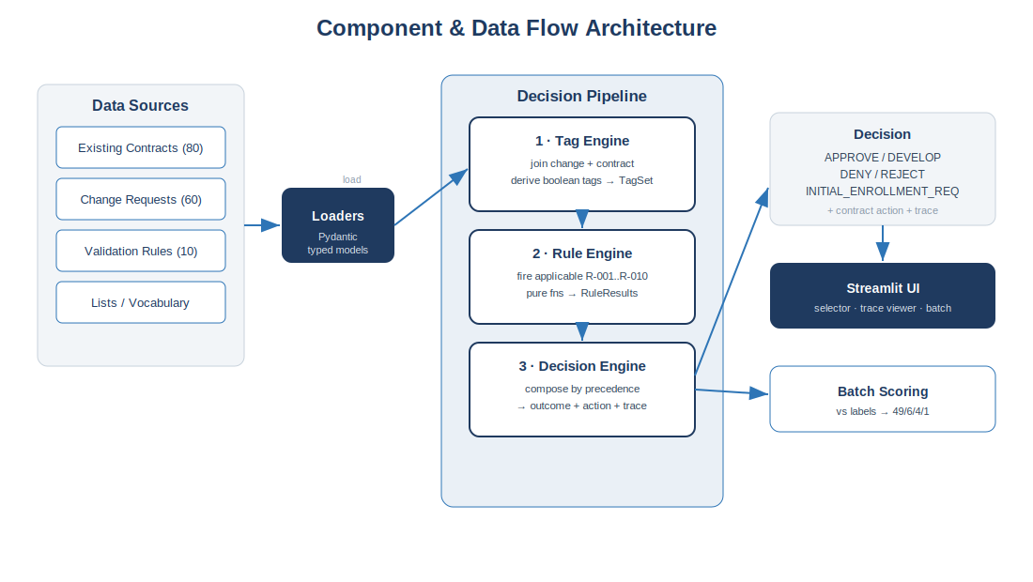
Figure 1. Component and data-flow architecture.

2. Layered View
Layer | Responsibility | Key Modules
Data / Ingestion | Load sheets into typed, validated models | loaders.py, models.py
Tagging | Join change↔contract; derive feature tags | tag_engine.py
Rules | Evaluate R-001…R-010 as pure functions | rules.py, rule_engine.py, config/rules.yaml
Decision | Compose verdicts + tags by precedence | decision_engine.py
Scoring | Batch run + metrics vs. labels | scoring.py
Presentation | Reviewer UI + reports | app/main.py, components/
Dependencies flow strictly downward: presentation depends on decision, which depends on rules and tagging, which depend on the typed models. No layer reaches upward, keeping the decision core pure and testable in isolation from the UI.

3. The Three Engines

3.1 Tag Engine
Joins each change request to its contract via linked_provider_contract_id and converts ~68 raw columns into a compact TagSet of booleans/enums that the rules actually test (e.g. cross_state, adverse_action_flag, reassignee_unverified, contract_suspended). This is the bridge between raw data and rule predicates.

3.2 Rule Engine
Maintains a registry of the ten rules, indexed by applies_to_change_category, so only the relevant subset fires per request. Each rule is a pure function returning a RuleResult (passed flag, verdict, message). Rule text and failure-actions live in config/rules.yaml so the rulebook is editable without touching decision code.

3.3 Decision Engine
Composes rule results and tags into one outcome using an explicit precedence ladder — the first matching tier wins and evaluation stops. Every path emits the full decision trace.
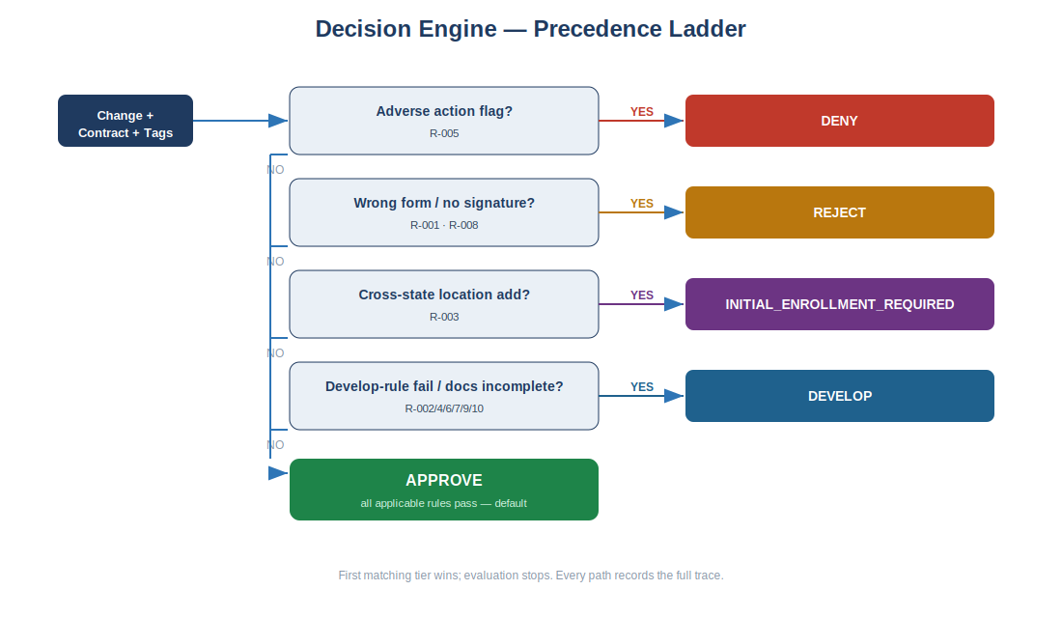
Figure 2. Decision-engine precedence ladder.

4. Data Architecture
Five source sheets map onto the runtime entities. Referential integrity is guaranteed at load time.
Source Sheet | Runtime Entity | Cardinality
Existing_Provider_Contracts | ProviderContract (baseline state) | 80
Requested_Contract_Changes | ChangeRequest (+ label oracle) | 60 → 1 contract each
Validation_Rules | RuleSpec (config) | 10
Lists | Outcome vocabulary | 5
Summary | Expected-count metadata | —
Integrity check: the loader asserts every ChangeRequest.linked_provider_contract_id resolves to a ProviderContract (0 orphans) and that every outcome is in the controlled vocabulary.

5. Sequence — Single Decision
UI/Batch Loaders TagEngine RuleEngine DecisionEngine
| request id | | | |
|--------------->| resolve change + contract | |
| |-------------->| derive TagSet | |
| | |---------------- >| evaluate rules |
| | | | (applicable only)|
| | | |----------------- >| compose by
| | | | | precedence
|<------------------------------ Decision(outcome, action, trace) -----|

6. Deployment View
v1 is a single-process Streamlit application. The decision core is a standalone Python package importable by both the UI and the batch scorer (and any future API).
Concern | v1 Approach | Future
Runtime | Single Streamlit process (local / container) | Split UI + decision API service
Config | YAML rulebook + sheets on disk | Versioned rule store / DB
Persistence | In-memory + decision log file | Audit DB for decision traces
Auth | None (single-tenant) | SSO + role-based review
Integration | Synthetic dataset | Live PECOS / CMS connectors

7. Cross-Cutting Concerns
- Explainability: the Decision object always carries evaluated rules, verdicts, and fired tags; the UI renders this as a readable trace.
- Determinism: no randomness in the decision path — identical inputs yield identical outputs, enabling exact regression.
- Auditability: every decision is logged with its trace; the rulebook is versioned so historical decisions can be reproduced.
- Testability: each rule is unit-tested; a regression suite reproduces all 60 labels (49/6/4/1) and synthetic REJECT fixtures cover the absent class.
- Extensibility: new rules are added by registering a pure function + a YAML entry; new tags by extending the Tag Engine — the decision ladder is the only place precedence is encoded.

8. Key Design Decisions
Decision | Rationale
Rule-driven, not ML-driven, decision path | Labels are 82% APPROVE and REJECT is absent; determinism + explainability are required for compliance.
Tags as an explicit layer | Decouples rule logic from raw schema; rules stay readable and stable as data evolves.
Precedence ladder over scoring | Outcomes are categorical with clear priority (hard blocks first); a ladder is transparent and auditable.
Rulebook as config | Lets product own CMS-standard content without code changes (BR-11).
Streamlit for v1 UI | Fastest path to an interactive reviewer + batch report on a Python core.

