Kagaz Writer Conversion
First paragraph: Office conversion preserves meaningful content.
Bold formatted paragraph and blue image below.
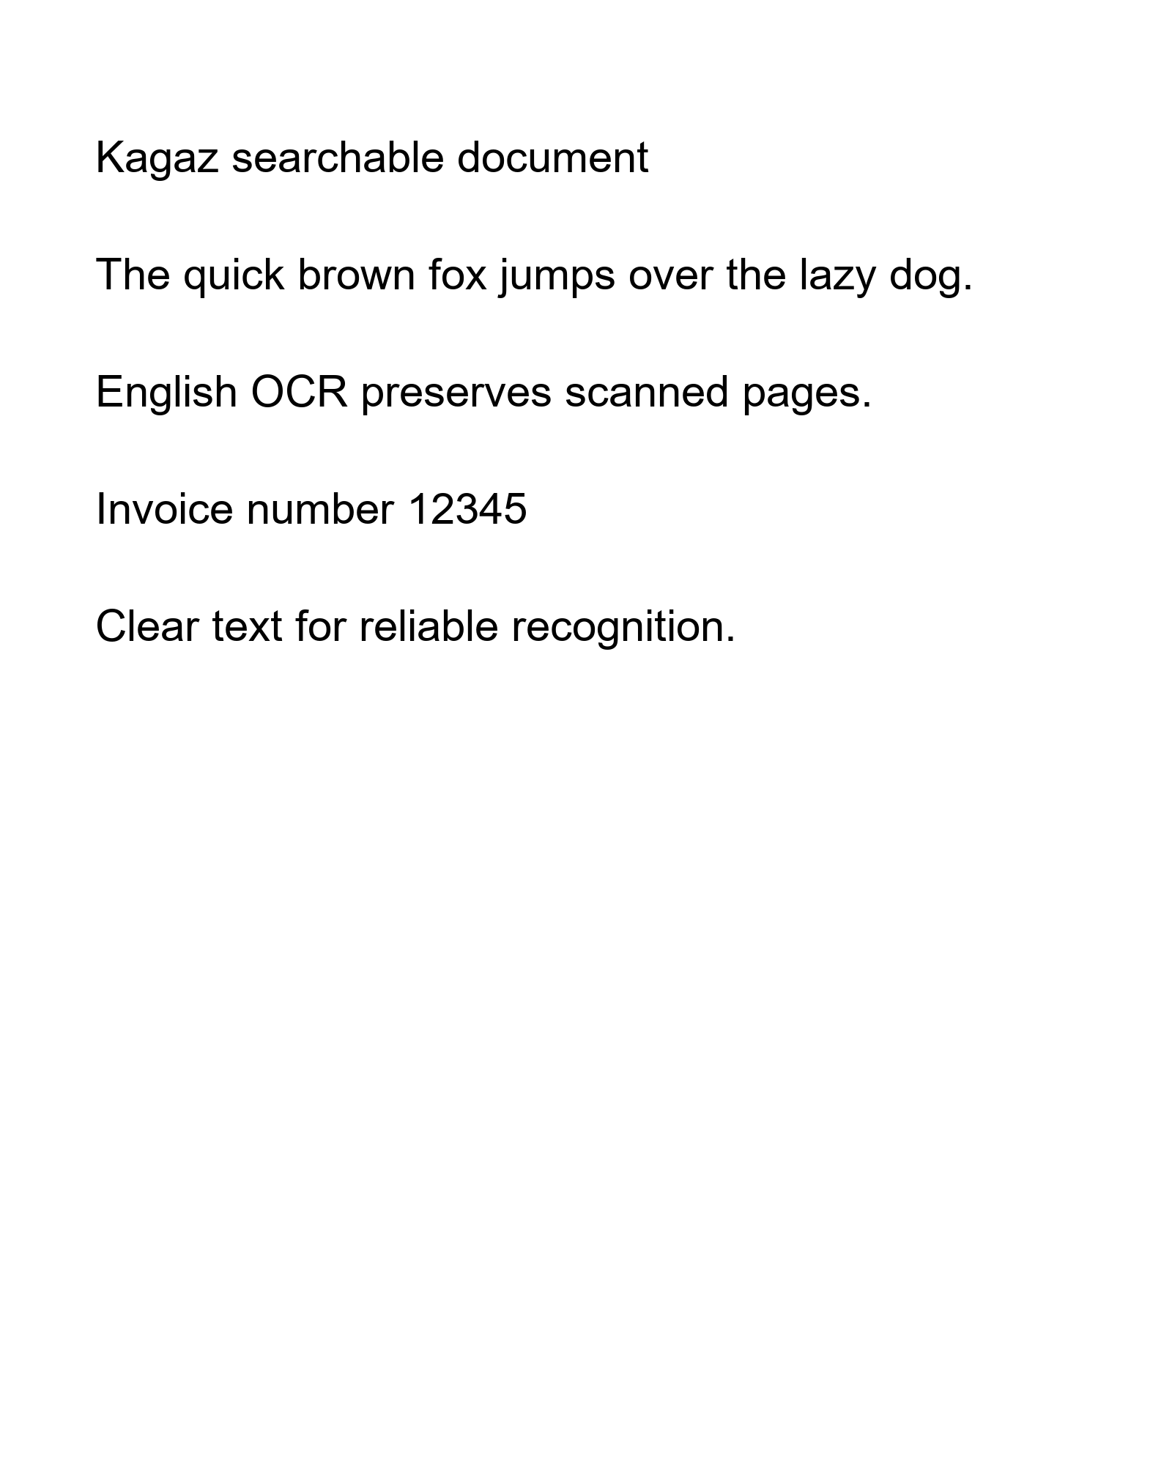

Second Page
Explicit page break produces another readable PDF page.

