Deploying 3-tier web application using Amazon CLI:

1. Create a VPC:

creates a VPC with the specified IPv4 CIDR block and a Name tag

aws ec2 create-vpc --cidr-block 192.168.0.0/16 --tag-specification ResourceType=vpc,Tags=[{Key=Name,Value=MyVpc}]

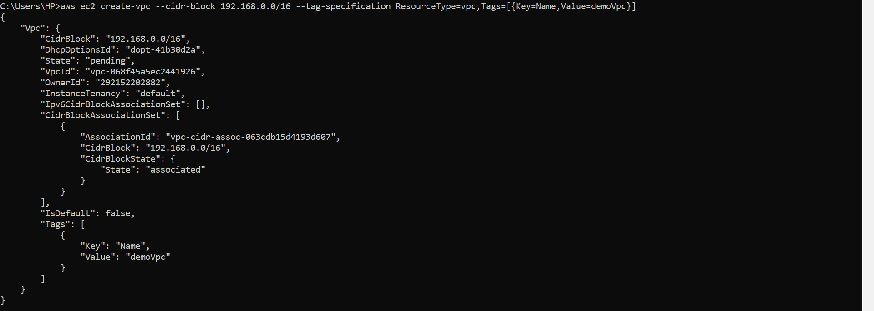

1. Create a subnet:

aws ec2 create-subnet --vpc-id vpc-068f45a5ec2441926 --cidr-block 192.168.0.0/24 --tag-specifications ResourceType=subnet,Tags=[{Key=Name,Value=my-ipv4-only-subnet}]

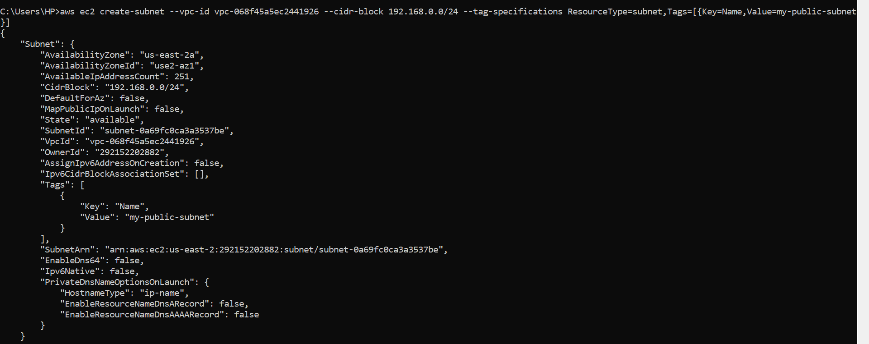

1. Create Internet Gateway (IG)

aws ec2 create-internet-gateway --tag-specifications ResourceType=internet-gateway,Tags=[{Key=Name,Value=my-igw}]

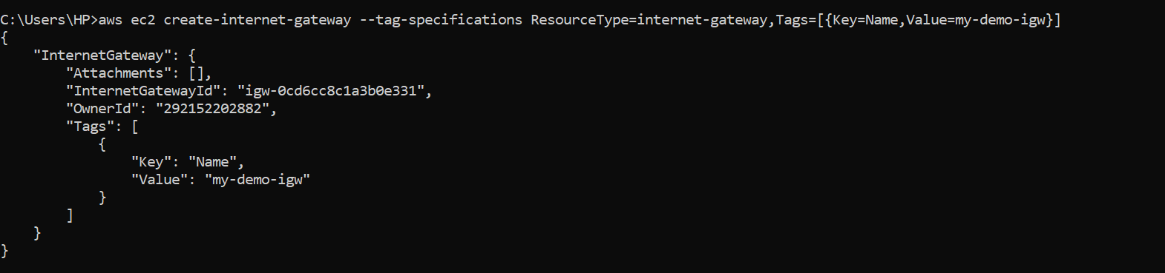

1. Create a route table

aws ec2 create-route-table --vpc-id vpc-a01106c2

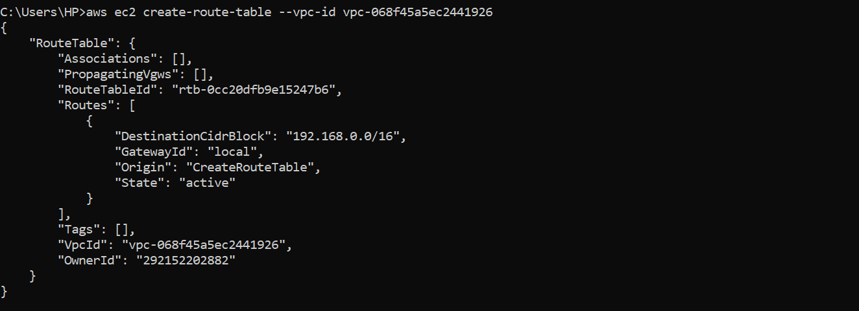

1. Associate subnet with the route table

aws ec2 associate-route-table --route-table-id rtb-0cc20dfb9e15247b6 --subnet-id subnet-0a69fc0ca3a3537be

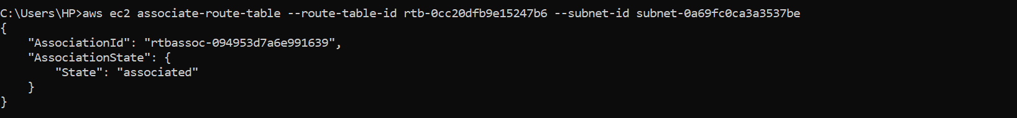

1. Attach internet gateway to vpc

aws ec2 attach-internet-gateway --internet-gateway-id igw-0cd6cc8c1a3b0e331 --vpc-id vpc-068f45a5ec2441926



1. Create routes in you route-table

All ipv4 -> IGW

aws ec2 create-route --route-table-id rtb-22574640 --destination-cidr-block 0.0.0.0/0 --gateway-id igw-c0a643a9



1. Create security group

aws ec2 create-security-group --group-name MySecurityGroup-Cli --description "My security group" --vpc-id vpc-068f45a5ec2441926



1. Adding the inbound rules to security-group

Add rule that allows inbound SSH traffic

aws ec2 authorize-security-group-ingress --group-id sg-034f59d60ed69308d --protocol tcp --port 22 --cidr 0.0.0.0/0

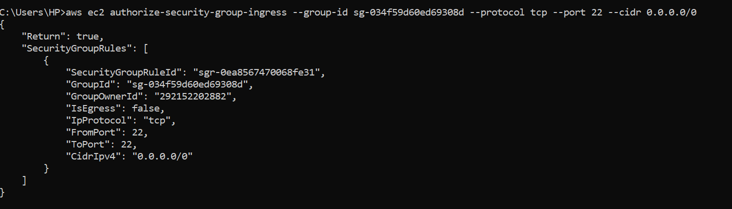

Add rule that allows inbound HTTP traffic

aws ec2 authorize-security-group-ingress --group-id sg-034f59d60ed69308d --protocol tcp --port 80 --cidr 0.0.0.0/0

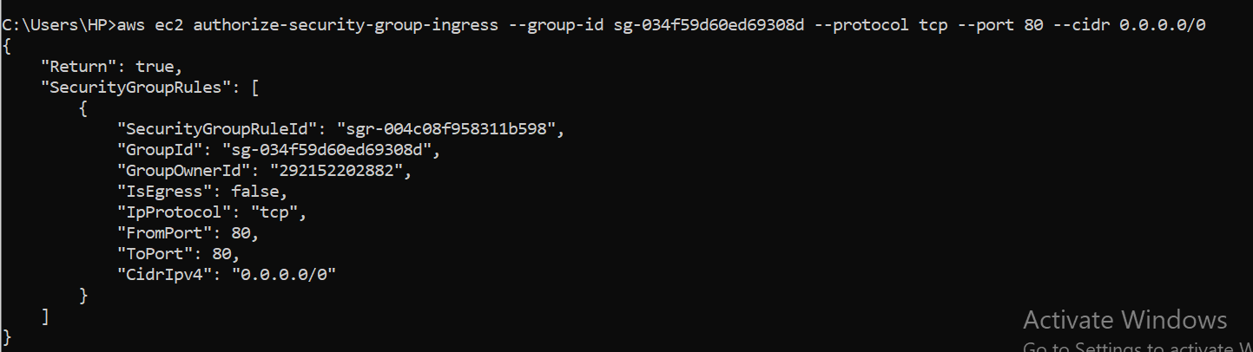

1. Create a key-pair

Aws ec2 create-key-pair –key-name MyKeyPair-1

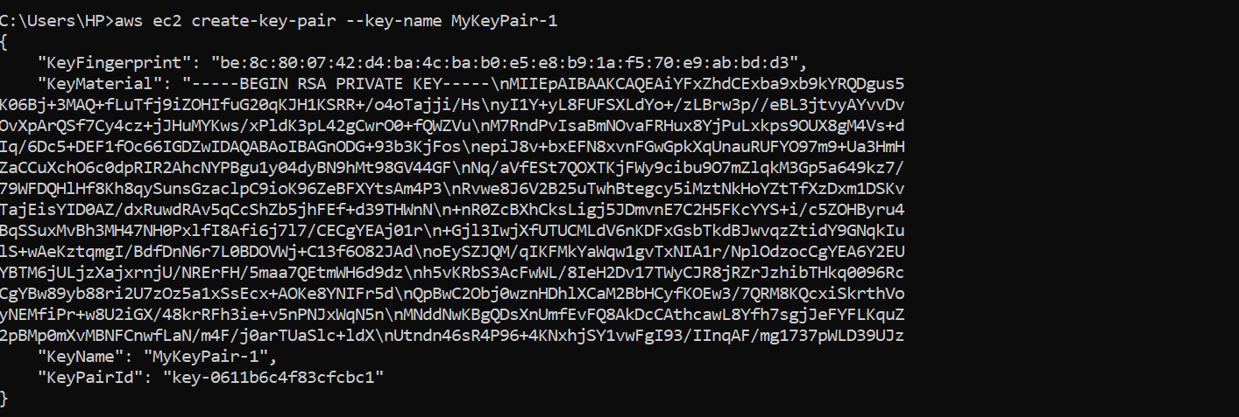

1. Creating the EC2 instance

aws ec2 run-instances --image-id ami-0827bad3f0c2fc7cd --instance-type t2.micro --subnet-id subnet-0a69fc0ca3a3537be --security-group-ids sg-034f59d60ed69308d --associate-public-ip-address --key-name MyKeyPair-1 --tag-specifications ResourceType=instance,Tags=[{Key=webserver,Value=web-application-server}]

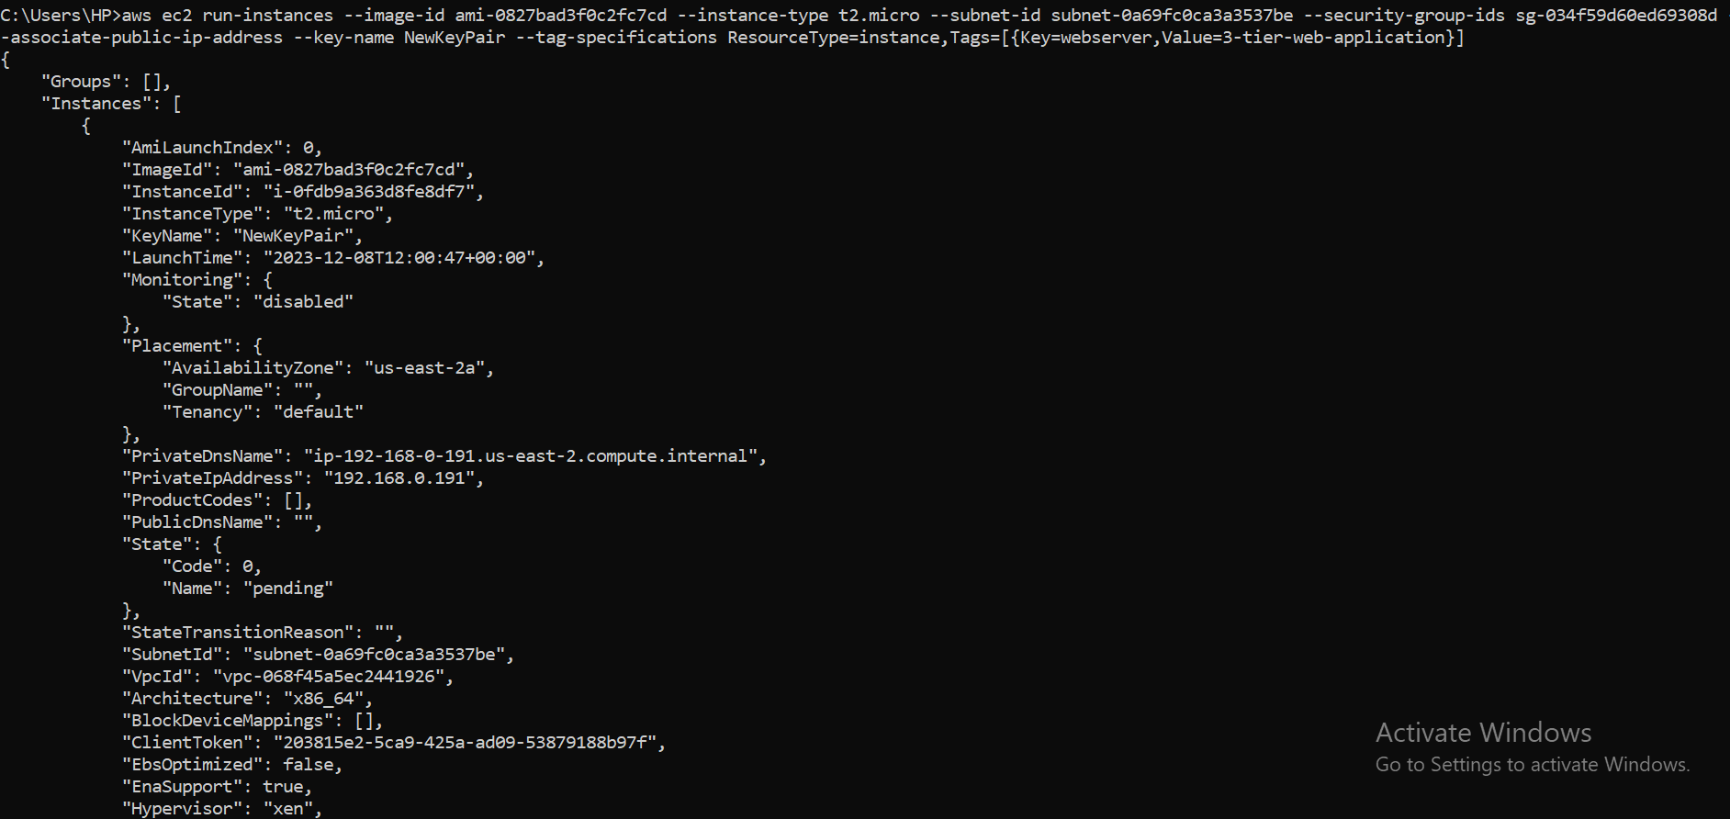

1. Starting the ec2 instance

Aws ec2 start-instances –instance-ids i-0fdb9a363d8fe8df7

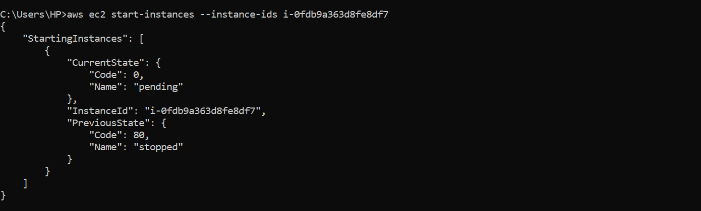

1. Checking gunicorn status

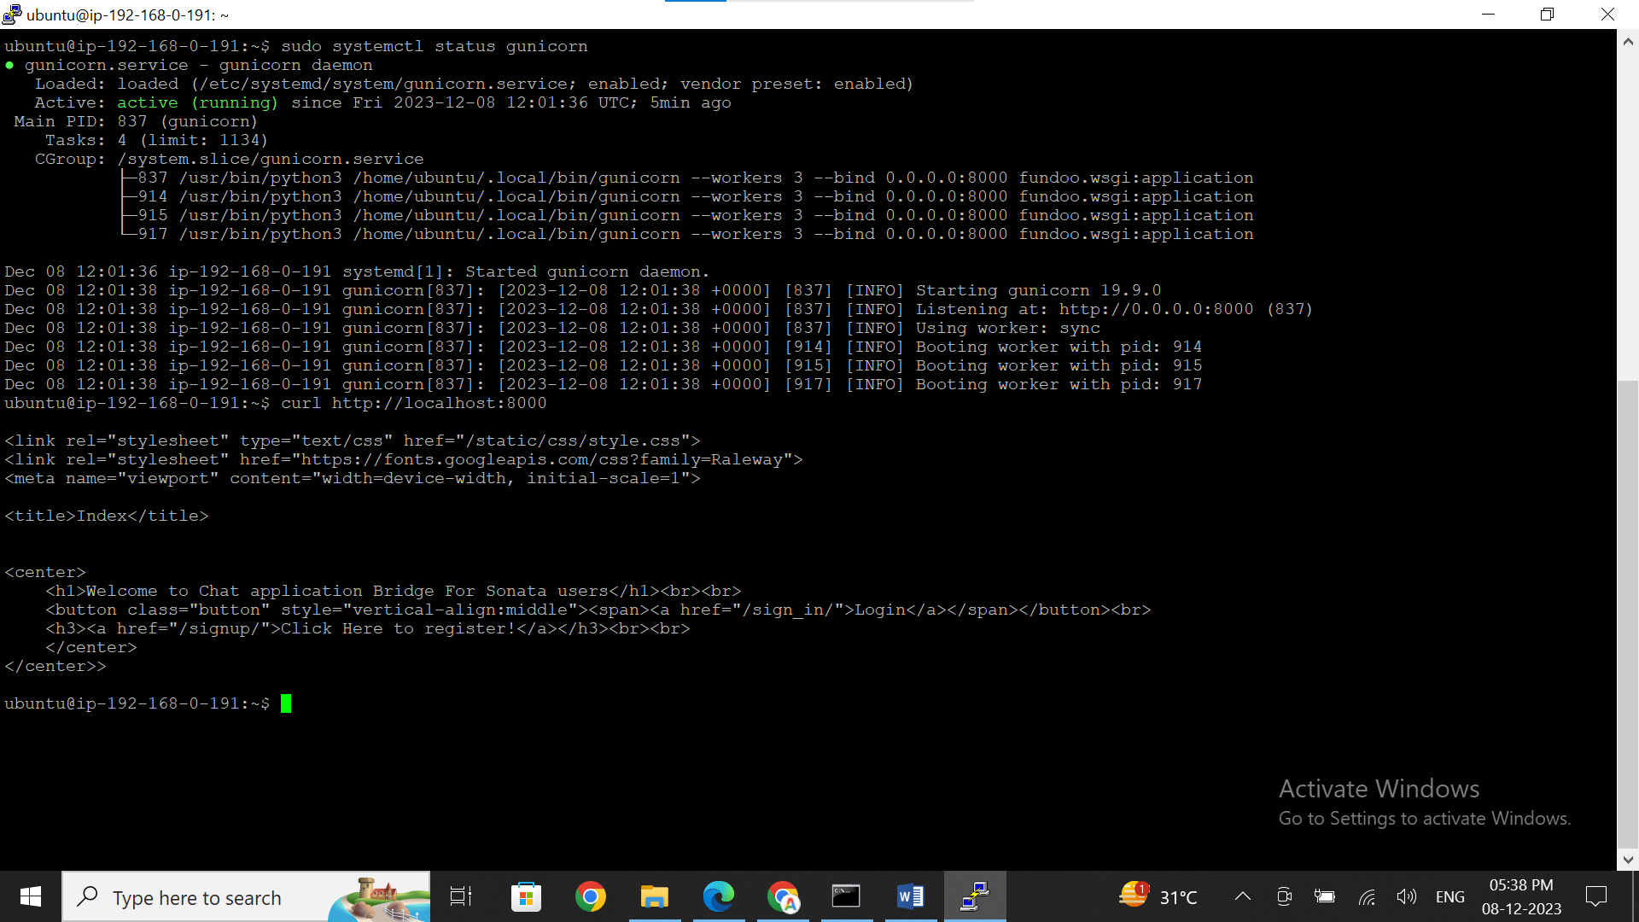

1. Stopping the instance

aws ec2 start-instances --instance-ids i-0fdb9a363d8fe8df7

