Launch virtual machine in the cloud , attach 20 GB EBS volume  
  
Important Note:-  Do not try partition, filesystem creation on your local desktop or laptop instead use virtual machine to do practice.  These operations are destructive , chances of system crash.  Work carefully.  
  
Create partition on newly attached disk as per below instructions –

1. Create 2 primary partitions of 3 GB each

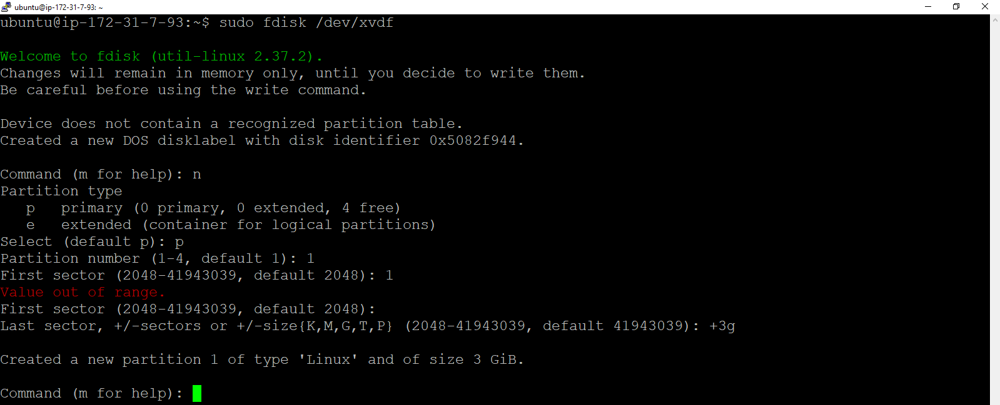

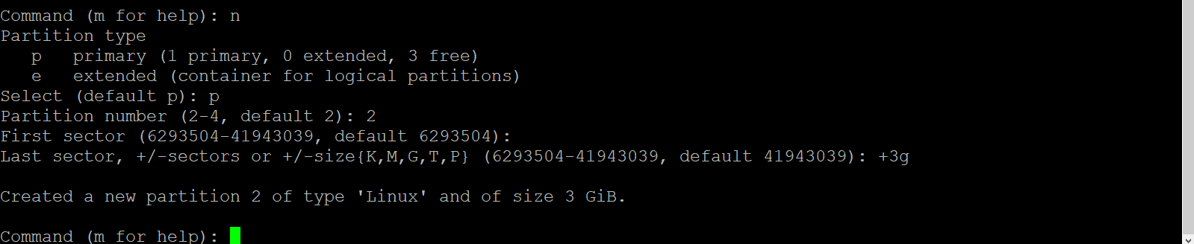

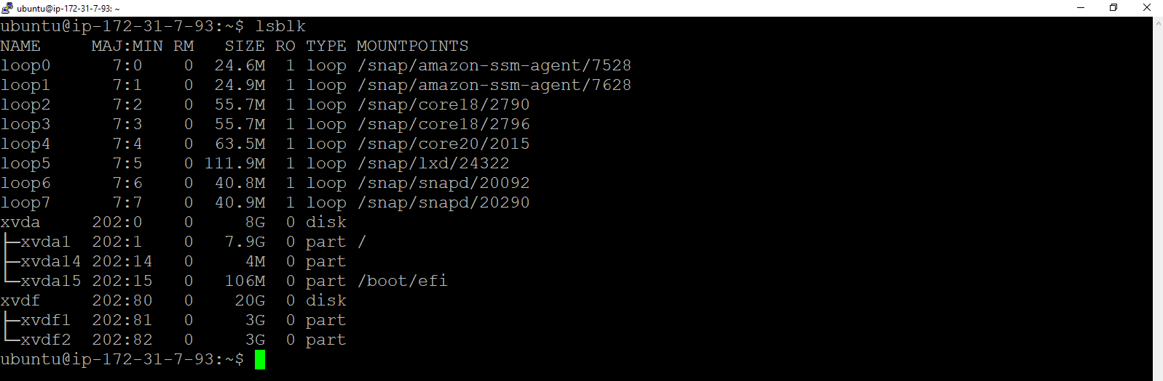

1. Create 2 logical partitions of 6 GB each

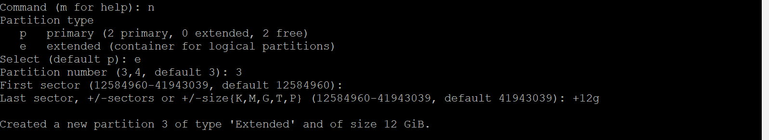

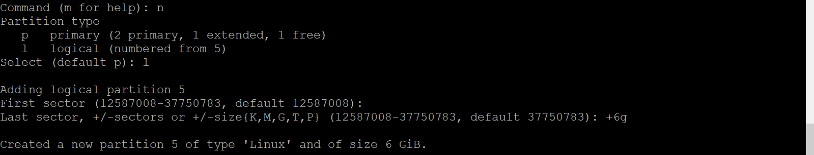

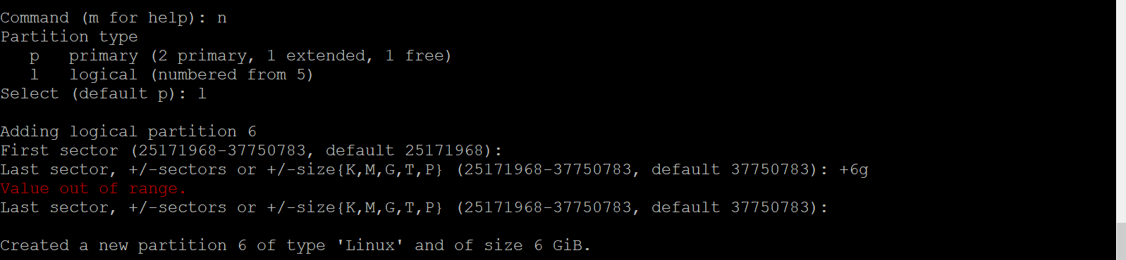

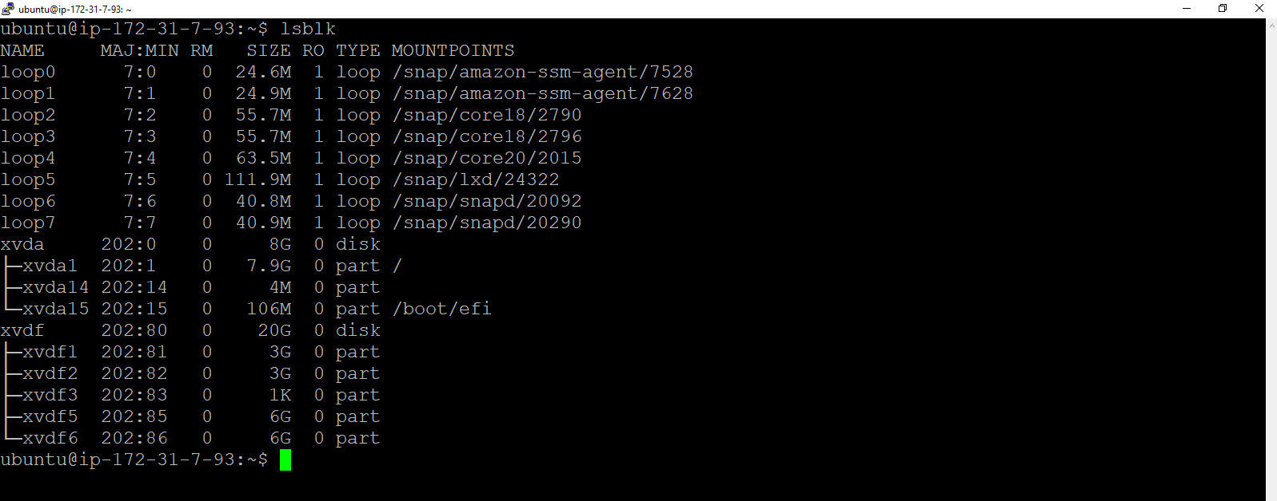

1. Format all 4 partitions and create ext4 filesystem on that

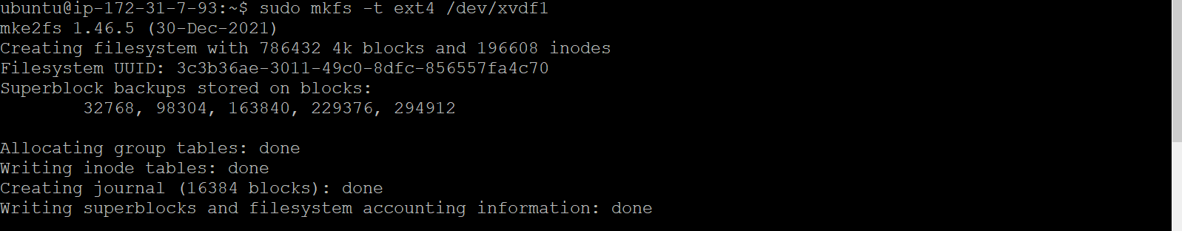

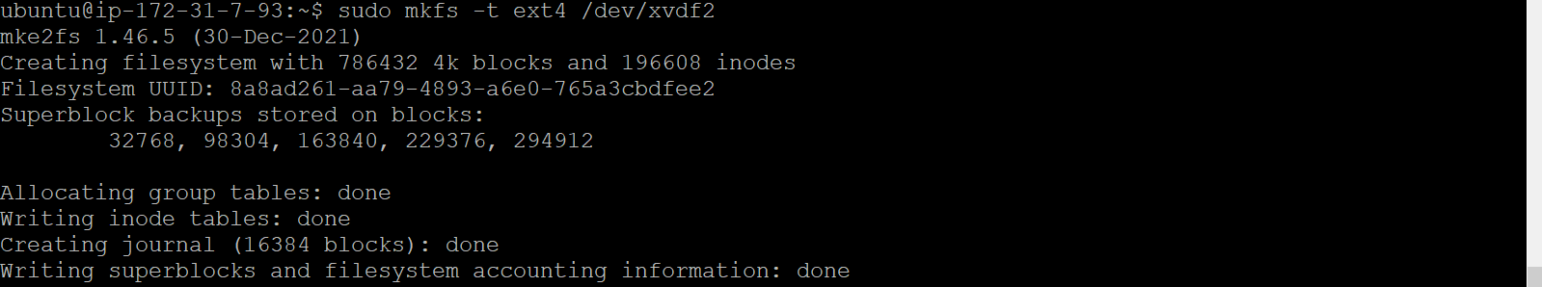

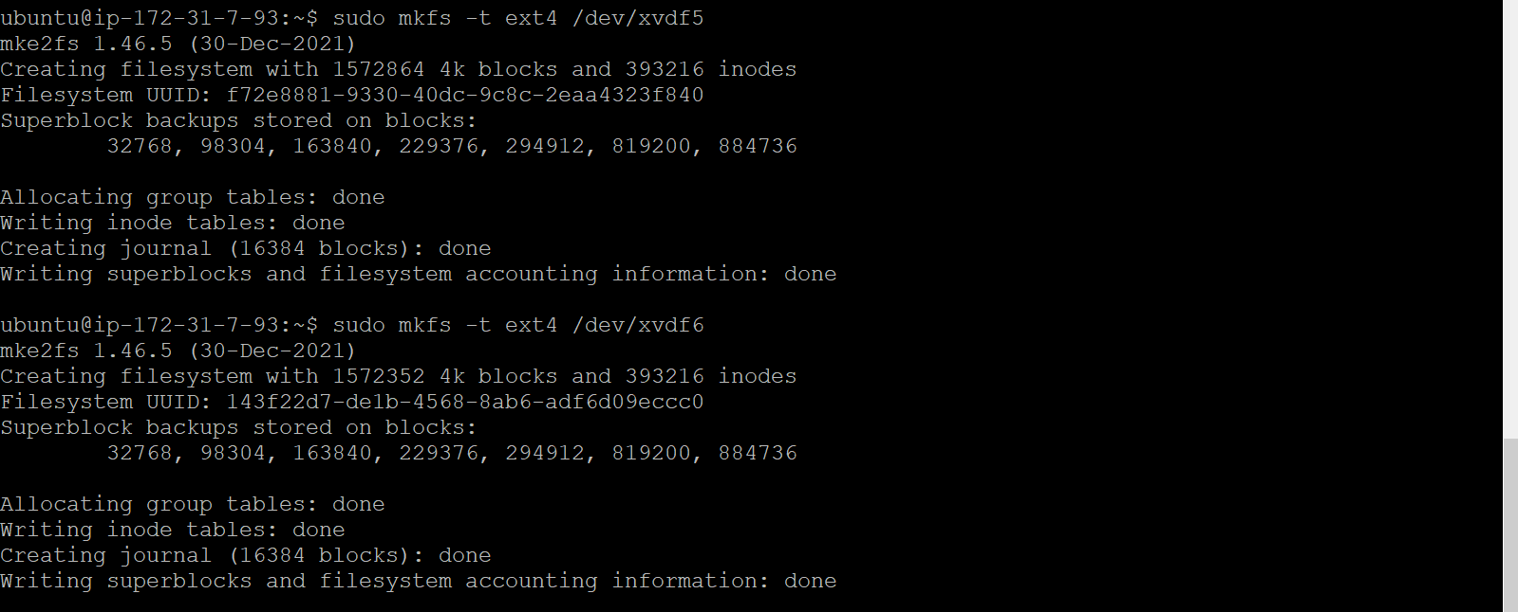

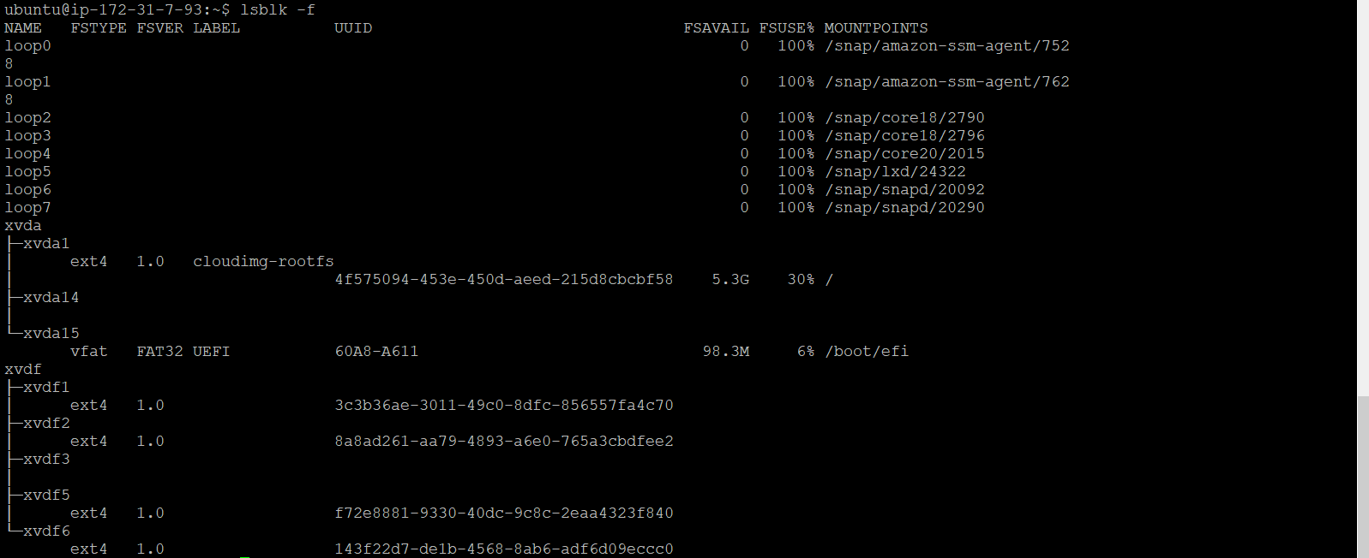

1. Create 4 folders inside root ( / ) folder name it as Data1, Data2, Data3, Data4

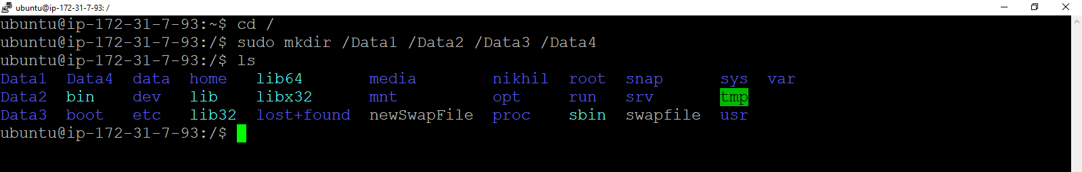

1. Mount all formated partitions on the respective folders

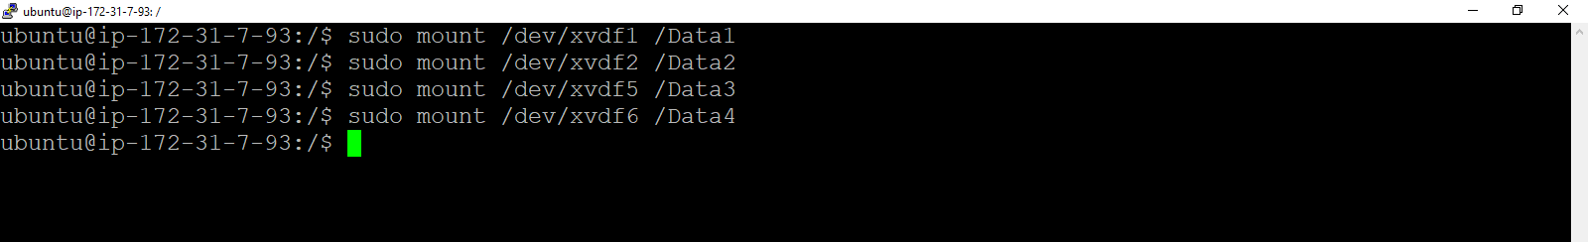

1. Create empty file inside each folders of size 2 GB, 2GB, 4 GB and 4 GB respectively  using  command -  dd - "convert and copy a file"

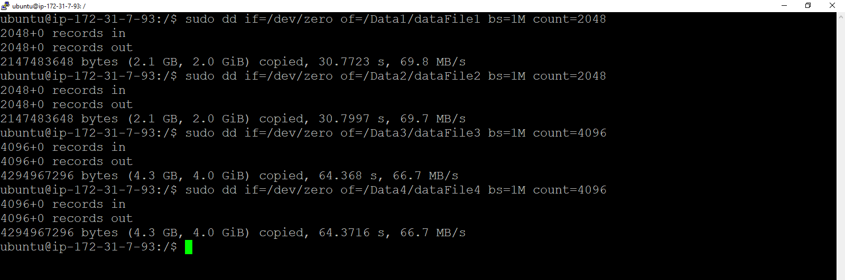

1. Go inside /Data1  and run  command -  while(true); do sleep 5s; done  , do ctrl-z

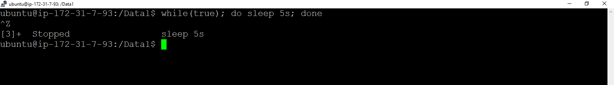

1. Check disk utilization of each mount point

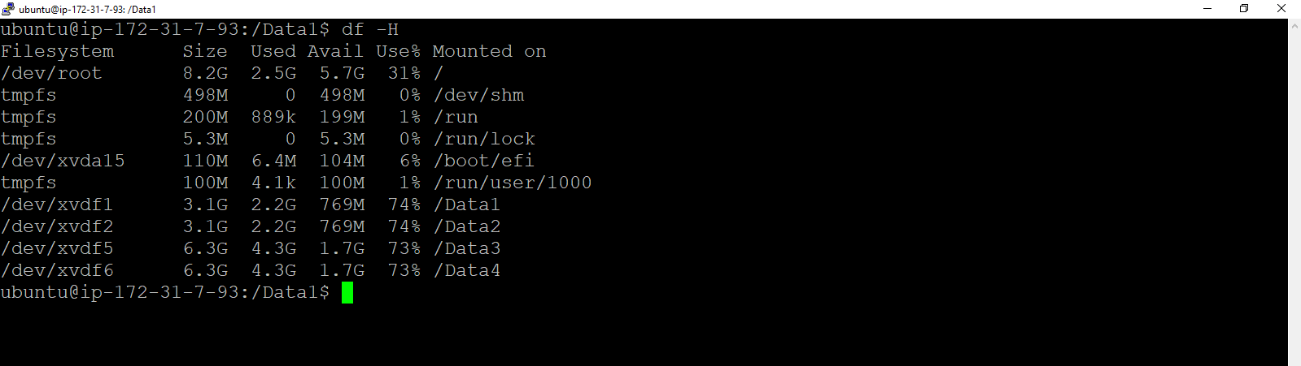

1. Unmount all partitions /Data1, /Data2, /Data3 and /Data4

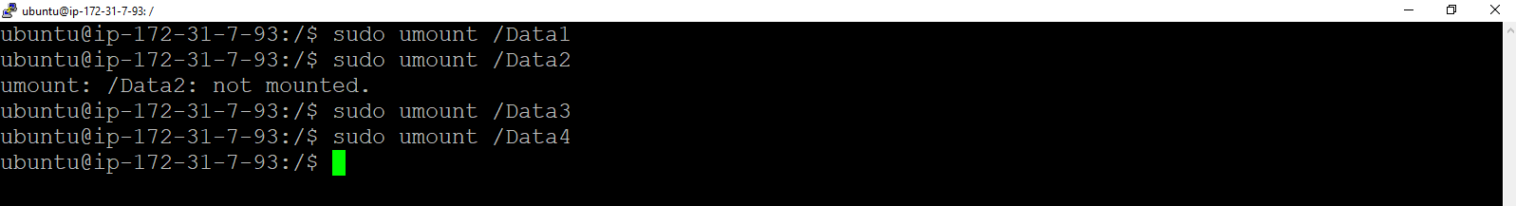

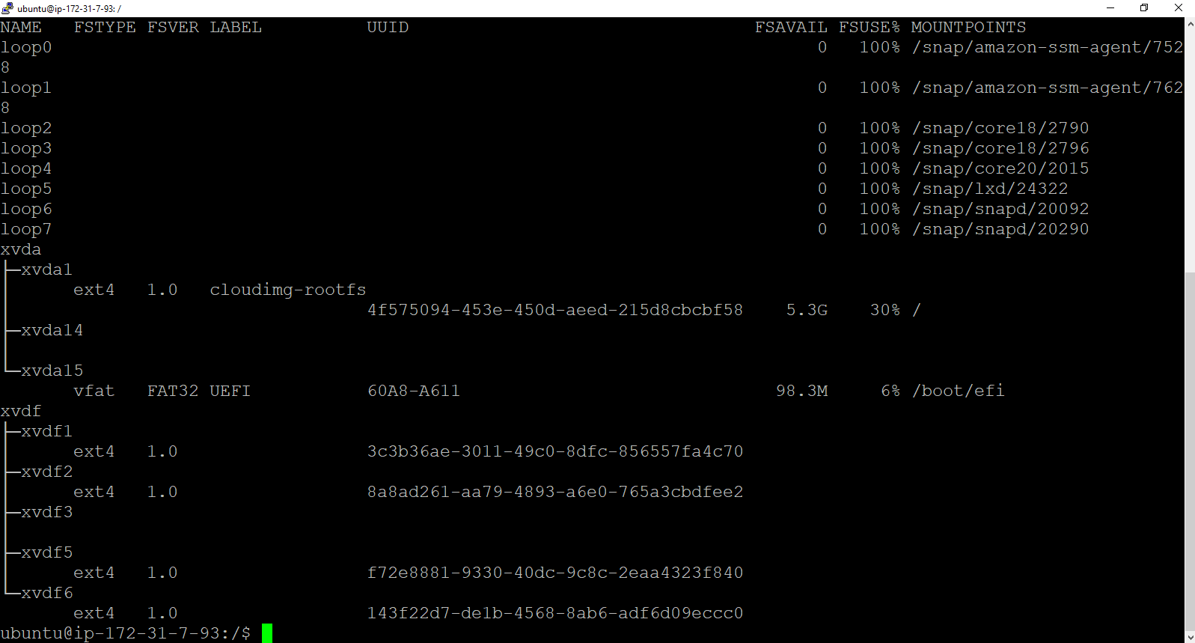

Note:-  All partitions should be automatically mounted post reboot.