1. Create user "nikhil" with home directory set as "/home/nikhil"  
          a) nikhil user should have "/bin/sh" shell for his environment  
          b) His password should expire in 9 days and 2 days before password expiry, he should get warning. User account must expire in 1 month from creation date  
         c) Give him root privileges to start/stop cron daemon.

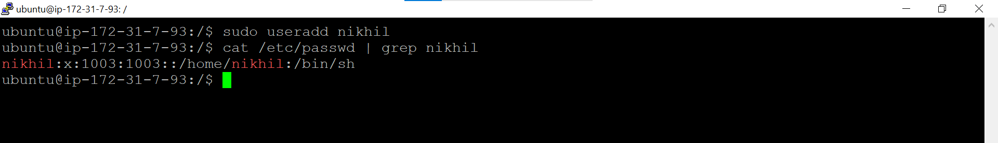

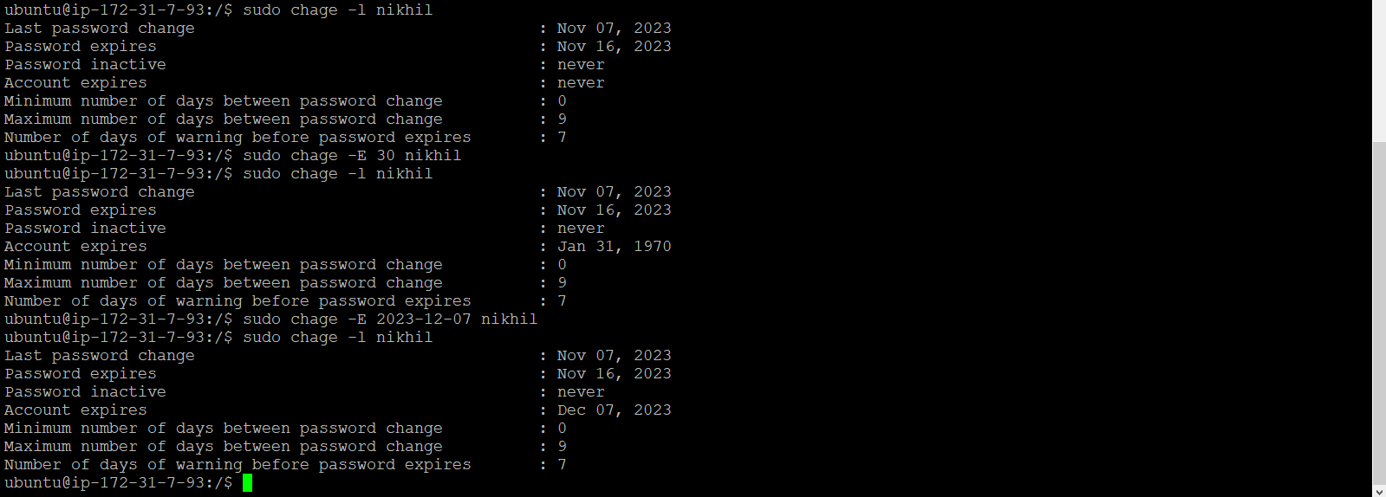

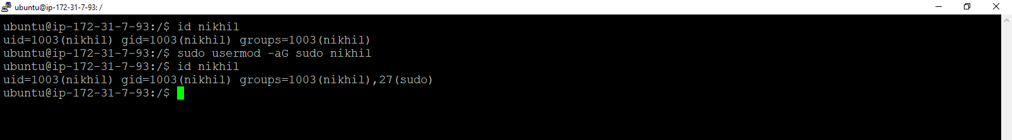

1. Inside folder "/" , create new home directory as "nikhil" (/nikhil) and setup this folder as a home directory for user "nikhil"

