Reliability-Focused Remote-Sensing Visual Question Answering with Locally Fine-Tuned Vision-Language Models
Atharva Uday Kalase (40509608)
School of EEECS, Queen’s University Belfast — ECS8060 Artificial Intelligence Engineering
Abstract—This project builds and evaluates a remote-sensing visual question answering (RS-VQA) system on the VRSBench benchmark using Qwen2.5-VL run locally in 4-bit precision, with reliability rather than raw accuracy as the object of study. Two research questions are examined—whether a detector-in-the-loop grounding stage improves accuracy (RQ1) and whether an answer–evidence consistency check reduces hallucination (RQ2)—alongside QLoRA fine-tuning and a model-scale comparison. On a fixed 1,000-question subset, off-the-shelf grounding degrades accuracy through a detector domain gap, a rule-based consistency check improves reliability at high precision, and answer-only-masked QLoRA lifts the 7B model to 56.7% exact-match / 66.7% under an LLM judge—the best configuration—while a larger general 35B model scores lower, indicating that domain fit matters more than scale. The system satisfies all required components: prompt engineering, a multimodal and lightly agentic pipeline, PEFT fine-tuning, fully local inference, and an interactive demonstration front end.
Index Terms—remote sensing, visual question answering, vision-language models, QLoRA, parameter-efficient fine-tuning, LLM-as-a-judge.
I. INTRODUCTION
Remote-sensing visual question answering asks a model to answer natural-language questions about overhead aerial or satellite imagery—the number, category, colour or position of objects in a scene. General vision-language models (VLMs) work reasonably out of the box, but their reliability is uneven, and in operational settings a confident wrong answer is worse than an honest abstention. This project therefore treats reliability, not raw accuracy, as the object of study, asking two questions. RQ1: does an explicit grounding stage (an object detector in the loop) improve accuracy? RQ2: where do models fail by question type, and can an answer–evidence consistency check reduce hallucination? Lightweight domain fine-tuning and a model-scale comparison accompany these.
Related work and contributions. VRSBench [1] is a remote-sensing VLM benchmark with twelve question types, used here as both evaluation set and fine-tuning source; Grounding DINO [2] is the open-vocabulary detector used as a tool; Qwen2.5-VL [3] is the answering model (3B/7B, quantisable on a laptop GPU); and fine-tuning uses LoRA [4]. The contributions are: (i) a local 4-bit RS-VQA pipeline with prompt engineering, a detector tool and a rule-based verifier; (ii) a dual evaluation using normalised exact-match and an LLM-as-a-judge; (iii) a QLoRA study that diagnoses and fixes catastrophic forgetting; and (iv) a 3B/7B/35B scale comparison. Every mandated component is fulfilled.
II. SYSTEM AND METHOD
The answering model is held constant and only the surrounding machinery varies, so any accuracy change is attributable to the intervention under test. The system comprises the five required components. (1) Prompt engineering: a concise system prompt constrains the model to short answers; the grounded variant adds an evidence block built from detector output. (2) A multimodal, lightly agentic pipeline: a VLM combined with an open-vocabulary detector used as a tool and a rule-based verifier that abstains on inconsistent answers—tool use plus self-verification. (3) QLoRA fine-tuning. (4) Local inference: 4-bit NF4 quantisation offline on a consumer GPU, with no paid APIs in the answering path. (5) An interactive Gradio dashboard.
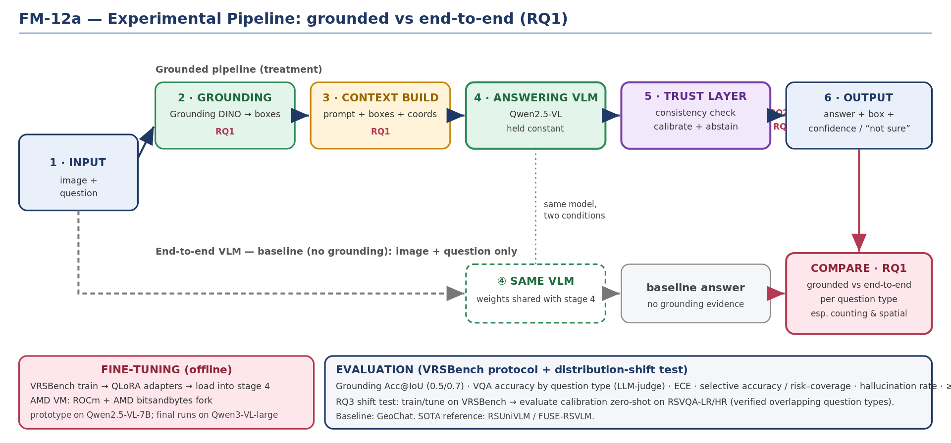
Fig. 1. System pipeline: image and question flow through the VLM, with an optional grounding stage and an answer–evidence consistency check before the final answer.
III. EXPERIMENTS
A. Dataset and protocol
Experiments use a fixed random subset of 1,000 questions from the VRSBench validation VQA split (seed 0), spanning twelve question types. Answers are graded by a normalised soft exact-match scorer (lower-casing; punctuation, article, number-word and plural normalisation; and a remote-sensing synonym map) and, as a secondary check, by an LLM-as-a-judge using the faculty Qwen3.6-35B model. Two reference points frame every result: a majority-per-type baseline of 34.5% and a random baseline of 23.1%.
B. Models and fine-tuning
Three configurations are compared: Qwen2.5-VL-3B and 7B (local, 4-bit) and the general Qwen3.6-35B via API. QLoRA uses rank-8, α-16 adapters on the attention projections, learning rate 2×10⁻⁵, answer-only loss masking, effective batch size 8 (batch 1 × grad-accum 8), and 1,000 VRSBench train questions; the final 7B adapter was trained for two epochs. An earlier run with a high learning rate (1×10⁻⁴) and full-sequence loss caused catastrophic forgetting, motivating the corrected recipe.
C. Metrics and implementation
Accuracy is reported overall and per type. The primary metric is normalised soft exact-match; the secondary is the LLM-judge, which credits synonyms and equivalent phrasings—two independent scorers guard against either being misleading. For abstention, the precision and recall of the hallucination flag are reported, with precision prioritised since a false flag discards a correct answer. The pipeline uses Hugging Face Transformers, PEFT and bitsandbytes with a Gradio front end; in 4-bit the 3B model uses ~4.6 GB and the 7B ~6.5 GB, both fitting an 8 GB laptop GPU without offloading, and fine-tuning a 7B adapter takes ~40–55 minutes. The faculty model is used only as a judge and comparison point, preserving local inference.
IV. RESULTS AND DISCUSSION
TABLE I. Overall accuracy (exact-match / LLM-judge) on the 1,000-question subset.
Model | Zero-shot | Fine-tuned
Qwen2.5-VL 3B | 51.0 / 60.8 | 51.5 / 61.3
Qwen2.5-VL 7B | 51.3 / 62.6 | 56.7 / 66.7
Qwen3.6-35B (API) | 42.8 / 53.5 | —
A. RQ1 — does grounding help?
No. Injecting detector evidence degraded exact-match accuracy (3B: 51.0→47.0) and the effect replicated across the 3B, 7B and API models. Accuracy fell whether or not the detector returned boxes, so the evidence is actively misleading rather than merely absent—consistent with a domain gap: Grounding DINO is trained on natural photographs, whereas the imagery is nadir-view with small, densely packed objects, so its labels are frequently wrong while the prompt tells the model to trust them. Bad evidence is worse than none.
B. RQ2 — consistency checking
A rule-based verifier flags answers that contradict the detector evidence (a named object must appear among detections; counts must match within tolerance) and abstains on them. On the grounded predictions it acts as a high-precision, low-recall filter: 83.8% flag precision, raising accuracy on the retained 89.5% of answers from 46.4% to 49.9%. It reduces hallucination, though its ceiling is bounded by the same unreliable detector.
TABLE II. Answer–evidence consistency check (RQ2), on the grounded predictions.
Metric | Value
Answers flagged (abstained) | 10.5%
Flag precision (flagged truly wrong) | 83.8%
Flag recall (wrong answers caught) | 16.4%
Accuracy before / on retained | 46.4% / 49.9%
Coverage retained | 89.5%
C. Fine-tuning, scale and metric validation
The corrected QLoRA recipe lifts the 7B model from 51.3/62.6 to 56.7/66.7—a +5.4-point exact-match gain—while improving the hardest type (object quantity) rather than collapsing it; the same recipe helps the 3B model, so it generalises across scale. The much larger general 35B model is the weakest of the three: domain fit matters more than raw scale. The LLM-judge raises every condition by roughly nine points without changing the ranking, and the synonym-normalised scorer independently recovers about +2.4 points—both confirming that much of the apparent error is vocabulary and label-convention mismatch rather than perception.
D. Demonstration and limitations
An interactive dashboard (Fig. 2) accepts an image and a question and returns a concise answer from the fine-tuned 7B model, with an optional overlay of detected objects; per-type accuracy and the model-scale comparison appear in Fig. 3. Limitations: the 1,000-question subset gives rare types wide confidence intervals; the confidence signal (mean generated-token probability) saturated near 1.0, making a distribution-shift calibration test inconclusive, which is why abstention relies on the rule-based check; and the LLM-judge is itself a model, not ground truth.
[ Fig. 2 — insert dashboard screenshot here ]
Fig. 2. The interactive demonstration dashboard (7B fine-tuned model).
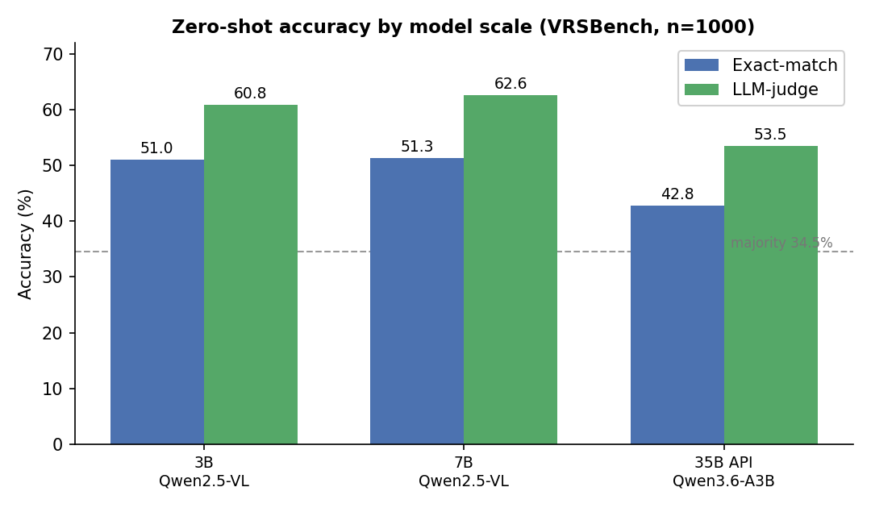
Fig. 3. Zero-shot accuracy by model scale (exact-match and LLM-judge).
V. CONCLUSION
A reliable, fully local RS-VQA system was built and used to test which engineering interventions genuinely help. Off-the-shelf grounding hurt accuracy through a detector domain gap; a rule-based consistency check improved reliability; and answer-only QLoRA fine-tuning lifted the 7B model to 56.7% / 66.7%—the best configuration—while a larger general model performed worse. In this domain naive additions fail and targeted, domain-aware ones succeed, and every component must be validated end-to-end. All mandated components are fulfilled.
REFERENCES
[1] X. Li et al., “VRSBench: A Versatile Vision-Language Benchmark for Remote Sensing Image Understanding,” NeurIPS Datasets and Benchmarks, 2024.
[2] S. Liu et al., “Grounding DINO: Marrying DINO with Grounded Pre-Training for Open-Set Object Detection,” arXiv:2303.05499, 2023.
[3] J. Bai et al., “Qwen2.5-VL Technical Report,” arXiv:2502.13923, 2025.
[4] E. Hu et al., “LoRA: Low-Rank Adaptation of Large Language Models,” ICLR, 2022.
APPENDIX
TABLE III. Per-type accuracy of the 7B fine-tuned model (exact-match / LLM-judge).
Question type | Exact / Judge | Question type | Exact / Judge
Object existence | 88.5 / 88.9 | Object shape | 42.5 / 50.0
Object colour | 66.3 / 74.2 | Object size | 38.5 / 42.3
Reasoning | 67.7 / 74.2 | Object category | 32.1 / 60.3
Rural / urban | 80.0 / 60.0 | Object quantity | 44.3 / 46.6
Object position | 52.1 / 65.5 | Object direction | 50.0 / 50.0
Scene type | 47.1 / 68.2 | Image-level | 74.2 / 83.9
The breakdown shows the model is strongest on object existence and colour and weakest on shape, size and category. The large exact-match/judge gap on object category (32.1 vs 60.3) confirms those errors are largely vocabulary and label-convention mismatches rather than perception failures—exactly what the synonym-normalised scorer and LLM-judge are designed to reveal.

