Atharva Yadav

Roll No : 127

Batch : S23

Network Lab

Assignment No. 1 Basic Networking Commands for Windows and Linux OS.

Aim : All 17 networking commands with description and appropriate options.

1.IPCONFIG

Syntax : ipconfig

Description :

IPCONFIG stands for INTERNET PROTOCOL CONFIGURATION .

ipconfig provides information about a computer's IP address, subnet mask, default gateway, DNS servers, MAC address, and connection-specific DNS suffix. It is a command-line utility in Windows, offering details on network configuration.

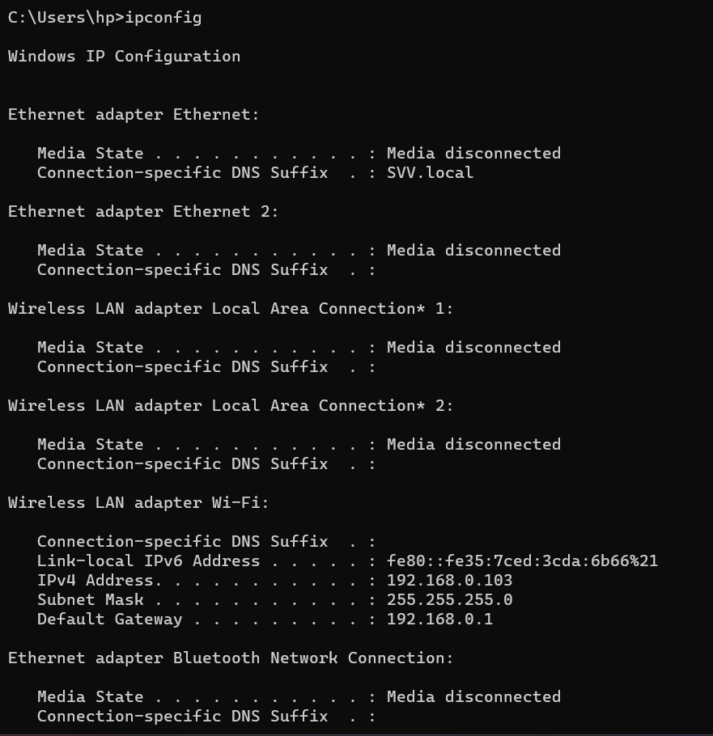

The ipconfig command in Windows has several options that you can use to customize its output and gather specific information. Some options include:

A.ipconfig/all

Description : Displays detailed configuration information for all network interfaces, including DNS settings, DHCP information, and more.

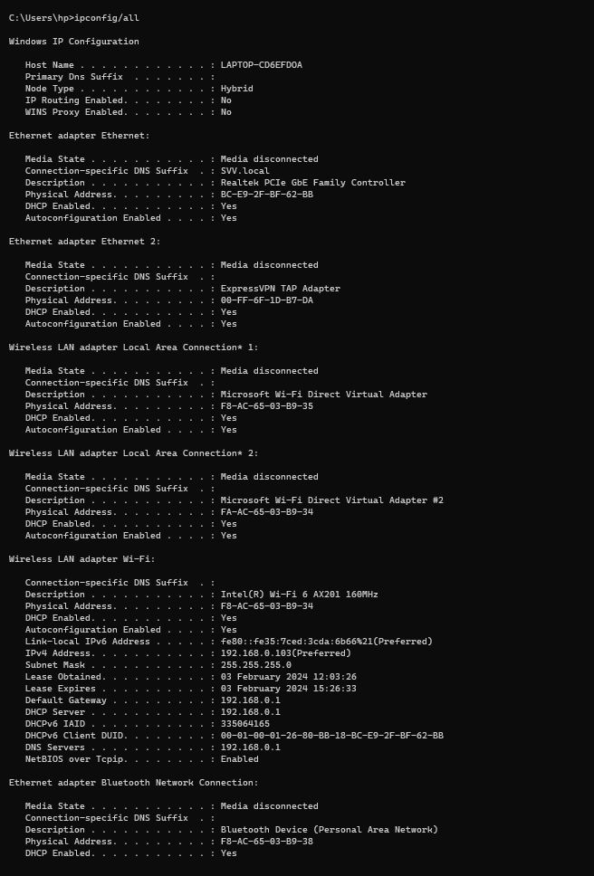

b.ipconfig/renew.

Description :Renews the IP address for all network interfaces.

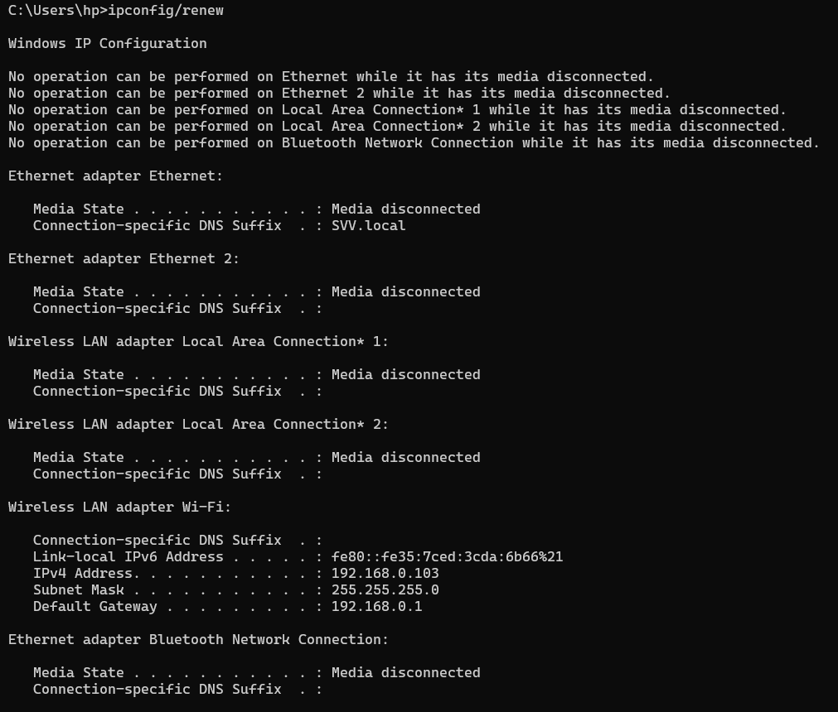

c.ipconfig/release

Description : Releases the currently assigned IP address for all network interfaces.

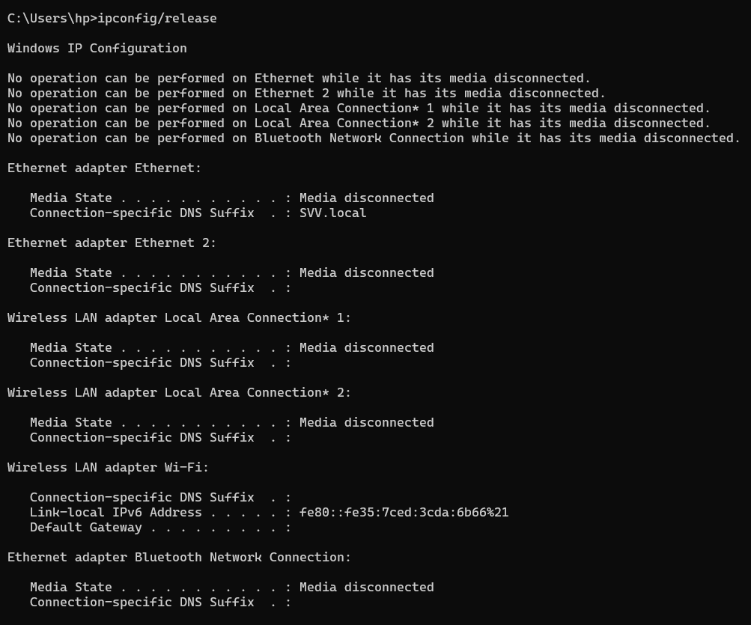

d.ipcongig/release6

Description : releases the IPV6 address

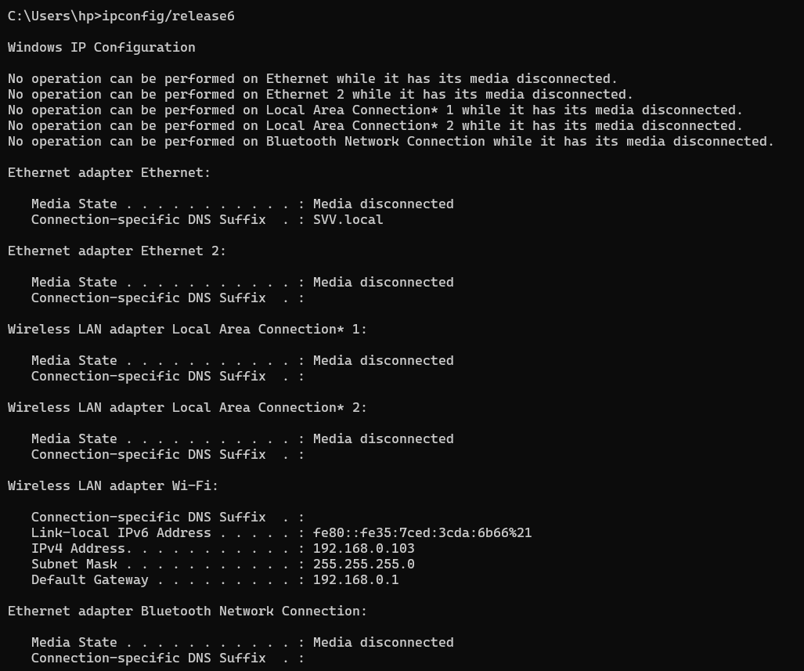

f.ipconfig/dispalydns

Description : Shows the contents of the DNS client resolver cache.

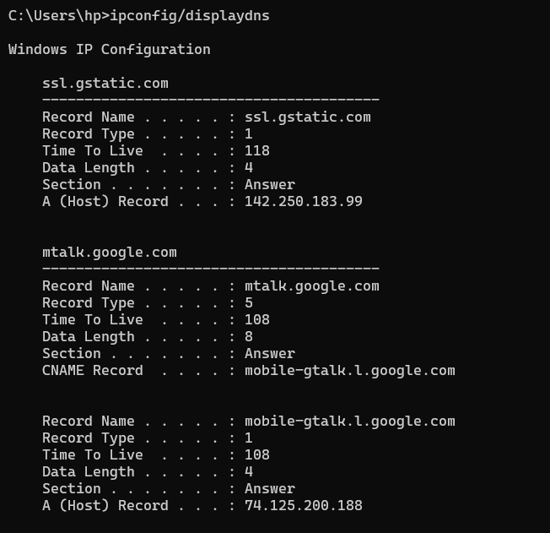

­2.ifconfig

Description : The command ifconfig stands for interface configurator. This command enables us to initialize an interface, assign IP address, enable or disable an interface. It display route and network interface.You can view IP address, MAC address and MTU (Maximum Transmission Unit) with ifconfig command. 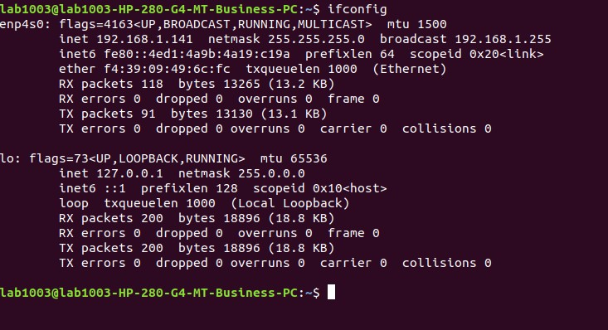

To find IP address of all three differently, use command

ifconfig eth0

ifconfig lo

ifconfig wlan0

3.nslookup

Description: nslookup is a command-line tool for querying DNS servers, retrieving information such as IP addresses or mail server details for a given domain. It is commonly used for troubleshooting DNS issues, verifying proper DNS configuration, and conducting reverse DNS lookups. Users can test connectivity and diagnose network problems by querying DNS information with nslookup in the command prompt or terminal.

A.nslookup <url>

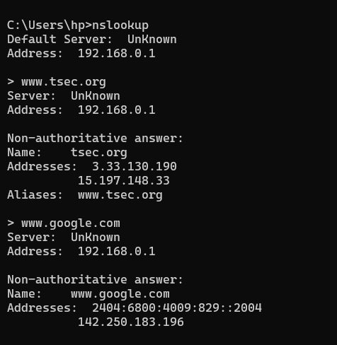

B.nslookup<IP_adress>

Performs revers lookup of the ip address and returns the corresponding domain name(if available)

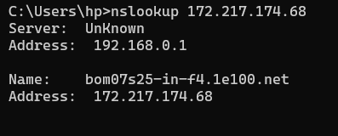

4.ip

Description :Linux IP command is the newer version of the ifconfig command. It is a handy tool for configuring the network interfaces for Linux administrators. It can be used to assign and remove addresses, take the interfaces up or down, and much more useful tasks.

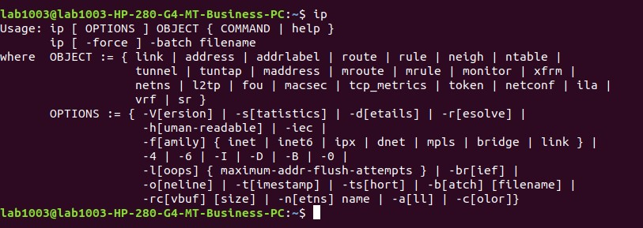

5.ping

This command sends four experimental packets to the destination host to check whether it receives them successfully, if so, then, we can communicate with the destination host. But in case the packets have not been received, that means, no communication can be established with the destination host.

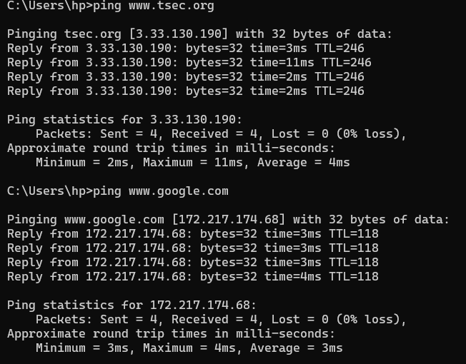

6.tracepath

It is similar to traceroute command, but it doesn't require root privileges. By default, it is installed in Ubuntu but you may have to download traceroute on Ubuntu. It traces the network path of the specified destination and reports each hop along the path. If you have a slow network then tracepath will show you where your network is weak.

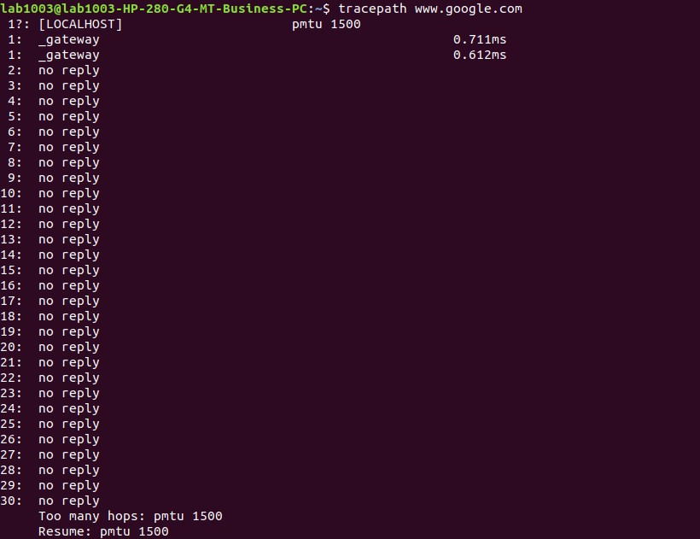

7.tracert

tracert, short for "traceroute," is a command-line utility used to trace the route that packets take to reach a destination on a computer network. It shows the sequence of routers or hops that data packets traverse from the source to the specified destination, providing information on the time it takes for each hop. tracert is valuable for diagnosing network connectivity issues and identifying bottlenecks by revealing the path and potential delays between the source and destination. To use it, enter "tracert" followed by the destination address or domain name in the Command Prompt or terminal

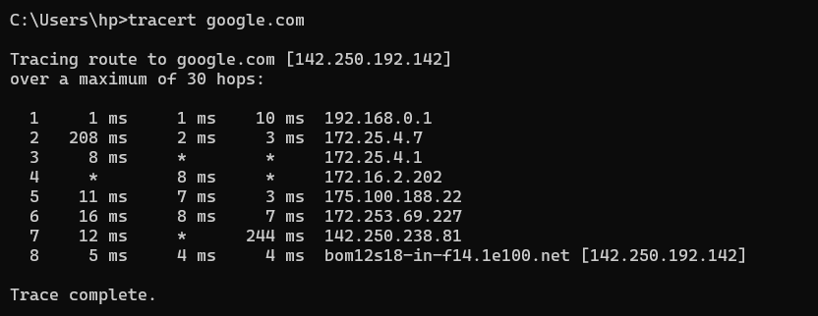

8.netstart

The netstat command is a command-line utility used to display information about network connections, routing tables, interface statistics, masquerade connections, and more on a computer. It provides details about open ports, active network connections, and listening sockets. netstat is valuable for diagnosing network issues, identifying active connections, and monitoring network activity. You can use parameters such as "-a" to display all connections and listening ports or "-n" to show numerical addresses.

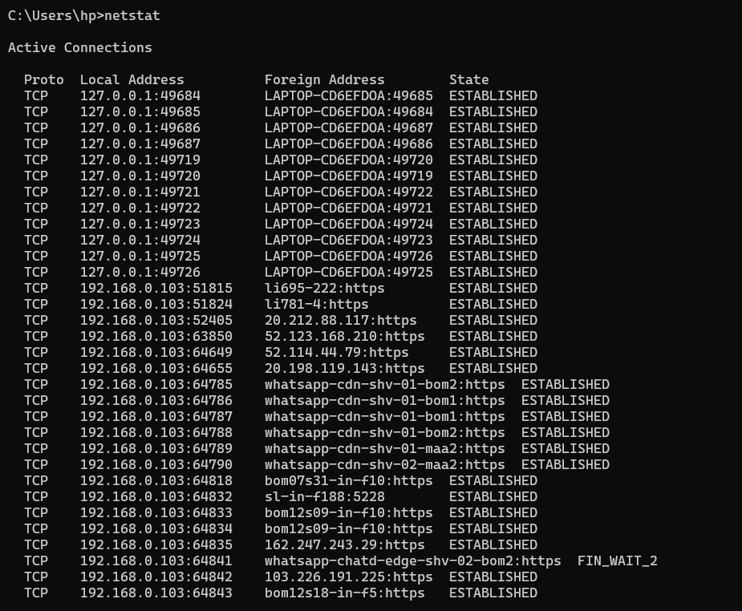

9.wget

wget is a command-line utility for non-interactive downloading of files from the web. It is widely used on Unix-like operating systems, including Linux. With wget, you can retrieve files using various protocols such as HTTP, HTTPS, FTP, and FTPS. Some common use cases include downloading files, mirroring entire websites, and fetching content for automated tasks or scripts. To use wget, you typically enter a command like wget [URL] in the terminal, where [URL] represents the web address of the file you want to download

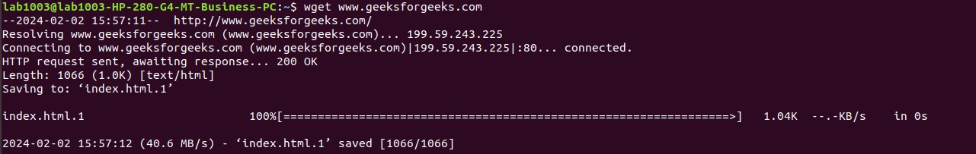

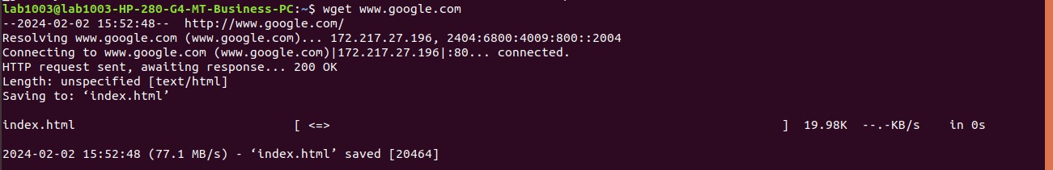

10.dig

dig, which stands for Domain Information Groper, is a command-line utility for querying Domain Name System (DNS) servers. It is commonly used on Unix-like operating systems, including Linux. dig provides detailed information about DNS queries and can be used to retrieve various types of DNS records such as A (IPv4 address), AAAA (IPv6 address), MX (mail exchange), and others. It's a versatile tool for troubleshooting DNS-related issues, checking DNS configurations, and obtaining DNS information for domain names

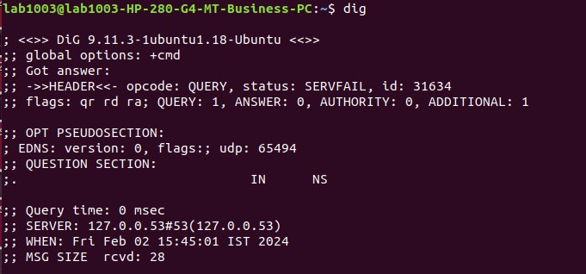

11.hostname

The hostname command is a command-line utility that provides the hostname of the current system. On Unix-like operating systems (including Linux and macOS) and Windows, using the hostname command without any options typically displays the host or computer name assigned to that system.





12.arp

The arp command is a network utility available on various operating systems, including Windows and Unix-like systems. It stands for Address Resolution Protocol and is used to display and manipulate the ARP cache, which is a table that maps IP addresses to MAC addresses on a local network.

The ARP command is useful for troubleshooting and verifying connectivity at the link layer of the OSI model. It helps in identifying and resolving issues related to MAC address resolution on a local network.



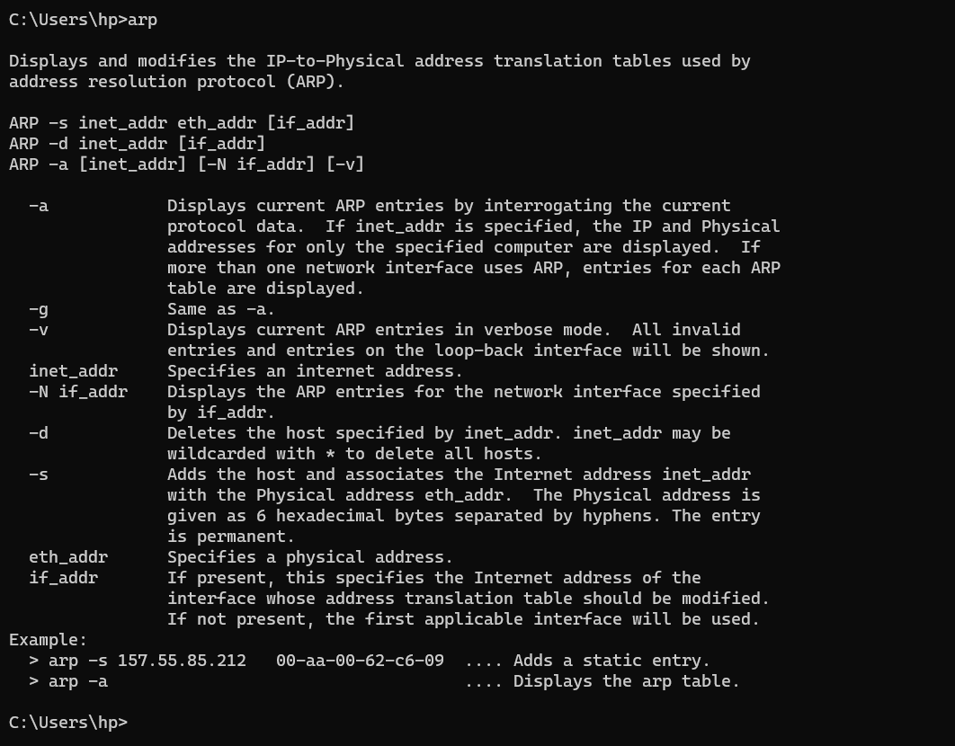

13.ss

The ss command is a utility for investigating sockets in Unix-like operating systems, providing information about network connections, listening ports, and socket statistics. It is often used as an alternative to the older netstat command.

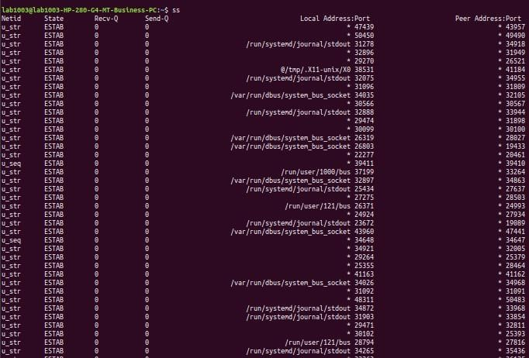

14.route

The route command is a network utility used to display or manipulate the IP routing table on Unix-like operating systems, including Linux. The routing table is a key component of a computer's network configuration, specifying how network packets should be forwarded to their destination.

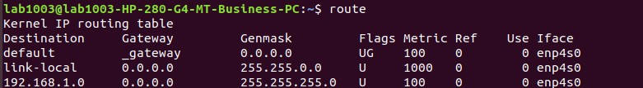

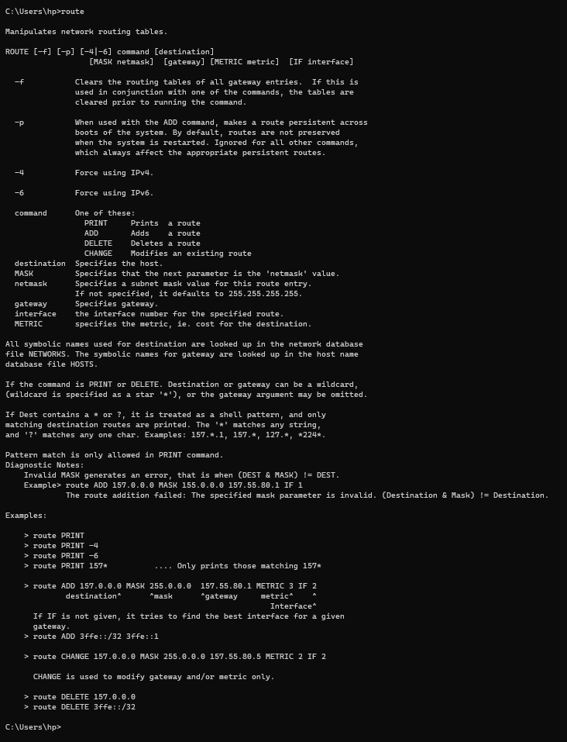

15.host

The host command is a utility used to perform Domain Name System (DNS) lookups and retrieve information about domain names or IP addresses. It is available on Unix-like operating systems, including Linux.

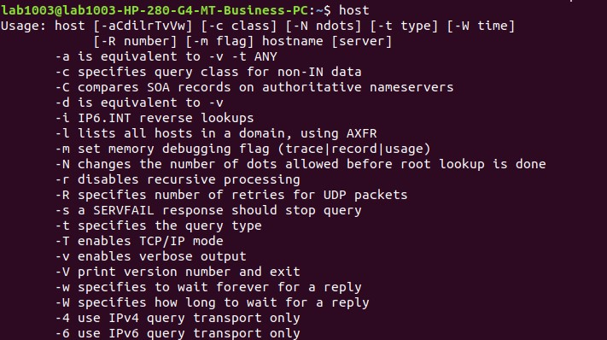

16.mtr

The mtr command, which stands for "My Traceroute," is a network diagnostic tool that combines the functionalities of traceroute and ping. It provides a continuous traceroute by sending packets to each hop on the route to a destination and measuring the response times. mtr is available on Unix-like operating systems, including Linux.

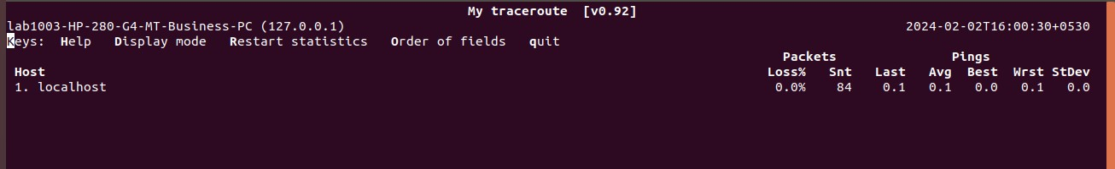

17.whoami

The whoami command is a simple command-line utility that prints the username associated with the current user who is executing the command. When you run whoami in a terminal or command prompt, it returns the username of the user logged in or executing the session.

