**Atharva Yadav**

**T23-101**

**Assignment-2**

**Aim: To Understand Version Control System, GIT installation & Github Account**

**Theory:**

# Version Control System

Version control - also known as source control or revision control - is an important software development practice for tracking and managing changes made to code and other files. It is closely related to source code management.

With version control, every change made to the code base is tracked. This allows software developers to see the entire history of who changed what at any given time — and roll back from the current version to an earlier version if they need to. It also creates a single source of truth.

Version control (or source control or revision control) serves as a safety net to protect the source code from irreparable harm, giving the development team the freedom to experiment without fear of causing damage or creating code conflicts.

If developers code concurrently and create incompatible changes, version control identifies the problem areas so that team members can quickly revert changes to a previous version, compare changes, or identify who committed the problem code through the revision history. With a version control system (VCS), a software team can solve an issue before progressing further into a project. Through code reviews, software teams can analyze earlier versions to understand the changes made to the code over time.

Depending on a team's specific needs and development process, a VCS can be local, centralized, or distributed. A local VCS stores source files within a local system, a centralized VCS stores changes in a single server, and a distributed VCS involves cloning a Git repository.

## 2.Benefits of version control

* Quality

Teams can review, comment, and improve each other's code and assets.

* Acceleration

Branch code, make changes, and merge commits faster. 

Visibility

Understand and spark team collaboration to foster greater release build and release patterns. Better visibility improves everything from project management to code quality. 2. GIT Installation

3. **What is Git?**

* **Version Control System**: Manages and tracks changes to source code.
* **Distributed System**: Each developer has a full copy of the repository.
* **Branching and Merging**: Easy creation and merging of branches.
* **Data Integrity**: Ensures the integrity of the codebase with checksums.
* **Staging Area**: Allows reviewing and committing changes selectively.

**4. What is Git Bash?**

* **Git Bash**: A command-line interface for using Git on Windows.
* **Bash Emulation**: Provides a Unix-like shell experience.
* **Command Utilities**: Includes standard Unix commands and Git commands.

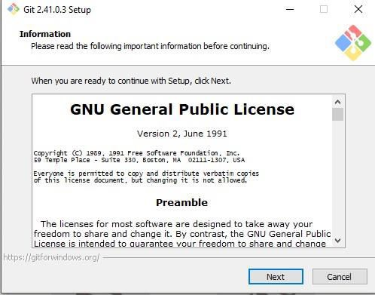

step -1 : select the file path for installation

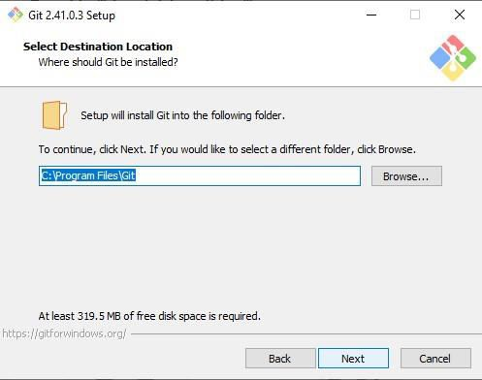

step -2 : select the required components for installation

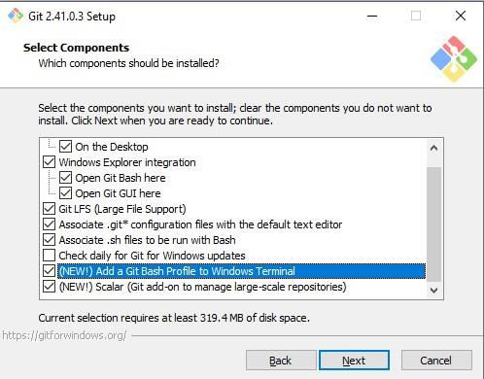

step -3 : select the folder name for setup

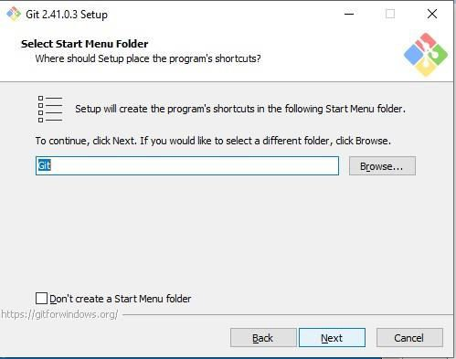

step -4 : select the default text editor for using Git

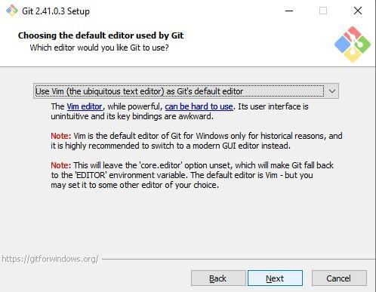

step -5 : setup required formats

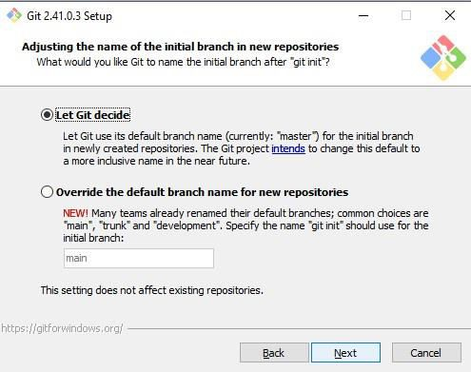

step-6 : Authorise necessary permissions

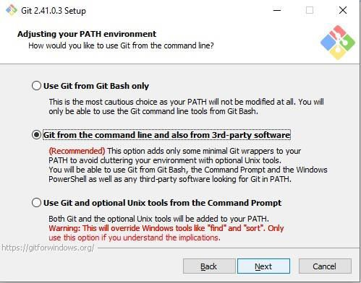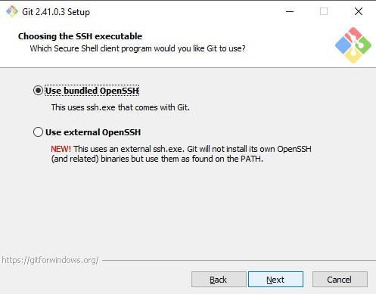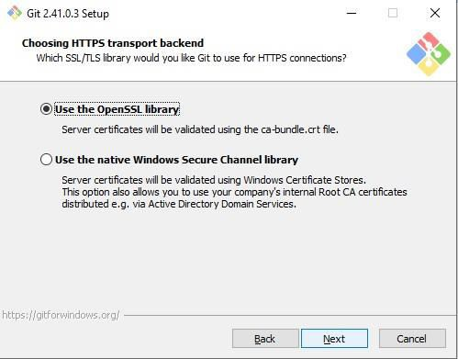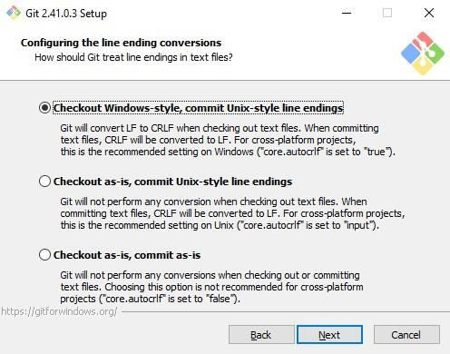

Step-7: Configure the BASH terminal

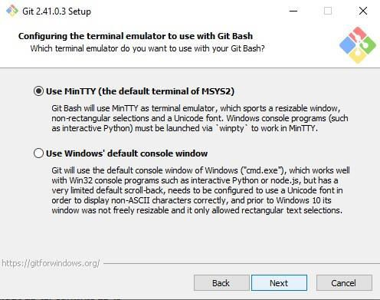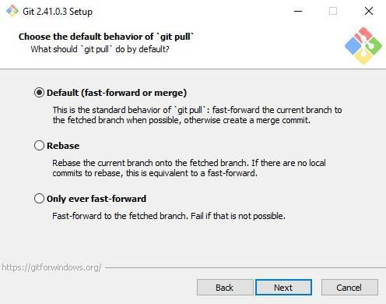

Step-8: Click Install

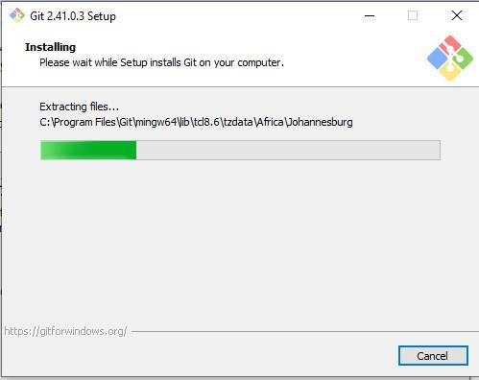

Step-9: Setup Complete

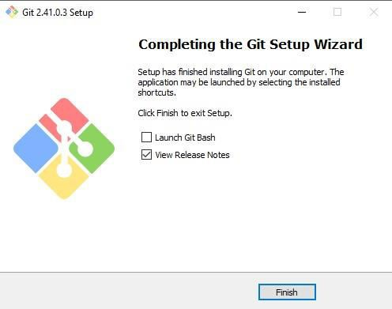

3.GITHUB ACCOUNT

GitHub is a web-based platform that provides hosting for Git repositories. It is a popular service for version control and collaboration, allowing developers to work together on projects from anywhere in the world. GitHub was founded by Tom Preston-Werner, Chris Wanstrath, PJ Hyett, and Scott Chacon in 2008 and is now owned by Microsoft.

**Uses of GitHub**

1. **Version Control**: Hosts Git repositories, enabling version control and tracking changes to code over time.
2. **Collaboration**: Allows multiple developers to work on the same project simultaneously, with tools for code review, pull requests, and issue tracking.
3. **Documentation**: Provides wikis and project documentation directly within repositories.
4. **Project Management**: Features like project boards, task lists, and issue tracking help manage development workflows.
5. **Continuous Integration/Continuous Deployment (CI/CD)**: Integrates with CI/CD tools to automate testing and deployment processes.
6. **Open Source Contributions**: Facilitates contributions to open source projects by forking, cloning, and submitting pull requests.
7. **Community Engagement**: Allows developers to follow projects, star repositories, and participate in discussions.
8. **Code Hosting**: Stores code securely with support for private and public repositories.
9. **GitHub Pages**: Hosts static websites directly from a repository.
10. **Integrations**: Supports integrations with various tools and services like Slack, Trello, and more.

4o

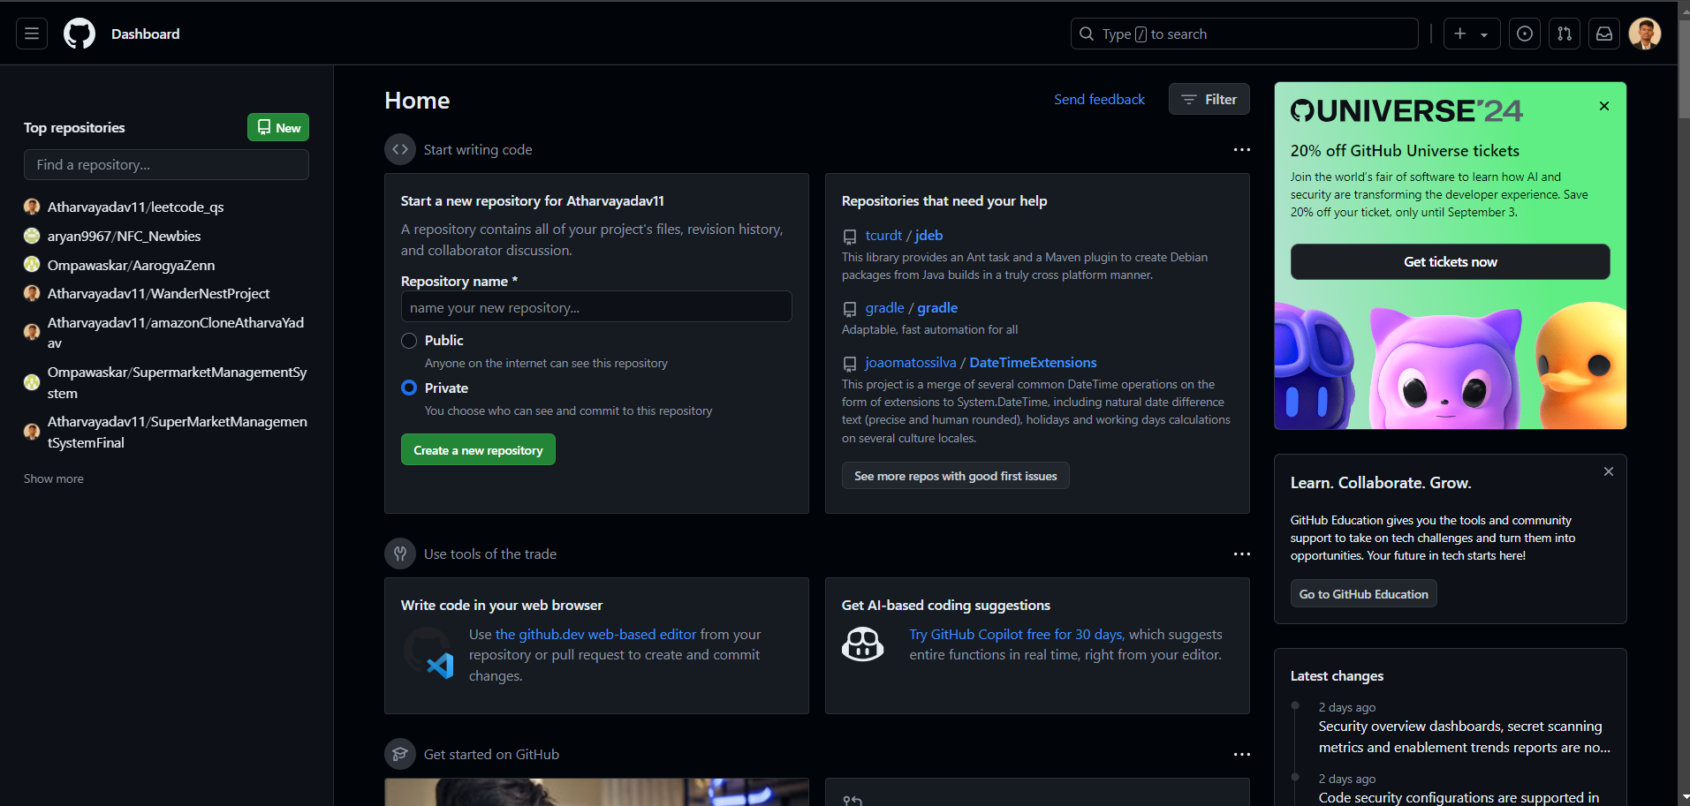

**Conclusion**: Basic knowledge regarding Git bash installation and Version Control System to effectively track changes augmented with git and github.

**LO Map: LO1,LO2.**