 Atharva Yadav

T23 – 101

BI LAB

**Assignment No. 2 – Power BI Tool**

**Aim**:Building dashboard using powerBI charts for strategic query analysis on super store dataset and its visualization.

Q1. Analyse country wise total profit using bubble map chart.

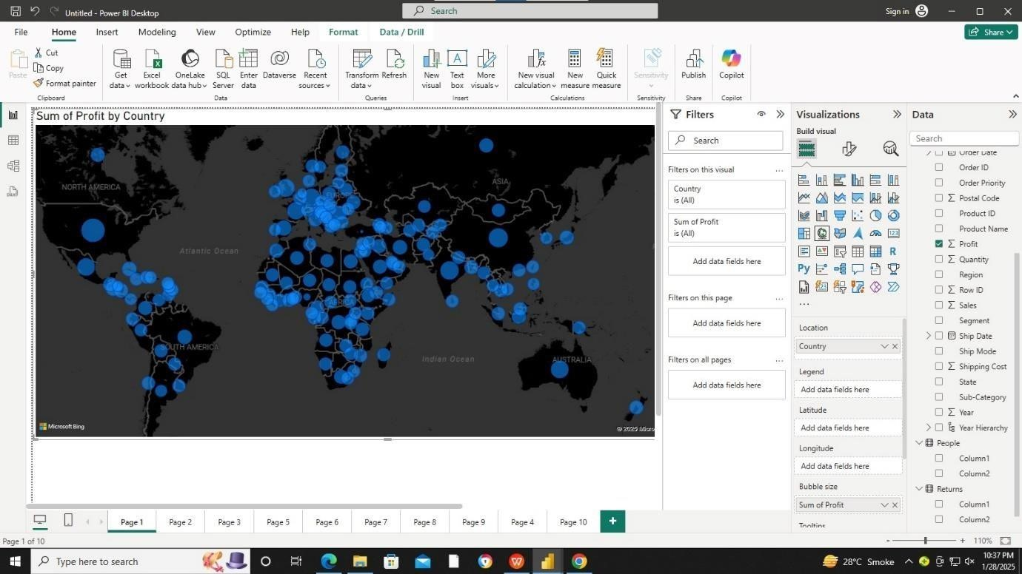

Q2. Analyse region wise total sales and profit using area chart.

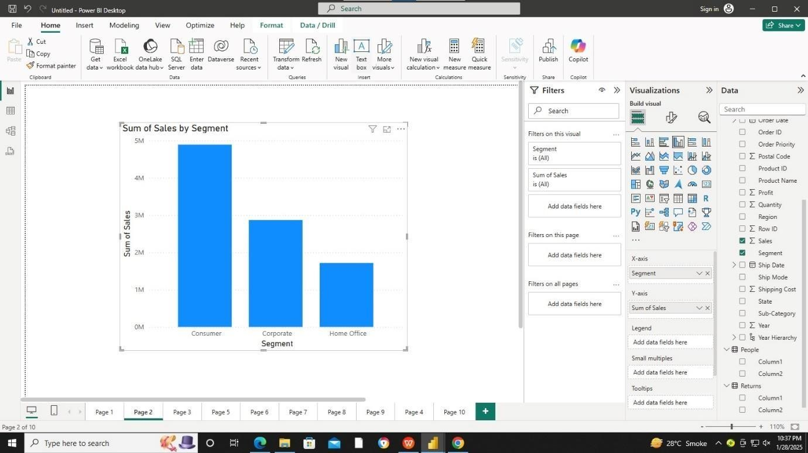

Q3. Analyze region wise total sales and profit using area chart.

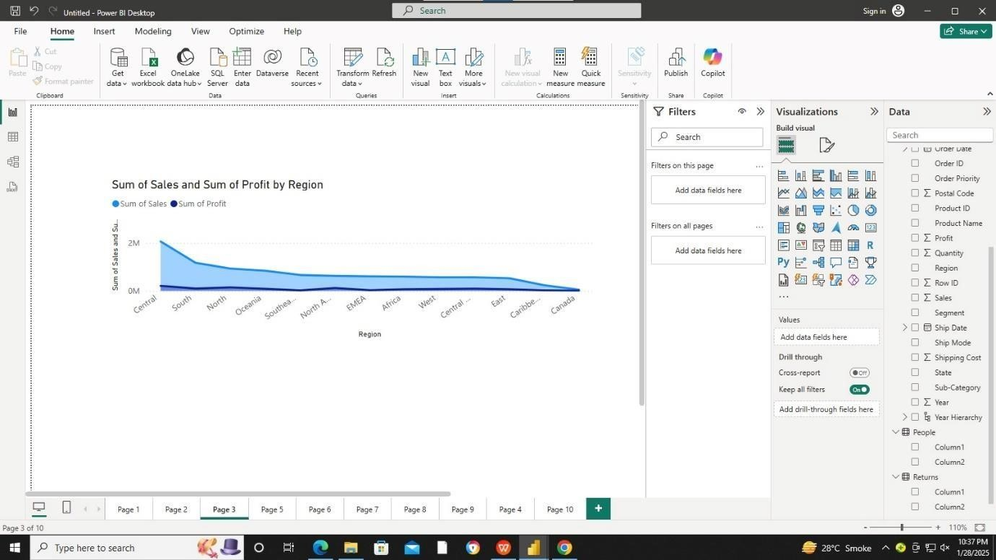

Q4.Display subcategory wise total sales using funnel chart.

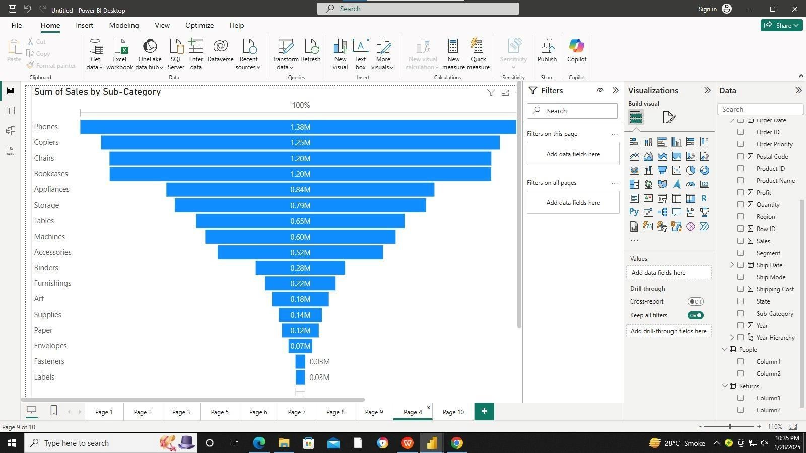

Q5.Display profit by region using donut chart.

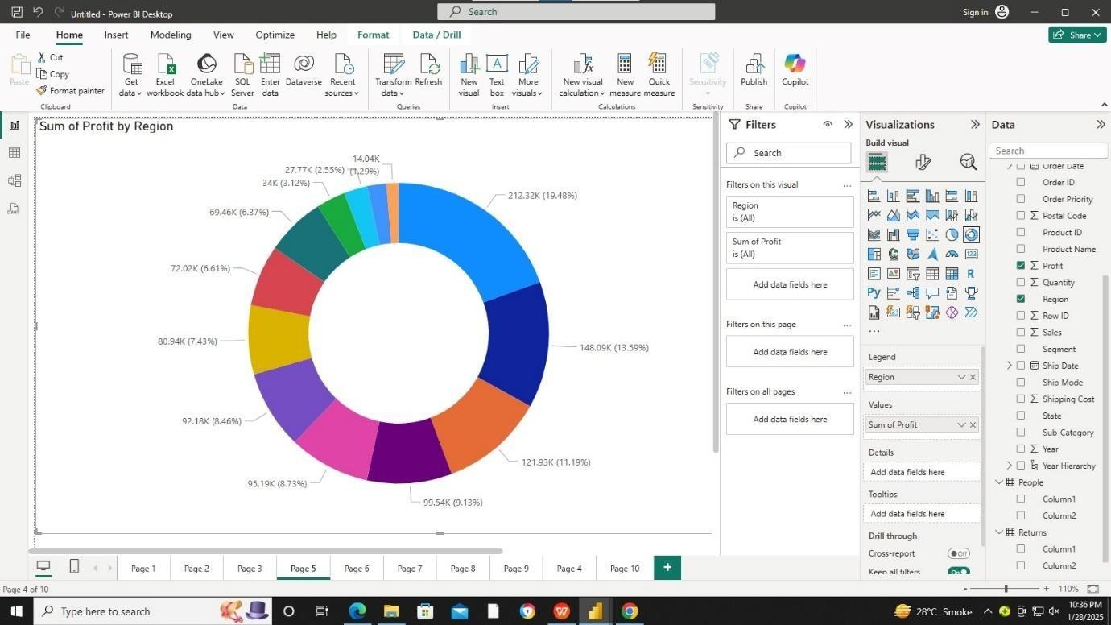

Q6.Display sum of quantity using Gauge chart.

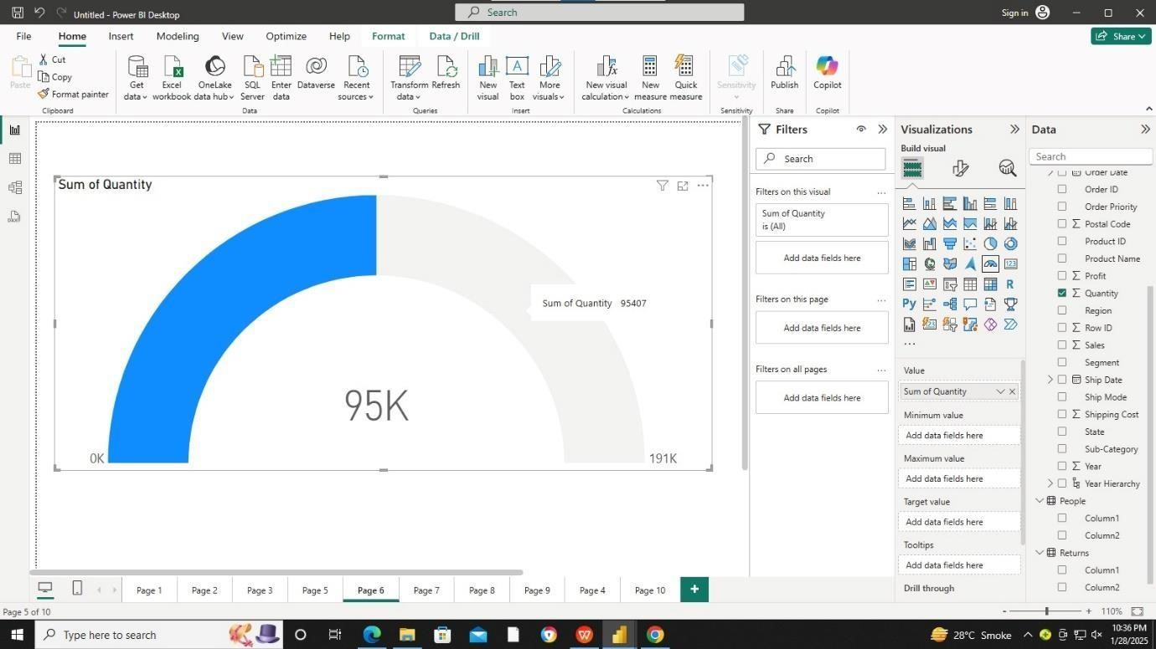

Q7. Insert bar chart to display year wise sum of sales.

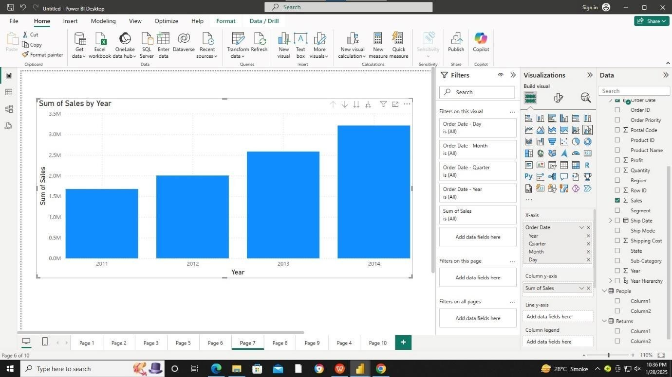

Q8. Use concept hierarchy and explore drill up and drill down operations by creating bar chart of sum of sales by year.

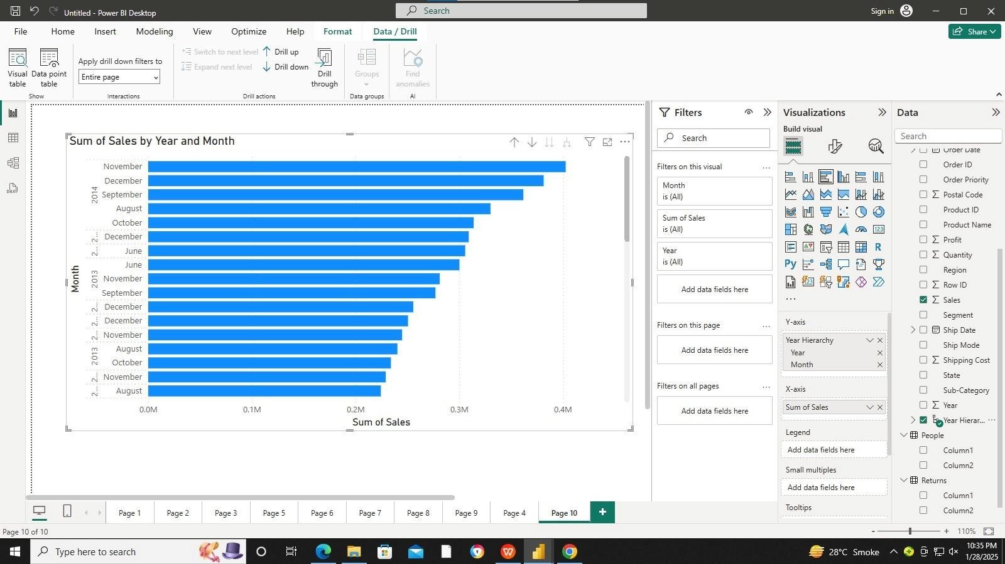

Conclusion: LO6 , LO4 mapped.