

**Atharva Yadav  
 T23 – 101  
 SL**

**Assignment No. 1**

**Aim:** Study of Various Sensors, Controllers, and Wireless Modules

**1. Sensors**

Sensors are devices that detect and respond to changes in the environment. They convert physical parameters into electrical signals for further processing. Below are descriptions of common types of sensors:

* Temperature Sensors:
  + Detect temperature variations and convert them into electrical signals.
  + Examples:
    - Thermocouples: Made of two different metals joined together, generating a voltage proportional to temperature difference.
    - LM35: A precision temperature sensor with an analog output proportional to the temperature in Celsius.
    - DHT11: Measures both temperature and humidity, providing digital output for easy interfacing.

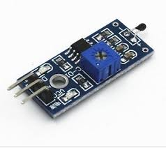

* Proximity Sensors:
  + Detect the presence or absence of objects without physical contact.
  + Examples:
    - Infrared (IR) Sensors: Emit and detect infrared light to sense objects; commonly used in obstacle detection.
    - Ultrasonic Sensors: Use sound waves to measure the distance to objects; suitable for range-finding and robotics.
    - Capacitive Sensors: Detect changes in capacitance when an object is near; used in touchscreens and proximity sensing.

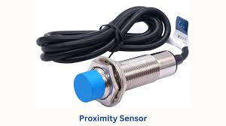

* Light Sensors:
  + Measure the intensity of light and convert it into electrical signals.
  + Examples:
    - LDR (Light Dependent Resistor): Resistance decreases with increasing light intensity; used in streetlights and light meters.
    - Photodiodes: Semiconductor devices that convert light into current; used in cameras and optical communication systems.

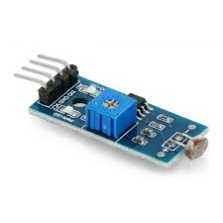

* Gas Sensors:
  + Detect the presence and concentration of specific gases.
  + Examples:
    - MQ-2: Detects flammable gases like methane, propane, and smoke.
    - CO2 Sensors: Measure carbon dioxide levels, often used in air quality monitoring.

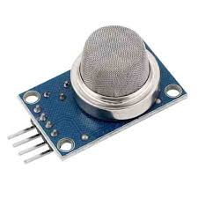

* Pressure Sensors:
  + Measure pressure in gases or liquids and convert it into an electrical signal.
  + Examples:
    - BMP180: Measures atmospheric pressure and altitude; commonly used in weather stations.
    - MPX5010: High-precision pressure sensor for industrial applications.

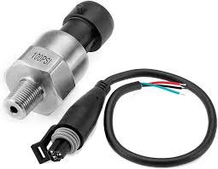

* Motion Sensors:
  + Detect movement or acceleration.
  + Examples:
    - PIR (Passive Infrared) Sensor: Detects motion by sensing changes in infrared radiation; used in security systems.
    - Accelerometers: Measure acceleration in one or more axes; used in smartphones and fitness trackers.

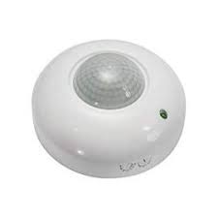

* Touch Sensors:
  + Detect physical touch or contact and convert it into an electrical signal.
  + Examples:
    - Capacitive Touch Sensors: Detect changes in capacitance when touched; used in modern touchscreens and control panels.

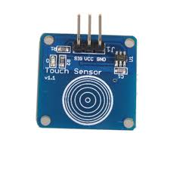

**2. Controllers**

Controllers like Arduino, Raspberry Pi, and NodeMCU are programmable hardware devices used to interface with sensors and control systems. Below are brief descriptions:

* Arduino:
  + Open-source microcontroller platform designed for hobbyists and professionals.
  + Popular Models: Arduino Uno, Mega, Nano.
  + Features:
    - Based on AVR microcontrollers (e.g., ATmega328).
    - Includes digital and analog input/output pins, PWM outputs, and serial communication interfaces (UART, SPI, I2C).
    - Simple to use with a vast library ecosystem.
    - Can be programmed using the Arduino IDE, with a simplified C/C++ syntax.
  + Applications:
    - Prototyping, robotics, home automation, and embedded systems projects.

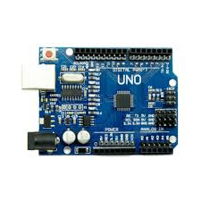

* Raspberry Pi:
  + A compact, affordable single-board computer that runs Linux-based operating systems (e.g., Raspberry Pi OS).
  + Popular Models: Raspberry Pi 4, Raspberry Pi Zero 2 W.
  + Features:
    - Equipped with GPIO (General-Purpose Input/Output) pins for interfacing sensors and modules.
    - Supports Ethernet, WiFi, HDMI, USB, and Bluetooth connectivity.
    - Powerful enough for AI/ML projects, media servers, and desktop computing.
    - Programming languages include Python, C++, Java, and more.
  + Applications:
    - IoT solutions, smart home systems, robotics, media streaming, and educational projects.

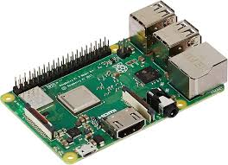

* NodeMCU:
  + Open-source development board based on the ESP8266 or ESP32 microcontroller, tailored for IoT applications.
  + Features:
    - Built-in WiFi and (in some models) Bluetooth capabilities.
    - Easy-to-use Lua scripting and Arduino IDE compatibility.
    - Compact, cost-effective, and low power consumption.
    - GPIO pins, ADC, PWM, and communication interfaces like UART, I2C, and SPI.
  + Applications:
    - Home automation, environmental monitoring, and wireless sensor networks.

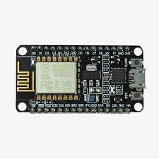

**3. Wireless Modules**

Wireless modules enable devices to communicate without physical connections. Here are commonly used wireless modules:

* Bluetooth:
  + Overview: Bluetooth is a short-range wireless communication technology used for exchanging data over short distances.
  + Example Modules:
    - HC-05/HC-06: Classic Bluetooth modules for serial communication.
    - BLE (Bluetooth Low Energy): Optimized for low-power applications like wearable devices.
  + Features:
    - Range: Typically up to 10 meters.
    - Low power consumption.
    - Secure pairing.
  + Applications:
    - Wireless peripherals (e.g., keyboards, headphones).
    - Data exchange between devices in IoT systems.

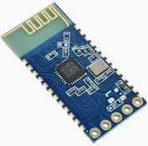

* WiFi:
  + Overview: WiFi enables devices to connect to the internet or local area networks wirelessly.
  + Example Modules:
    - ESP8266: A low-cost WiFi microchip with full TCP/IP stack and microcontroller capability.
    - ESP32: An advanced module with dual-core processors, Bluetooth, and WiFi support.
  + Features:
    - High-speed data transfer.
    - Wide range (up to 100 meters indoors, more outdoors).
    - Supports multiple connections.
  + Applications:
    - IoT devices (e.g., smart thermostats, cameras).
    - Smart home systems.
    - Wireless data logging.

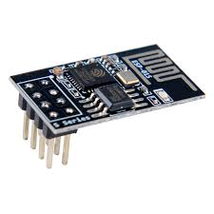

* GSM (Global System for Mobile Communication):
  + Overview: GSM modules allow devices to communicate over mobile networks for voice, SMS, and data.
  + Example Modules:
    - SIM800/SIM900: Widely used GSM/GPRS modules for sending SMS, making calls, and connecting to the internet.
  + Features:
    - Global coverage through mobile networks.
    - SMS and call functionality.
    - Internet connectivity via GPRS.
  + Applications:
    - Remote monitoring and control.
    - Vehicle tracking systems.
    - Alert systems (e.g., SMS notifications).

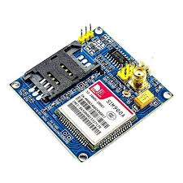

**Conclusion**

Understanding sensors, controllers, and wireless modules is crucial for building modern embedded systems and IoT applications. Sensors capture environmental data, controllers process and act on this data, and wireless modules enable seamless communication between devices. These technologies form the foundation of smart devices and connected systems.