PROJECT REPORT ON EDUAI
An AI-Powered Personalized Learning Companion
Focus Area: United Nations SDG 4 – Quality Education
ARTIFICIAL INTELLIGENCE INTERNSHIP FINAL PROJECT

Project Metadata | Details
Student Name | Atharv Kudtarkar
Project Title | EduAI – Smart Learning Companion
Sustainable Development Goal | SDG 4 – Quality Education
Artificial Intelligence Model | Google Gemini 2.0 Flash (REST API)
Application Platform | HTML5 / CSS3 / Vanilla JavaScript
Live Simulation URL | http://eduai-sdg4.surge.sh
Open Source Repository | https://github.com/Atharvk4406/eventopia
Submission Date | June 2026

1. Selected SDG and Reason for Selection
Selected Goal: United Nations SDG 4 – Quality Education
The Sustainable Development Goal 4 (SDG 4) established by the United Nations aims to "ensure inclusive and equitable quality education and promote lifelong learning opportunities for all" by the year 2030. Education is recognized globally as a foundational driver of individual empowerment, socio-economic mobility, and national development. Inclusive and quality education can break cycles of poverty, reduce systemic inequality, and equip youth with the tools necessary to thrive in a rapidly changing knowledge economy.
However, modern educational systems face severe structural bottlenecks, particularly in developing regions. The choice of SDG 4 for this project is driven by several critical challenges that persist in traditional classroom environments today:
- High Student-to-Teacher Ratios: Overburdened Teachers: Student-to-teacher ratios in municipal and low-cost schools frequently exceed 50:1. Under these conditions, teachers cannot provide personalized guidance or adjust their pacing to accommodate struggling students.
- Socio-Economic Barriers to Tutoring: Quality private tutoring and exam preparation resources are expensive, creating an unfair advantage for students from affluent families while leaving underprivileged students behind.
- Inefficiencies in Static Self-Study: Traditional textbooks and pre-recorded online lectures are static. If a student is confused by a specific paragraph or step in a mathematical derivation, they cannot interact with the material to ask follow-up questions.
- Lack of Real-Time Query Resolution: A self-study student studying late at night has no immediate recourse when they hit a concept they do not understand, leading to frustration, misconceptions, and decreased learning motivation.
By leveraging generative AI, we can build tools that provide personalized, high-quality, and interactive tutoring at zero marginal cost. EduAI was developed to demonstrate how conversational AI can democratize quality learning, giving every student access to a patient, knowledgeable, and always-available private tutor.
2. Problem Statement
Problem Context: Despite high internet penetration and the availability of generic online courses, students still face major barriers when studying independently. The core problems that this project addresses are defined below:
- What is the problem? A student studying a complex subject (e.g., quadratic equations in mathematics, photosynthesis in biology, or recursion in computer science) often experiences specific points of confusion. Without a personal tutor, there is no immediate way to get custom explanations tailored to their current level of understanding. This leads to gaps in knowledge that accumulate as the syllabus progresses.
- Where does the problem exist? This problem is prevalent in developing nations and semi-urban or rural school districts (such as public schools in India), where academic support infrastructure outside of school is practically non-existent and classrooms are heavily overcrowded.
- Who is affected? The primary group affected consists of high school and university students, particularly those from middle-income and lower-income families who must master technical subjects for board or competitive exams but cannot afford high-cost private coaching classes.
- Why is the problem serious? When academic difficulties are left unaddressed, students experience a gradual loss of academic self-esteem, which leads to poor performance in standard assessments and ultimately higher dropout rates in STEM streams. It prevents capable students from pursuing higher education simply because they lacked conceptual guidance at crucial learning stages.
- What could happen if it is not solved? If educational support remains a commodity accessible only to the wealthy, the educational achievement gap between social classes will widen. Underprivileged students will be systemically locked out of high-paying technical and scientific jobs, reinforcing generational cycles of inequality.
3. Proposed Solution
EduAI is an interactive, web-based, AI-powered study companion designed to give students 24/7 access to structured, personalized tutoring. The system leverages the Google Gemini 2.0 Flash API to simulate an on-demand private educator, combining Q&A, adaptive assessment, study organization, and curated learning recommendations into a single free-to-use interface.
How the System Works
The user interface is built using client-side technologies (HTML5, CSS3, and Vanilla JavaScript) to ensure the application remains extremely lightweight, fast-loading, and responsive on mobile devices and low-bandwidth connections. The workflow operates as follows:
- Accessing the Portal: The student visits the live EduAI portal on any smartphone, tablet, or desktop computer. The entire experience is hosted statically and runs in the browser, requiring no registration or user logins.
- Interactive AI Tutoring: The student selects a target subject (e.g., Mathematics, Physics, Chemistry, Computer Science, English, or History) and enters their specific query or doubt in natural language.
- Processing and AI Response: The query is packaged with structured system instructions that tell the AI to act as a helpful, encouraging school teacher. The request is sent to the Google Gemini 2.0 Flash API, which returns a clear, step-by-step, and academically sound explanation. Mathematical formulas and code syntax are formatted for readability.
- Adaptive Evaluation: To gauge their comprehension, the student can request an AI-generated multiple-choice quiz on any topic. The system parses the AI's JSON output to display an interactive quiz. When submitted, the application grades the answers instantly, highlighting correct selections in green and incorrect selections in red, alongside brief conceptual explanations.
- Structured Goal Tracking: The student can log their tasks and track their progress using the client-side Goal Planner. As tasks are marked complete, a visual progress bar updates in real time. If the student completes at least one task a day, the local storage increments their study streak, providing gamified motivation to study daily.
Mitigating the Problem and Core Audience
EduAI addresses the core problems of self-study by removing the barrier of 'getting stuck'. It provides safe, non-judgmental, and immediate feedback. The primary audience for this application is secondary and higher-secondary school students (grades 9 through 12), undergraduate college students, and independent self-learners seeking a structured path to master new academic concepts.
4. Project Features
The EduAI platform is divided into five core functional areas designed to support the student through the entire learning cycle:
- AI Subject Tutor: A conversational chat interface where students can ask complex questions and receive structured, step-by-step guidance. The AI tutor avoids giving direct answers to homework and instead guides the student through the logical steps to solve the problem themselves.
- AI Quiz Generator: Generates dynamic 5-question multiple-choice quizzes on any user-specified topic. It evaluates answers dynamically, displays a final score card, and offers immediate explanations for each answer choice to ensure active learning.
- Study Planner & Streak Tracker: A productivity checklist where students add, organize, and check off daily learning tasks. Features a visual progress bar showing percent completion and a study streak tracker that saves progress in localStorage.
- Resource Recommender: Accessible through the tutor panel, this feature allows students to ask the AI for learning resource recommendations. The AI analyzes the subject and lists highly-rated textbooks, free interactive platforms, and educational YouTube channels.
- Unified Student Dashboard: The main landing page acts as a central hub, displaying live counters for total tutoring sessions, quizzes taken, goals completed, and current study streaks to give students a clear overview of their effort.
5. Technology Stack
The technology stack was chosen to prioritize high performance, portability, ease of deployment, and minimal operational costs. This allows the app to be run by a single developer at virtually zero hosting expense, making it highly scalable.
Stack Component | Technology Used | Role in Project
Cognitive AI Engine | Google Gemini 2.0 Flash (via REST API) | Generates structured educational explanations, builds custom MCQ quizzes, and provides curated recommendations.
Frontend Structure | HTML5 (Semantic Markup) | Defines clean, accessible structures for the landing dashboard, tutoring chat, quiz panels, and planner layouts.
Design System | Vanilla CSS3 (Glassmorphism & Flexbox/Grid) | Applies a modern, dark-mode design system using CSS custom variables, backdrop filters, responsive grid structures, and transitions.
Client-Side Scripting | Vanilla JavaScript (ES6+) | Handles API fetch requests, parses JSON responses, dynamically updates DOM nodes, controls quiz grading, and manages local storage variables.
Client Data Persistence | Web Storage API (localStorage) | Saves student goals, completed task lists, tutoring logs, and study streaks locally on the user's browser, ensuring user privacy.
Hosting & Deployment | Surge.sh (Global Static CDN) | Hosts static frontend assets globally, providing fast load times and automatic HTTPS encryption.
Version Control | Git & GitHub | Tracks codebase changes and manages the open-source repository.

6. Project Screenshots (Proof of Work)
The screenshots below demonstrate the fully functional EduAI system running in a browser. Each interface is designed to be clean, intuitive, and responsive.
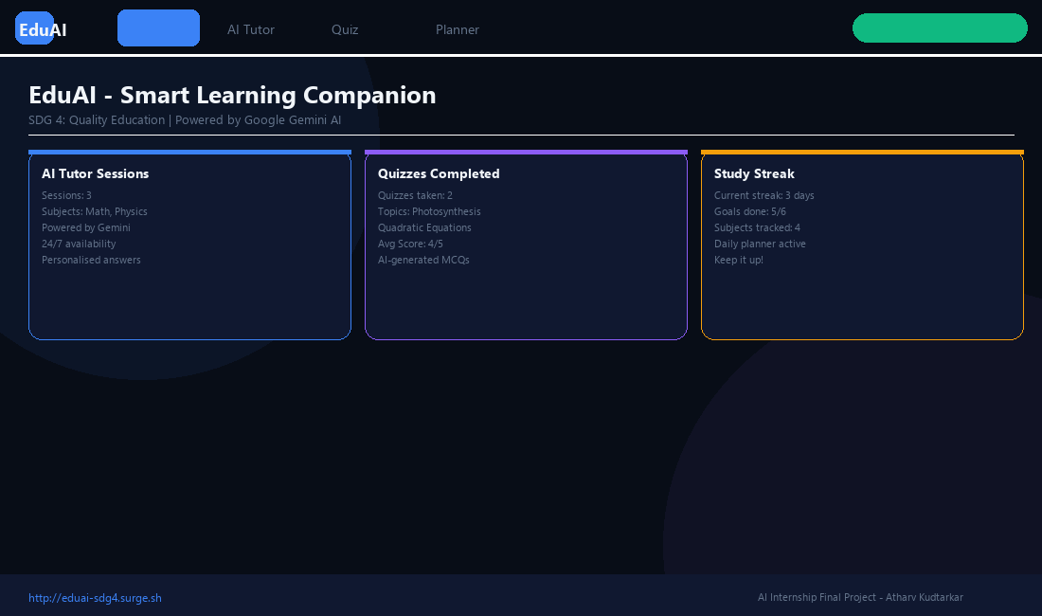
Figure 1: EduAI Main Dashboard. Displays active stats (sessions, quizzes, streaks), the SDG 4 mission summary, and quick navigation cards to launch the Tutor, Quiz, and Planner modules.
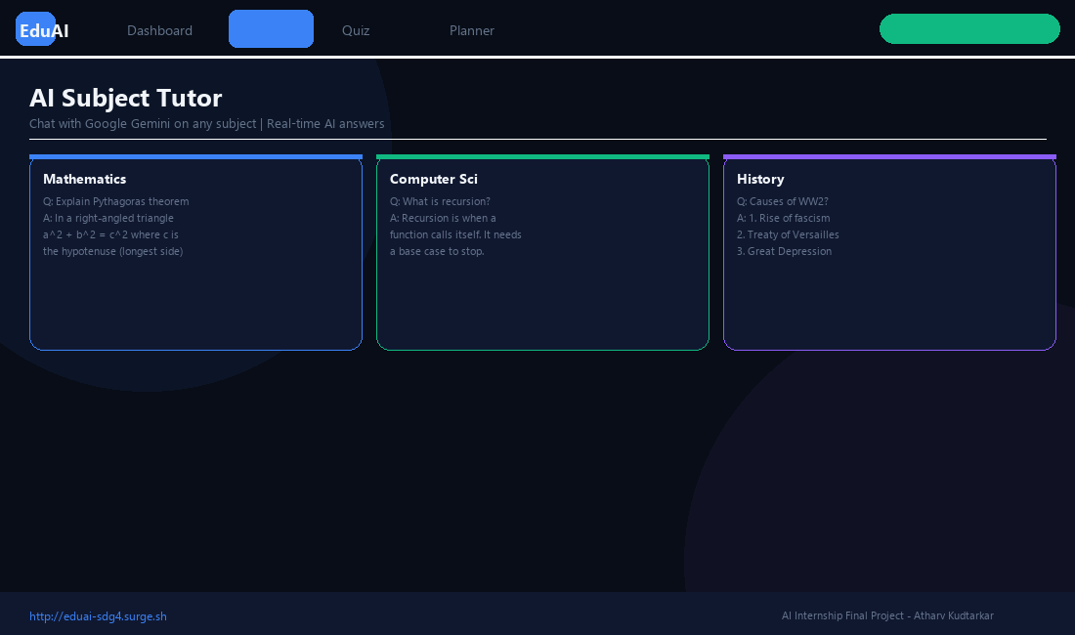
Figure 2: AI Subject Tutor. Shows real-time conversations with the AI tutor resolving doubts in Mathematics (Pythagorean theorem), Computer Science (recursion), and History (WW2 causes).
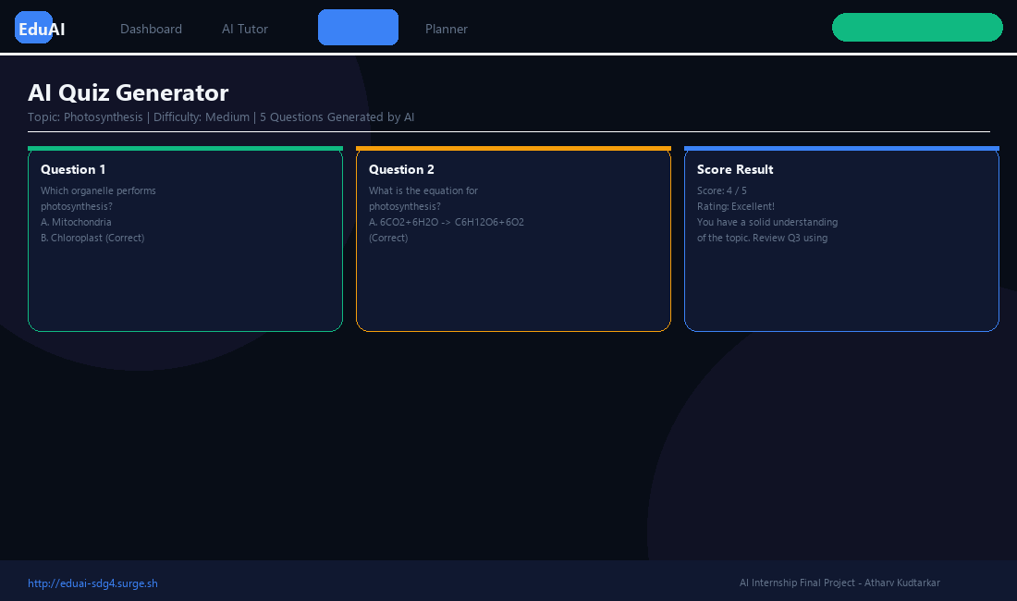
Figure 3: AI Quiz Generator. Displays an interactive quiz on photosynthesis. Highlights selected, correct, and incorrect options with real-time grading and feedback.
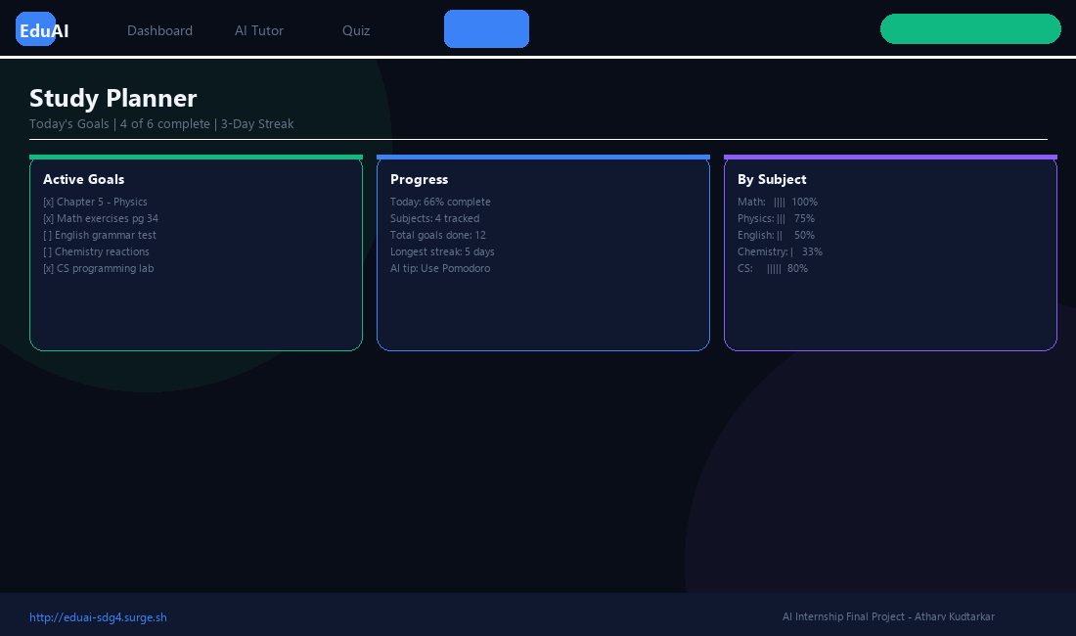
Figure 4: Study Planner. Displays a daily study checklist with categorized subject tags, a visual percentage progress bar, and a streak tracker.
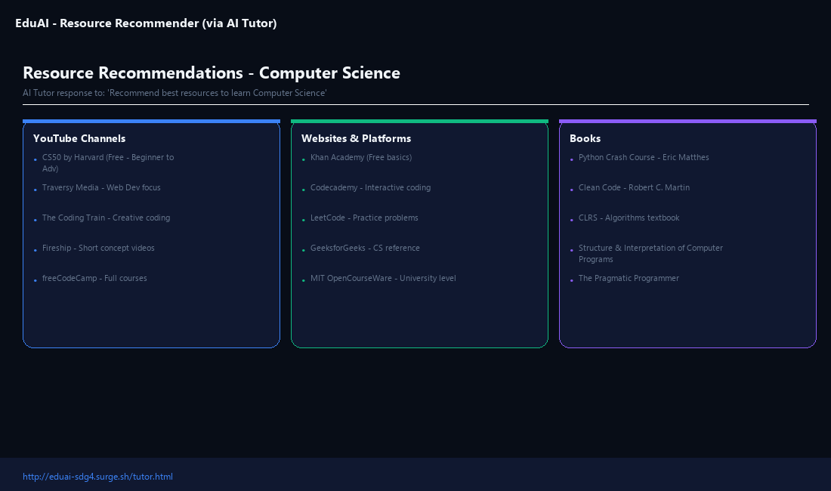
Figure 5: Resource Recommender. Demonstrates the AI recommendations page suggesting books, websites, and courses to learn Computer Science.
7. Open Source Repository & Project Links
The code and assets for this project are fully open source. The repository and live deployment links are as follows:
- GitHub Repository: https://github.com/Atharvk4406/eventopia
- EduAI Project Directory: https://github.com/Atharvk4406/eventopia/tree/main/eduai
- Live Interactive Application: http://eduai-sdg4.surge.sh
The open-source repository contains the following core files and directories that make up the client-side application:
- index.html: The primary landing page and user dashboard containing aggregated learning statistics.
- tutor.html: The conversational chatbot tutor interface with specific subject selection dropdowns.
- quiz.html: The interactive evaluation module containing the AI-generated quiz interface.
- planner.html: The daily checklist planner and streak tracking screen.
- style.css: Contains the glassmorphic dark theme styles, responsive flexbox layout definitions, and keyframe animations.
- app.js: Contains the core logic for the Gemini API call handling, JSON query formatting, and localStorage CRUD operations.
8. Future Scope & Enhancements
While EduAI is fully functional as a lightweight client-side application, several key improvements can be implemented in future releases to scale its impact:
- Mobile Application: Developing native mobile applications for Android and iOS using React Native or Flutter. This will allow push notifications for study reminders and support offline local database cache storage.
- Multi-Language Support: Adding support for Indian regional languages (such as Hindi, Marathi, Telugu, and Tamil) to allow students in rural areas who are not proficient in English to leverage the AI tutor.
- Adaptive Learning Paths: Analyzing historical quiz scores and chat logs to automatically map a student's weak areas and recommend targeted practice sets, creating a truly adaptive study curriculum.
- Teacher & Parent Dashboard: Creating a secondary login portal for teachers and parents to review students' study progress, assign specific topics to read, and monitor AI tutor chat histories for safety and guidance.
- Voice-Based Learning Interface: Integrating speech-to-text and text-to-speech APIs to allow students with visual impairments or reading difficulties to communicate with the tutor naturally using voice commands.
9. Conclusion & Summary
EduAI successfully demonstrates how Generative AI models like Google Gemini 2.0 Flash can be applied practically to support United Nations SDG 4 (Quality Education). By providing 24/7 personal tutoring, adaptive evaluations, structured organization, and resource recommendations, the application bridges the gap between passive content consumption and active conceptual learning.
Because the system runs entirely client-side and requires no dedicated backend servers, it operates at virtually zero cost, making it highly scalable and easy to maintain. Key learnings from building this project include masterfully integrating generative model APIs in raw JavaScript, designing a cohesive glassmorphic UI using modern CSS, managing browser-level data persistence, and implementing clean error handling to handle API request rate limits gracefully. The project stands as proof that accessible, impactful educational technology can be developed and deployed rapidly using modern AI APIs.

