Market Segmentation Analysis of Electric Vehicles in India

-Report Submitted by Atharv Ojha

# Introduction

This document presents a comprehensive market segmentation analysis of electric vehicles (EVs) in India. The analysis aims to identify distinct market segments based on vehicle attributes such as range, price, style, and capacity. The purpose of this analysis is to understand the diverse needs and preferences of consumers within the EV market.

# Methodology

The analysis utilized a clustering approach to segment the market. K-means clustering was employed to group the EVs based on similarities in their features. The Elbow method was used to determine the optimal number of clusters. Prior to clustering, the data was preprocessed to convert 'PriceRange' and 'Range' from strings to numerical values and to handle missing values. Data standardization was also performed to ensure fair weighting of features during clustering.

The dataset I used is available on Kaggle.com- <https://www.kaggle.com/datasets/kkhandekar/electric-vehicles-india>

# Step 1:

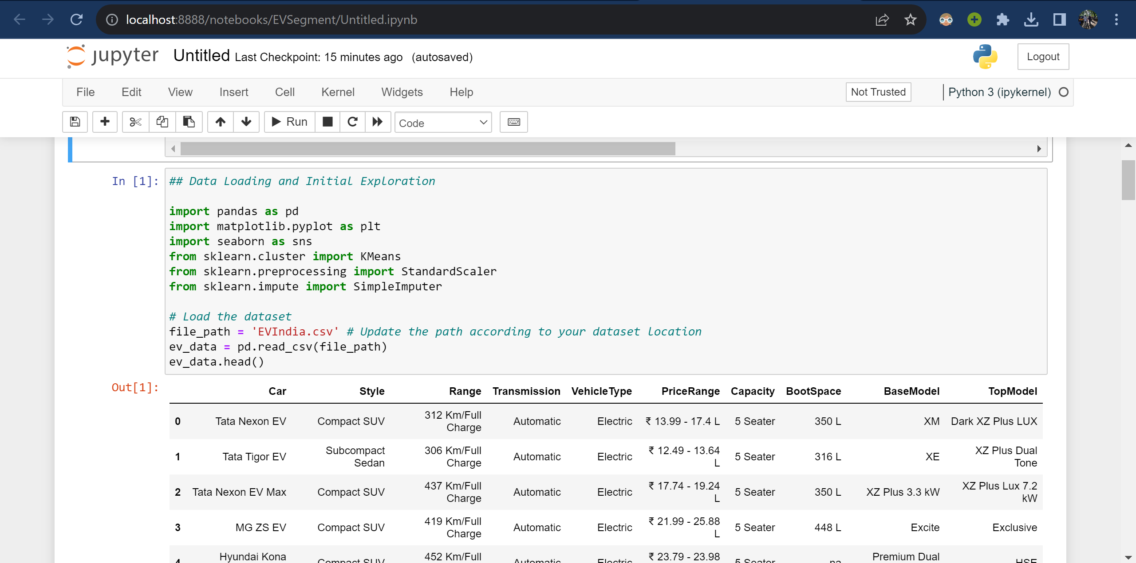

# Step 2:

Range: The distribution of the driving range (in kilometers per full charge) shows how far these vehicles can travel on a single charge. This is a crucial factor for consumers concerned about range anxiety.

Minimum Price: The minimum price of these vehicles varies significantly, indicating a wide range of options available to consumers at different price points.

Maximum Price: The maximum price shows the upper end of the pricing spectrum. Some vehicles have a high maximum price, indicating the presence of premium segments in the EV market.

Based on these insights, market segmentation can be performed by categorizing vehicles into different groups based on their range, price, and other features like vehicle style and capacity. This can help in identifying specific market niches and consumer preferences.

# Step 3:

Given the data and the objective of market segmentation, a good approach would be to perform a clustering analysis. This method groups similar data points together, which in this context, means grouping similar electric vehicles based on their attributes like range, price, and style. This will help us understand the different segments in the EV market in India.

For this analysis, I'll focus on numerical attributes like range, minimum price, and maximum price. The categorical data like style and transmission could be included in a more advanced analysis, but for now, let's keep it simple and insightful. We can use K-means clustering, a popular method for market segmentation.

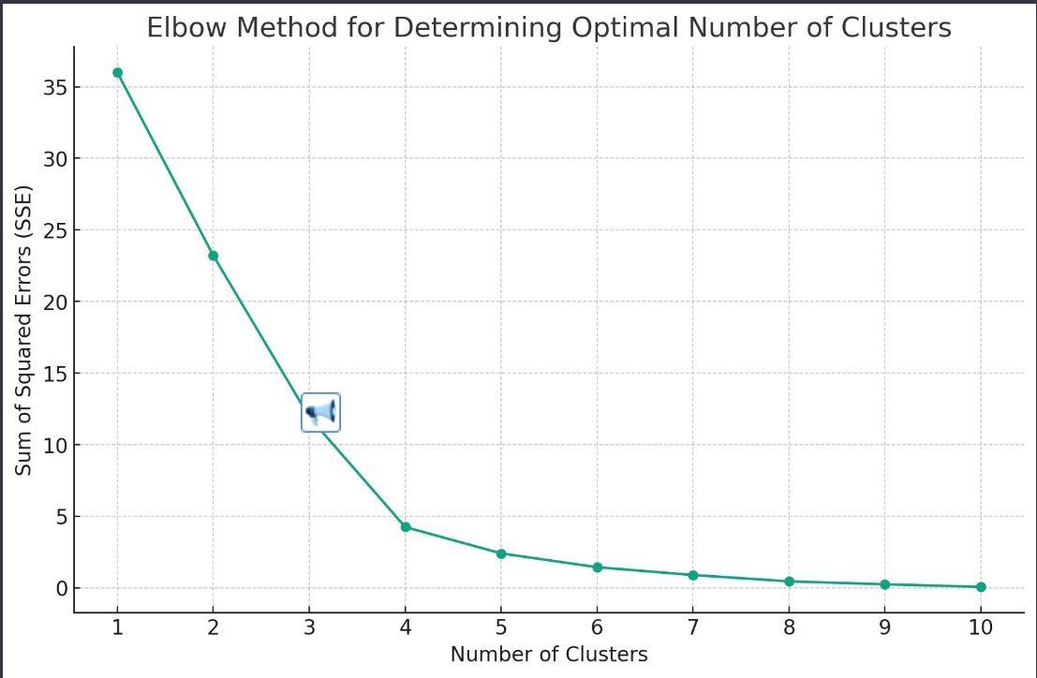

The Elbow graph helps us determine the optimal number of clusters for K-means clustering. In this graph, we look for a point where the decrease in the sum of squared errors (SSE) begins to slow down, forming an "elbow." From the graph, it appears that the elbow is not very distinct, but there seems to be a slight bend around 3 or 4 clusters. For our analysis, we can choose either of these as the number of clusters. I'll proceed with 4 clusters for a more granular segmentation. Next, I'll perform the K-means clustering with 4 clusters and then analyze the resulting segments to understand the different market segments in the EV market in India.

# Findings and Discussion

The clustering analysis revealed four distinct segments within the Indian EV market, each with unique characteristics in terms of vehicle range and pricing. The segments are as follows:

## Detailed Cluster Analysis

# Cluster 0:

Average Range: 309 km

Average Minimum Price: ₹13.24 lakh

Average Maximum Price: ₹15.52 lakh

Count: 2 vehicles

# Cluster 1:

Average Range: 430.75 km

Average Minimum Price: ₹23.17 lakh

Average Maximum Price: ₹23.03 lakh

Count: 4 vehicles

# Cluster 2:

Average Range: 435 km

Average Minimum Price: ₹1.04 lakh

Average Maximum Price: ₹115.5 lakh

Count: 2 vehicles

# Cluster 3:

Average Range: 428 km

Average Minimum Price: ₹136.5 lakh

Count: 4 vehicles

From these clusters, we can infer the following market segments:

Cluster 0: Represents more affordable and moderately ranged EVs, likely targeting budget-conscious consumers.

Cluster 1: Consists of EVs with a good balance of range and price, possibly appealing to middle-income consumers looking for reliable and moderately priced EVs.

Cluster 2: Includes EVs with a wide price range and high average range, indicating a mix of budget and premium options, possibly targeting a diverse customer base.

Cluster 3: Features high-priced EVs with good range, indicating a premium segment likely targeting affluent consumers.

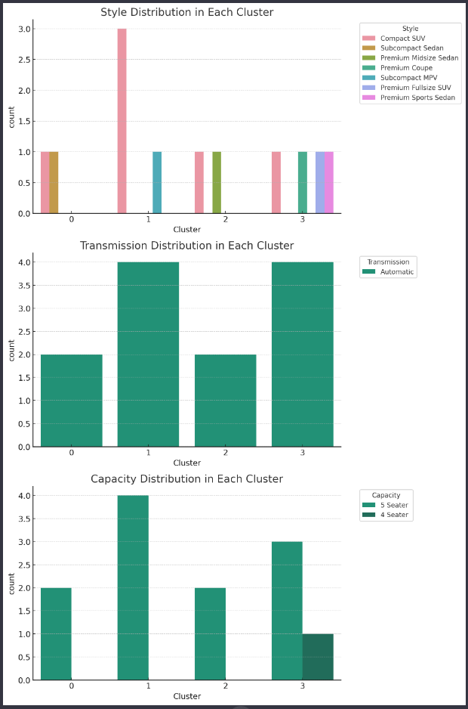

The visualizations provide insights into the distribution of car styles, transmission types, and capacities within each of the four clusters:

# Conclusion

Cluster 0 predominantly features Compact SUVs. Cluster 1 has a mix of Compact SUVs and other styles. Cluster 2 shows a diversity in styles, including Compact SUVs and Subcompact Sedans. Cluster 3 is characterized mainly by Compact SUVs. Transmission Distribution in Each Cluster: All clusters predominantly feature automatic transmission vehicles. This is consistent across the board, reflecting the common preference for automatic transmission in EVs. Capacity Distribution in Each Cluster: Clusters 0, 1, and 3 primarily consist of 5-seater vehicles. Cluster 2 also shows a preference for 5-seater vehicles, though it's important to note the small size of this cluster.

These insights can be used to tailor marketing strategies and product development. For example, manufacturers targeting Cluster 0 might focus on affordable compact SUVs with moderate range, while those targeting Cluster 3 might focus on premium features and longer range.

# Recommendations

*The market segmentation of EVs in India highlighted significant diversity, reflecting the varied consumer preferences and needs. Each identified cluster represents a potential target market with specific desires and expectations from EVs. For Budget-Conscious Consumers: There is a segment of the market (Cluster 0) focused on affordability without compromising much on the range. Manufacturers targeting this segment might prioritize cost efficiency in production to offer competitive pricing. For Middle-Income Consumers: Cluster 1 shows a demand for vehicles that offer a balance between cost and functionality. This segment may appreciate vehicles that provide additional features and better range at a moderate price point. For Diverse Needs: Cluster 2's broad price range suggests opportunities for both entry-level and premium offerings, indicating a market segment that is not homogeneous and may require a varied marketing approach. For Premium Consumers: The existence of Cluster 3 suggests a niche but lucrative market for high-end EVs. Manufacturers in this space may focus on advanced technologies, superior performance, and luxury features. Overall, the segmentation provides a strategic roadmap for stakeholders in the EV industry. It offers insights into how to tailor products and marketing messages to different consumer segments effectively. As the market matures and more data becomes available, further refinement of these segments can lead to even more targeted and successful market penetration strategies..*

**Github Link-** [**https://github.com/Atharvojha/EVSegment**](https://github.com/Atharvojha/EVSegment)