A Mini Project on
Retail Sales Analysis using Power BI
Using
Power BI



Name of Student
Atharv Surendra Magdum

Name of University
Paris School of Technology and Business
Tech MBA


1.INTRODUCTION

In the modern business environment, data plays a very important role in decision-making. Companies generate large amounts of data every day through their sales, customers, and operations. However, raw data alone is not useful unless it is properly analyzed and presented in a meaningful way.
This project focuses on analyzing retail transaction data using Power BI, a powerful data visualization tool. The aim is to convert raw transactional data into clear, interactive, and easy-to-understand insights. By doing this, businesses can better understand their performance and make smarter decisions.
The dataset used in this project contains information about customer purchases, including product details, quantity, price, and country. Using this data, a dashboard has been created to track key performance indicators such as total sales, number of customers, total orders, and quantity sold.
In addition to basic analysis, this project also explores trends over time, identifies top-performing products, and examines how sales are distributed across different countries. The use of interactive visuals like charts, graphs, and filters makes it easier to explore the data from multiple perspectives.
Overall, this project demonstrates how data visualization tools like Power BI can help transform complex data into valuable business insights in a simple and effective way.

2.OBJECTIVES:
The key objectives of this project are:

- To analyze overall sales performance
- To identify top-performing products
- To understand customer distribution
- To study sales trends over time
- To analyze geographic contribution (country-wise sales)
- To create an interactive dashboard for easy decision-making

3.Dataset Description
The dataset used in this project includes the following columns:
- Invoice No – Unique order number
- Stock Code – Product ID
- Description – Product name
- Quantity – Number of items purchased
- Invoice Date – Date and time of transaction
- Unit Price – Price per unit
- CustomerID – Unique customer identifier
- Country – Customer location
From this dataset, a new column called Total Sales was created using:
Total Sales = Quantity × Unit Price
This helped in analyzing revenue more effectively.

4.Data Cleaning and Preparation
Before building the dashboard, the data was cleaned using Power BI:
- Removed missing Customer IDs
- Handled negative quantities (returns)
- Converted data types correctly (date, numbers)
- Removed duplicate or unnecessary values
- Created calculated fields like Total Sales
This step was important to ensure accurate analysis.
5.Dashboard Overview
The dashboard created in Power BI provides a complete overview of the business performance. It includes key metrics and visualizations.
5.1 Key Performance Indicators (KPIs)
The dashboard displays the following KPIs:
- Total Customers
- Total Sales
- Total Quantity Sold
- Total Orders
These KPIs give a quick summary of overall business performance.
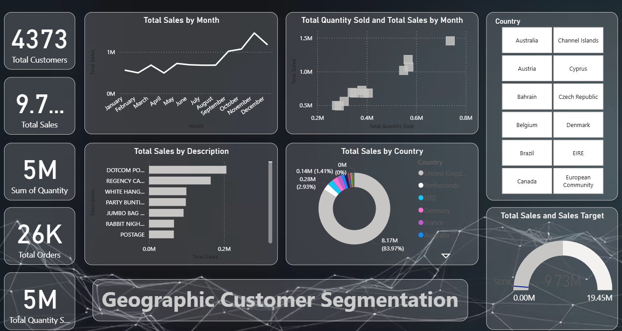
5.2 Sales Trend Analysis
A line chart shows Total Sales by Month, which helps in understanding:
- Sales growth over time
- Monthly trends
- Peak sales periods
From the dashboard, it is observed that sales increase significantly towards the end of the year.

5.3 Product Performance
A bar chart displays Total Sales by Product Description, highlighting:
- Top-selling products
- Products generating highest revenue
This helps businesses focus on high-performing products.
5.4 Geographic Analysis
A donut chart and slicer are used to analyze Sales by Country.
Key insights:
- A major portion of sales comes from the United Kingdom
- Other countries contribute smaller shares
This shows that the business is highly dependent on a single region.

5.5 Customer Segmentation
The dashboard includes Geographic Customer Segmentation, showing how customers are distributed across countries.
This helps in:
- Identifying major customer bases
- Understanding market reach

5.6 Sales vs Target Analysis
A gauge chart is used to compare Total Sales with Sales Target.
This helps to:
- Measure performance against goals
- Track whether targets are achieved
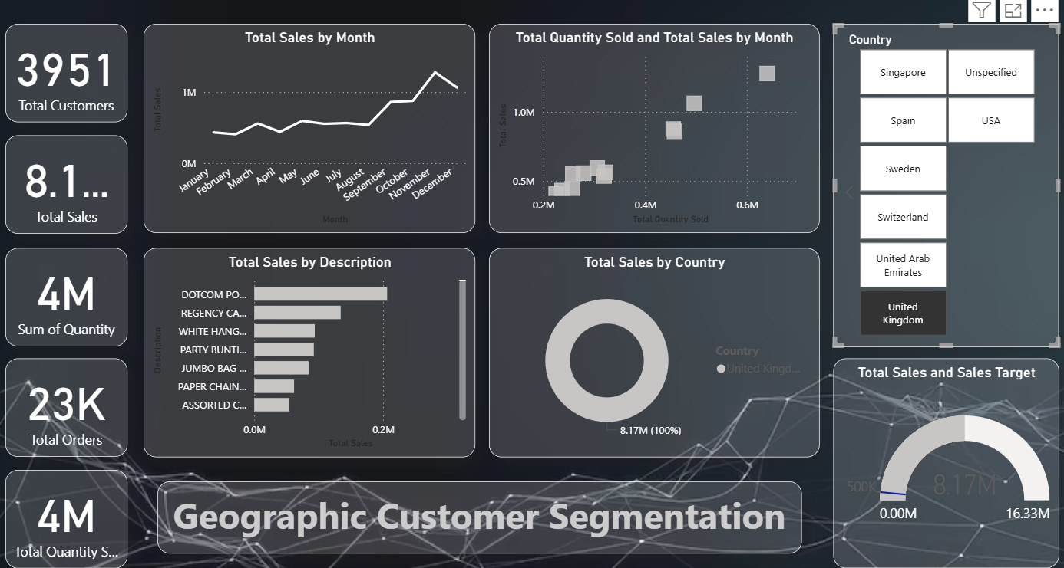

6. Key Insights from the Dashboard
From the analysis, the following insights were observed:
- Most sales come from a limited number of countries
- The United Kingdom contributes the highest revenue
- A few products generate most of the sales (Pareto principle)
- Sales show an increasing trend towards the end of the year
- Customer base is concentrated in specific regions

7.CONCLUSION
This project demonstrates how raw transactional data can be transformed into meaningful insights using Power BI.
The dashboard provides a clear understanding of:
- Sales performance
- Customer behavior
- Product demand
- Geographic distribution
These insights can help businesses make better decisions, improve strategies, and increase profitability.

8. Future Scope
This project can be further improved by:
- Adding profit analysis (if cost data is available)
- Performing customer segmentation (RFM analysis)
- Adding predictive analysis for future sales
- Integrating real-time data

9. Tools Used
- Power BI
- Power Query
- DAX (Data Analysis Expressions)

10. Final Outcome
An interactive and user-friendly dashboard was created that helps users:
- Monitor business performance
- Identify key trends
- Make data-driven decisions

